

User Guide – Promotion Details

Promotion Details User guide

Opentext

138 Market Street

Level 33

Singapore 048946

[www.opentext.com](http://www.opentext.com)

OpenText Professional Services

January, 2017

Contents

1. Component Break-up 3

1.1. Component List 3

1.2. Page Structure 3

2. Promotion Details Common DCR Break-up 6

2.1. Header 6

2.2. Navigation 6

2.3. Breadcrumb 6

2.4. Footer 6

3. Promotion Details specific DCR Break-up 7

3.1. Promotion Details 7

3.2. Promotion Categories DCT 13

4. Resources 14

4.1. CSS Resources 14

4.2. JavaScript Resources 14

# Component Break-up

## Component List

The Promotion Details is composed of the following components

1. Common Components
   1. Header
   2. Navigation
   3. Breadcrumb
   4. Footer
2. Promotion Details specific components
   1. Promotion details

## Page Structure

The page structure (component order) and brief explanation as follows. For component’s detailed explanation refer to Functional Specifications Document.

1. Header Component



Global Component composed from UOB logo, “right by you” logo, section menu details, login button and add country section data items

The header component’s default setting should have the following values in Content and Appearance:

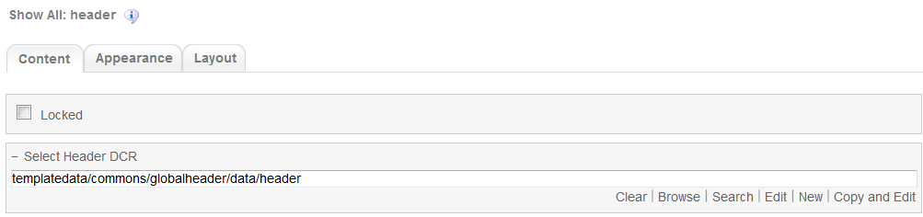

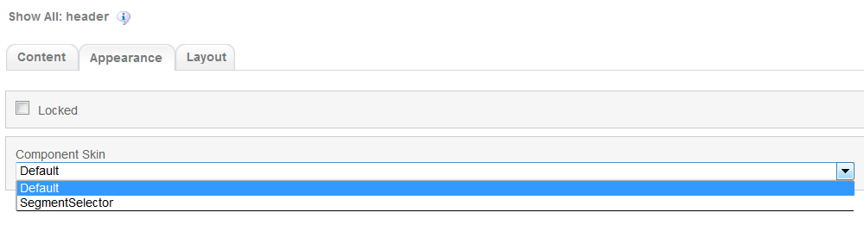

1. Navigation Component



Global component which uses TeamSite Site Map as the content source. Quick links information can be customized

Navigation Component’s default setting should have the following values in Content:

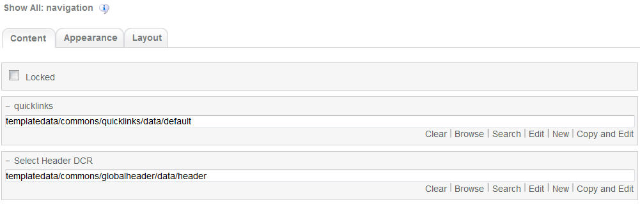

1. Breadcrumb Component



Global component to display the Home Link, Home Link Label and Home Link Target. Can be changed from component properties. If the pageName component properties is left blank then it will take the page name from the respective sitemap node

Breadcrumb Component’s default setting should have the following values in Content

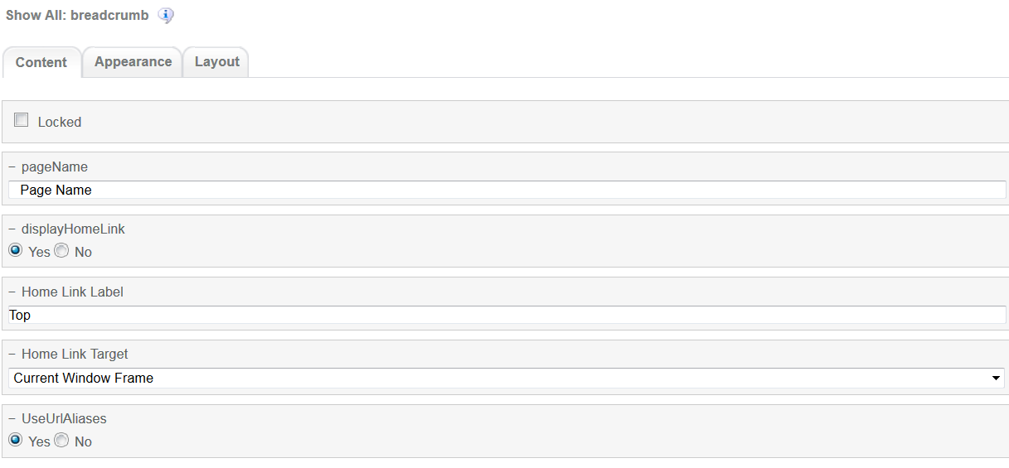

1. Promotion Details

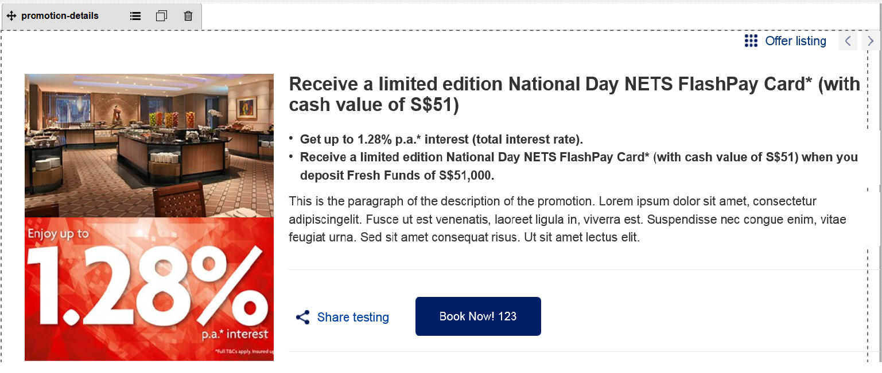

Promotion details main component. Can be customized through DCR

Promotion details component’s default setting should have the following values in Content  
  
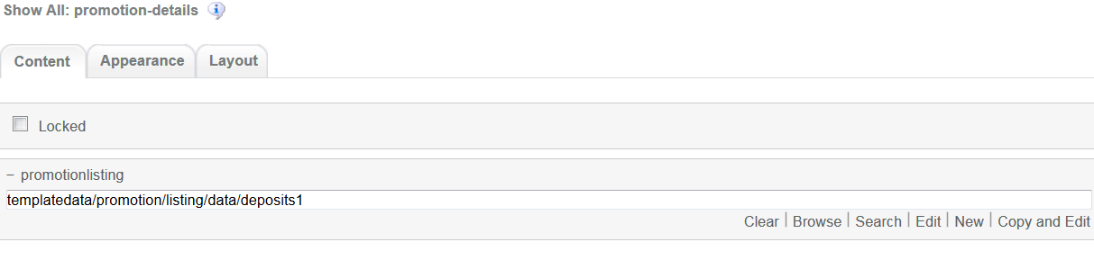

1. Footer component



Global component controlled by DCR. Links and Copyright text can be customized

Footer component’s default setting should have the following values in Content:

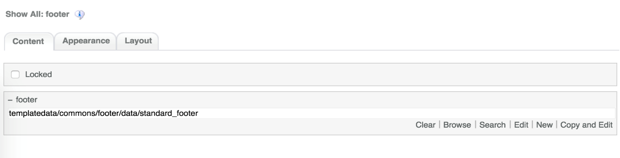

# Promotion Details Common DCR Break-up

In this section, a brief explanation of Promotion Details common DCR will be made. Please refer to User_Guide-Home_page on how to navigate and select edit DCR’s

## Header

Please refer to User_Guide-Home_page “Homepage Common DCR Break-up” for information on Header component

## Navigation

Please refer to User_Guide-Home_page “Homepage Common DCR Break-up” for information on Navigation component

## Breadcrumb

Please refer to User_Guide-Product_Landing “Product Landing Common DCR Break-up” for information on Breadcrumb component

## Footer

Please refer to User_Guide-Home_page “Homepage Common DCR Break-up” for information on Footer component

# Promotion Details specific DCR Break-up

In this section, a brief explanation of each Promotion Details specific component DCR will be made. Please refer to User_Guide-Home_page on how to navigate and select edit DCR’s.

## Promotion Details

The DCT to create the Promotion Details promotion-detail DCT is located on *templatedata/promotion/listing/* under the name datacapture.cfg and can be located using Team Site CCProfessional user interface.

The Promotion Details DCT has the following items

1. Promotion Details container  
   Promotion details main container has the following fields
   1. Promotion Id  
      Text area. The promotion ID is generated automatically  
      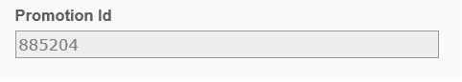
   2. Product Category  
      Inline Selector field  
      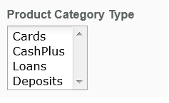

The fields that appear on the Product Category Type are read from another DCR under /templatedata/promotion/categories/data. For explanation on this DCT, please refer to Promotion Categories DCT section

* 1. Country  
     Inline Selector field  
     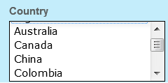

The fields that appear on the Country selector are read from a text file located in /iwov-resources/text under the name countries.txt. Countries can be added and deleted from this list. **DO NOT** change the name or delete the file. Doing so will cause the DCT to fail when trying to retrieve the countries names

* 1. Promotion Page Name  
     Browse field to select where the user can select the corresponding page name (.page extension)  
     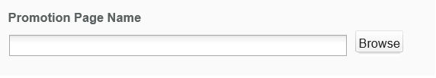
  2. Title  
     Text field. This is a required field  
     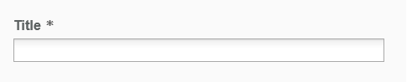
  3. Image for listing page  
     Browse field where user can select the corresponding image  
       
     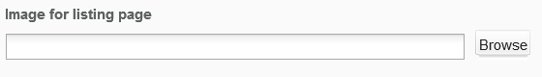
  4. Alt Text  
     Text field  
     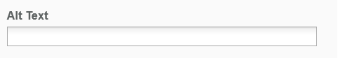
  5. Activate Date  
     Text field with option to select the activation date by clicking on the Select Date button. This is a required field  
       
     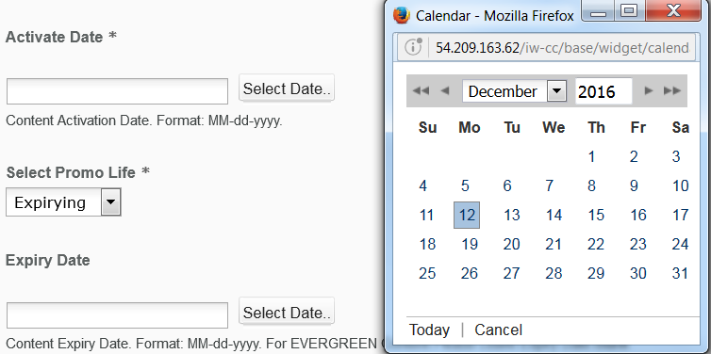
  6. Select Promo Life  
     Drop Down field. This is a required field  
       
     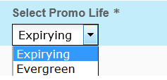
  7. Expiry Date  
     Text field with option to select the expiry date by clicking on the Select Date button  
       
     

1. Promotion Features container  
   The promotion features container has the following fields
   1. Title Text  
      Text field. This is a required field  
        
      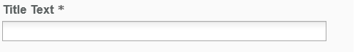

The promotion features container consists of other 3 main containers, Banner Image, Offer Content Blocks and Terms and Conditions Accordion Content container.

1. Banner Image Container  
   There can be a maximum of 2 Banner Image container and each one has the following fields
   1. Image  
      Browse field where user can select the corresponding image by clicking on the Browse button  
      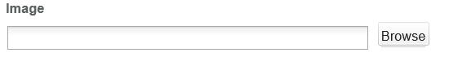
2. Offer Content Block Container  
   The offer content container can have multiple options like shown as follows (The drop down menu can be displayed by clicking on the plus sign on the container). Each time an option is selected a new Offer Content Container will be made and there is a limit of 10 containers  
     
   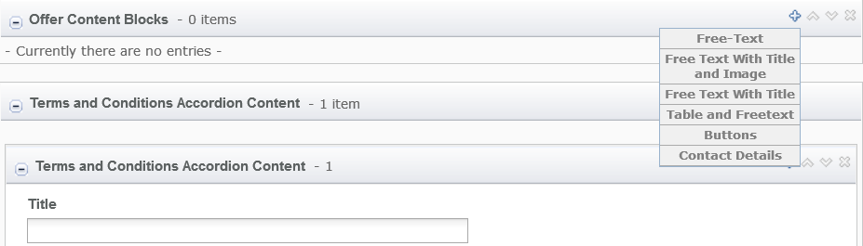
   1. Free-Text Option  
      This option has the following fields
      1. Description  
         A free format field that uses TinyMCE for editing. This is a required field  
         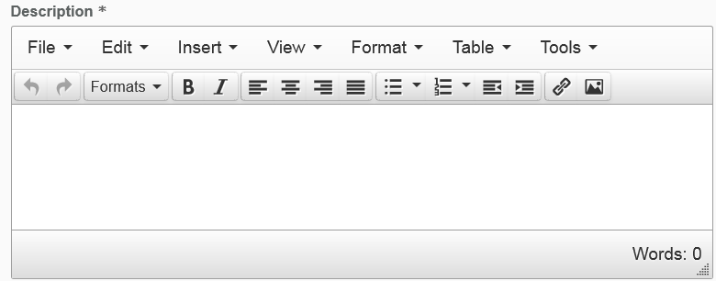
   2. Free Text with Title and Image  
      This option has the following fields
      1. Title  
         Text field  
         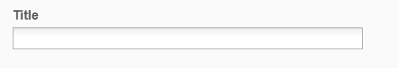
      2. Image Link  
         Browse field where user can select the corresponding image by clicking on the Browse button  
         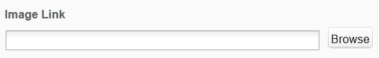
      3. Description  
         A free format field that uses TinyMCE for editing. This is a required field  
           
         
   3. Free Text with Title  
      This option has the following fields
      1. Title  
         Text field  
         
      2. Description  
         A free format field that uses TinyMCE for editing. This is a required field  
           
         
   4. Table and Freetext  
      This option has the following fields
      1. Title  
         Text field  
         
      2. Table Content  
         A free format field that uses TinyMCE for editing. This is a required field  
           
         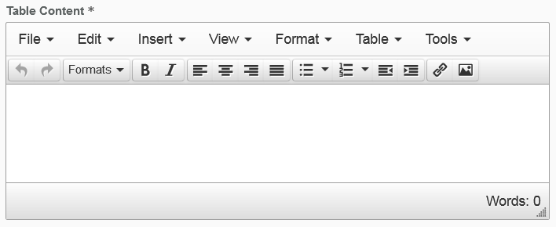
      3. Table Context Description  
         A free format field that uses TinyMCE for editing  
           
         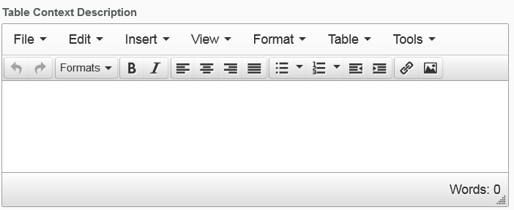
      4. Image Link  
         Browse field where user can select the corresponding image by clicking on the Browse button  
         
      5. Image Context Free Text  
         A free format field that uses TinyMCE for editing   
           
         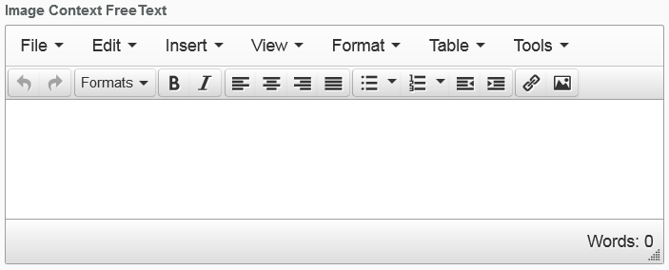
   5. Buttons  
      This option has the following fields
      1. Social Text, Social Hyperlink, CTA Text and CTA Hyperlink  
         Text field  
         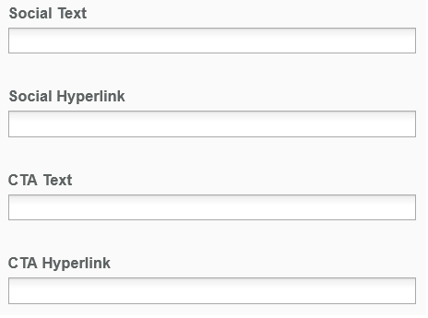
   6. Contact Details  
      This option has the following fields
      1. Contact Heading  
         Text field  
           
         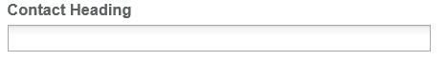
      2. Contact Value  
         A free format field that uses TinyMCE for editing  
           
         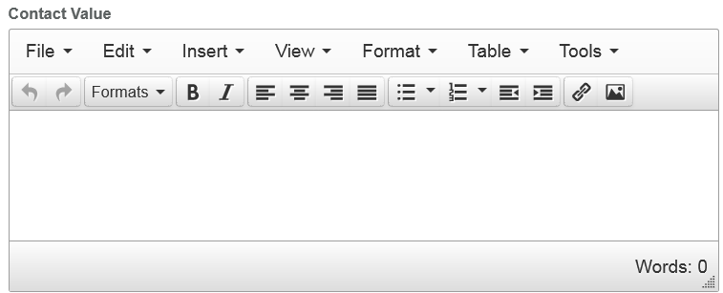
3. Terms and Conditions Accordion Content  
   The Terms and Conditions Accordion Content container can have up to 5 replicas with the following fields
   1. Title  
      Text field  
      
   2. Description  
      A free format field that uses TinyMCE for editing  
        
      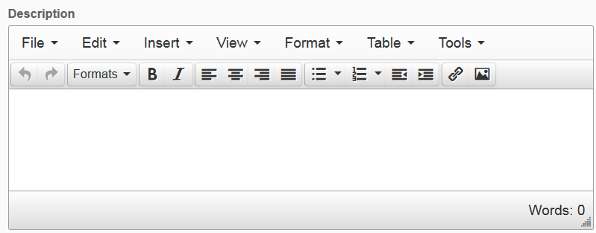

## Promotion Categories DCT

The promotion categories DCT can be found in */templatedata/promotion/categories/* under the name of datacapture.cfg. The DCR resulting from editing the DCT is referenced by the promotion details DCR “Product Category Type” explained in the section before.

The Promotion categories DCT has the following items

1. Promotion Category Details Container  
   The promotion category details container can have up to 15 replicas with the following fields
   1. Product Category Name  
      Text field. This is a required field  
      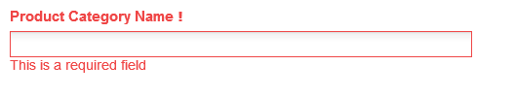
   2. Image  
      Browse field to select the desired image by clicking on the Browse button  
      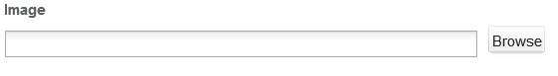
   3. Alt Text  
      Text field  
      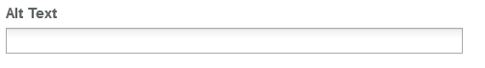
   4. Target Promotion Listing Page  
      Browse field to select the desired page by clicking on the Browse button  
      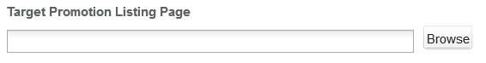
   5. Link Title  
      Text field  
      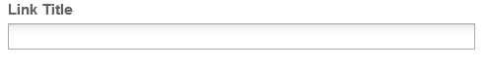

The value entered on the Product Category Name will be reflected on the “Product Category Type inline selector field on the Promotion Details DCT.

# Resources

This section provides a list of the necessary resources (CSS & JavaScript) to create a Promotion Details template. On how to create a template please refer to the User_Guide-Home_Page.

## CSS Resources

The css resources for the Promotion Details template are as follows

|  |  |
| --- | --- |
| **Devices to use with** | **Path** |
| Desktop, Tablet, Mobile | <wa-path>/iwov-resources/css/productlanding/bootstrap.min.css |
| <wa-path>/iwov-resources/css/promotion-details/style.css |
| Desktop | <wa-path>/iwov-resources/css/promotion-details/desktop-style.css |
| Tablet | <wa-path>/iwov-resources/css/promotion-details/tablet-style.css |
| Mobile | <wa-path>/iwov-resources/css/promotion-details/mobile-style.css |
| Desktop, Tablet, Mobile | <wa-path>/iwov-resources/css/style.css |
| Desktop | <wa-path>/iwov-resources/css/desktop-style.css |
| Tablet | <wa-path>/iwov-resources/css/tablet-style.css |
| Mobile | <wa-path>/iwov-resources/css/mobile-style.css |

These resources must be entered on the same order as the previous table or the page style will break

## JavaScript Resources

The JavaScript resources for the Promotion Details template are as follows

|  |  |
| --- | --- |
| **Devices to use with** | **Path** |
| Desktop, Tablet, Mobile | <wa-path>/iwov-resources/js/analytics.js |
| <wa-path>/iwov-resources/js/cookie_handler.js |
| <wa-path>/iwov-resources/js/initiator.js |
| <wa-path>/iwov-resources/js/promotionlanding/modernizr.min.js |
| <wa-path>/iwov-resources/js/promotionlanding/jquery.min.js |
| <wa-path>/iwov-resources/js/promotionlanding/bootstrap.min.js |
| <wa-path>/iwov-resources/js/promotionlanding/plugins.min.js |
| <wa-path>/iwov-resources/js/promotion-details/main.js |
| <wa-path>/iwov-resources/js/promotion-details/promotion_details_support.js |
| <wa-path>/iwov-resources/js/promotion-details/offerlistinghandler.js |

These resources must be entered on the same order as the previous table or the page will break