

User Guide – Segment Selector

Segment Selector User guide

Opentext

138 Market Street

Level 33

Singapore 048946

[www.opentext.com](http://www.opentext.com)

OpenText Professional Services

December, 2016

Contents

1. Component Break-up 3

1.1. Component List 3

1.2. Page Structure 3

2. Segment Selector Common DCR Break-up 7

3. Segment Selector specific DCR Break-up 8

3.1. Segment Selector 8

4. Resources 9

4.1. CSS Resources 9

4.2. JavaScript Resources 9

# Component Break-up

## Component List

The Segment Selector template is composed of the following components

1. Common Components
   1. Header
   2. Carousel
   3. 2-column-tile
   4. 3-column-tile
   5. 4-column-tile
   6. Footer
2. Segment Selector specific components
   1. Segment Selector

## Page Structure

The page structure (component order) and brief explanation as follows. For component’s detailed explanation refer to Functional Specifications Document.

1. Header Component



Global Component composed from UOB logo, “right by you” logo, section menu details, login button and add country section data items

The header component’s default setting should have the following values in Content and Appearance:

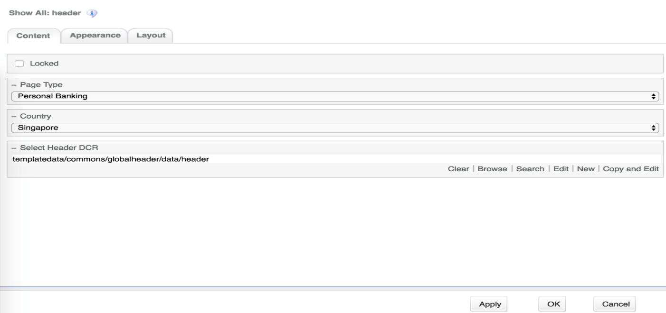

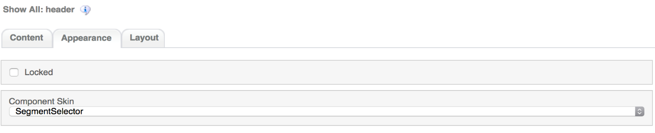

1. Carousel Component  
     
   

Global component to display banners. Banner DCR can be changed from component properties and DCR can be customized.

Carousel component’s default setting should have the following values in Content:  
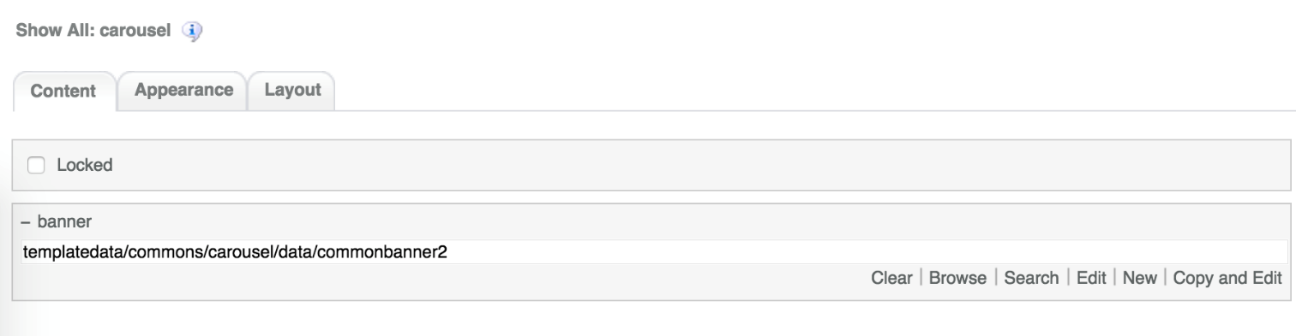

1. Segment Selector Component  
   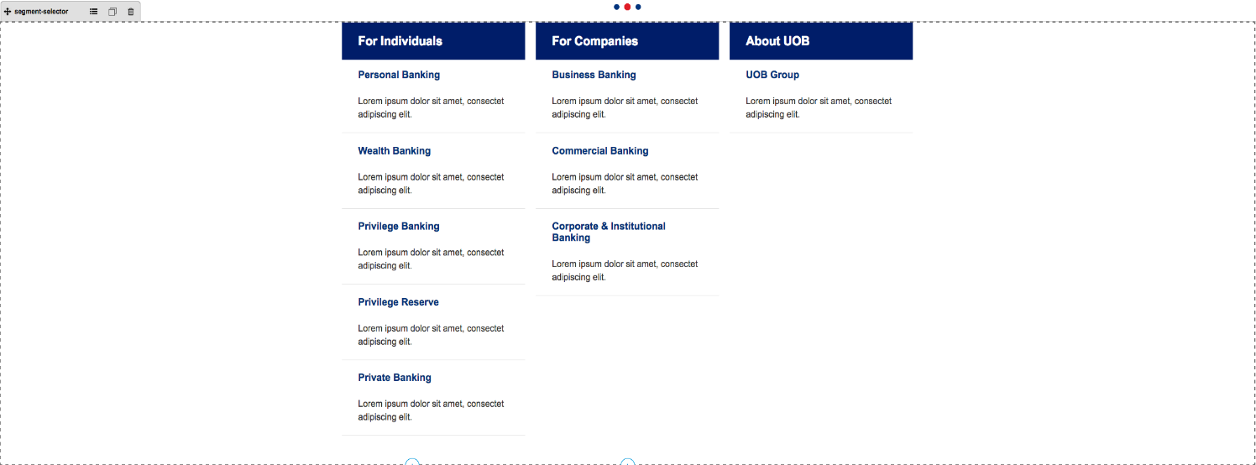

Segment Selector Template specific component. Can be customized through DCR

Segment selector component default setting should have the following values in Content:

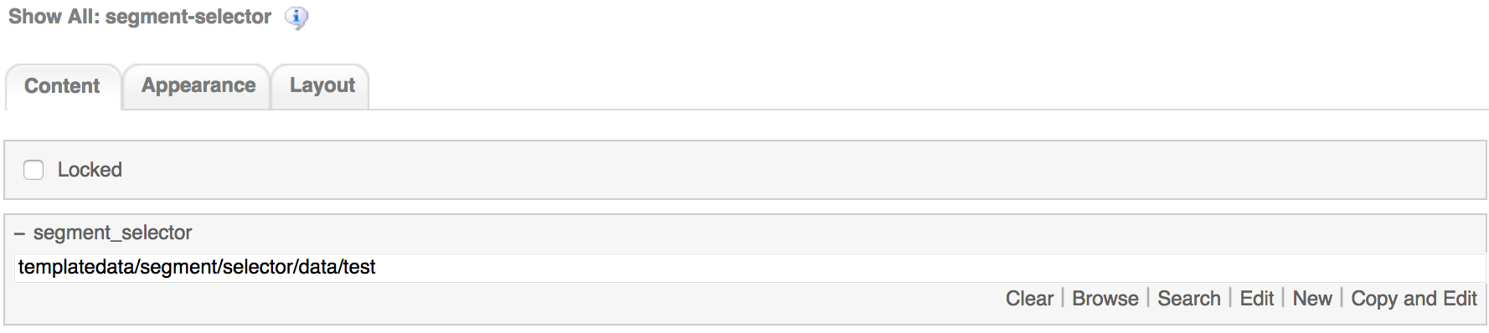

1. 2-column-tile component  
   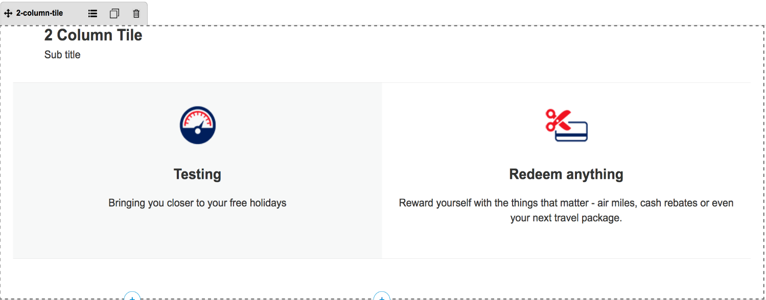

Common component controlled by DCR. Images, tile details, background, links and other resources can be customized

2-coloumn-tile component default setting should have the following values in content:  
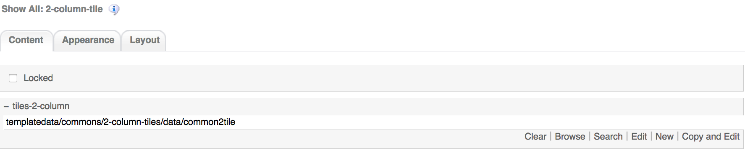

1. 3-column-tile component  
   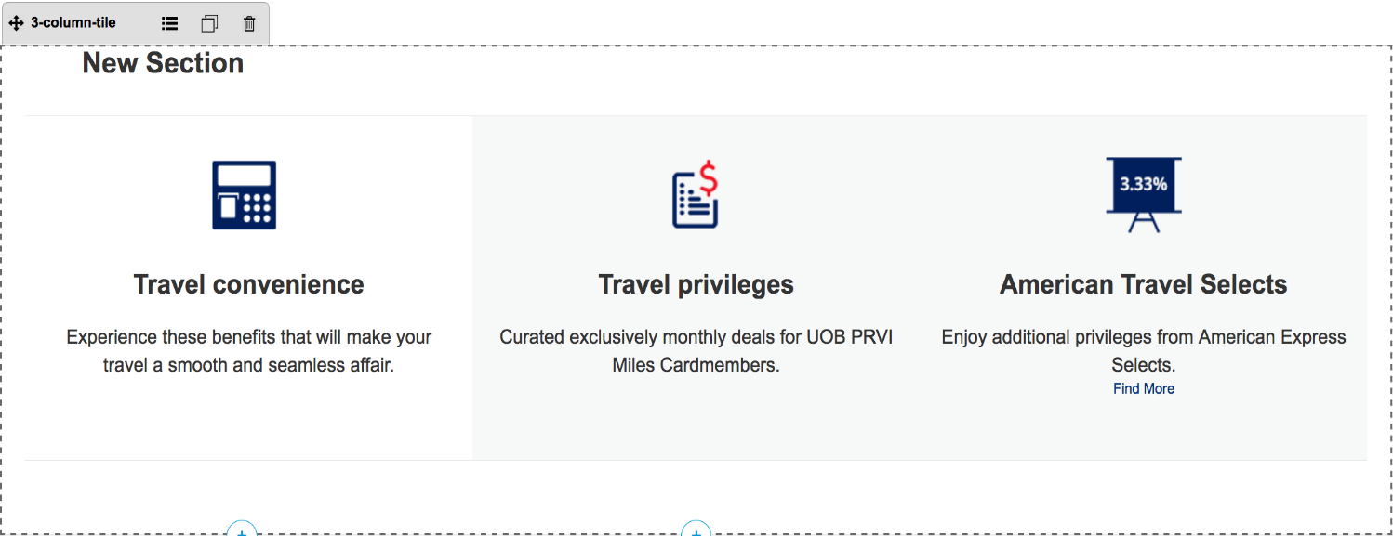

Common component controlled by DCR. Images, tile details, background, links and other resources can be customized

3-column-tile component default setting should have the following values in content:  
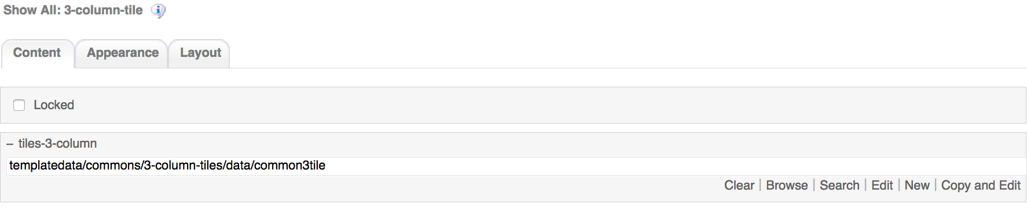

1. 4-column-tile component  
     
   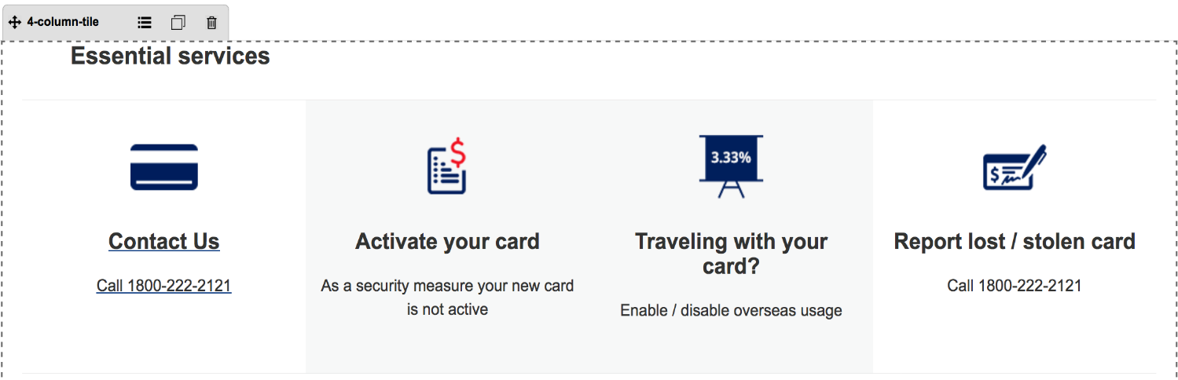

Common component controlled by DCR. Images, tile details, background, links and other resources can be customized

4-column-tile component default setting should have the following values in content:  
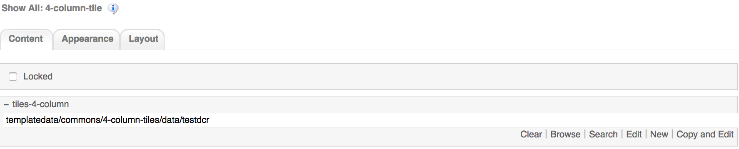

1. Footer component

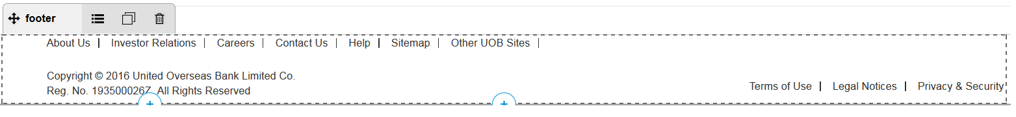

Global component controlled by DCR. Links and Copyright text can be customized

Footer component’s default setting should have the following values in Content:

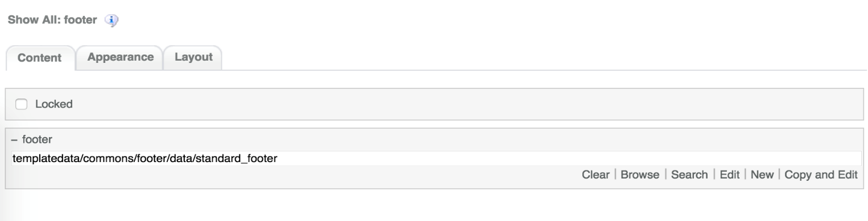

# Segment Selector Common DCR Break-up

The common components used in Segment Selector are the same as the ones used in Product Landing. For information on each common component please refer to User_Guide-Product_Landing user guide.

The only difference is with 2-column-tile and 3-column-tile. Basically, these 2 components have the same structure as 4-column-tile, except for the following 2 fields on the Tile Details container.

1. CTA Text and CTA Link  
   Text field  
   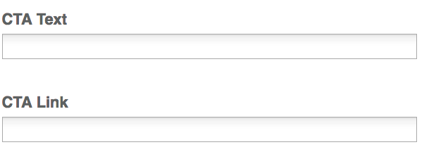

4-colum-tile has only one text field named Tile Target Link as explained on User_Guide-Product_Landing user guide

# Segment Selector specific DCR Break-up

In this section, a brief explanation of each Segment Selector specific component DCR will be made. Please refer to User_Guide-Home_page on how to navigate and select edit DCR’s.

## Segment Selector

The DCT to create the Segment Selector segment-selector DCT is located on *templatedata/segment/selector/* under the name datacapture.cfg and can be located using Team Site CCProfessional user interface.

The main container has by default 3 Section container. Each of the Section container has the following items

1. Section Title  
   Text field. This is a required field  
   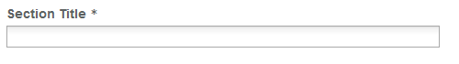
2. Segment container  
   1 Segment container per Section container. The Segment container can have until 10 replicas. The Segment container has the following fields
   1. Segment Title  
      Text field. This is a required field  
      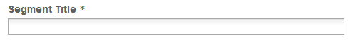
   2. Link  
      Text field. This is a required field  
      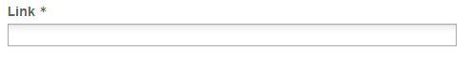
   3. Link Opening Option  
      Drop down menu field  
      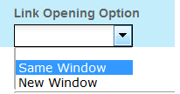
   4. Description  
      Text area with free formatting using TinyMCE  
      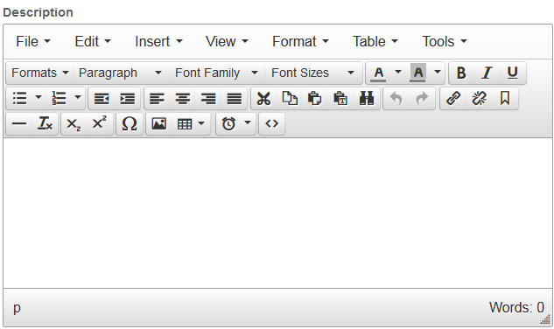

# Resources

This section provides a list of the necessary resources (CSS & JavaScript) to create a Segment Selector template. On how to create a template please refer to the User_Guide-Home_Page.

## CSS Resources

The css resources for the Segment Selector template are as follows

|  |  |
| --- | --- |
| **Devices to use with** | **Path** |
| Desktop, Tablet, Mobile | <wa-path>/iwov-resources/css/bootstrap.min.css |
| <wa-path>/iwov-resources/css/style.css |
| Desktop | <wa-path>/iwov-resources/css/desktop-style.css |
| Tablet | <wa-path>/iwov-resources/css/tablet-style.css |
| Mobile | <wa-path>/iwov-resources/css/mobile-style.css |
| Desktop | <wa-path>/iwov-resources/css/segment-selector/segment-selector-desktop-style.css |
| Tablet | <wa-path>/iwov-resources/css/segment-selector/segment-selector-tablet-style.css |
| Mobile | <wa-path>/iwov-resources/css/segment-selector/segment-selector-mobile-style.css |
| Desktop | <wa-path>/iwov-resources/css/desktop-style-support.css |

These resources must be entered on the same order as the previous table or the page style will break

## JavaScript Resources

The JavaScript resources for the Segment Selector template are as follows

|  |  |
| --- | --- |
| **Devices to use with** | **Path** |
| Desktop, Tablet, Mobile | <wa-path>/iwov-resources/js/cookie_handler.js |
| <wa-path>/iwov-resources/js/libs/jquery.min.js |
| <wa-path>/iwov-resources/js/libs/bootstrap.min.js |
| <wa-path>/iwov-resources/js/main.js |
| <wa-path>/iwov-resources/js/libs/plugins.min.js |
| <wa-path>/iwov-resources/js/libs/modernizr.min.js |
| <wa-path>/iwov-resources/js/segment-selector/geoip2.js |
| <wa-path>/iwov-resources/js/segment-selector/segment-seletor-main.js |

These resources must be entered on the same order as the previous table or the page will break