

User Guide – Stay Informed

Stay Informed User guide

Opentext

138 Market Street

Level 33

Singapore 048946

[www.opentext.com](http://www.opentext.com)

OpenText Professional Services

December, 2016

Contents

1. Component Break-up 3

1.1. Component List 3

1.2. Page Structure 3

2. Stay Informed Common DCR Break-up 9

3. Stay Informed specific DCR Break-up 10

3.1. Stay Informed 10

4. Resources 12

4.1. CSS Resources 12

4.2. JavaScript Resources 12

# Component Break-up

## Component List

The Stay Informed template is composed of the following components

1. Common Components
   1. Header
   2. Navigation
   3. Breadcrumb
   4. 3-column-menu
   5. Footer
2. Stay Informed specific components
   1. Stay Informed

## Page Structure

The page structure (component order) and brief explanation as follows. For component’s detailed explanation refer to Functional Specifications Document.

1. Header Component



Global Component composed from UOB logo, “right by you” logo, section menu details, login button and add country section data items

The header component’s default setting should have the following values in Content and Appearance:

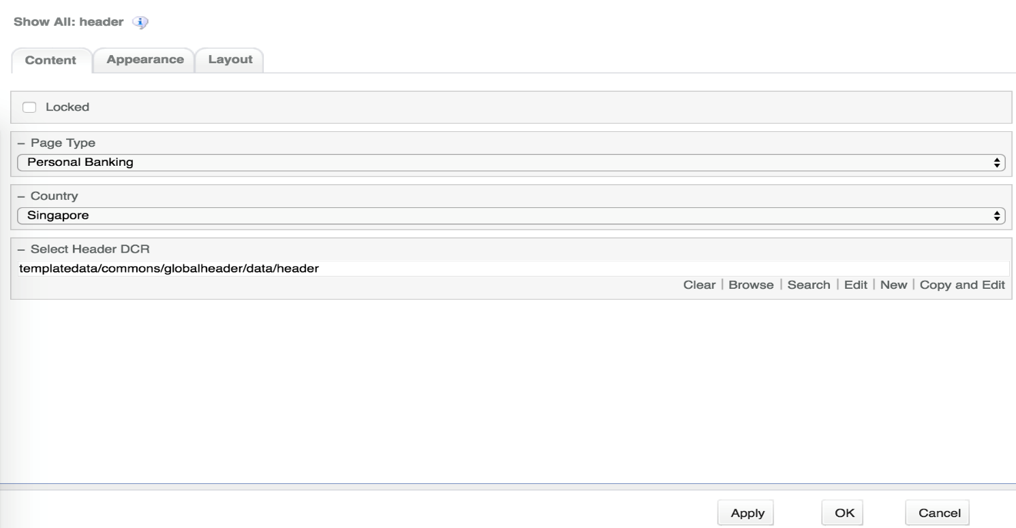

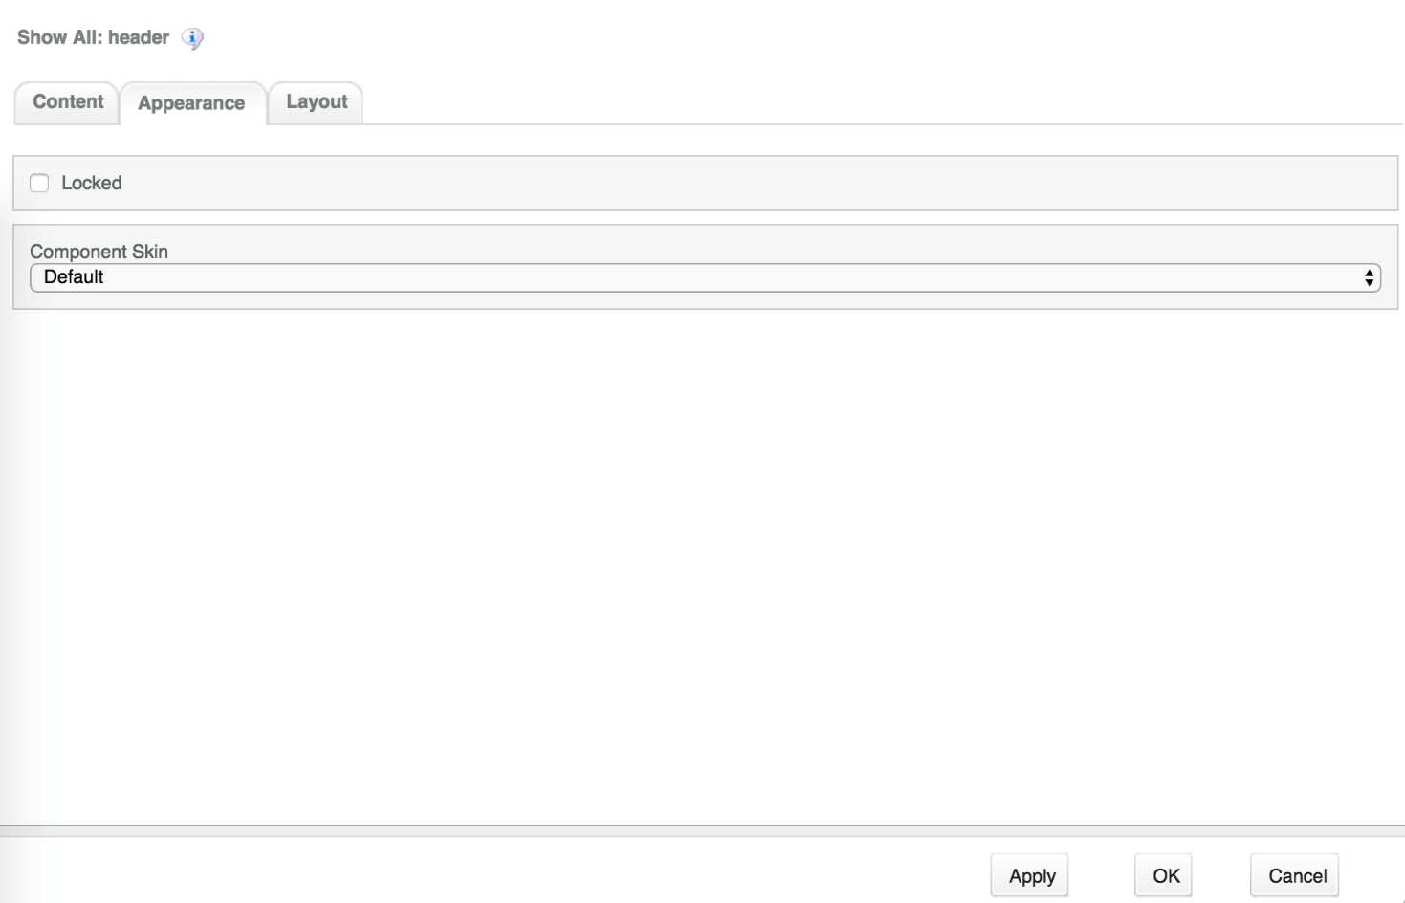

1. Navigation Component



Global component which uses TeamSite Site Map as the content source. Quick links information can be customized

Navigation Component’s default setting should have the following values in Content:

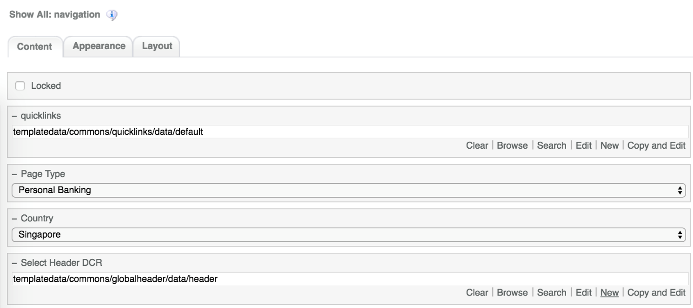

1. Breadcrumb Component



Global component to display the Home Link, Home Link Label and Home Link Target. Can be changed from component properties.

Breadcrumb Component’s default setting should have the following values in Content

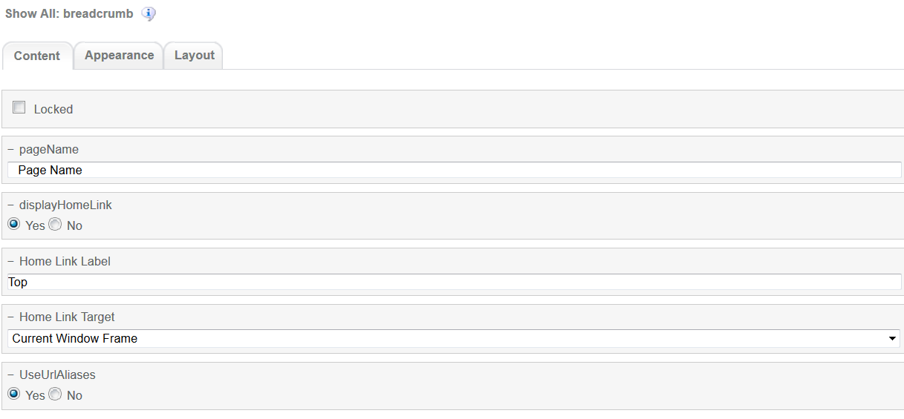

1. Stay Informed Component  
   There are 3 flavours of the stay Informed Component
   1. Flash Notes  
      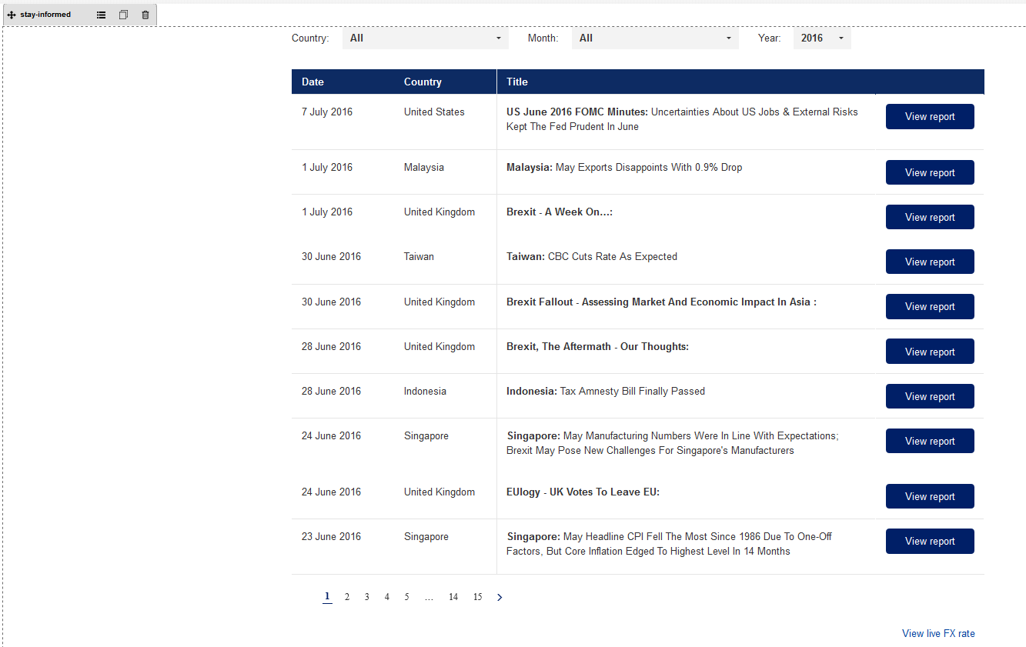

Stay Informed Flash Notes flavour or stay-informed component. The Component can be customized through DCR

Stay Informed component Flash Notes flavour component setting should have the following values in Content

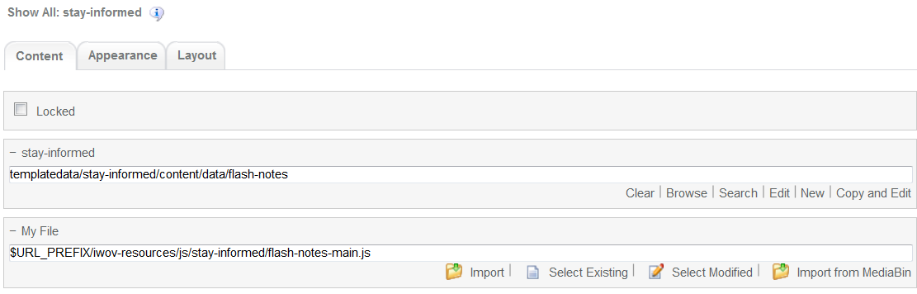

The values for Appearance should be as follows

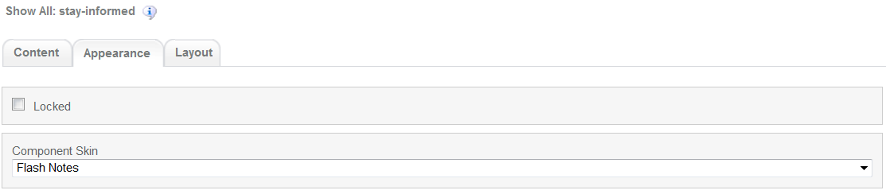

* 1. Quarterly Global Outlook  
     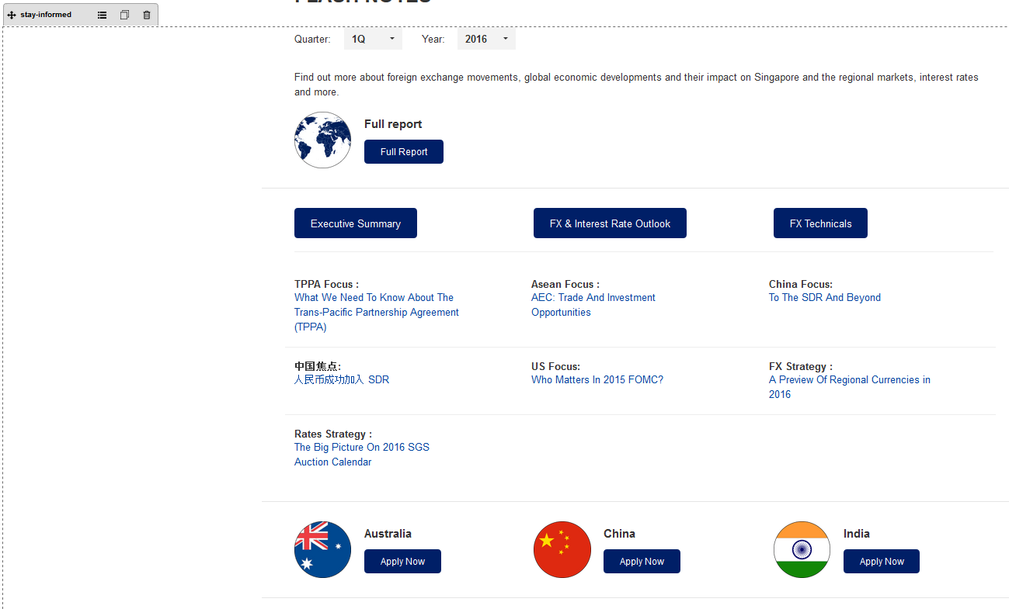

Stay Informed Quarterly Global Outlook flavour or stay-informed component. The Component can be customized through DCR

Stay Informed component Quarterly Global Outlook flavour component setting should have the following values in Content

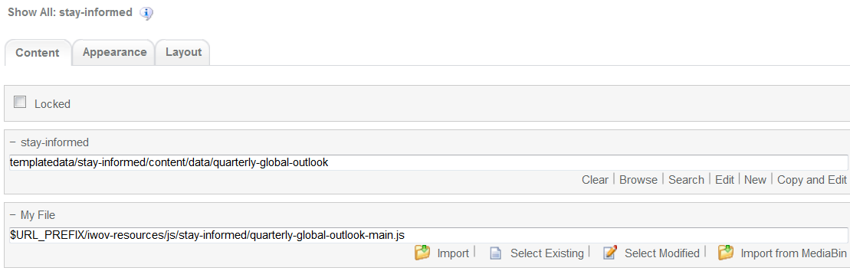

The values for Appearance should be as follows

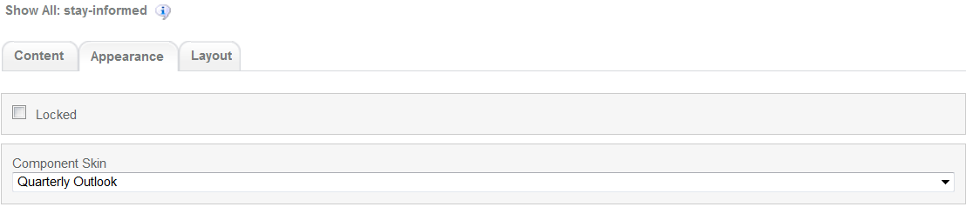

* 1. Foreign Exchange  
     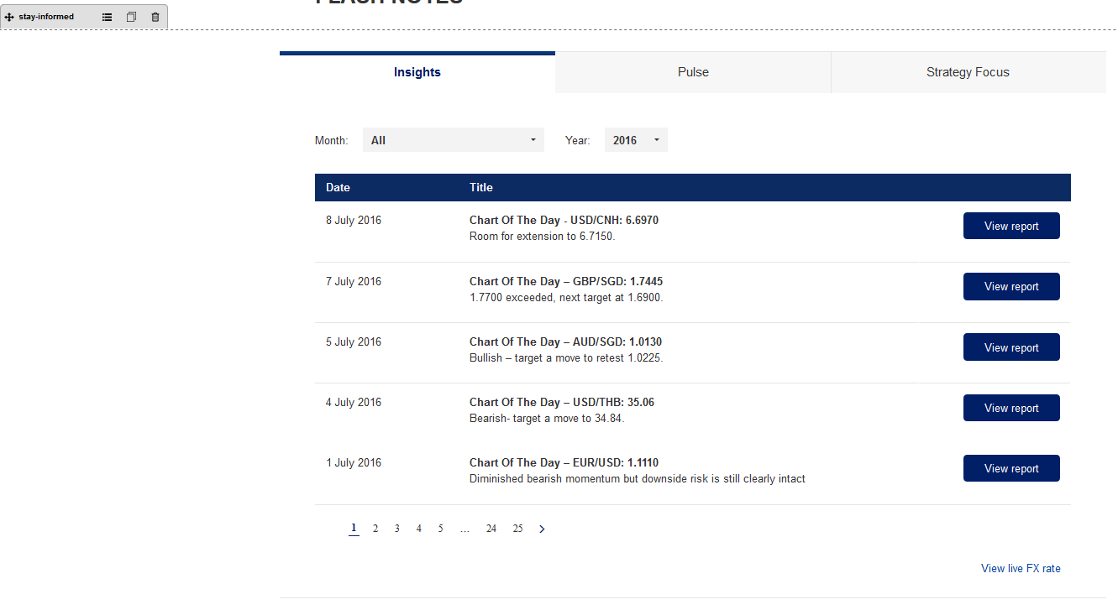

Stay Informed Foreign Exchange flavour or stay-informed component. The Component can be customized through DCR

Stay Informed component Foreign Exchange flavour component setting should have the following values in Content  
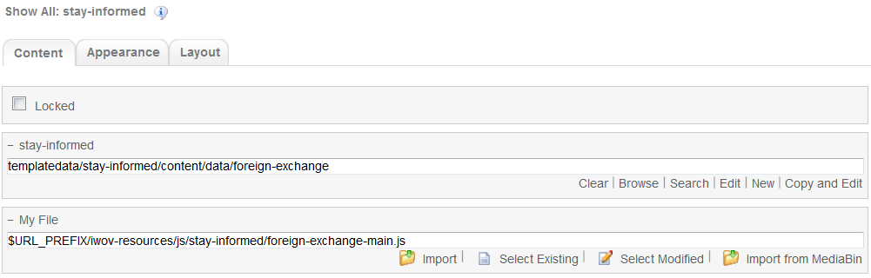

The values for Appearance should be as follows

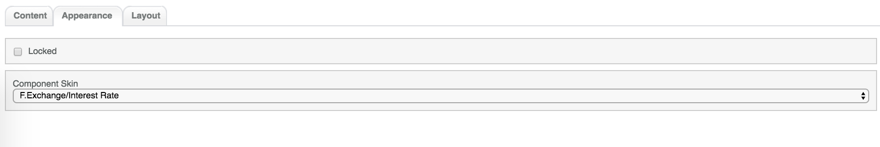

d. Market Overview

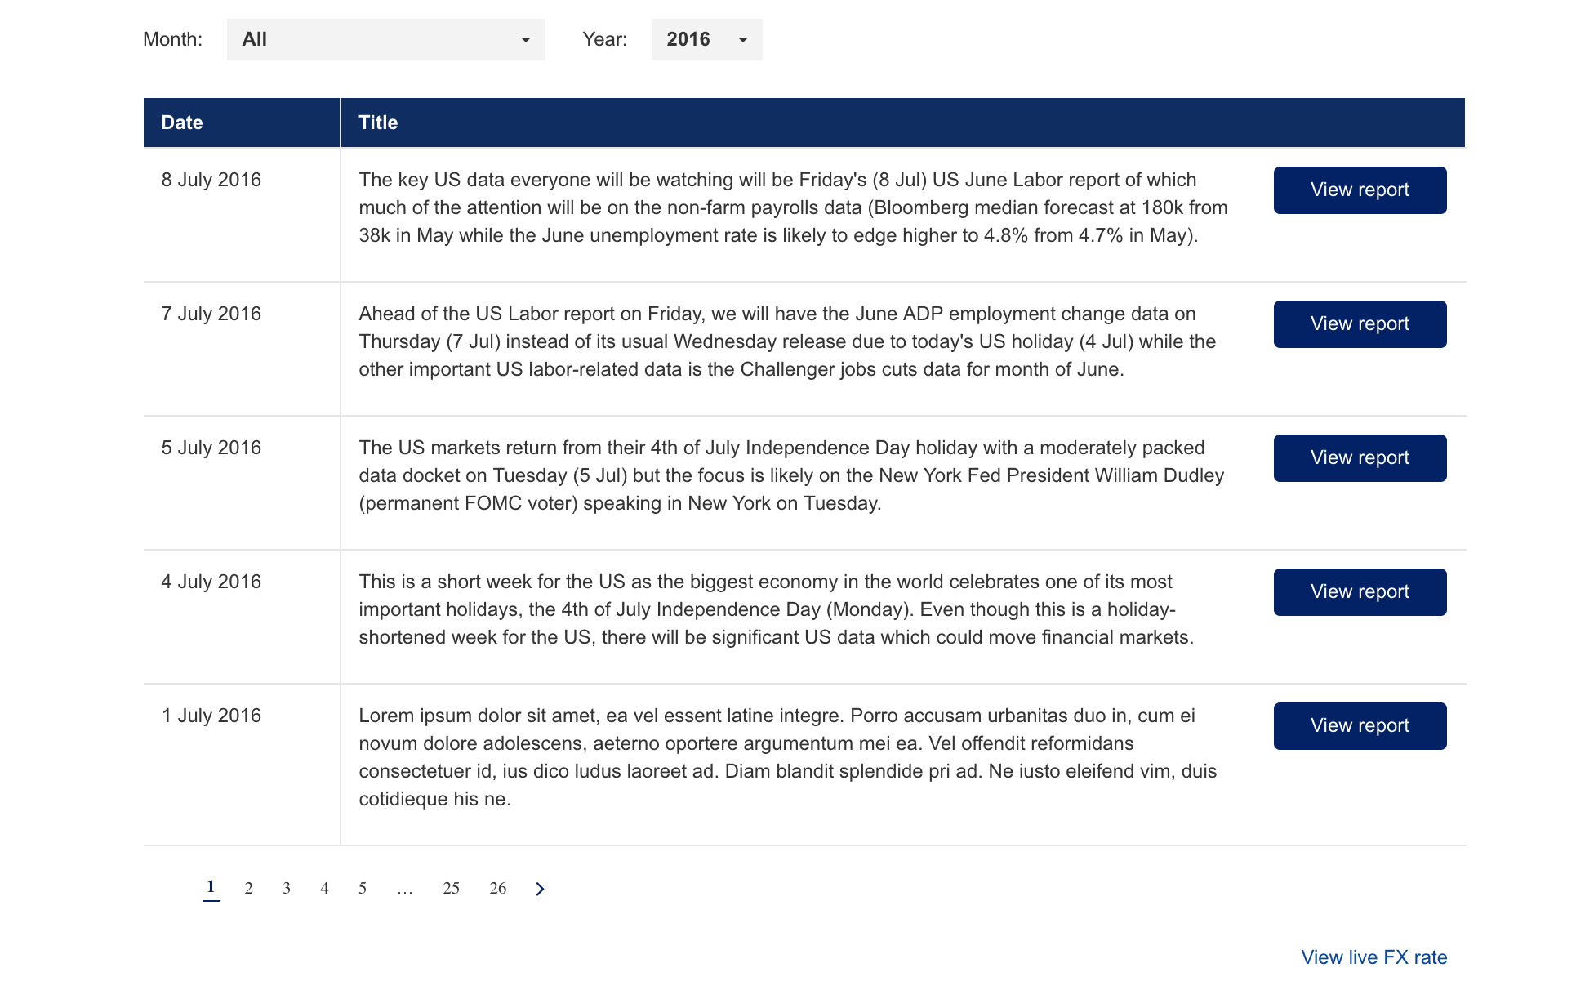

Stay Informed component Market Overview flavour component setting should have the following values in Content

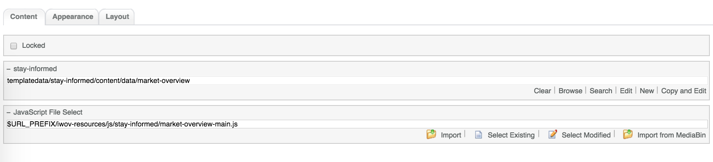

The values for Appearance should be as follows

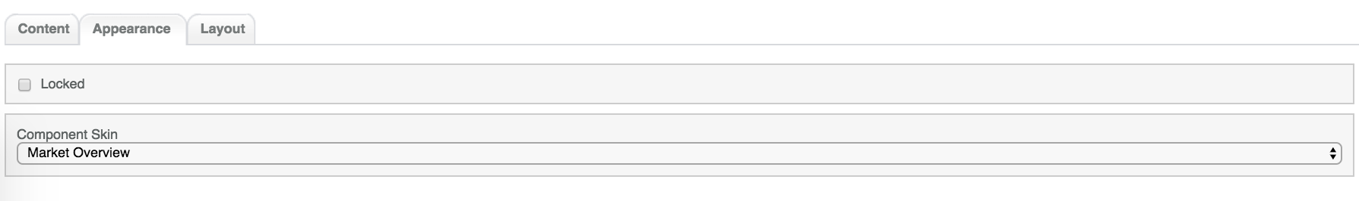

e. Interest Rate

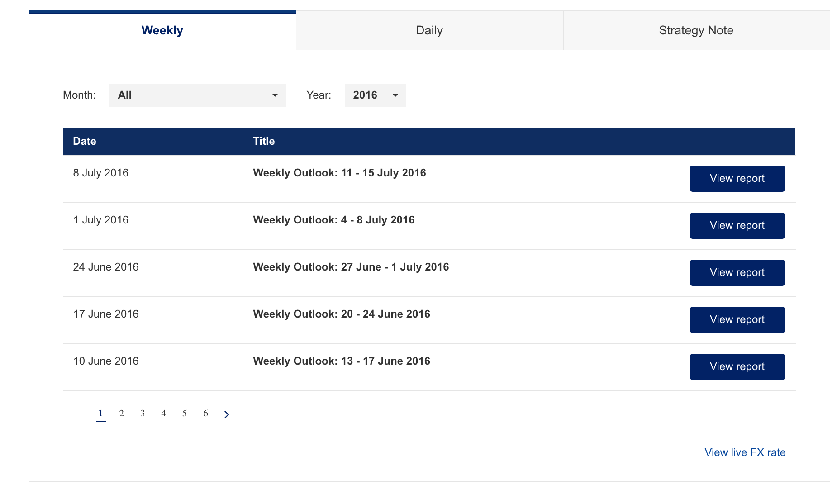

Stay Informed component Interest Rate flavour component setting should have the following values in Content

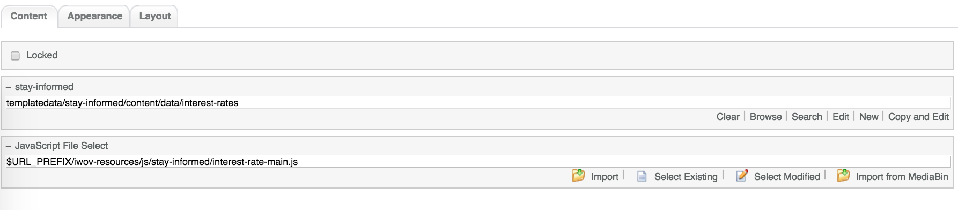

The values for Appearance should be as follows



1. 3-column-menu component

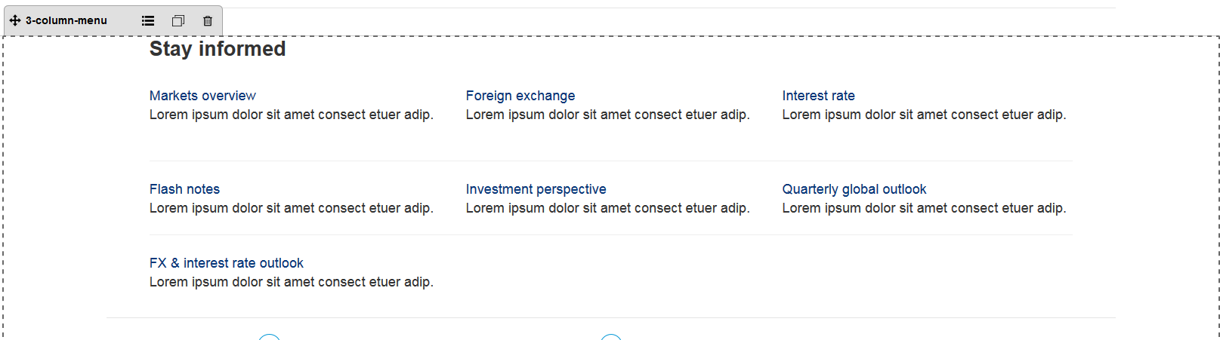

Common component controlled by DCR. Title, links, free formatting text can be customized

3-coloumn-menu component default setting should have the following values in content

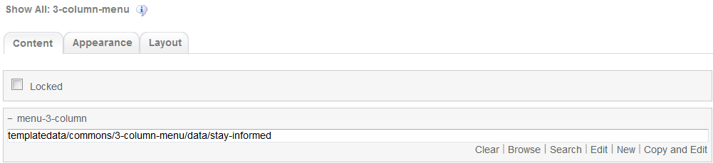

1. Footer component

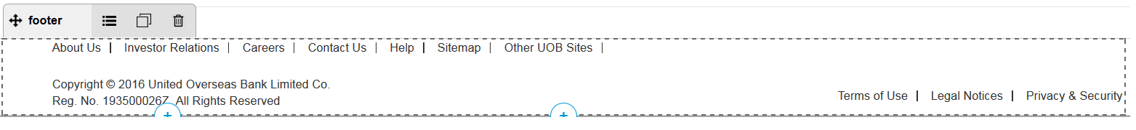

Global component controlled by DCR. Links and Copyright text can be customized

Footer component’s default setting should have the following values in Content:

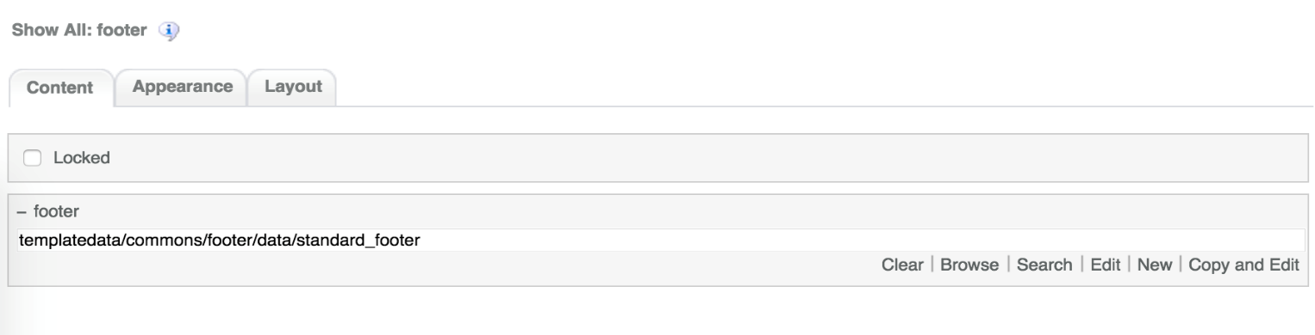

# Stay Informed Common DCR Break-up

The common components used in Stay Informed are the same as the ones used in Product Landing. For information on each common component please refer to User_Guide-Product_Landing user guide.

# Stay Informed specific DCR Break-up

In this section, a brief explanation of each Stay Informed specific component DCR will be made. Please refer to User_Guide-Home_page on how to navigate and select edit DCR’s.

## Stay Informed

The DCT to create the Stay Informed stay-informed DCT is located on *templatedata/stay-informed/content/* under the name datacapture.cfg and can be located using Team Site CCProfessional user interface.

3 different DCR will be created from this DCT

1. flash-notes DCR  
   The flash-notes DCR has a main flash-notes container with the following items
   1. Page Name  
      Text field  
      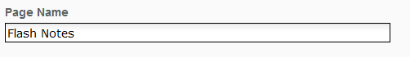
   2. Inside the flash-notes container, there is another Non Tabbed content container with one max replica with the following fields
      1. Content Path  
         Browse field where the user selects the correct csv file. This is a required field  
         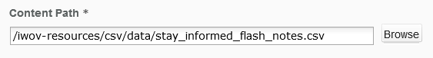
2. quarterly-global-outlook DCR  
   The quarterly-global-outlook DCR has a main quarterly-global-outlook container with the following items
   1. Page Name  
      Text field  
      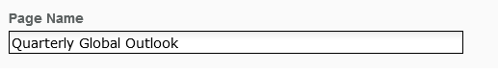
   2. Inside the quarterly-global-outlook container, there is another Non Tabbed content container with one max replica with the following fields
      1. Content Path  
         Browse field where the user selects the correct csv file. This is a required field  
         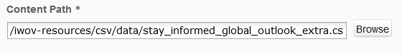
3. foreign-exchange DCR  
   The foreign-exchange DCR has a main foreign-exchange container with the following items
   1. Page Name  
      Text field  
      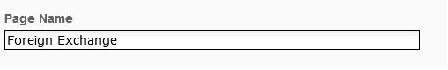
   2. Inside the foreign-exchange container, there is another Non Tabbed content container with 3 replicas by default. Each container has the following fields
      1. Tab Title  
         Text field. This is a required field  
         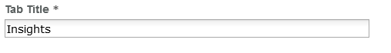
      2. Content Path  
         Browse field where the user selects the correct csv file. This is a required field.  
         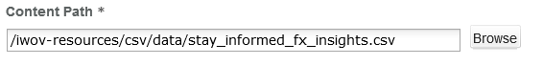

The Title and csv paths for each container as follows:

1. Container 1:
   1. Title: Insights
   2. Content Path: /iwov-resources/csv/data/stay_informed_fx_insights.csv
2. Container 2:
   1. Title: Pulse
   2. Content Path: /iwov-resources/csv/data/stay_informed_fx_pulse.csv
3. Container 3:
   1. Title: Strategy Focus
   2. Content Path: /iwov-resources/csv/data/stay_informed_fx_strategy_focus.csv

# Resources

This section provides a list of the necessary resources (CSS & JavaScript) to create a Stay Informed template. On how to create a template please refer to the User_Guide-Home_Page.

## CSS Resources

The css resources for the Stay Informed template are as follows

|  |  |
| --- | --- |
| **Devices to use with** | **Path** |
| Desktop, Tablet, Mobile | <wa-path>/iwov-resources/css/bootstrap.min.css |
| <wa-path>/iwov-resources/css/style.css |
| Desktop | <wa-path>/iwov-resources/css/desktop-style.css |
| Tablet | <wa-path>/iwov-resources/css/tablet-style.css |
| Mobile | <wa-path>/iwov-resources/css/mobile-style.css |
| Desktop | <wa-path>/iwov-resources/css/stay-informed/stay-informed-desktop-style.css |
| Tablet | <wa-path>/iwov-resources/css/stay-informed/stay-informed-tablet-style.css |
| Mobile | <wa-path>/iwov-resources/css/stay-informed/stay-informed-mobile-style.css |
| Desktop, Tablet, Mobile | <wa-path>/iwov-resources/css/stay-informed/stay-informed-style.css |

These resources must be entered on the same order as the previous table or the page style will break

## JavaScript Resources

The JavaScript resources for the Stay Informed template are as follows

|  |  |
| --- | --- |
| **Devices to use with** | **Path** |
| Desktop, Tablet, Mobile | <wa-path>/iwov-resources/js/cookie_handler.js |
| <wa-path>/iwov-resources/js/libs/modernizr.min.js |
| <wa-path>/iwov-resources/js/libs/jquery.min.js |
| <wa-path>/iwov-resources/js/libs/bootstrap.min.js |
| <wa-path>/iwov-resources/js/libs/plugins.min.js |
| <wa-path>/iwov-resources/js/main.js |
| <wa-path>/iwov-resources/js/stay-informed/stay-informed-plugin.js |

These resources must be entered on the same order as the previous table or the page will break