NayePankh Foundation
Data Analytics Assignment
Project Report — Option 2: Data Analysis, Dashboard & Reporting

Datasets Analyzed:
Donations Dataset (1,500 records) & Volunteers Dataset (800 records)
Tools Used:
Microsoft Excel (PivotTables & Formulas) and Power BI Desktop (Interactive Dashboard)

1. Introduction
This report presents a complete data analytics project carried out as part of the NayePankh Foundation Data Analytics Internship assignment (Option 2). The objective of this project was to analyze two key operational areas of the organization — donations and volunteer engagement — and translate raw data into meaningful insights through structured analysis and an interactive dashboard.
Since real organizational data was not available for this assignment, two realistic synthetic (sample) datasets were created to represent donation transactions and volunteer records. These datasets were then analyzed using Microsoft Excel, and the findings were further visualized in an interactive Power BI dashboard.
The report covers the structure of the datasets, the analysis performed in Excel, the dashboard built in Power BI, key insights derived from the data, and recommendations for the organization.

2. About NayePankh Foundation
NayePankh Foundation is a non-profit organization that promotes the culture of kindness and aims to instill a sense of giving back to society among today's youth. The organization relies on donor contributions and volunteer participation to run its programs, including education support, skill development, health camps, and community welfare drives.
As the organization grows, tracking donations and volunteer activity through structured data analysis can help leadership make informed, data-driven decisions about fundraising strategy, volunteer management, and campaign planning.

3. Datasets Used
Two datasets were created for this project. Both are synthetic/sample datasets generated for demonstration purposes, designed to closely resemble real-world NGO data.

3.1 Donations Dataset
Contains 1,500 donation transaction records covering the period January 2024 to December 2025.
Column | Description
Donor_ID, Donor_Name, Email | Donor identity information
Date | Date of the donation transaction
Amount_INR | Donation amount in Indian Rupees
Payment_Mode | UPI, Credit Card, Debit Card, Net Banking, Cash, Bank Transfer
Campaign_Name | One of 10 fundraising campaigns (e.g., Education for All, Scholarship Fund)
City | Donor's city
Recurring_Donor | Whether the donor contributes on a recurring basis (Yes/No)

3.2 Volunteers Dataset
Contains 800 volunteer profile records.
Column | Description
Volunteer_ID, Volunteer_Name, Age, Gender, Email, Phone | Volunteer identity and demographic information
Join_Date | Date the volunteer joined the organization
City, Education_Level | Location and educational background
Activity_Type | Teaching, Social Media, Event Management, Content Writing, Administration, Fundraising Support, Field Survey, Logistics
Hours_Contributed_Per_Month | Monthly hours contributed by the volunteer
Performance_Rating | Rating on a scale of 2.0 to 5.0
Status | Active, Inactive, or On Leave

4. Methodology & Tools Used
The project was carried out in three stages:
- Data Preparation: Both datasets were generated and cleaned, then loaded into Excel as structured Tables for analysis.
- Exploratory Analysis in Excel: PivotTables, summary formulas (SUM, AVERAGE, MAX, MIN, COUNT, IFS), and helper columns (e.g., Month-Year grouping, Age Group buckets) were used to explore trends, distributions, and top performers within each dataset.
- Dashboard Development in Power BI: The cleaned datasets were imported into Power BI Desktop, where a 3-page interactive dashboard was built with KPI cards, charts, slicers, and custom DAX measures, using a consistent black & white visual theme.
Tools used: Microsoft Excel / WPS Office (PivotTables and formulas), Power BI Desktop (interactive dashboard with DAX measures and slicers), and Python (pandas) for synthetic dataset generation.

5. Donation Data Analysis (Excel)
The donations dataset was analyzed using PivotTables and summary formulas across multiple sheets. The table below summarizes each analysis performed and its key result.
Analysis | Method | Key Result
Overall Donation Statistics | SUM, AVERAGE, MAX, MIN, COUNT formulas | Total = Rs. 57,23,284.69 | Avg = Rs. 3,815.52 | Max = Rs. 49,677.31 | Min = Rs. 101.26 | Count = 1,500
Donation Trend Over Time | PivotTable with Date grouped by Month & Year | Monthly donation pattern identified from Jan 2024 to Dec 2025, with visible peaks around early and mid-2025
Top Campaigns by Funds Raised | PivotTable: Campaign_Name vs Sum of Amount_INR | Scholarship Fund (Rs. 9.30 lakh) and Education for All (Rs. 7.42 lakh) lead all campaigns
City-wise Donations | PivotTable: City vs Sum of Amount_INR | Lucknow, Indore, and Pune are the top contributing cities
Payment Mode Distribution | PivotTable: Payment_Mode vs Sum of Amount_INR | UPI (Rs. 21.88 lakh) is the most used payment mode, far ahead of Credit Card (Rs. 10.41 lakh)
Recurring vs One-time Donors | PivotTable: Recurring_Donor vs Count and Sum | Only 368 of 1,500 donations (about 24.5%) are recurring
Top 10 Donors | PivotTable with Top 10 Value Filter on Sum of Amount_INR | Identified the highest cumulative-value individual donors

6. Volunteer Data Analysis (Excel)
The volunteers dataset was similarly analyzed using PivotTables, helper columns, and average/count summaries.
Analysis | Method | Key Result
Status Distribution | PivotTable: Status vs Count | 479 Active (about 60%), 233 Inactive (about 29%), 88 On Leave (about 11%)
Volunteer Growth Trend | PivotTable: Join_Date grouped by Month & Year | Volunteer joining pattern tracked across 2024-2025
Activity Type Distribution | PivotTable: Activity_Type vs Count | Content Writing (115) is the most common activity, followed by Event Management (103) and Social Media (102)
City-wise Volunteer Count | PivotTable: City vs Count | Kolkata, Agra, and Ahmedabad have the highest volunteer counts
Average Hours Contributed | PivotTable: Average of Hours_Contributed_Per_Month by Activity Type/City | Total of 10,852 hours contributed per month across all volunteers
Average Performance Rating | PivotTable: Average of Performance_Rating by Status | Overall average rating of 3.70 out of 5.0
Age Group Analysis | Helper column (IFS formula) + PivotTable | Volunteers grouped into 18-25, 26-35, 36-45, and 46+ age bands
Gender Distribution | PivotTable: Gender vs Count | 389 Female, 374 Male, 37 Other
Education vs Activity Type | Cross-tab PivotTable | Mapped education levels against the type of activity volunteers take up

7. Power BI Dashboard
An interactive, 3-page dashboard was built in Power BI Desktop using a consistent black & white theme. The dashboard includes a home page with foundation branding and navigation, and two analytical pages — one for donations and one for volunteers.

7.1 Home Page
The home page introduces the foundation with a brief description of its mission, along with navigation buttons that allow the user to move between the Donation Dashboard and the Volunteer Dashboard.

7.2 Donation Dashboard
This page provides a complete view of donation activity:
- KPI Cards: Total Donations (1.5K), Total Donation Amount (Rs. 5.72M), Average Donation Amount (Rs. 3.82K), Max Donation Amount (Rs. 49.68K), Min Donation Amount (Rs. 101.26)
- Donation Trend Over Time — an area chart showing monthly donation totals from Jan 2024 to Dec 2025
- Top Campaigns by Funds Raised — bar chart of the top 5 campaigns
- Payment Mode Distribution — bar chart comparing donation totals across payment modes
- Top 5 Donors — bar chart of the highest cumulative contributors
- Slicers: Select Campaign Name, Select City
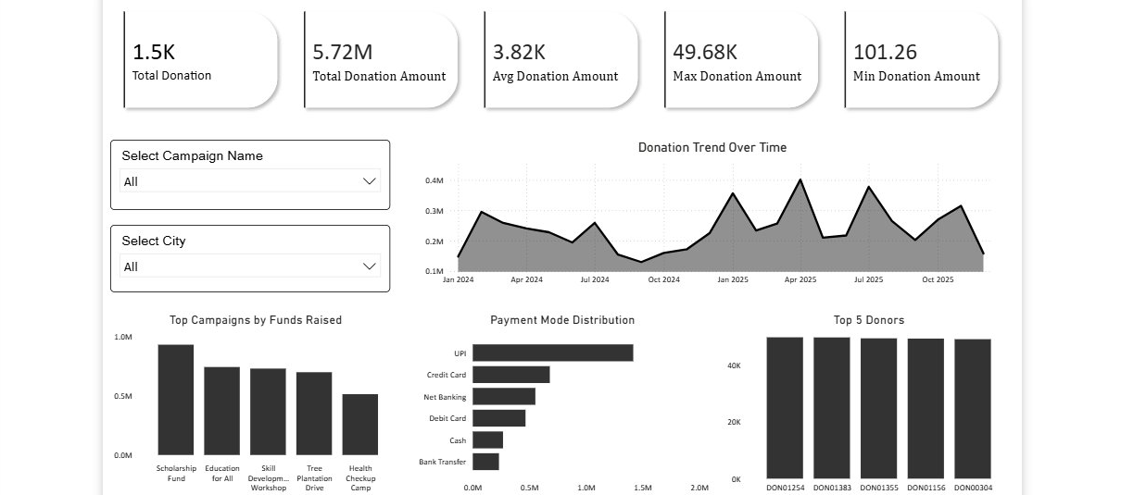
Figure 1: Donation Dashboard — Power BI

7.3 Volunteer Dashboard
This page provides a complete view of volunteer engagement:
- KPI Cards: Total Volunteers (800), Total Active Volunteers (479), Total Inactive Volunteers (233), On Leave Volunteers (88), Total Hours Contributed (10.85K), Avg Performance Rating (3.70)
- Volunteer Growth Over Time — area chart of volunteers joining month by month
- Activity Type Distribution — bar chart across the 8 activity categories
- Gender Distribution — bar chart of Male/Female/Other volunteers
- Age Group Distribution — bar chart across 18-25, 26-35, 36-45, and 46+ bands
- Slicers: Select City, Select Activity Type
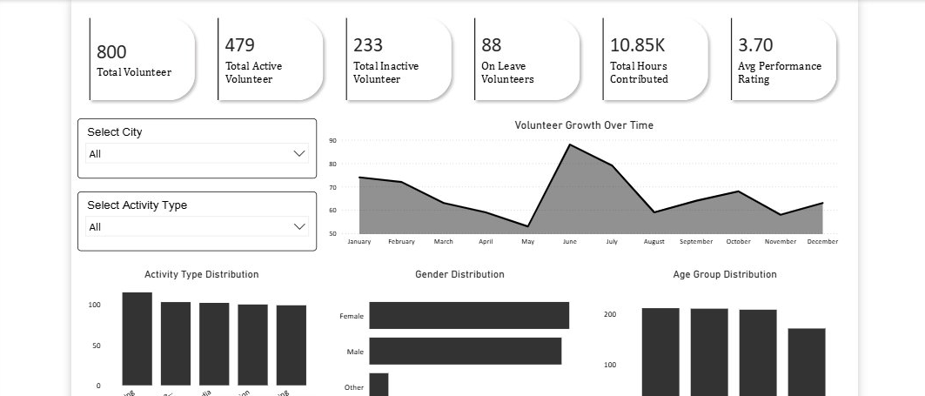
Figure 2: Volunteer Dashboard — Power BI

7.4 DAX Measures Used
The following custom DAX measures were created to power the volunteer status KPI cards, ensuring the figures respond correctly to the City and Activity Type slicers:
Active Volunteers = CALCULATE(COUNTROWS(volunteers_dataset), volunteers_dataset[Status] = "Active")
Inactive Volunteers = CALCULATE(COUNTROWS(volunteers_dataset), volunteers_dataset[Status] = "Inactive")
On Leave Volunteers = CALCULATE(COUNTROWS(volunteers_dataset), volunteers_dataset[Status] = "On Leave")

8. Key Insights & Trends

8.1 Donation Insights
- Total funds raised across the dataset stand at Rs. 57.23 lakh from 1,500 transactions, with an average donation size of Rs. 3,815.
- Scholarship Fund and Education for All are the strongest-performing campaigns, together accounting for a significant share of total funds raised.
- UPI dominates as a payment mode, suggesting that digital, low-friction payment options are key to donor convenience.
- Only about 24.5% of donations come from recurring donors — the majority of donors give only once, representing a major retention opportunity.
- Donations are geographically concentrated, with Lucknow, Indore, and Pune contributing the most.

8.2 Volunteer Insights
- Out of 800 volunteers, 60% (479) are currently Active, while 29% (233) are Inactive — a sizeable share of the volunteer base is currently disengaged.
- Content Writing, Event Management, and Social Media are the most popular volunteer activities, suggesting strong interest in creative and outreach-based roles.
- Volunteers collectively contribute over 10,800 hours per month, representing significant operational capacity.
- The average performance rating across all volunteers is 3.70/5.0, indicating room for improvement in training or engagement support.
- The volunteer base is fairly gender-balanced, with close to equal representation of male and female volunteers.

9. Recommendations
- Convert one-time donors into recurring donors: Since only about 24.5% of donations are recurring, the foundation should run targeted campaigns (e.g., UPI auto-pay enrollment, monthly giving programs) to convert high-value one-time donors into recurring supporters.
- Double down on top-performing campaigns: Scholarship Fund and Education for All should be studied for what makes them successful (messaging, timing, channels) and these learnings applied to boost lower-performing campaigns.
- Promote UPI as the primary donation channel: Since UPI already leads in usage, prominently featuring UPI options on donation pages and outreach material can further reduce friction and increase conversions.
- Re-engage inactive volunteers: With 233 volunteers (29%) currently inactive, the foundation should run periodic check-in surveys, offer flexible/remote volunteering options, and recognize active contributors to improve retention.
- Align volunteer recruitment with high-donation regions: Building a stronger volunteer presence in Lucknow, Indore, and Pune (top donor cities) could strengthen local community engagement and on-ground campaign delivery.
- Track these metrics on an ongoing basis: Refreshing this dashboard monthly or quarterly with real organizational data would allow leadership to monitor trends over time and measure the impact of new initiatives.

10. Conclusion
This project demonstrates how structured data analysis and an interactive dashboard can support better decision-making for an organization like NayePankh Foundation. By analyzing donation patterns and volunteer engagement, clear opportunities emerge — particularly around donor retention, campaign optimization, and re-engaging inactive volunteers.
The Excel analysis provided a detailed, granular view of both datasets, while the Power BI dashboard brings these insights together into an accessible, interactive format that non-technical stakeholders can explore on their own. Together, these deliverables show how data analytics can directly support NayePankh Foundation's mission of promoting kindness and giving back to society — by helping the organization use its resources, donor relationships, and volunteer base more effectively.

