BIRLA INSTITUTE OF TECHNOLOGY & SCIENCE, PILANI

Pilani Campus

EEE F434: Digital Signal Processing

**LAB 5: DISCRETE FOURIER TRANSFORM (DFT)**

**Learning Outcomes:**

1. Analyze and understand the magnitude and phase spectrums of any speech-related audio signals using DFT.

2. Understand the effect of DFT length on frequency resolution of the signal.

3. Understand the spectral sampling errors using DFT.

**Note: Please write your MATLAB codes in this .doc file and save it. Capture and paste the snapshots of your plots, wherever required. Make sure you get it signed before leaving the lab.**

**Please make sure you add a title, axis labels, x-axis limit and y-axis limit, grid on, and legend (if required) to each of your figures.**

**PART A: DFT of speech signal**

Q1) Use the following link below to access the speech signal x[n]:

.

1. Plot the signal x[n] and its magnitude and phase spectrum using N-point DFT, where N=length(x). You can use the MATLAB inbuilt function to compute DFT. Make sure to use the subplot command such that these three plots are shown in one column and three rows. Additionally, the x-axis for the DFT plots should be in frequency (Hz). Make sure the phase spectrum has absolute values.

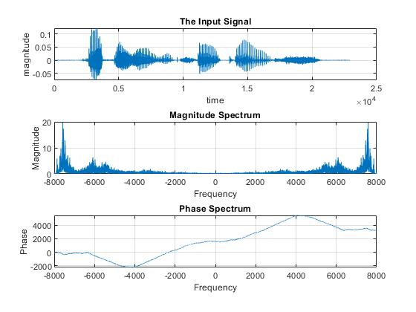

[x,Fs]=audioread("C:\Users\user\Downloads\si1188.wav");

N=length(x);

X=fft(x,N);

freq_axis=linspace(-Fs/2,Fs/2,N);

subplot(3,1,1)

stem(x);

ylabel("magnitude")

xlabel("time")

grid on

title("The Input Signal")

subplot(3,1,2)

stem(freq_axis',abs(X));

ylabel("Magnitude")

xlabel("Frequency")

grid on

title("Magnitude Spectrum");

subplot(3,1,3)

stem(freq_axis',angle(X));

ylabel("Phase")

xlabel("Frequency")

grid on

title("Phase Spectrum");

1. Now, compute the same with 2*N DFT and repeat a). Record your observations.

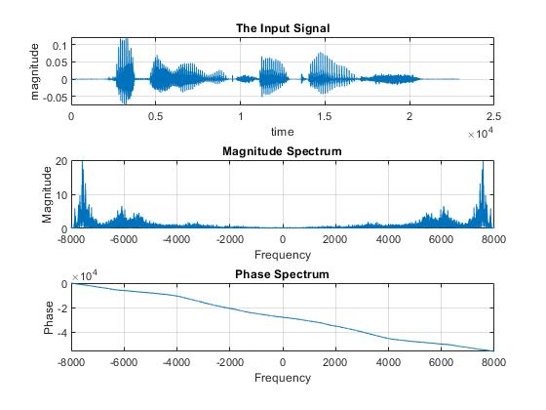

To access the sound file (‘si1188.wav’):

<https://drive.google.com/file/d/0B7-qexRAlXuTUldYOUdPTXFYSW8/view?usp=sharing>

**PART B: Spectral sampling**

Q2) Consider a discrete time sequence given below:

x[n] = cos(2*π* (f1/fs)*n) + cos(2π* (f2/fs)* n); 0 ≤ n ≤ N-1. Assume that rectangular window of length N is used. Here, f1 = 170 Hz and f2 = 390 Hz, fs = 6630 Hz.

1. Compute the N-point DFT of the sequence for the following values of N:

i) N = 170 ii) N = 390 iii) N = 663 iv) N = 200

Plot the sequence x[n] and its magnitude spectrum for different values of N. Use the subplot command with two columns and four rows such that all 8 plots are shown in one figure. Column 1 should have the time domain sequence with the corresponding DFT magnitude spectrum in column 2. Additionally, the x-axis for the DFT plots should be in frequency (Hz).

Observe clearly the spectral peak values in each of the four values of N (use stem command instead of plot). Note down your observations.

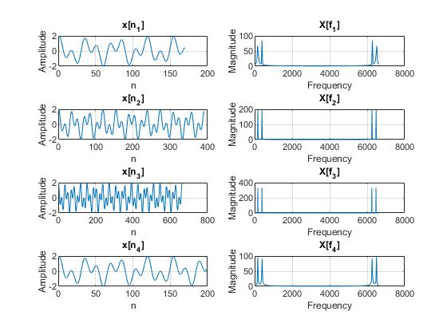

b) Based on the observations from part a), mark if frequency is present in the magnitude spectrum.

|  |  |  |
| --- | --- | --- |
| N | f1 = 170Hz | f2 = 390Hz |
| 170 | No | No |
| 390 | Yes | No |
| 663 | Yes | Yes |
| 200 | No | No |

1. Use the “fftshift” command to change the frequency range to [–fs/2, fs/2]. Plot the sequence x[n], original magnitude spectrum and shifted spectrum for N = 170. Make sure to use the subplot command such that these three plots are shown in one column and three rows. Note down your observations.

