BIRLA INSTITUTE OF TECHNOLOGY & SCIENCE, PILANI

Pilani Campus

EEE F434: Digital Signal Processing

**LAB 6: INFINITE IMPULSE RESPONSE (IIR) FILTERS**

**Learning Outcomes:**

1. Design a low-pass filter, high-pass and band-pass filters based on given specifications for different filter types (Butterworth, Type1 Chebyshev, Type2 Chebyshev and Elliptic).

2. Understand filtering operation using in-built FDA toolbox.

**Note: Please write your MATLAB codes in this .doc file and save it. Capture and paste the snapshots of your plots, wherever required. Make sure you get it signed before leaving the lab.**

**Please make sure you add a title, axis labels, x-axis limit and y-axis limit, grid on, and legend (if required) to each of your figures.**

**PART A: Filtering**

Q1) Consider the following specification. f1=100Hz, f2=200Hz, f3=400Hz, f4=600Hz,

f5=800Hz, f6=1000, f7=1200, f8=1400 and sampling frequency fs=5000Hz.

1. Construct a signal x(t) given by:

x(t)= $\sum_{i=1}^{8}{xi(t)}$,

where xi(t)=sin(2*pi*fi*t) and plot it for a duration of 0.1 second. Determine its magnitude response.

f=[100 200 400 600 800 1000 1200 1400];

Fs=5000;

t=0:1/Fs:0.1;

for i=1:8

x_t=x_t+sin(2*pi*f(i)*t);

end

plot(t,x_t);

grid on

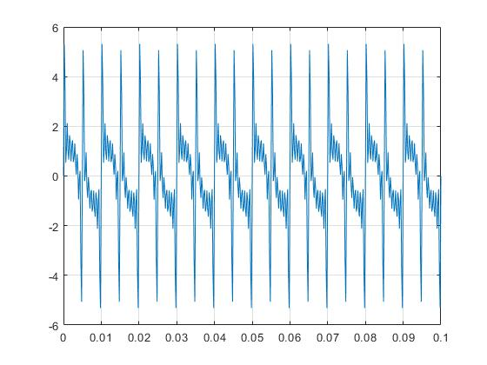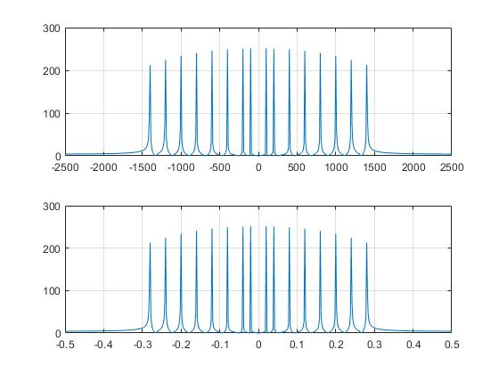

1. Consider the **low pass** filter with the following specifications

Minimum stop band attenuation, Rs=50dB,

Maximum pass band attenuation Rp=0.01dB,

Pass band frequency Wp=100Hz,

Stop band frequency Ws=200Hz.

Design low pass Butterworth filter, Type1 Chebyshev filter, Type2 Chebyshev filter, Elliptical filter. Plot the frequency response (both magnitude and phase responses) of each filter and tabulate the filter order in each case.

[n,Wn]=buttord(100/2500,200/2500,0.01,50);

% [z,p,k] = butter(n,Wn);

% sos = zp2sos(z,p,k);

%

% freqz(sos,1024)

% title(sprintf('n = %d Butterworth Lowpass Filter',n))

[b,a]=butter(n,Wn);

freqz(b,a);

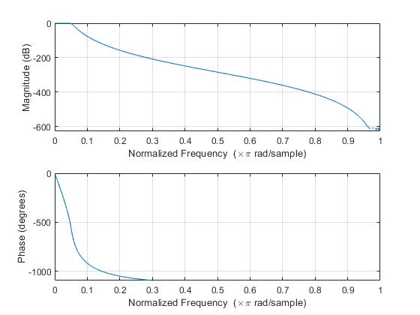

%Type1 Chebyshev Lowpass Filter

[n,Wp]=cheb1ord(100/2500,200/2500,0.01,50);

[b,a]=cheby1(n,0.01,Wp,'low');

freqz(b,a);

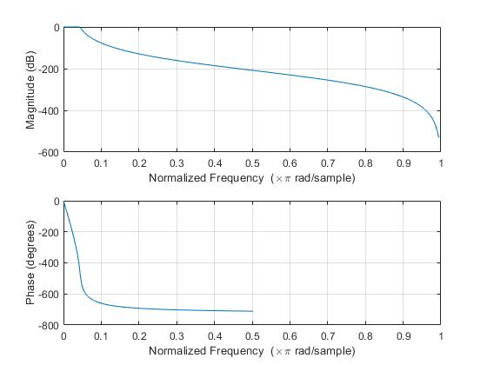

%Type2 Chebyshev Lowpass Filter

[n,Ws]=cheb2ord(100/2500,200/2500,0.01,50);

[b,a]=cheby2(n,50,Ws,'low');

freqz(b,a);

Pass the signal constructed in (a) through each of these designed filters. Plot the time domain and the FFT magnitude spectrum of the signal in each of the case using subplot (4x2)

%%%%%%%%%%%%%%%%%%%%%%%%%%%%%%%%%%%%%%

f=[100 200 400 600 800 1000 1200 1400];

x_t=0;

x_1=0;

Fs=5000;

t=0:1/Fs:0.1;

for i=1:8

x_t=x_t+sin(2*pi*f(i)*t);

x_1=x_1+sin(2*pi*(f(i)/Fs)*t);

end

%Butterworth Lowpass Filter

% [n,Wn]=buttord(100/2500,200/2500,0.01,50);

% % % [z,p,k] = butter(n,Wn);

% % % sos = zp2sos(z,p,k);

% % %

% % % freqz(sos,1024)

% % % title(sprintf('n = %d Butterworth Lowpass Filter',n))

[b,a]=butter(n,Wn);

y1=filter(b,a,x_t);

subplot(4,2,1);

plot(t,y1);

grid on

N1=length(y1);

freqaxis1=linspace(-Fs/2,Fs/2,N);

Y1=fft(y1,N);

subplot(4,2,2);

plot(freqaxis1,fftshift(abs(Y1)));

grid on

%%%%%%%%%%%%%%%%%%%%%%%%%%%%%%%%%%%%%%%%%%%%%

%Type1 Chebyshev Lowpass Filter

[n,Wp]=cheb1ord(100/2500,200/2500,0.01,50);

[d,c]=cheby1(n,0.01,Wp,'low');

y2=filter(d,c,x_t);

subplot(4,2,3);

plot(t,y2);

grid on

N2=length(y2);

freqaxis2=linspace(-Fs/2,Fs/2,N2);

Y2=fft(y2,N2);

subplot(4,2,4);

plot(freqaxis2,fftshift(abs(Y2)));

grid on

%%%%%%%%%%%%%%%%%%%%%%%%%%%%%%%%%%%%%%%%%%%%%%

%Type2 Chebyshev Lowpass Filter

[n,Ws]=cheb2ord(100/2500,200/2500,0.01,50);

[f,e]=cheby2(n,50,Ws,'low');

y3=filter(f,e,x_t);

subplot(4,2,5);

plot(t,y);

grid on

N3=length(y3);

freqaxis3=linspace(-Fs/2,Fs/2,N3);

Y3=fft(y3,N3);

subplot(4,2,6);

plot(freqaxis3,fftshift(abs(Y3)));

grid on

%%%%%%%%%%%%%%%%%%%%%%%%%%%%%%%%%%%%%%%%%%%%%%

%Elliptical filter

[n,Wp]=ellipord(100/2500,200/2500,0.01,50);

[h,g]=ellip(n,0.01,50,Wp,'low');

y4=filter(h,g,x_t);

subplot(4,2,7);

plot(t,y4);

grid on

N4=length(y4);

freqaxis4=linspace(-Fs/2,Fs/2,N4);

Y4=fft(y4,N4);

subplot(4,2,8);

plot(freqaxis4,fftshift(abs(Y4)));

grid on

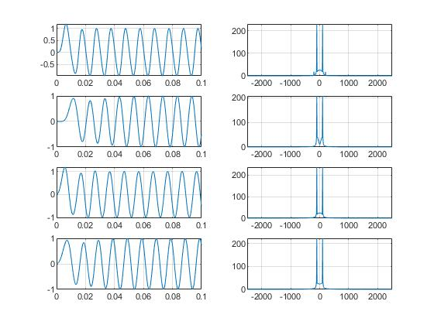

1. Repeat the above question (b) for the **high pass** filter specifications given below.

Minimum stop band attenuation, Rs=50dB,

Maximum pass band attenuation Rp=0.01dB,

Pass band frequency Wp=1400Hz,

Stop band frequency Ws=800Hz.

%%%%%%%%%%%%%%%%%%%%%%%%%%%%%%%%%%%%%%

f=[100 200 400 600 800 1000 1200 1400];

x_t=0;

x_1=0;

Fs=5000;

t=0:1/Fs:0.1;

for i=1:8

x_t=x_t+sin(2*pi*f(i)*t);

x_1=x_1+sin(2*pi*(f(i)/Fs)*t);

end

%Butterworth Lowpass Filter

[n1,Wn1]=buttord(1400/2500,800/2500,0.01,50);

% % % [z,p,k] = butter(n,Wn);

% % % sos = zp2sos(z,p,k);

% % %

% % % freqz(sos,1024)

% % % title(sprintf('n = %d Butterworth Lowpass Filter',n))

[b,a]=butter(n1,Wn1,'high');

y1=filter(b,a,x_t);

subplot(4,2,1);

plot(t,y1);

grid on

N1=length(y1);

freqaxis1=linspace(-Fs/2,Fs/2,N);

Y1=fft(y1,N);

subplot(4,2,2);

plot(freqaxis1,fftshift(abs(Y1)));

grid on

%%%%%%%%%%%%%%%%%%%%%%%%%%%%%%%%%%%%%%%%%%%%%

%Type1 Chebyshev Lowpass Filter

[n2,Wp]=cheb1ord(1400/2500,800/2500,0.01,50);

[d,c]=cheby1(n2,0.01,Wp,'high');

y2=filter(d,c,x_t);

subplot(4,2,3);

plot(t,y2);

grid on

N2=length(y2);

freqaxis2=linspace(-Fs/2,Fs/2,N2);

Y2=fft(y2,N2);

subplot(4,2,4);

plot(freqaxis2,fftshift(abs(Y2)));

grid on

%%%%%%%%%%%%%%%%%%%%%%%%%%%%%%%%%%%%%%%%%%%%%%

%Type2 Chebyshev Lowpass Filter

[n3,Ws]=cheb2ord(1400/2500,800/2500,0.01,50);

[f,e]=cheby2(n3,50,Ws,'high');

y3=filter(f,e,x_t);

subplot(4,2,5);

plot(t,y3);

grid on

N3=length(y3);

freqaxis3=linspace(-Fs/2,Fs/2,N3);

Y3=fft(y3,N3);

subplot(4,2,6);

plot(freqaxis3,fftshift(abs(Y3)));

grid on

%%%%%%%%%%%%%%%%%%%%%%%%%%%%%%%%%%%%%%%%%%%%%%

%Elliptical filter

[n4,Wp]=ellipord(1400/2500,800/2500,0.01,50);

[h,g]=ellip(n4,0.01,50,Wp,'high');

y4=filter(h,g,x_t);

subplot(4,2,7);

plot(t,y4);

grid on

N4=length(y4);

freqaxis4=linspace(-Fs/2,Fs/2,N4);

Y4=fft(y4,N4);

subplot(4,2,8);

plot(freqaxis4,fftshift(abs(Y4)));

grid on

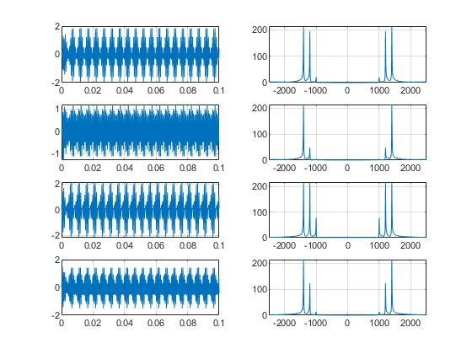

1. Repeat the above question (c) for the **bandpass** filter specification

Minimum stop band attenuation, Rs=50dB,

Maximum pass band attenuation Rp=0.01dB,

Pass band frequency Wp = [400 1000],

Stop band frequency Ws = [100 1400] Hz.

%%%%%%%%%%%%%%%%%%%%%%%%%%%%%%%%%%%%%%

f=[100 200 400 600 800 1000 1200 1400];

x_t=0;

x_1=0;

Fs=5000;

t=0:1/Fs:0.1;

for i=1:8

x_t=x_t+sin(2*pi*f(i)*t);

x_1=x_1+sin(2*pi*(f(i)/Fs)*t);

end

%Butterworth bandpass Filter

[n1,Wn1]=buttord([400 1000]/2500,[100 1400]/2500,0.01,50);

% % % [z,p,k] = butter(n,Wn);

% % % sos = zp2sos(z,p,k);

% % %

% % % freqz(sos,1024)

% % % title(sprintf('n = %d Butterworth Lowpass Filter',n))

[b,a]=butter(n1,Wn1,'bandpass');

y1=filter(b,a,x_t);

subplot(4,2,1);

plot(t,y1);

grid on

N1=length(y1);

freqaxis1=linspace(-Fs/2,Fs/2,N);

Y1=fft(y1,N);

subplot(4,2,2);

plot(freqaxis1,fftshift(abs(Y1)));

grid on

%%%%%%%%%%%%%%%%%%%%%%%%%%%%%%%%%%%%%%%%%%%%%

%Type1 Chebyshev Bandpass Filter

[n2,Wp]=cheb1ord([400 1000]/2500,[100 1400]/2500,0.01,50);

[d,c]=cheby1(n2,0.01,Wp,'bandpass');

y2=filter(d,c,x_t);

subplot(4,2,3);

plot(t,y2);

grid on

N2=length(y2);

freqaxis2=linspace(-Fs/2,Fs/2,N2);

Y2=fft(y2,N2);

subplot(4,2,4);

plot(freqaxis2,fftshift(abs(Y2)));

grid on

%%%%%%%%%%%%%%%%%%%%%%%%%%%%%%%%%%%%%%%%%%%%%%

%Type2 Chebyshev Bandpass Filter

[n3,Ws]=cheb2ord([400 1000]/2500,[100 1400]/2500,0.01,50);

[f,e]=cheby2(n3,50,Ws,'bandpass');

y3=filter(f,e,x_t);

subplot(4,2,5);

plot(t,y3);

grid on

N3=length(y3);

freqaxis3=linspace(-Fs/2,Fs/2,N3);

Y3=fft(y3,N3);

subplot(4,2,6);

plot(freqaxis3,fftshift(abs(Y3)));

grid on

%%%%%%%%%%%%%%%%%%%%%%%%%%%%%%%%%%%%%%%%%%%%%%

%Elliptical Bandpass filter

[n4,Wp]=ellipord([400 1000]/2500,[100 1400]/2500,0.01,50);

[h,g]=ellip(n4,0.01,50,Wp,'bandpass');

y4=filter(h,g,x_t);

subplot(4,2,7);

plot(t,y4);

grid on

N4=length(y4);

freqaxis4=linspace(-Fs/2,Fs/2,N4);

Y4=fft(y4,N4);

subplot(4,2,8);

plot(freqaxis4,fftshift(abs(Y4)));

grid on

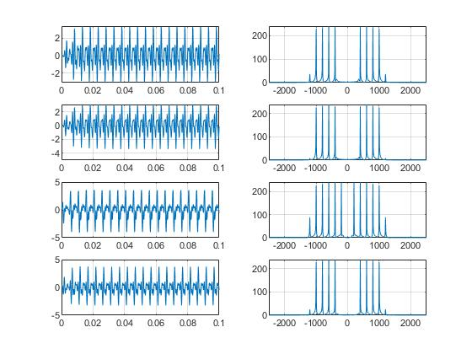

**PART B) Filtering using FDA tool:**

1. With the filter specifications of low pass filter mentioned in part 1 b), design the low pass filter using FDA tool in MATLAB.

b) Also design a high-pass and band-pass filter with the filter specifications given in 1c) and 1 d) respectively.

Observe the impulse response, step response, pole-zero plot, Magnitude response and phase response of the designed filters in the fdatool.