BIRLA INSTITUTE OF TECHNOLOGY & SCIENCE, PILANI

Pilani Campus

EEE F434: Digital Signal Processing

## LAB 8: DISCRETE TIME-FIR FILTERS

**Learning Outcomes:**

1. Design a low-pass filter, high-pass and band-pass filters based on given specifications using windowing method.

2. Implement the same design using optimal equiripple filters.

**Note: Please write your MATLAB codes in this .doc file and save it. Capture and paste the snapshots of your plots, wherever required. Make sure you get it signed before leaving the lab.**

**Please make sure you add a title, axis labels, x-axis limit and y-axis limit, grid on, and legend (if required) to each of your figures.**

**PART I: Linear Phase FIR Filters**

Consider the following specifications: f1 = 100 Hz, f2 = 200 Hz, f3 = 400 Hz, f4 = 600 Hz, f5 = 800 Hz, f6 = 1000 Hz, f7 = 1200 Hz, f8 = 1400 Hz and sampling frequency fs=5000 Hz.

1. Construct a signal x(t) given by

x(t)= $\sum_{i=1}^{8}{xi(t)}$,

where xi(t)=sin(2*pi*fi*t) and duration of the signal is 0.1 sec. Plot the time-domain representation, magnitude and phase spectra of x(t). Note: Show results as subplots of 1x3.

freq=[100 200 400 600 800 1000 1200 1400]

Fs=5000;

t=0:1/Fs:0.1;

n=length(freq);

x_t=0;

for i=1:n

x_t=x_t + sin(2*pi*freq(i)*t);

end

N=length(x_t);

x_f=fft(x_t);

freq_axis=linspace(-Fs/2,Fs/2,N);

subplot(3,1,1)

plot(t,x_t);

grid on

subplot(3,1,2)

plot(freq_axis,fftshift(abs(x_f)));

grid on;

subplot(3,1,3)

plot(freq_axis,fftshift(x_f));

grid on;

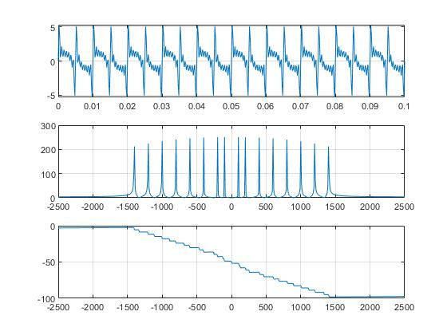

1. Design a linear phase FIR low pass filter of order (N = 13) with the cut - off frequency = 128 Hz.

Plot the magnitude and phase spectra of the filter as a subplot of 2x1. Obtain the desired filter type using the pole-zero diagram.

*Note: use the inbuilt MATLAB command “fir1” to design the linear phase FIR filter for Parts b-d). Please read this function before using the command.*

lowpass = fir1(13,(128*2)/5000);

freqz(lowpass,1)

zplane(lowpass)

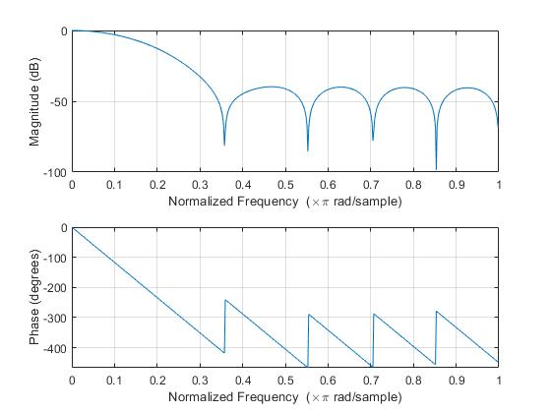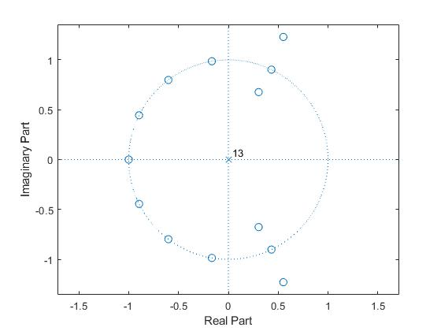

Pass the signal constructed in (a) through the filter (designed above). Plot the time domain, magnitude and phase spectra of the original signal as well as the filtered signal as a subplot of 2x3. Note down your observations.

freq=[100 200 400 600 800 1000 1200 1400]

Fs=5000;

t=0:1/Fs:0.1;

n=length(freq);

x_t=0;

for i=1:n

x_t=x_t + sin(2*pi*freq(i)*t);

end

N=length(x_t);

x_f=fft(x_t);

freq_axis=linspace(-Fs/2,Fs/2,N);

subplot(3,2,1)

plot(t,x_t);

title('Time-domain representation of x_t')

grid on

subplot(3,2,3)

plot(freq_axis,fftshift(abs(x_f)));

title('Magnitude Response of x_f')

grid on;

subplot(3,2,5)

plot(freq_axis,unwrap(angle(fftshift(x_f))));

title('Phase Response of x_f')

grid on;

lowpass = fir1(13,(128*2)/5000);

y_t=filter(lowpass,1,x_t);

y_f=fft(y_t);

subplot(3,2,2)

plot(t,y_t);

title('Time-domain representation of y_t')

grid on

subplot(3,2,4)

plot(freq_axis,fftshift(abs(y_f)));

title('Magnitude response of y_f')

grid on

subplot(3,2,6)

plot(freq_axis,unwrap(angle(fftshift(y_f))))

title('Phase Response of y_f')

grid on

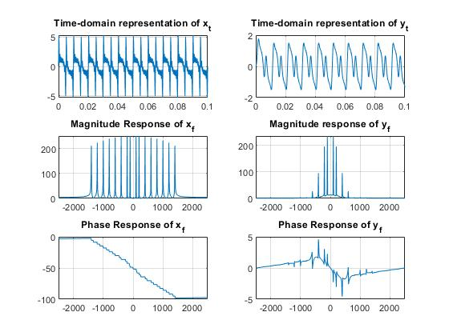

1. Design a linear phase FIR high pass filter of order (N = 12) with the cut - off frequency = 1155 Hz.

Plot the magnitude and phase spectra of the filter as a subplot of 2x1. Obtain the desired filter type using the pole-zero diagram.

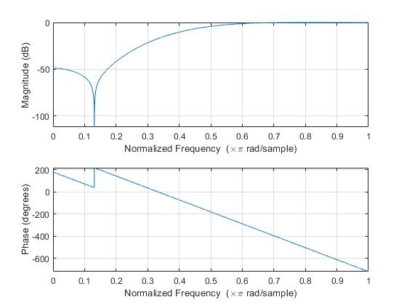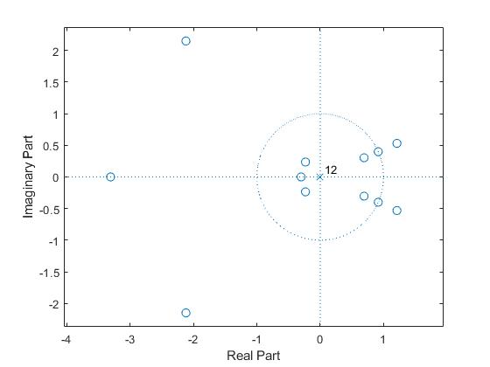

Pass the signal constructed in (a) through the filter (designed above). Plot the time domain, magnitude and phase spectra of the original signal as well as the filtered signal as a subplot of 2x3. Note down your observations.

freq=[100 200 400 600 800 1000 1200 1400]

Fs=5000;

t=0:1/Fs:0.1;

n=length(freq);

x_t=0;

for i=1:n

x_t=x_t + sin(2*pi*freq(i)*t);

end

N=length(x_t);

x_f=fft(x_t);

freq_axis=linspace(-Fs/2,Fs/2,N);

subplot(3,2,1)

plot(t,x_t);

title('Time-domain representation of x_t')

grid on

subplot(3,2,3)

plot(freq_axis,fftshift(abs(x_f)));

title('Magnitude Response of x_f')

grid on;

subplot(3,2,5)

plot(freq_axis,unwrap(angle(fftshift(x_f))));

title('Phase Response of x_f')

grid on;

highpass = fir1(13,(1155*2)/5000,'high');

y_t=filter(highpass,1,x_t);

y_f=fft(y_t);

subplot(3,2,2)

plot(t,y_t);

title('Time-domain representation of y_t')

grid on

subplot(3,2,4)

plot(freq_axis,fftshift(abs(y_f)));

title('Magnitude response of y_f')

grid on

subplot(3,2,6)

plot(freq_axis,unwrap(angle(fftshift(y_f))))

title('Phase Response of y_f')

grid on

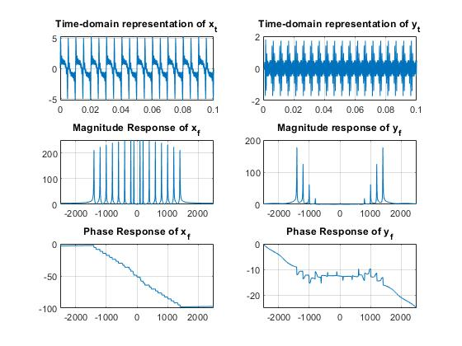

1. Design a linear phase FIR band pass filter of order (N = 12) with the cut - off frequencies = 345 Hz and 1117 Hz.

Plot the magnitude and phase spectra of the filter as a subplot of 2x1. Obtain the desired filter type using the pole-zero diagram.

b = fir1(12,[(345*2)/5000 (1117*2)/5000]);

freqz(b,1,8192)

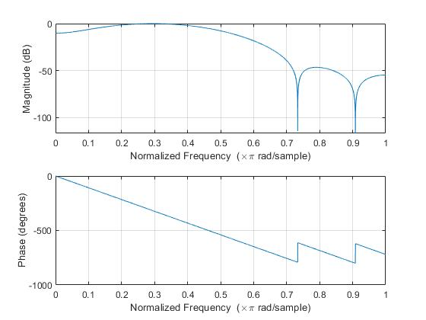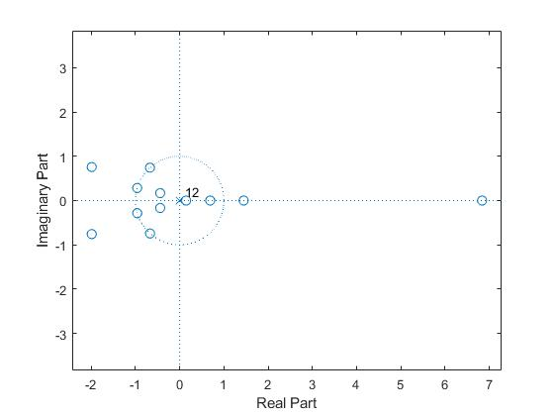

Pass the signal constructed in (a) through the filter (designed above). Plot the time domain, magnitude and phase spectra of the original signal as well as the filtered signal as a subplot of 2x3. Note down your observations.

freq=[100 200 400 600 800 1000 1200 1400]

Fs=5000;

t=0:1/Fs:0.1;

n=length(freq);

x_t=0;

for i=1:n

x_t=x_t + sin(2*pi*freq(i)*t);

end

N=length(x_t);

x_f=fft(x_t);

freq_axis=linspace(-Fs/2,Fs/2,N);

subplot(3,2,1)

plot(t,x_t);

title('Time-domain representation of x_t')

grid on

subplot(3,2,3)

plot(freq_axis,fftshift(abs(x_f)));

title('Magnitude Response of x_f')

grid on;

subplot(3,2,5)

plot(freq_axis,unwrap(angle(fftshift(x_f))));

title('Phase Response of x_f')

grid on;

bandpass = fir1(12,[(345*2)/5000 (1117*2)/5000]);

y_t=filter(bandpass,1,x_t);

y_f=fft(y_t);

subplot(3,2,2)

plot(t,y_t);

title('Time-domain representation of y_t')

grid on

subplot(3,2,4)

plot(freq_axis,fftshift(abs(y_f)));

title('Magnitude response of y_f')

grid on

subplot(3,2,6)

plot(freq_axis,unwrap(angle(fftshift(y_f))))

title('Phase Response of y_f')

grid on

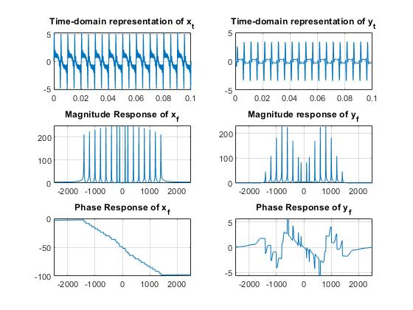

**PART II: Equiripple filters**

Design an FIR Equiripple filter (with using inbuilt MATLAB functions) with following specifications:

Low Pass Filter:

Passband frequency = 200 Hz

Pass band ripple = 0.08

Stopband frequency = 250 Hz

Stop band ripple = 0.1

rp = 0.08; % Passband ripple

rs = 0.1; % Stopband ripple

fs = 5000; % Sampling frequency

f = [200 250]; % Cutoff frequencies

a = [1 0]; % Desired amplitudes

dev = [(10^(rp/20)-1)/(10^(rp/20)+1) 10^(-rs/20)];

[n,fo,ao,w] = firpmord(f,a,dev,fs);

b = firpm(n,fo,ao,w);

freqz(b,1,8192,fs)

title('Lowpass Filter Designed to Specifications')

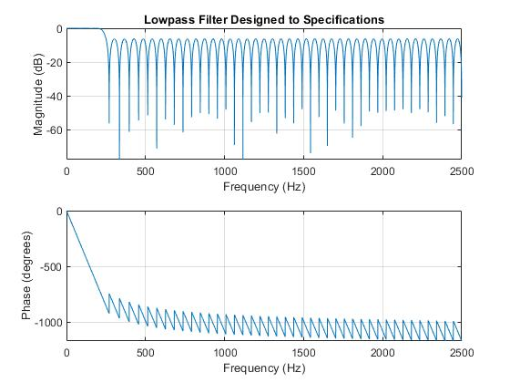

High Pass Filter:

Passband frequency = 600 Hz

Pass band ripple = 0.08

Stopband frequency = 400 Hz

Stop band ripple = 0.2

rp = 0.08; % Passband ripple

rs = 0.2; % Stopband ripple

fs = 5000; % Sampling frequency

f = [400 600]; % Cutoff frequencies

a = [0 1]; % Desired amplitudes

dev = [(10^(rp/20)-1)/(10^(rp/20)+1) 10^(-rs/20)];

[n,fo,ao,w] = firpmord(f,a,dev,fs);

b = firpm(n,fo,ao,w);

freqz(b,1,8192,fs)

title('Lowpass Filter Designed to Specifications')

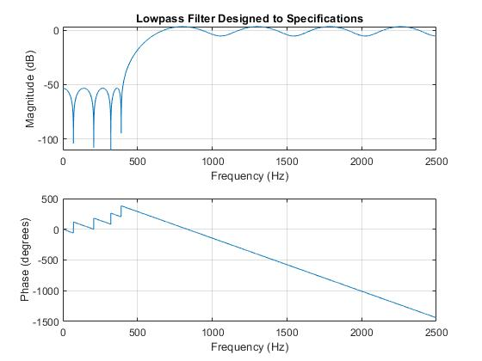

Band Pass Filter:

Passband frequencies = [300 700] Hz

Stopband frequencies = [200 800] Hz

For filter order of the band-pass filter, make sure you take the minimum filter order between low pass filter and high pass filter.

fs=5000;

f = [0 200/2500 300/2500 700/2500 800/2500 1];

a = [0 0 1 1 0 0];

b = firpm(24,f,a);

freqz(b,1,8192,fs)

title('Bandpass Filter Designed to Specifications')

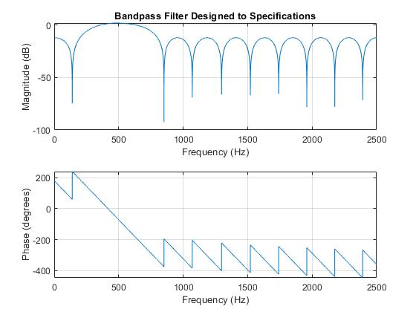

Pass the signal constructed in (1a) through the filter (designed above). Plot the time domain, magnitude and phase spectra of the original signal as well as the filtered signal as a subplot of 2x3. Note down your observations.

freq=[100 200 400 600 800 1000 1200 1400]

Fs=5000;

t=0:1/Fs:0.1;

n=length(freq);

x_t=0;

for i=1:n

x_t=x_t + sin(2*pi*freq(i)*t);

end

N=length(x_t);

x_f=fft(x_t);

freq_axis=linspace(-Fs/2,Fs/2,N);

subplot(3,2,1)

plot(t,x_t);

title('Time-domain representation of x_t')

grid on

subplot(3,2,3)

plot(freq_axis,fftshift(abs(x_f)));

title('Magnitude Response of x_f')

grid on;

subplot(3,2,5)

plot(freq_axis,unwrap(angle(fftshift(x_f))));

title('Phase Response of x_f')

grid on;

fs=5000;

f = [0 200/2500 300/2500 700/2500 800/2500 1];

a = [0 0 1 1 0 0];

b = firpm(24,f,a);

title('Bandpass Filter Designed to Specifications')

y_t=filter(b,1,x_t);

y_f=fft(y_t);

subplot(3,2,2)

plot(t,y_t);

title('Time-domain representation of y_t')

grid on

subplot(3,2,4)

plot(freq_axis,fftshift(abs(y_f)));

title('Magnitude response of y_f')

grid on

subplot(3,2,6)

plot(freq_axis,unwrap(angle(fftshift(y_f))))

title('Phase Response of y_f')

grid on

