BIRLA INSTITUTE OF TECHNOLOGY & SCIENCE, PILANI
Pilani Campus

EEE F434: Digital Signal Processing

LAB 7: IMAGE PROCESSING USING MATLAB

Learning Outcomes:

1. Familiarize the basic commands in the image processing toolbox.
2. Learn and design the low pass (i.e., image smoothing) and high pass filters (i.e., edge detection) for images.
.

Note: Write your answers in this .doc file only and save it. Capture and paste snapshots of graphs, wherever required.

A) Basic commands in Image processing tool box
- Take the 'toysflash.png' image present in MATLAB.
- Read this image using the ‘imread’ command?
img=imread(‘toysflash.png’)
- Display the image using ‘imshow’ command?
imshow(img)
- Find the size of this color image? Observe the significance of each color component? Display each color component?
size(img)
684 x 912 x 3
Implies that it is a 684 by 912 pixel image with 3 colour channels
- Save the image with a different file name and in ‘jpg’ format?
imwrite(img, ‘SomeOtherFileName.jpg’, ‘jpg’)
- Convert the color image into a grey scale image?
imggray=rgb2gray(img)
- Find the range of intensity values present in the grey scale image?
0-255
- Resize the above grey scale image using default command (imresize) in MATLAB? Write your own code to do the same operation?
img1=imresize(img,0.67)
scale = [0.67 0.67]; % The resolution scale factors:[rows columns]
oldSize = size(img);
newSize = max(floor(scale.*oldSize(1:2)),1);

rowIndex = min(round(((1:newSize(1))-0.5)./scale(1)+0.5),oldSize(1));
colIndex = min(round(((1:newSize(2))-0.5)./scale(2)+0.5),oldSize(2));
outputImage = img(rowIndex,colIndex,:);

- Display the negative of the grey scale image?
imgnegative=255-imggray;
imshow(imgnegative);
- Write a program to display the mirror image of the above read grey scale image?
fliplr(imgnegative)
- Write a program to display the grey scale image such that the pixels having intensity values below 50 will display as black (0) and pixels above 150 will display as white (255). The remaining pixels in between [50, 150] will be displayed as it is?
imgnegative1=imgnegative
imgnegative1(imgnegative1>150)=255;
imgnegative1(imgnegative1<50)=0;

B) Low pass filtering for smoothening the image
- Read the ‘cameraman.tif’ image in MATLAB. Create an average (Low pass) filter of size (3*3). Then apply this filter to the ‘cameraman.tif’ image. Do the same filtering operation by using ‘fspecial’ command? Make the observations with these two approaches.

Average filter=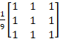
function[out]=avgFilter(image)

filter=(1/9).*ones(3);
out1=conv2(image,filter);
out=uint8(out1);
end
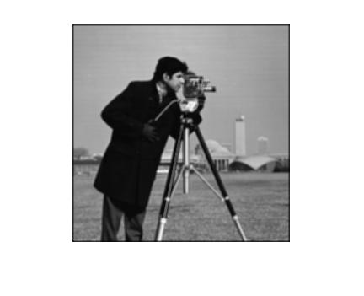

- Read the ‘cameraman.tif’ image in MATLAB. Add salt and pepper noise to this image. Create an average and median filters (3*3), then apply filtering operation on the noised image. Make your observations from the denoised images?
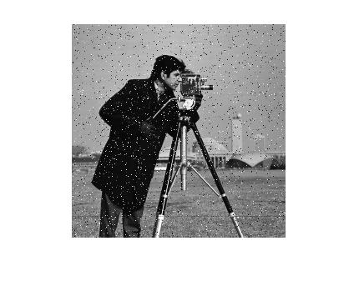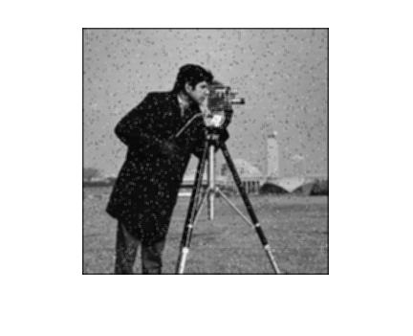
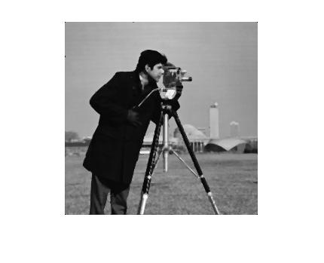

C) High pass filtering for finding the edges in the Image

- Read the ‘cameraman.tif’ image in MATLAB. Use the ‘edge’ command to detect the sharpened image with different methods (prewitt, canny, sobel, roberts). Use the subplot command to plot all the four outputs in a single image. To detect the high frequency components (edges) use the following filters
Gx = 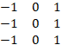 Gy = 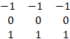
Detect the edges in the x-direction using Gx as the filter. Detect the edges in y-direction using Gy as the filter. To detect the complete edges, do the following operation (If the filtered output in x and y- directions are Zx and Zy respectively)
Find also the edges of the image ‘circuit.tf’ file, by using the above operations. The commands in MATLAB which are useful in this lab
‘filter2’, ‘imnoise’, ‘fspecial’, ‘medfilt2’

