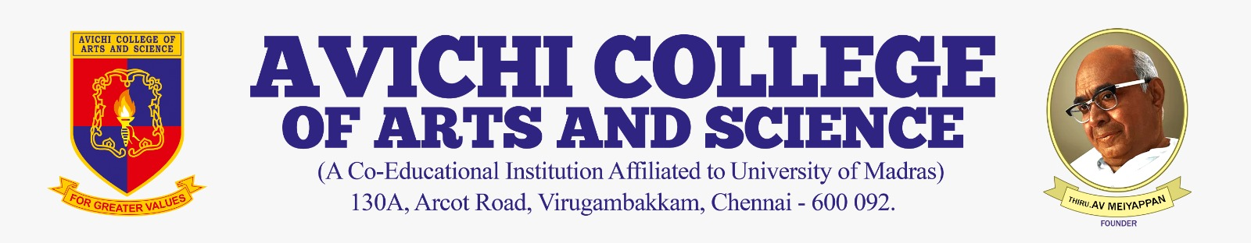
DEPARTMENT OF COMPUTER APPLICATIONS
EXTENTION ACTIVITY
Date: 20/02/2026
Time: 10:00 AM
Venue: Avichi School ‘XI-B’
No.of Participants: 59

The Department of Computer Applications conducted an Extension Activity on Canva on 20th February 2026 for XI B students of Avichi School. The program aimed to enhance students’ digital literacy and creative skills through practical exposure to a widely used design tool.
The session followed a hands-on approach, enabling students to design posters and digital content by editing images, customizing templates, adjusting text styles, and organizing layouts. Active guidance from BCA students promoted peer learning and made the session interactive and engaging. By the end of the program, students were able to independently create digital designs.

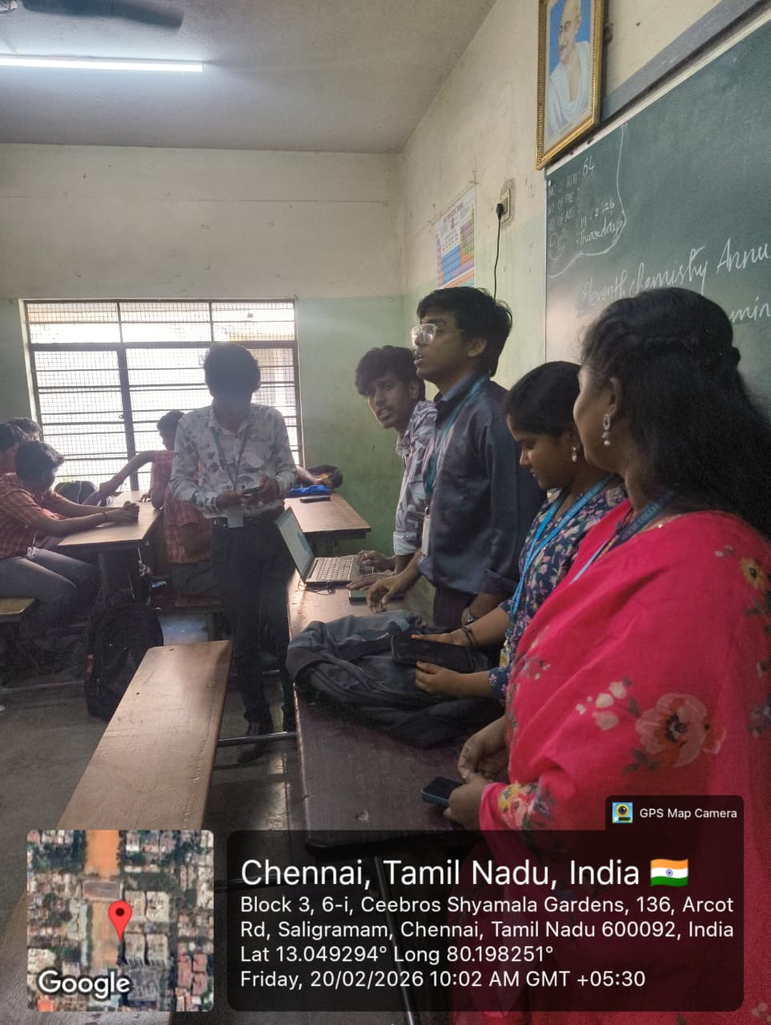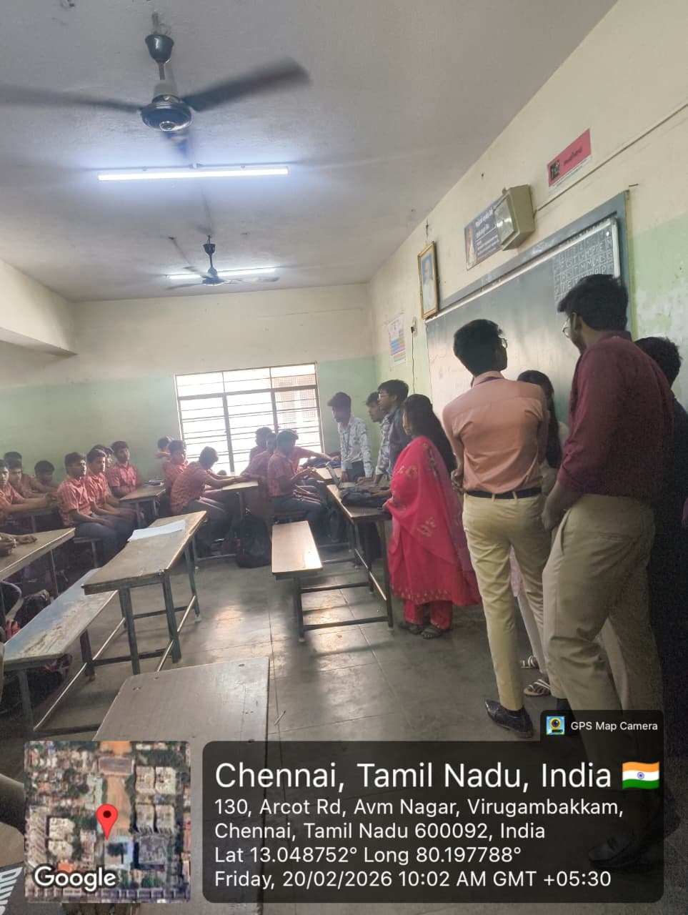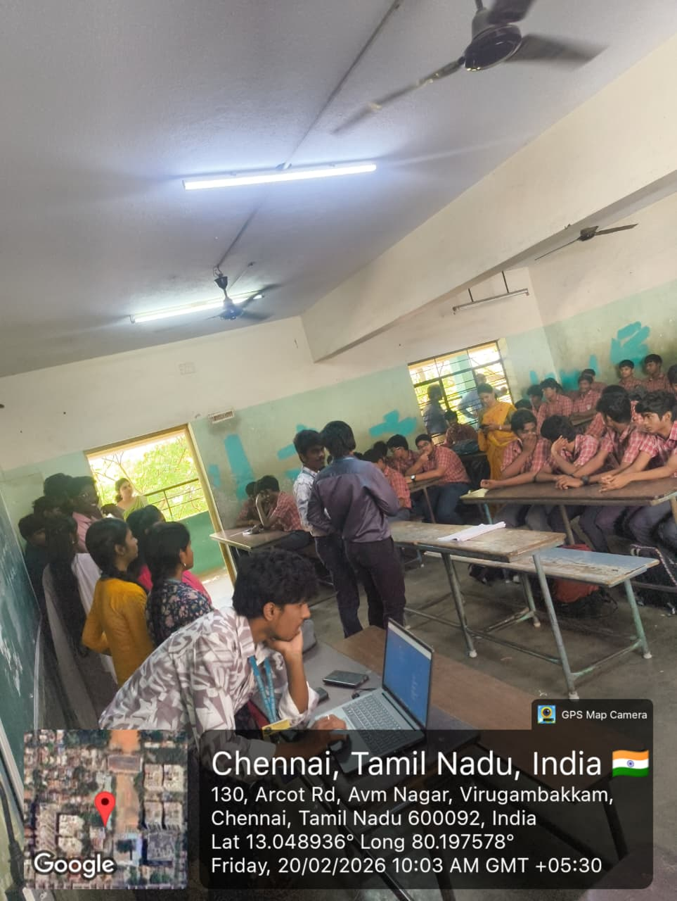

College Student Trainers:
- Davesh.R – 25BCA08
- Sundar – 25BCA47
- Monashri – 25BCA30
- Midhun – 25BCA28
- Mohamed Arshad – 25BCA29
- Selvin Thomas – 25BCA42
- Raghu.R – 25BCA36
- Kannan.T – 25BCA20
- T. Nithish Kumar – 25BCA33
- Mohammed Asan – 24BCA29
- Gokul Sriram – 24BCA09
- V. Sri Lekha – 24BCA46
- S. Kaviya – 24BCA22
- C. Ramya – 24BCA39
- S. Navin Ganesan – 24BCA33
SDG Mapping:
SDG 4 – Quality Education: The program supported creativity, digital literacy, and skill development through practical learning.
Outcome:
The activity effectively enhanced students’ digital creativity, practical design skills, and technical confidence.

Feedback
