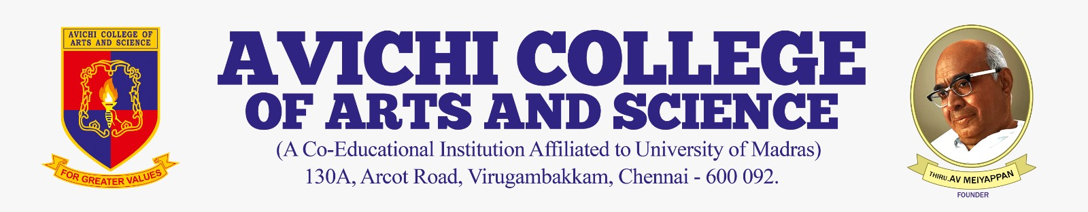

CIRCULAR

Ref No: Acas/BCA/Ext/Cir/25–26 | Date: 2026-02-13

This is to inform that the Department of bca will be organizing an sports day for the students of XI at ground on 2026-02-13 at 08:09.

The program aims to enhance digital skills and creativity among school students through practical learning.

All concerned are requested to take note of the same.

Event Coordinator | Principal

Copy To:
All HODs
IQAC

