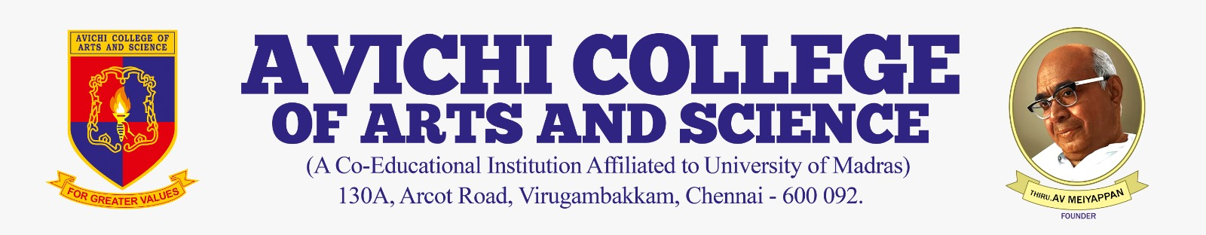

CIRCULAR

Ref No: Acas/BCA/Ext/Cir/25–26 | Date: 2026-02-20

This is to inform that the Department of Computer Applications will be organizing an Hands-on Canva for the students of XI at Avichi School on 2026-02-20 at 10:00 AM.

The program aims to enhance digital skills and creativity among school students through practical learning.

All concerned are requested to take note of the same.

Event Coordinator | Principal

Copy To:
All HODs
IQAC

