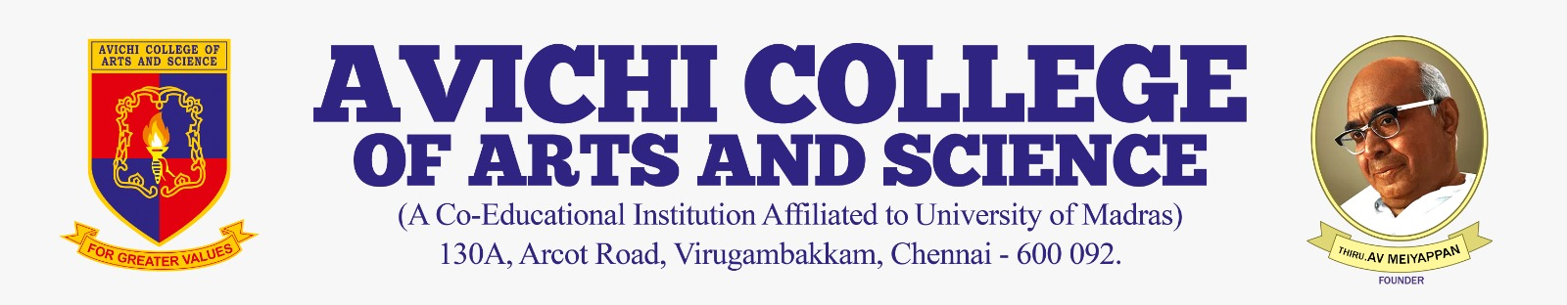

MINIT STREET

Target Audience | public,students,staff
Proposed Budget | ₹ 60,000,000.00
Prepared Date | 26 February 2026

Introduction
This event proposal pertains to 'minit street'. It has been prepared by the department in accordance with institutional guidelines to formally communicate relevant information to all stakeholders.

Objectives
• To enhance academic and co-curricular excellence among students.
• To foster interdisciplinary learning and collaboration.
• To align institutional activities with national and global quality benchmarks.

Expected Outcomes
Participants will gain practical exposure, develop critical thinking skills, and contribute meaningfully to the academic community. The activity is expected to yield measurable improvements in student engagement.

Conclusion
The institution remains committed to organizing high-quality programs that promote holistic development. This initiative reflects our vision of academic excellence and community engagement.

Budget Breakdown
Venue & Logistics
Guest Honorarium
Printing & Stationery
Miscellaneous

Submitted By:
_________________________
Event Coordinator

