Mini Project
Semester- VII
Summer Internship Report
Submitted by

Name: Krishnaraj Yadav Internal Guide:
Enrollment :180170107124 Prof.Nirav Suthar,
Assistant Professor
COMPUTER ENGINEERING DEPARTMENT



VISHWAKARMA GOVERNMENT ENGINEERING COLLEGE , CHANDKHEDA

Gujarat Technological University
Academic Year 2021-22

Vishwakarma Government Engineering College, chandkheda
Computer Department
CERTIFICATE

This is to certify that the Summer Internship Report entitled
Mini-Project: FlashBack . Submitted by Enroll No: 180170107124 Name: Krishnaraj Yadav towards the fulfillment of Subject: Summer Internship (3170001) of Gujarat Technological University is the record of work carried out by him under our supervision and guidance in the Academic Year 2021-22.

Internal Guide Head of Department

Prof. Nirav Suthar, Prof M. T. Savaliya
Assistant Professor Associate Professor
VGEC Chandkheda VGEC Chandkheda

TABLE OF CONTENTS

Certificate 2
Table of Contents 3
Acknowledgement 4
Abstract 5
Chapter: 1 Introduction 4
Chapter: 2 System Analysis 7
Chapter:3 System Modeling 9
Chapter: 4 Design Analysis, Design Methodology 10
and Implementation Strategies:
Chapter 5 : Conclusion and future scope 15

Acknowledgement
I hereby, would like to have the privilege to show our gratitude to all the persons, helped me in whatever way for the successful completion of this project without hindrance. I am grateful to all our mentors who inspired me by setting an example of them for the kind purpose of motivating us to reach my targeted objective. Without their knowledge and wisdom along with experience and specialization in their specific field, I would not have been able to think of doing or completing this work. All the persons who have contributed directly or indirectly with their kind support and humble approach are highly appreciative and we would always remain indebted to them in all the ways. We are especially thankful of Prof. Nirav Suthar, who is our internal guide, for their kind support and motivation. We extend our heartfelt thanks to Prof. Mansukh Savaliya, Head of Computer Department for his co-operation in our project work.

Abstract
- The project relies mainly on refreshing the memory of a person when he/she has visited any place.

- The project is based on web application that is user-friendly as all types of users can use it easily.
- The user can write , update , delete and add new blogs .

- This project is developed with various feature like nightmode and chatbot .
- The site also has uploading photos to the project and make a collection .

Chapter 1
Introduction

Flashback is a web-application that will help the person to share his beautiful experience with others and relive the life of that events . It also contain different features like night-mode and chatbot which helps the user to access the site very efficiently . This web application aims at making the web-app very user-friendly . This web-app will fill the requirement of a person to relive the past events .

Chapter 2 System Analysis

2.1 Why Do People Blog ?

a) Express Yourself and Share Your Passions
The landscape has changed, but there are still countless blogs that serve as a platform for people to voice their ideas, thoughts, and feelings. Whether your passion is business, personal finance, cooking, politics, photography, or marketing, blogging gives you the opportunity to connect and network with likeminded individuals who share the same passions.
b) Make A Difference
Some people’s passions lean toward supporting a cause. Whether it’s a political, environmental or social cause, a blog is a great way to build awareness and garner support.
c) Share Your Knowledge
If you’re someone who loves to teach, starting a blog can provide the opportunity to educate others interested in your field of expertise. The best part is that, as you build resources on your blog to teach others, you may realize there is a chance to monetize your blog by creating educational products or services online.
d) Refine Your Writing Skills
The more you write, the better you become at it. Most professional bloggers write on a regular basis and therefore analyze and proofread their writing constantly. You may even get feedback from readers to help you become a better writer.
However, being a good writer is not a prerequisite for a successful blog. Many very high profile bloggers are self-proclaimed terrible writers, and part of their success could be attributed to their message of “If I can do it, so can you”.

2.2 Requirement analysis of new system:

- This platform will help people to write there own story and help them to express there feeling in words which is also an art .
- People can just provide the email , name and password and they would be ready to write there blogs.
- Our system deals with the providng all the facilty to write personal blog .

Chapter:3
System Modeling
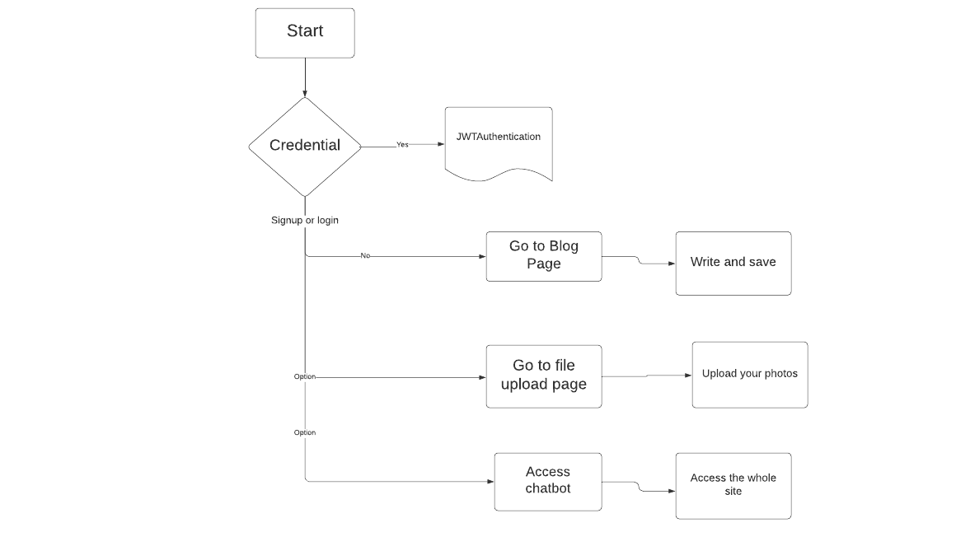
Flowchart :
Below is the activity diagram of the project.

Chapter 4 Design Analysis, Design Methodology, and Implementation Strategies:

Design Analysis:
There are some Competitor application and website, but they lack in features that they provide to users. The interface is very light which will not make any bad impact on the user’s eyes.
The website is very easy to understand to even a beginner .

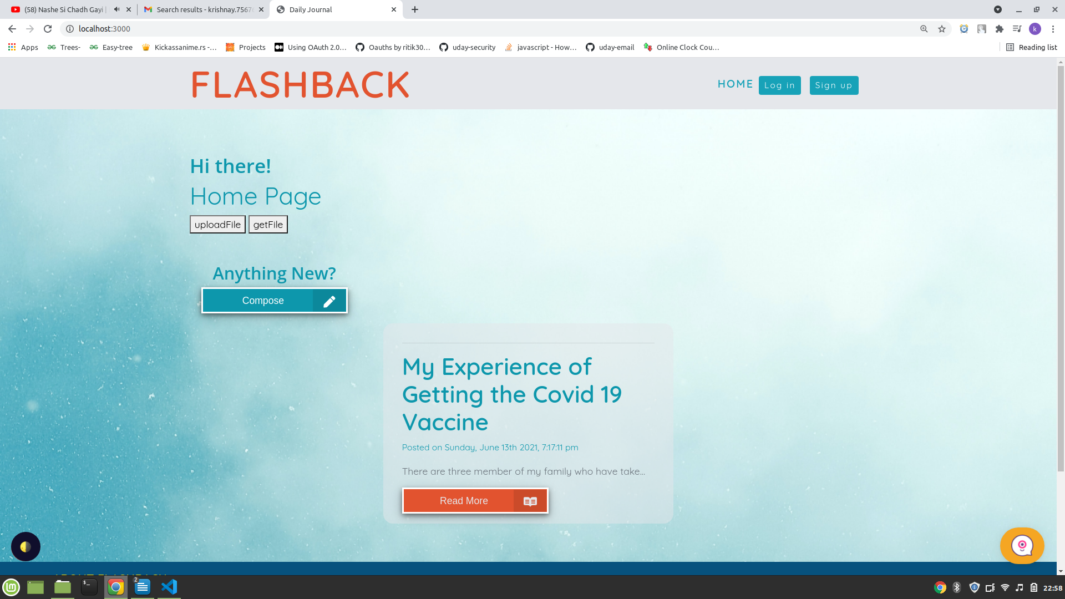

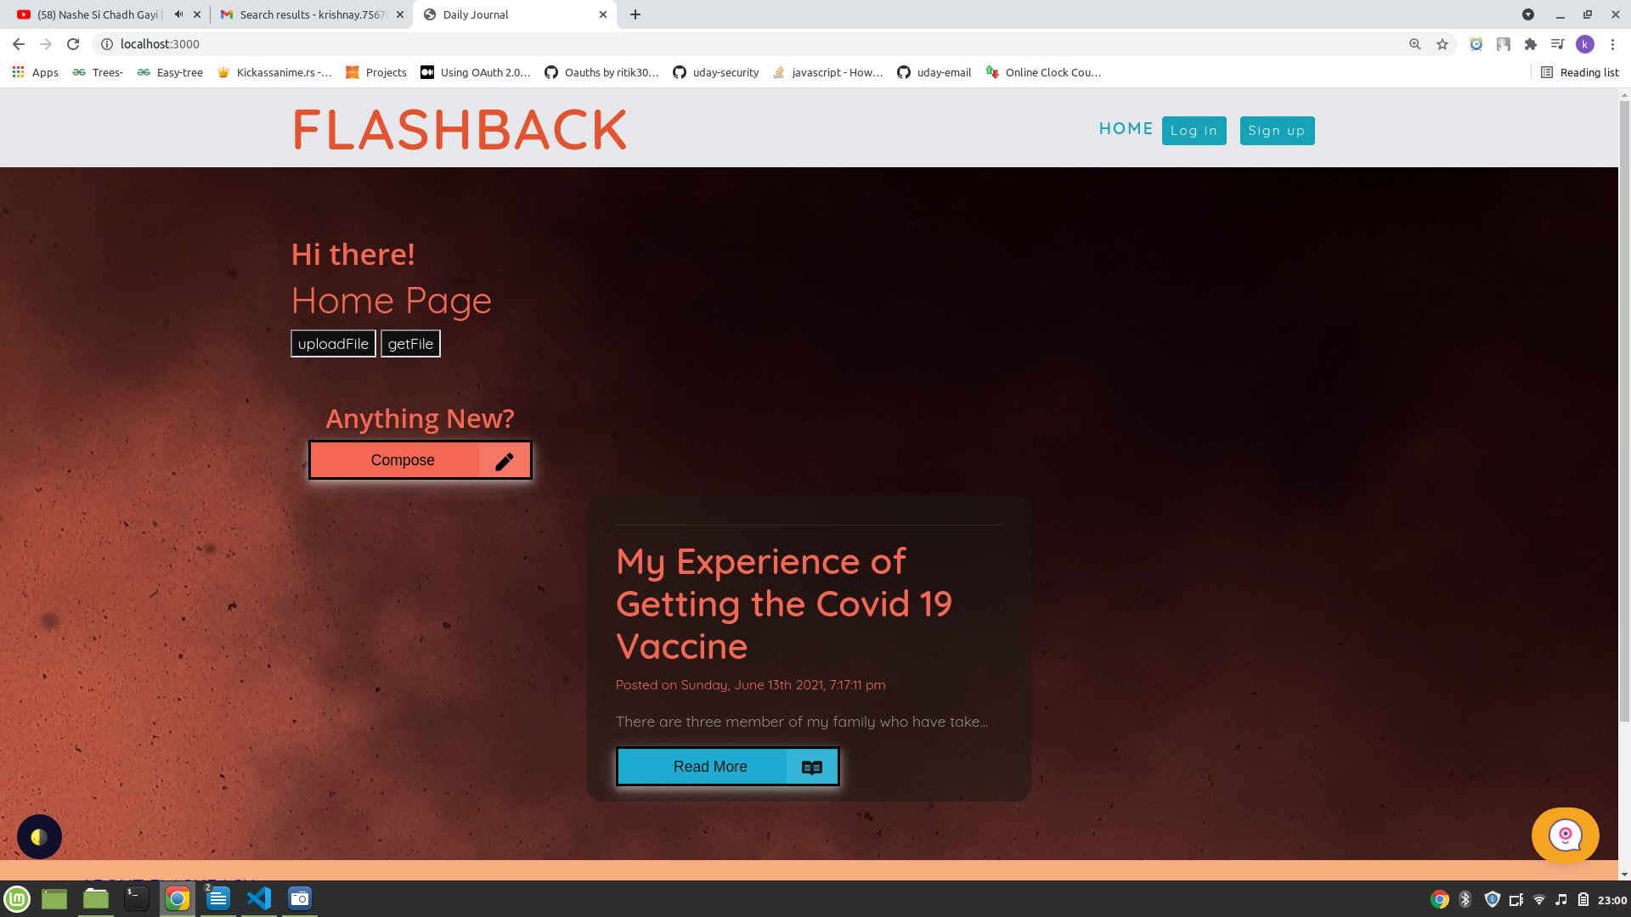
Night mode version of web-app :

Chatbot implementation :

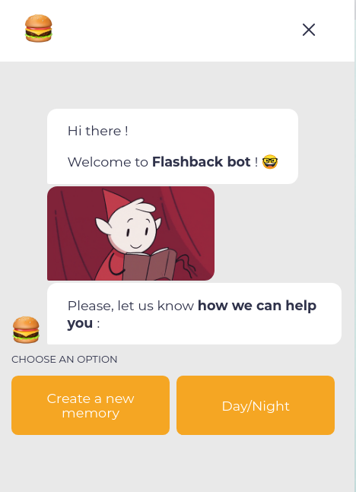

File Upload :

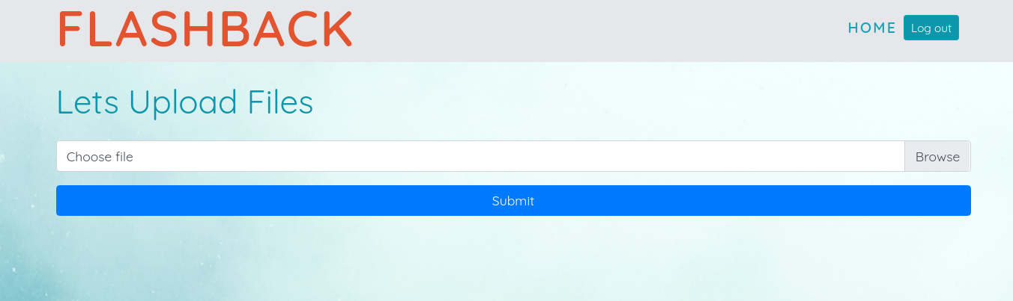

Blog page :

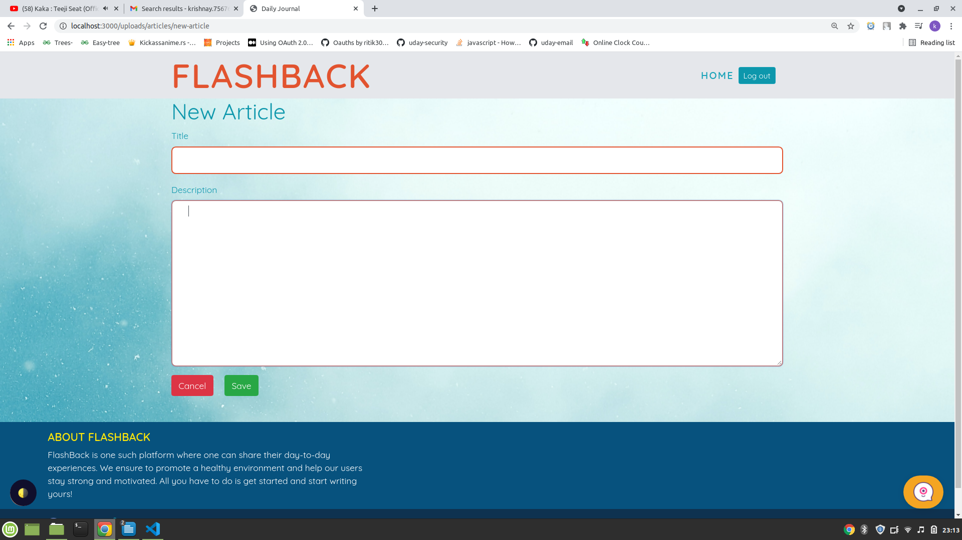

Getting all the files :
We can download and remove the files from the uploaded files .All files are listed in a very organized manner .

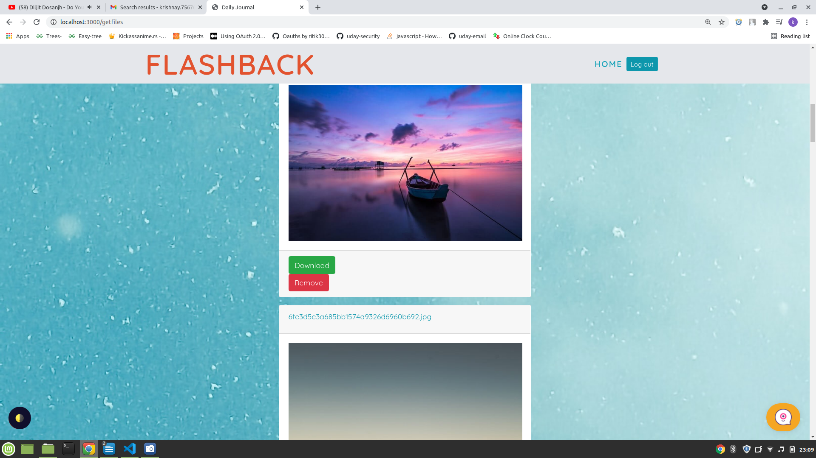

Conclusion and Future Scope :
This project will definately help all the people of society to redraw there memory and there is high possibility that it will get different new feature like applying for newslatter , sending photos and blogs experience to other people through social sites and email . I also working in text-to-speech blog that will reduce the afford to write the blog and increase the speed .

