Computer Networks Laboratory
Experiment: Exploring UDP with DNS using Wireshark
Name | SRN | Section
Kruthik Reddy S | PES2UG24CS241 | D

Part‑1: DNS Analysis

PART–1: DNS Analysis (Refined Write‑up)
- Observing DNS Caching Command Executed:
dig www.google.com (run twice)

Observation:
  - The initial DNS query required the resolver to contact external authoritative servers, resulting in a comparatively higher response time.
  - The subsequent query was answered more quickly because the DNS record had been stored in the local cache.
  - Both requests and responses used UDP over port 53, confirming the default transport mechanism for DNS.

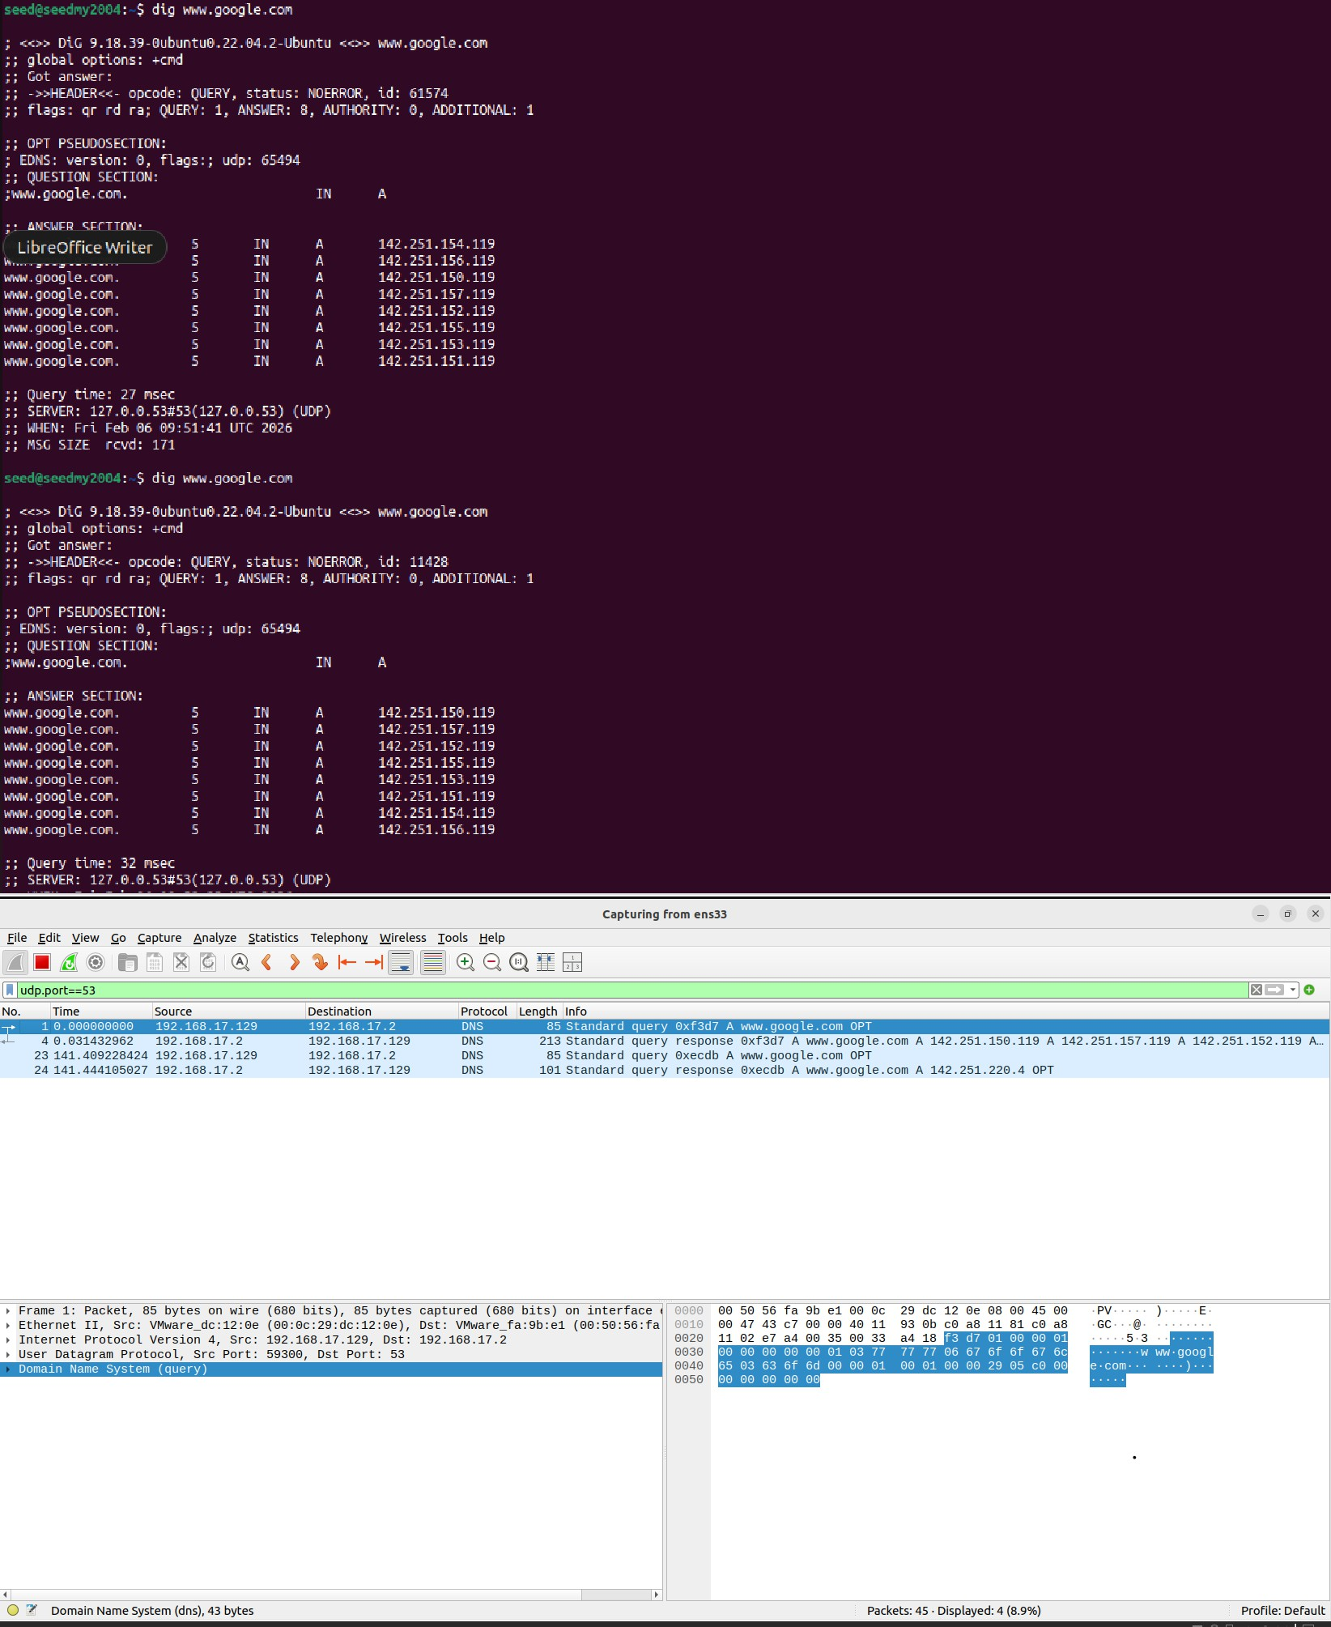

Report Statement:
When the dig www.google.com command was executed twice consecutively, the second response time was noticeably lower due to DNS caching. This demonstrates how caching improves network efficiency by avoiding repeated external lookups.

- Querying Different DNS Record Types
(a) AAAA Record (IPv6) Command Executed:
dig www.google.com AAAA

Observation:
  - The resolver returned an IPv6 address for the domain.
  - Wireshark labeled the packet as “Standard query AAAA www.google.com.”
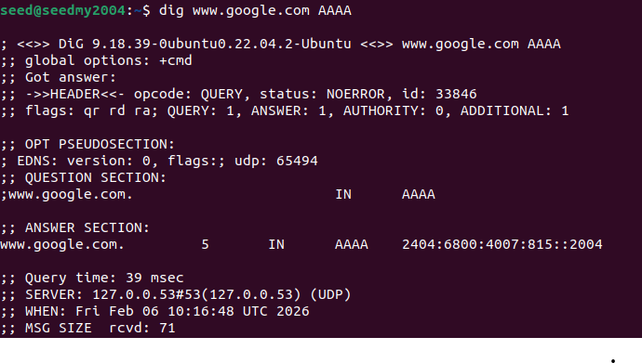
  - Example IPv6 address observed: 2404:6800:4007:815::2004.

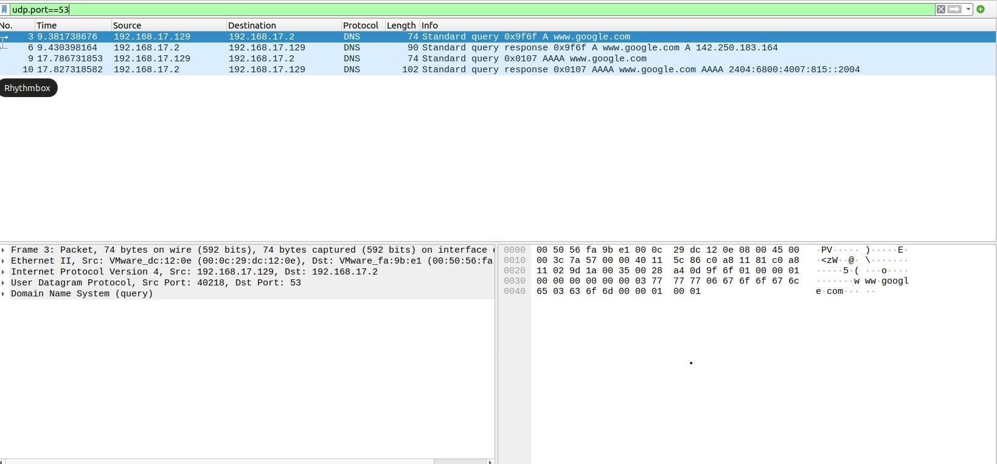

Report Statement:
The AAAA query resolved the IPv6 address of www.google.com, illustrating DNS support for IPv6 in addition to IPv4. The transaction was carried over UDP port 53.
(b) MX Record (Mail Exchange) Command Executed:
dig www.google.com MX

Observation:
  - No mail exchange records were present for the subdomain.
  - An SOA (Start of Authority) record was returned instead, indicating administrative information for the domain.
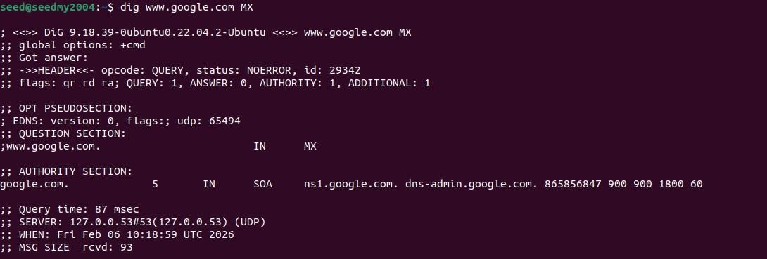
  - This confirms that www.google.com does not directly handle email services.

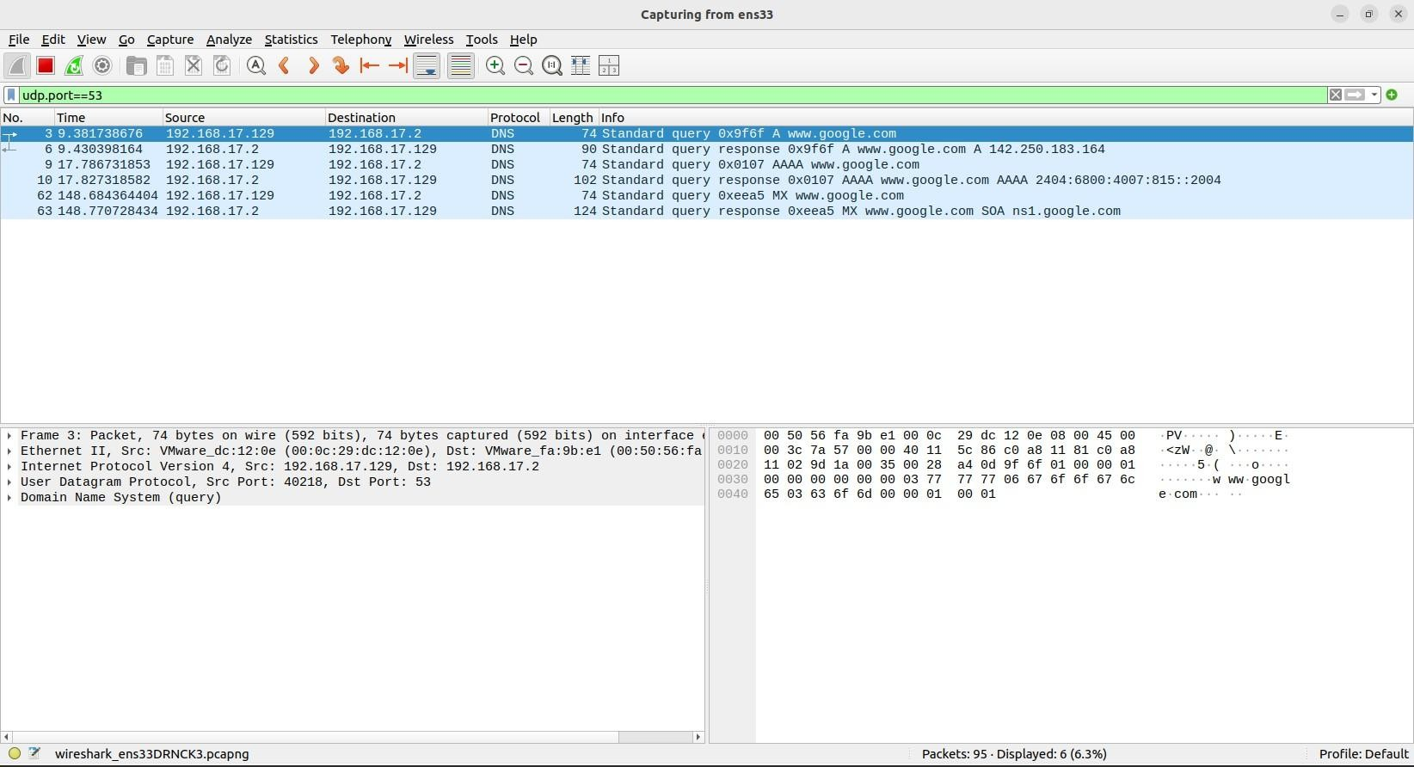

Report Statement:
The MX query for www.google.com returned only an SOA record, showing that the host is not configured to receive electronic mail.

- Changing the DNS Resolver
(a) Cloudflare Public DNS (1.1.1.1) Command Executed:
dig @1.1.1.1 google.com

Observation:
  - Resolver used: 1.1.1.1.
  - IPv4 address returned: 172.217.24.206.
  - Approximate response time: 31 ms.
  - Communication continued to use UDP.

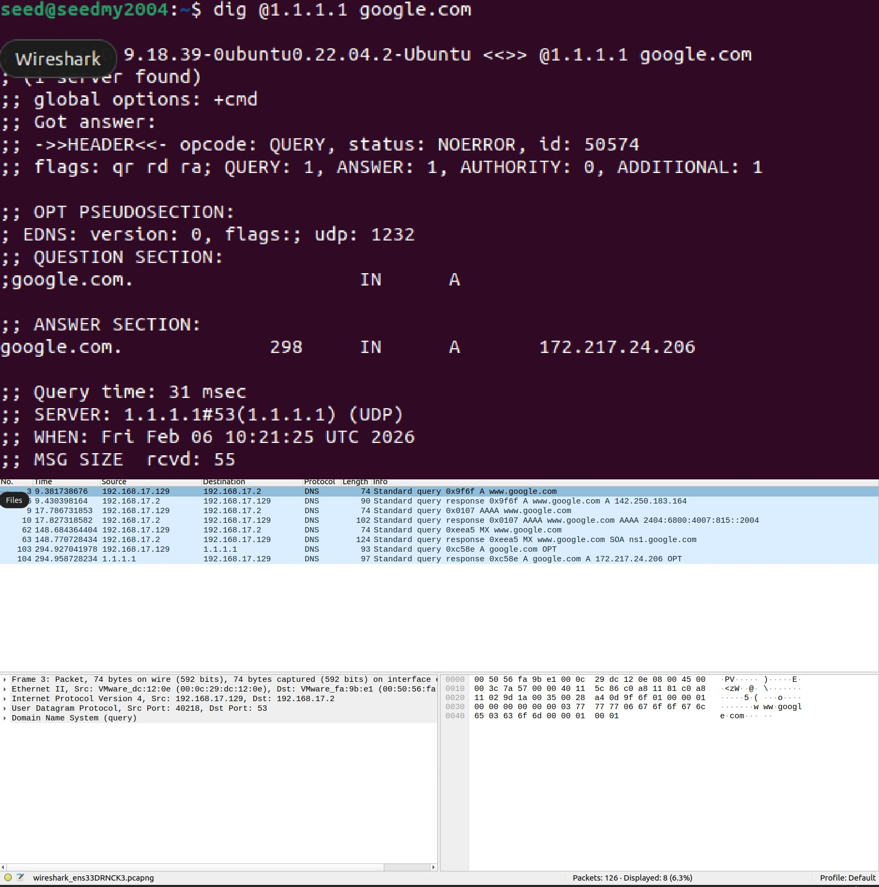
(b) Google Public DNS (8.8.8.8) Command Executed:
dig @8.8.8.8 google.com

Observation:
  - Resolver used: 8.8.8.8.
  - IPv4 address returned: 142.251.221.206.
  - Approximate response time: 39 ms.

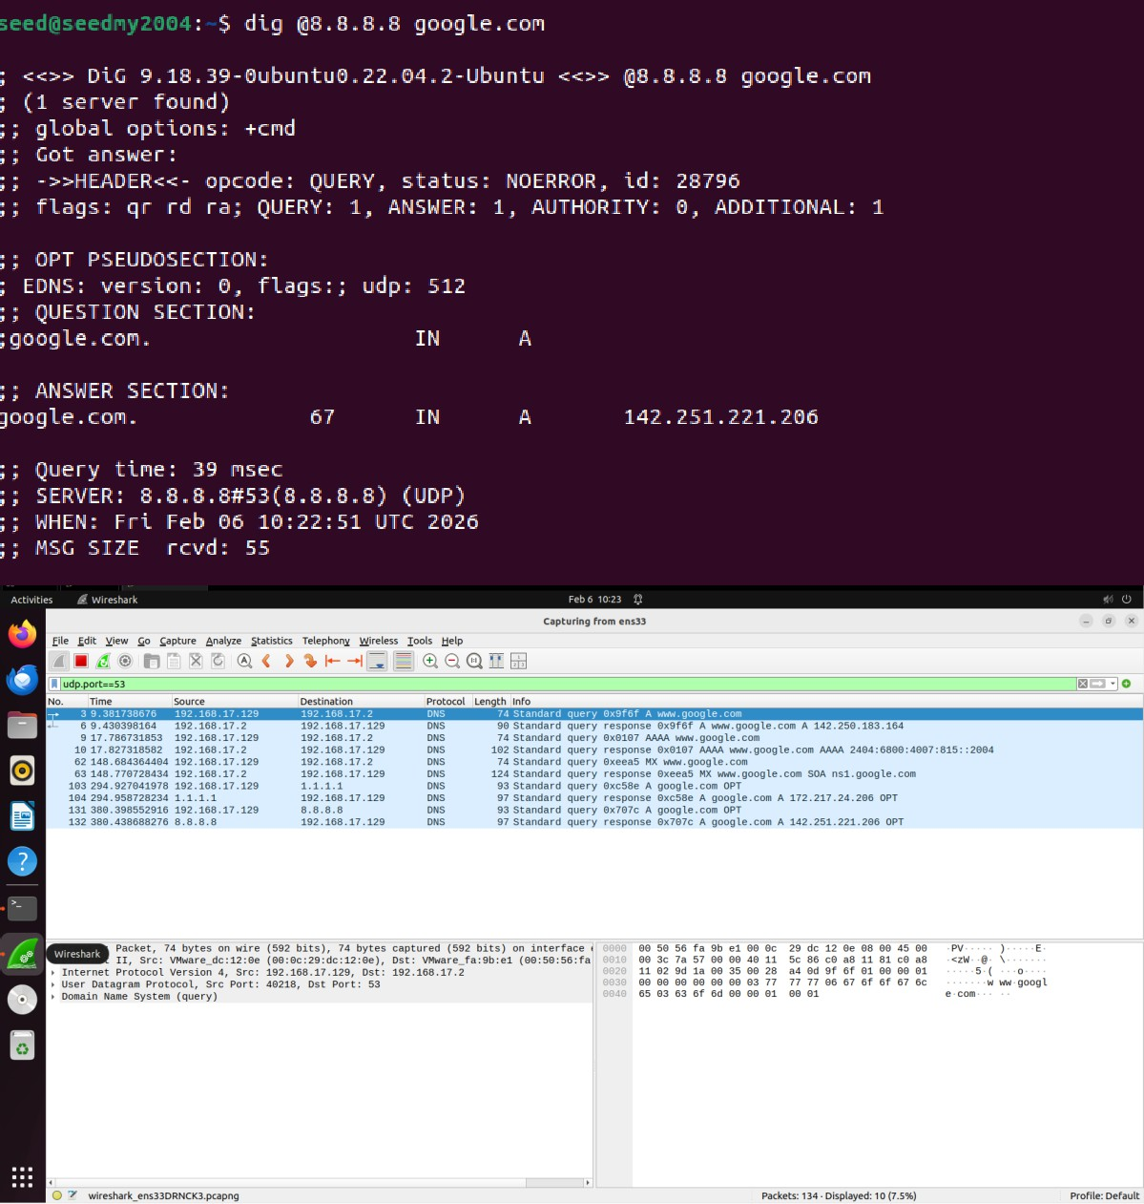

Report Statement:
Using different public DNS resolvers produced variations in both response times and resolved IP addresses. This behavior occurs due to load‑balancing mechanisms and geographic optimization employed by DNS providers.
- DNS Packet‑Level Analysis in Wireshark Observed Characteristics:
  - Application protocol: DNS.
  - Transport protocol: UDP.
  - Server port: 53.
  - Matching transaction IDs between queries and responses.

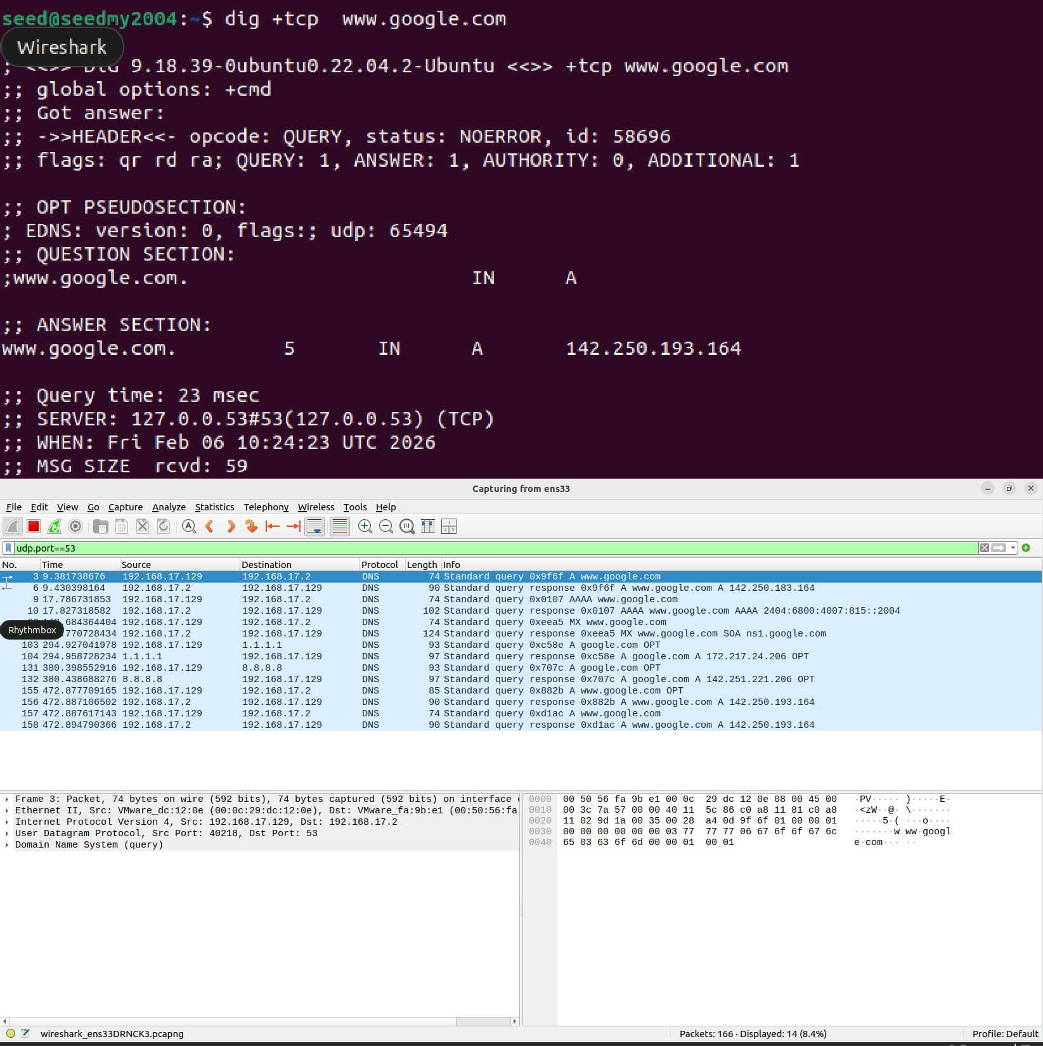
  - Multiple IP addresses returned in certain responses for load distribution.

Report Statement:
Wireshark packet inspection confirmed that DNS primarily relies on UDP for rapid query‑response exchanges. The presence of identical transaction identifiers in corresponding packets ensures correct association between requests and replies.

Part-2: UDP Communication Analysis

- Experimental Setup

A UDP server was created using the netcat utility by binding it to port 54321. This server

remained in listening mode to receive incoming datagrams from a client application.

Server Command:
nc -u -l 54321

A separate terminal instance was used as the UDP client to transmit three independent messages to the server.

Client Commands:
echo "Hello Server" | nc -u 192.168.17.128 54321 echo "Message two" | nc -u 192.168.17.128 54321 echo "Final msg" | nc -u 192.168.17.128 54321
Wireshark packet capture was enabled on the active network interface, and a display filter (udp.port == 54321) was applied to isolate the relevant traffic.

- Observations from Wireshark

  - Each transmitted message appeared as a separate UDP datagram.
  - No connection establishment or termination packets were observed, confirming the connectionless nature of UDP.
  - The UDP header size was consistently 8 bytes.
  - Payload data was visible in clear text within the packet details pane.
  - Source ports were dynamically assigned ephemeral ports, while the destination port

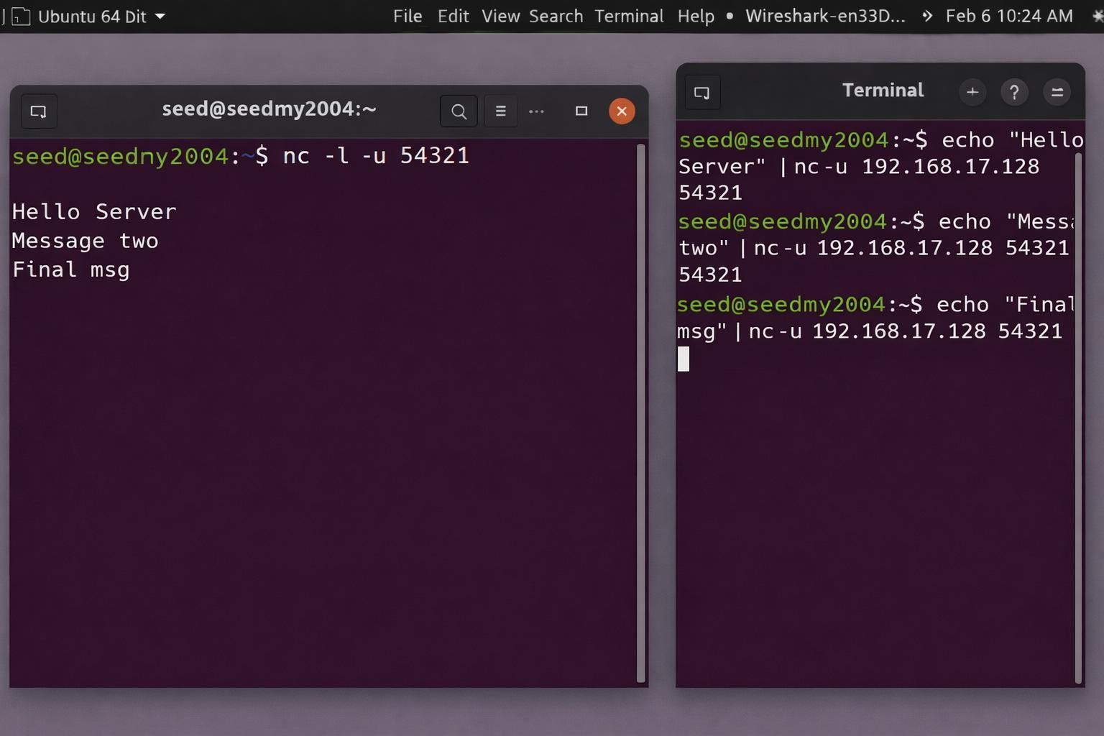
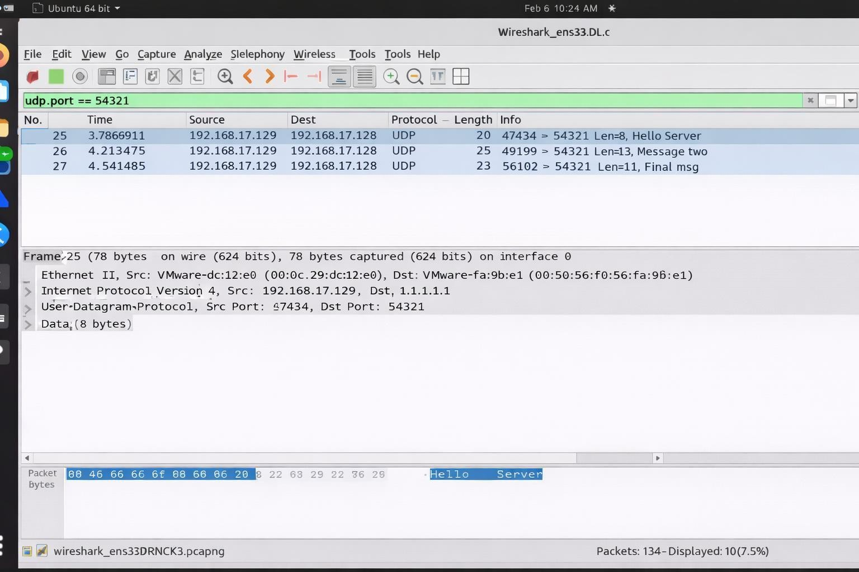
remained fixed at 54321 for the server.

- Discussion: UDP versus TCP

UDP is a lightweight, connectionless transport-layer protocol that does not guarantee delivery, ordering, or retransmission of packets. TCP, on the other hand, establishes a reliable session through a three-way handshake and provides acknowledgments, flow control, and retransmission mechanisms.

UDP’s reduced overhead makes it suitable for applications that prioritize speed and low latency over reliability.

- Why UDP Is Used for DNS

DNS commonly uses UDP because queries are typically small and require rapid responses. Eliminating connection setup reduces latency and conserves network resources. When responses exceed size limits or reliability is required, DNS automatically switches to TCP.

- Summary of Findings

This experiment demonstrated how UDP transmits data efficiently without maintaining state between endpoints. Wireshark analysis clearly highlighted the simplicity of the UDP header structure and the absence of reliability mechanisms.

Part-3: UDP Packet-Level Examination in DNS

- Identification of the First UDP Segment

The first UDP packet captured in the trace file corresponded to packet number 1. This segment carried a DNS query message generated by the client system.

- Application-Layer Payload

Inspection of the packet details revealed that the UDP payload contained a Domain Name System (DNS) query. The application-layer protocol was clearly identified by Wireshark in the protocol hierarchy pane.

- UDP Header Fields

The UDP header was observed to consist of four fields:
  - Source Port
  - Destination Port
  - Length
  - Checksum

- UDP Header Length

Wireshark reported a fixed UDP header length of 8 bytes, consistent with the UDP specification.

- Request–Response Packet Pair
A matching query–response pair was identified at packet numbers 1 and 4. In the first packet:
  - Source Port: 35510
  - Destination Port: 53

In the reply packet:
  - Source Port: 53
  - Destination Port: 35510

- Port Number Relationship

The reversal of source and destination port numbers between the two packets confirms the standard client–server interaction pattern in UDP-based DNS communication. The DNS server replies from its well-known port (53) to the ephemeral port originally selected by the client, allowing the client to associate the response with the correct request.

