**1. What is software? What is software engineering?**  
**Software:**  
A piece of code written in form of programming language to sort of specific task is called Software

**Software Engineering:**

The application of engineering principles to the development of software. It's like building a bridge or a machine, but with code instead of physical materials.

Involves a structured process to ensure high-quality, reliable, and maintainable software. This process includes various phases like:

Planning: Defining the project's goals and scope.

Design: Creating a blueprint for the software's architecture.

Development: Writing the code that makes the software function.

Testing: Identifying and fixing bugs or errors.

Deployment: Releasing the software to users.

Maintenance: Fixing issues, adding new features, and keeping the software up-to-date.

**2. Explain types of software**

**Types of software:**

1) System software (Software created to run hardware - E.g. - Drivers used to run webcam, Bluetooth - interreact between software and hardware)

2) Programming software (converts high level language into low level (machine) language E.g. - Compiler and Interpreter)

3) Web application software (used to website applications)

**3. What is DFD? Create a DFD diagram on Flipkart**

A DFD(Data Flow Diagram) is like a map for information moving through a system. It shows where data comes from (inputs), what happens to it (processes), and where it goes (outputs). DFDs focus on the big picture, not the nitty-gritty details like decisions or loops. Those can be explained with a different tool called a flowchart.

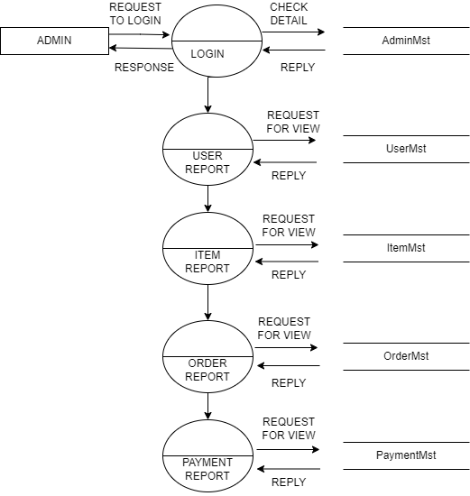

**5. What is Flow chart? Create a flowchart to make addition of two numbers**

A flowchart is a visual representation of a process that uses geometric shapes connected by arrows to illustrate the sequence of steps, decisions, and data flow. It's a helpful tool for:

Planning and designing algorithms (step-by-step instructions)

Documenting existing processes

Improving understanding and communication between technical and non-technical audiences

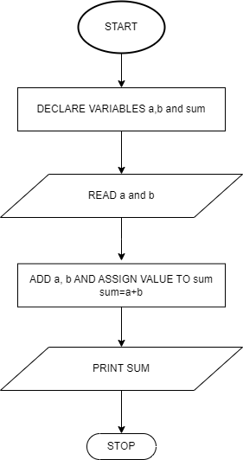

**6. What is Use case Diagram? Create a use-case on bill payment on Paytm.**

A use case diagram is a visual representation in Unified Modelling Language (UML) that depicts the functional interactions between a system and its external actors (users, other systems).