DAV- Practical 1

Name:- Krishna Mundada

Roll no:- 45  
Batch:- E3  
Subject:- DAV Lab

# AIM: Introduction to weka and data preprocessing on the given data set in Weka

## 1.Press the Explorer button on the main panel and load the weather dataset and answer the following questions

## Output:

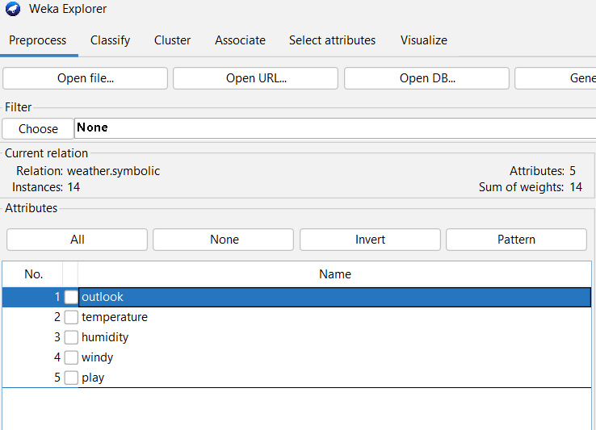

**(1) How many instances are there in the dataset?**

-> 14

**(2) State the names of the attributes along with their types and values.**

->

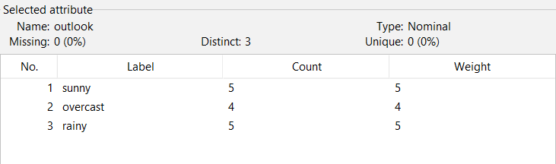

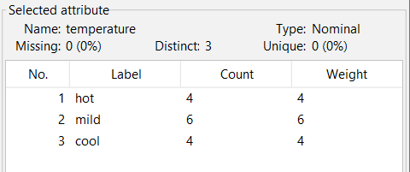

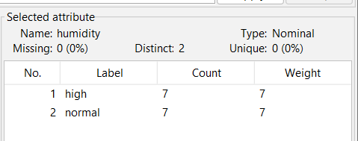

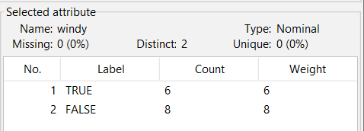

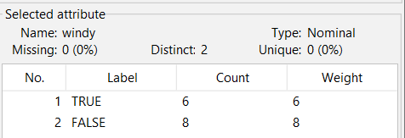

**(3) What is the class attribute?**

-> Play

**(4) How will you determine how many instances of each class are present in the data**

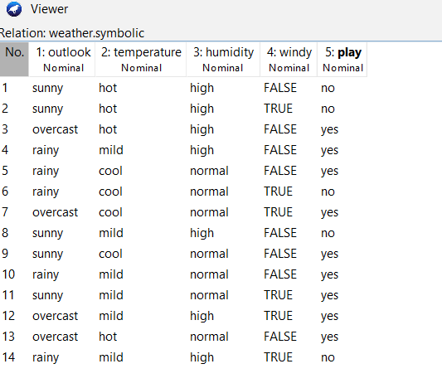

**(5) What happens with the Visualize All button is pressed?**

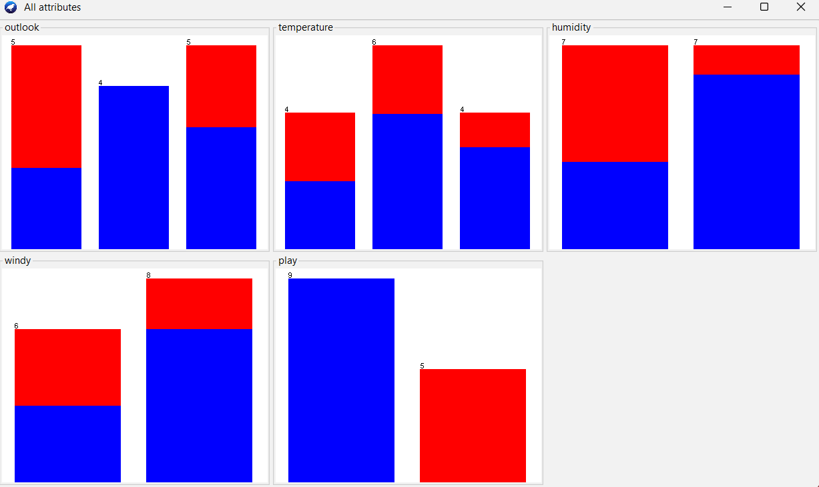

**(6) How will you view the instances in the dataset? How will you save the changes?**

-> Click edit button



**(7) Now, extend the dataset to include 50 instances in total.**

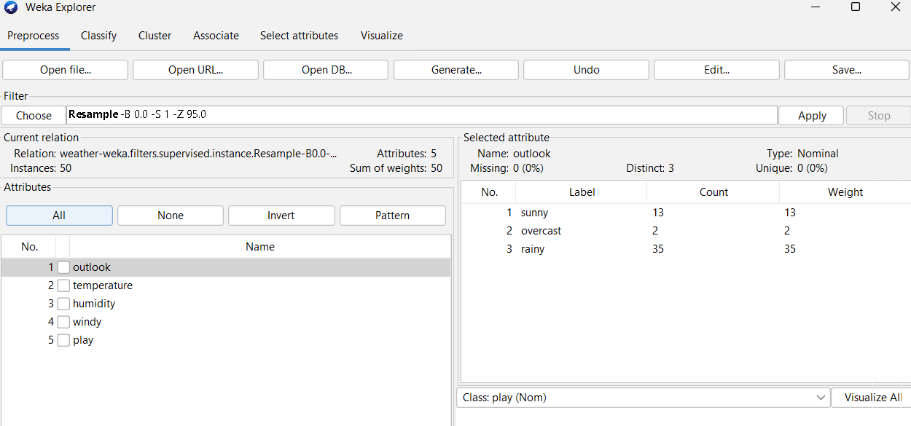

## 2. Do as directed to apply Filter

1. **Use the unsupervised filter RemoveWithValues to remove all instances where the Attribute ‘humidity’ has the value ‘high’? Undo the effect of the filter.**

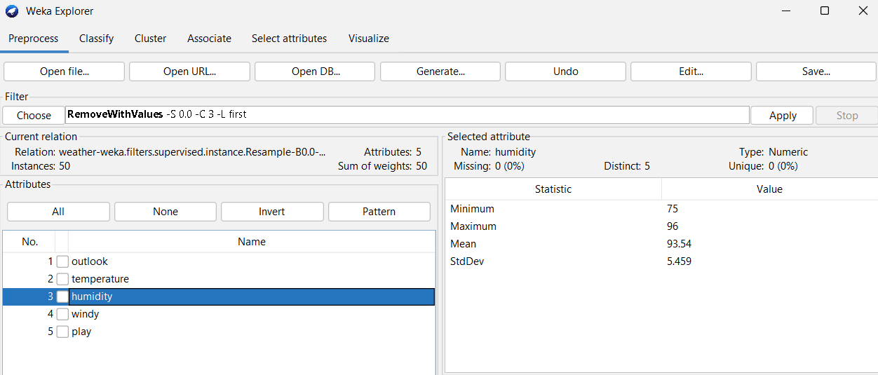

1. **Remove the ‘FALSE’ instances of windy attribute and undo the effect.**

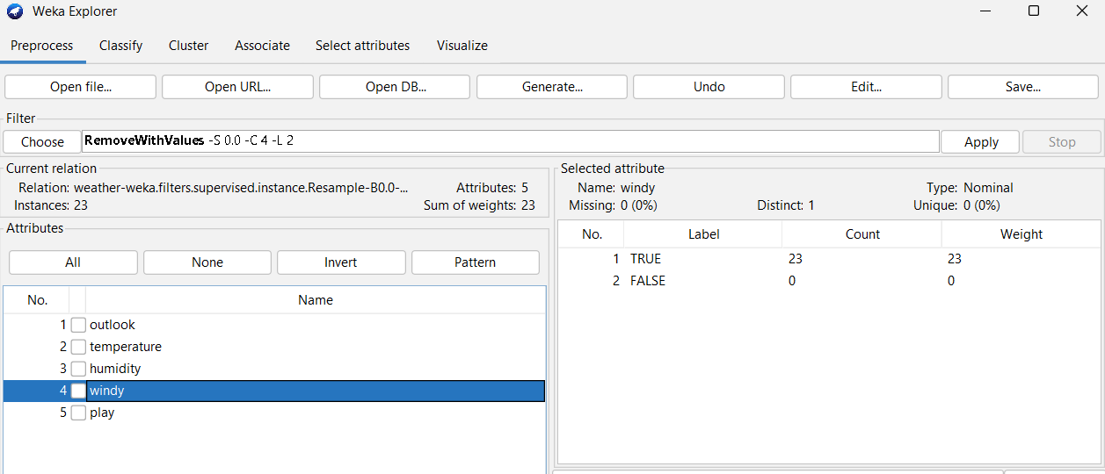

1. **Remove the attribute outlook and undo the effect.**

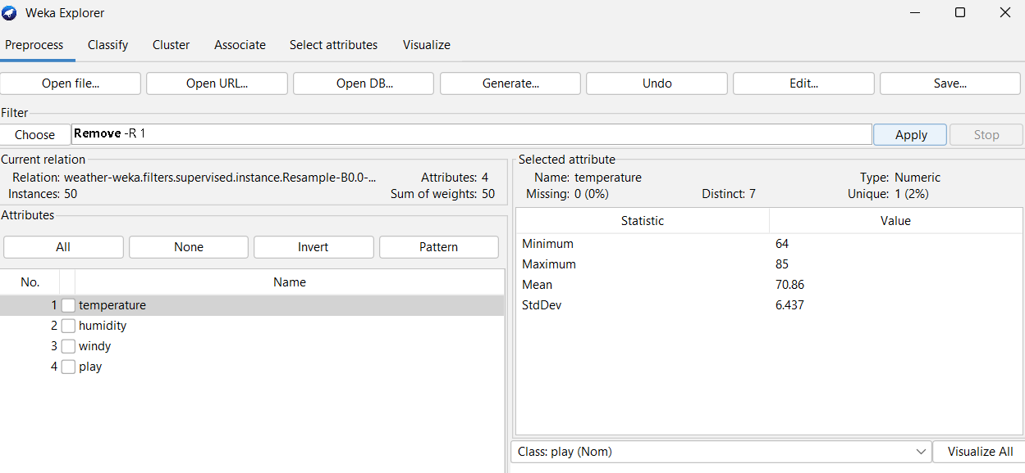

1. **Experiment with different filters and report their effects.**

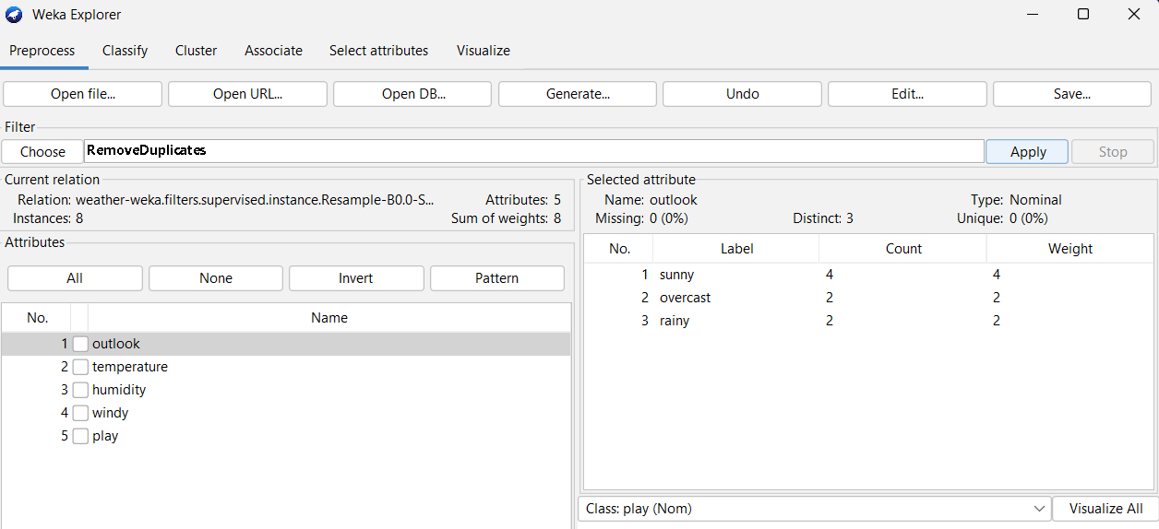

## 3. Application of Discretization Filters [use sick.arff dataset]

**1. Load the sick.arff dataset.**

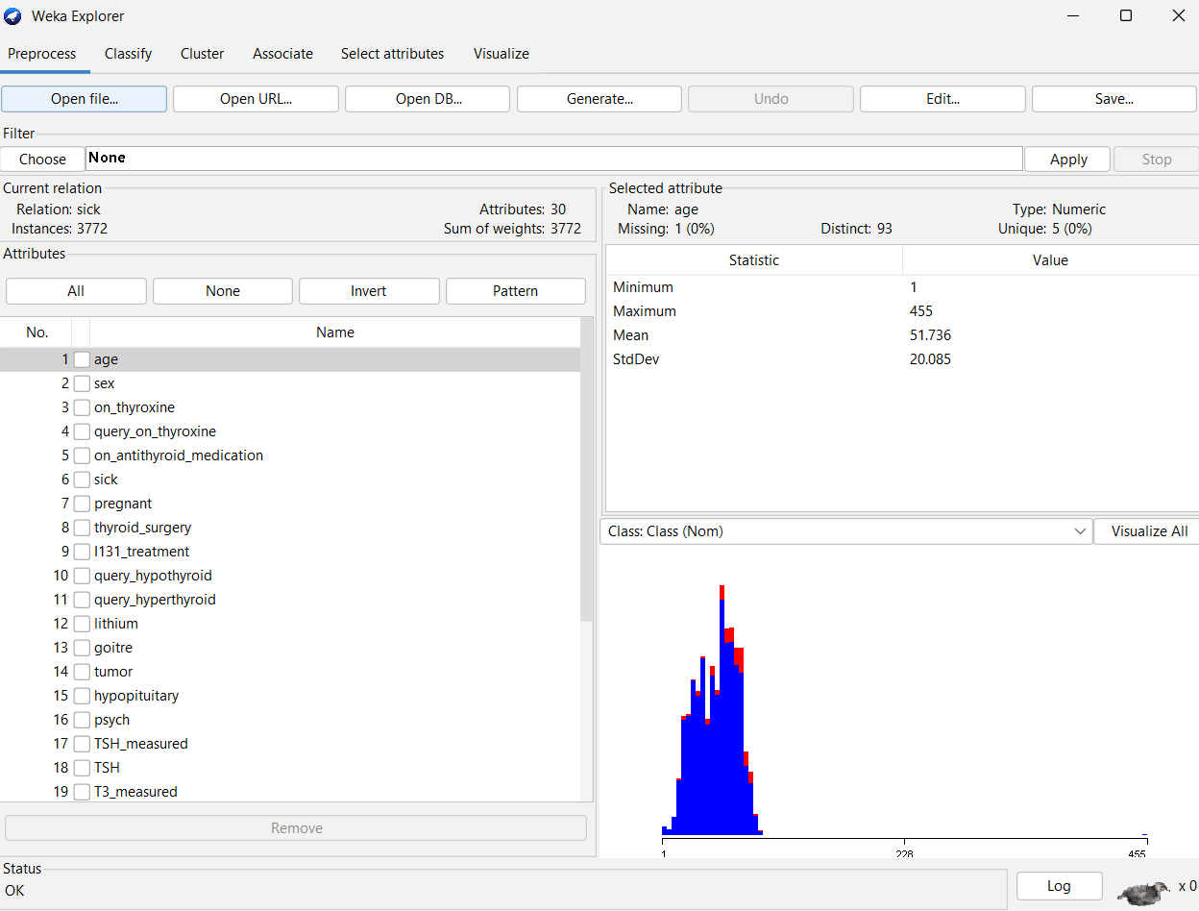

**2. Apply the supervised discretization filter on different attributes.**

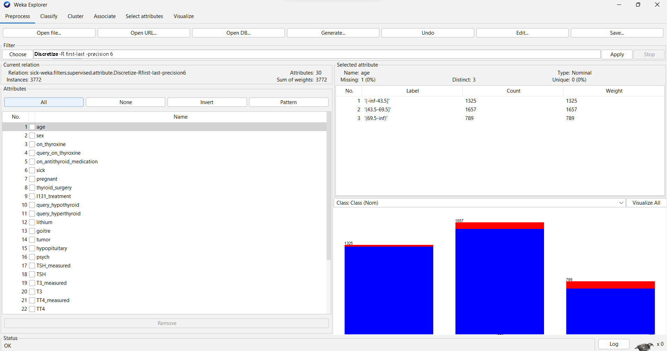

**3. What is the effect of this filter on the attributes?**

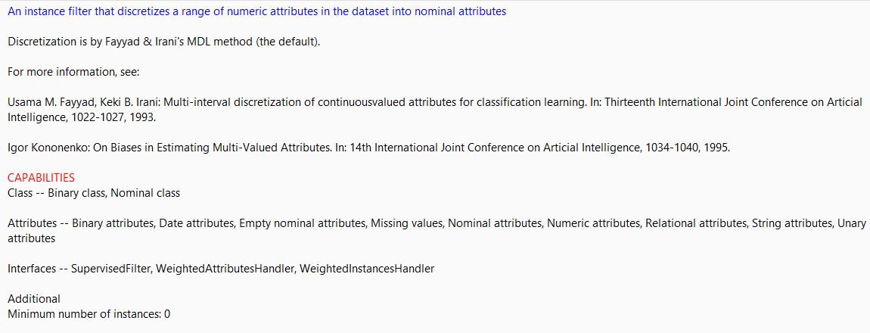

**4. How many distinct ranges have been created for each attribute?**

**-> 2**

**5. Undo the filter applied in the previous step.**

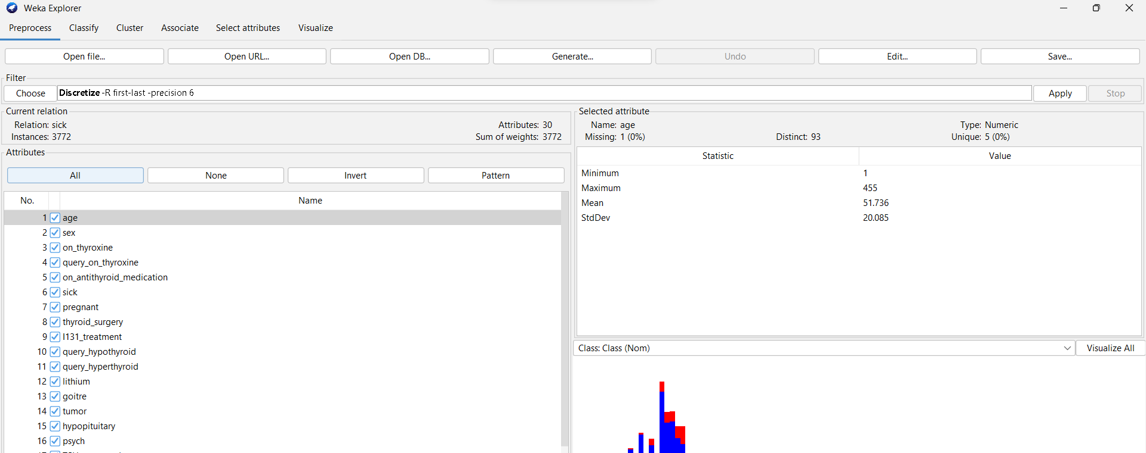

## 6. Apply the unsupervised discretization filter. Do this twice:

**1. In this step, set bins=5**

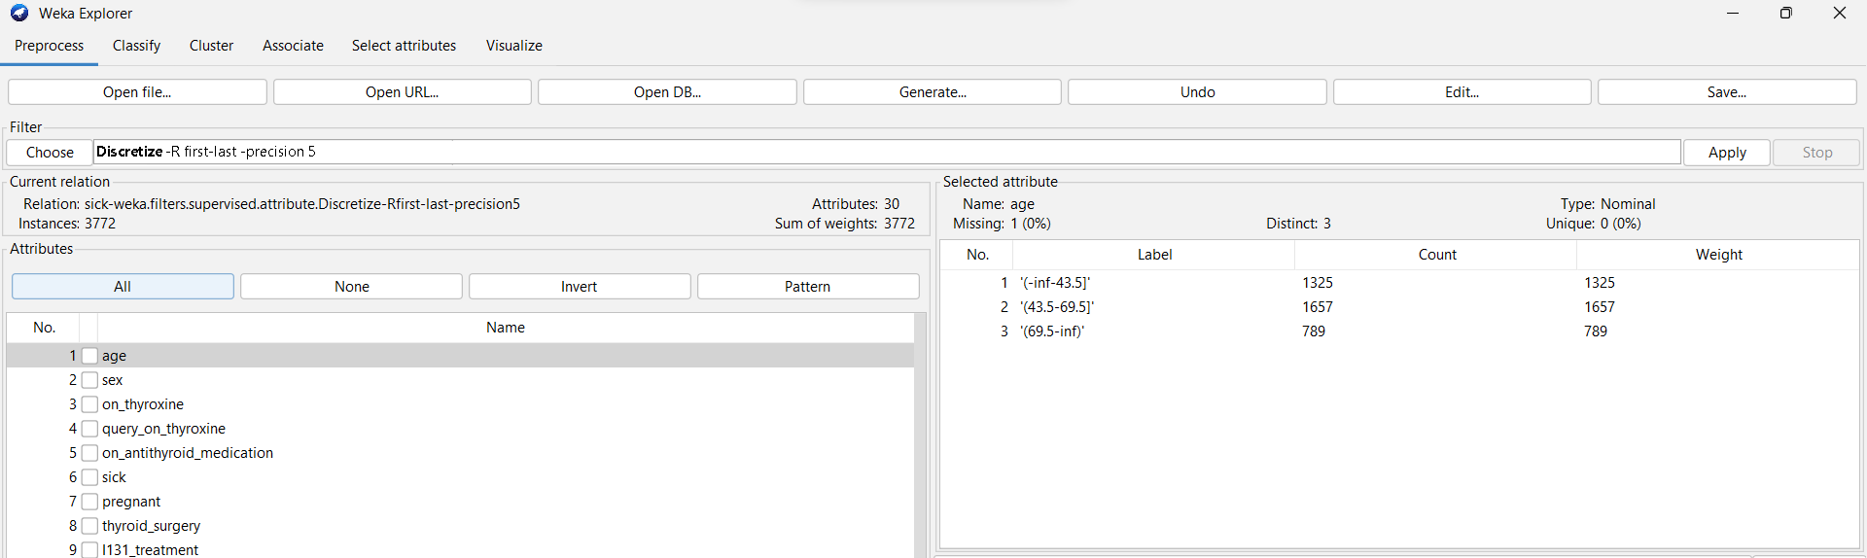

**2. In this step, set bins=10**

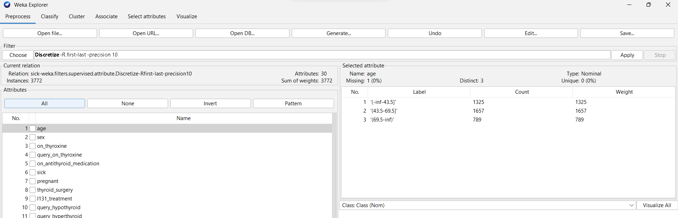

**3. What is the effect of the unsupervised filter on the dataset?**

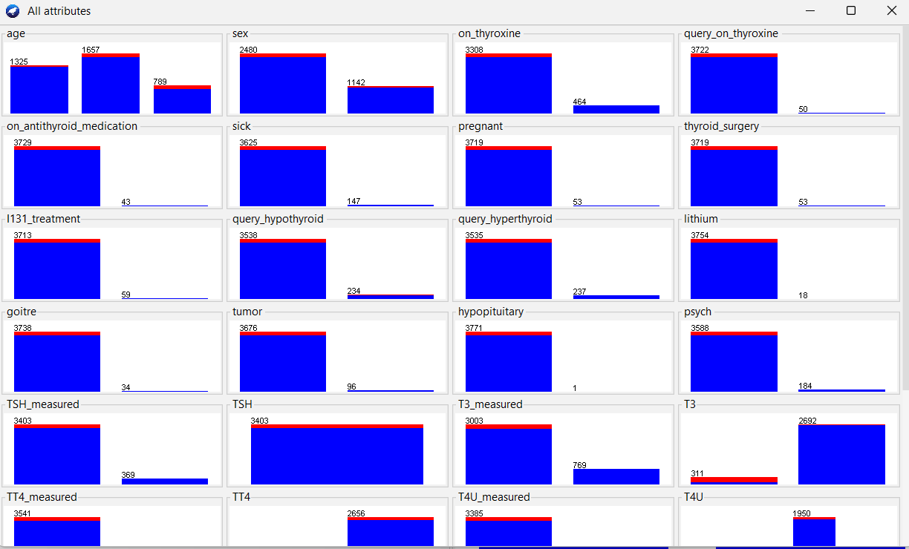

## 7. Run the the Naive Bayes classifier after apply the following filters

**1. Unsupervised discretized with bins=5**

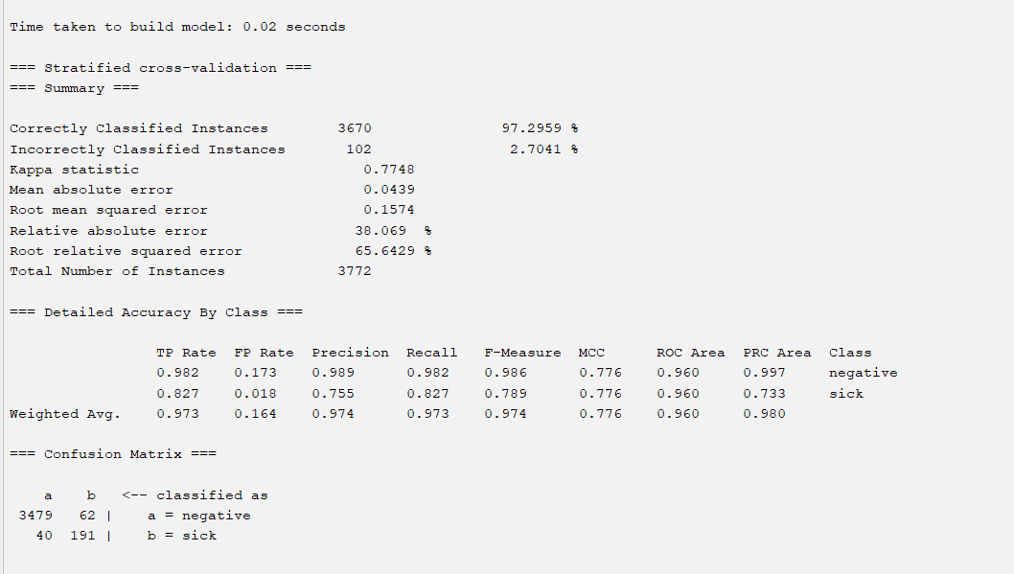

**2. Unsupervised discretized with bins =10**

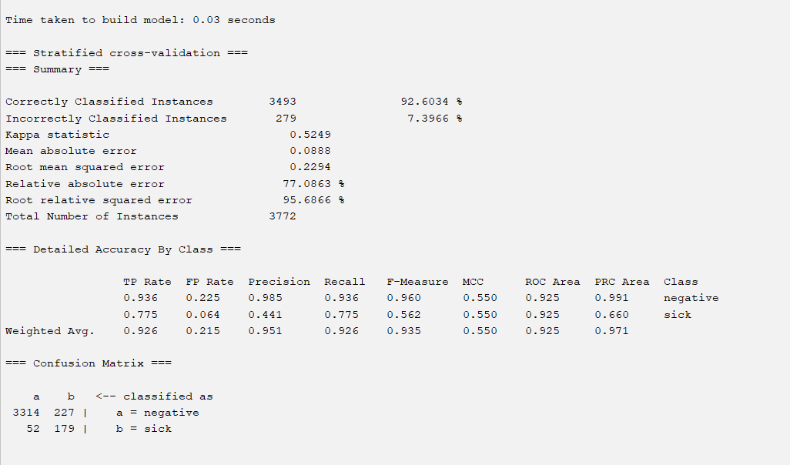

**3. Unsupervised discretized with bins=20.**

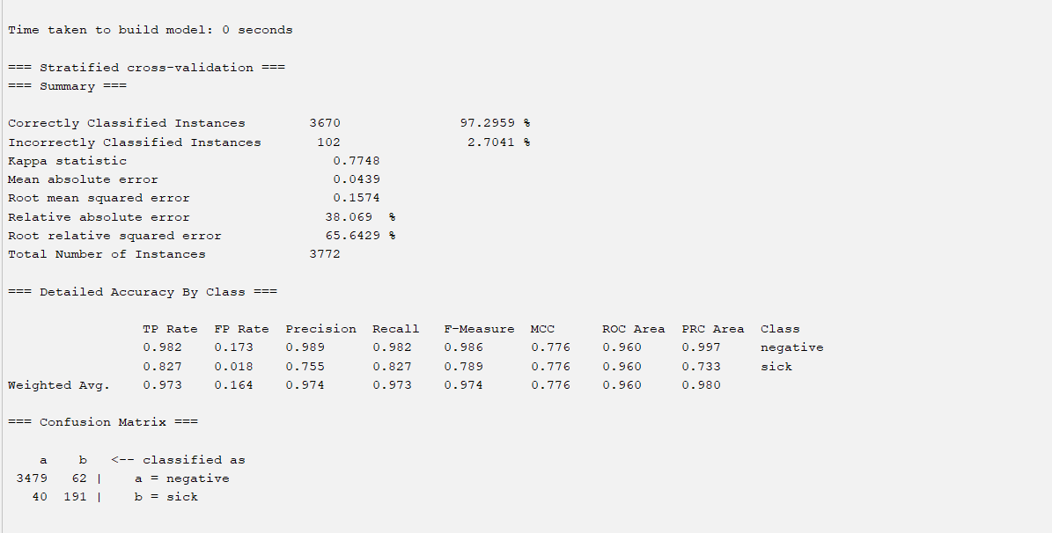

## 8. Compare the accuracy of the following cases

**1. Naive Bayes without discretization filters**

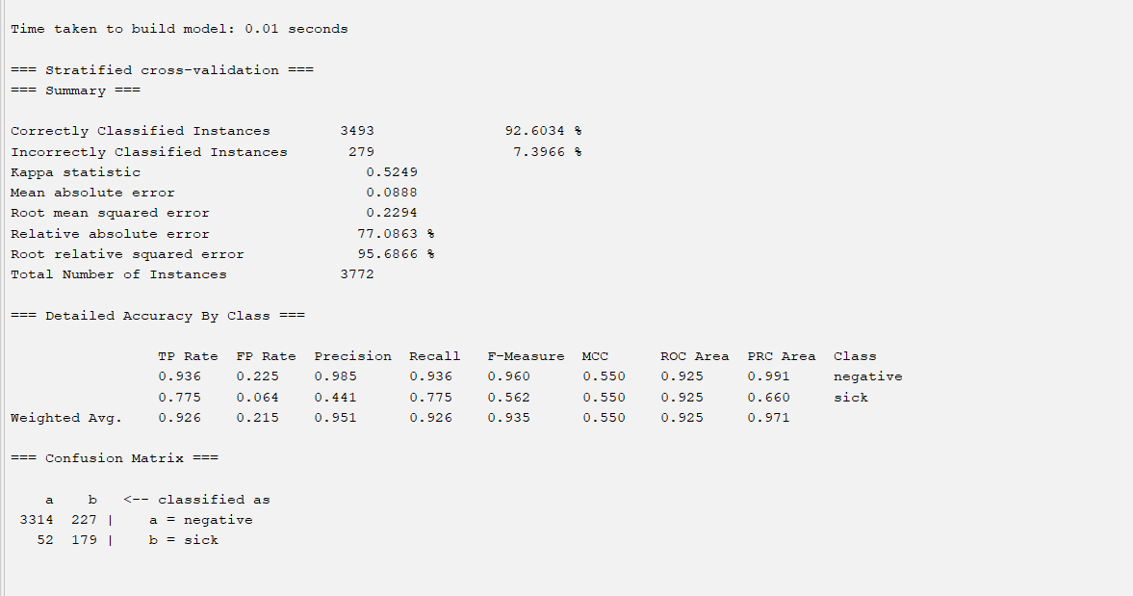

**2. Naive Bayes with a supervised discretization filter**



**3. Naive Bayes with an unsupervised discretization filter with different values for the bins attributes.**

**Bin = 10**



**Bin = 20**

