So Let’s start with our mini project :-

Step 1:-

-Create a virtual environment so your installed libraries will not get messed up with other local libraries

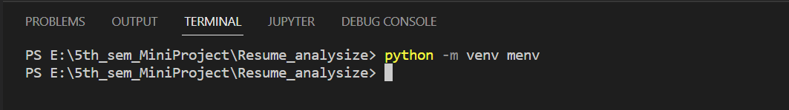

The command **python -m venv menv** created a virtual environment folder by name menv

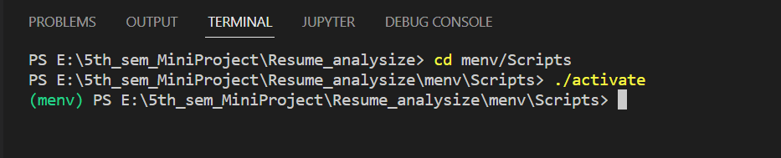

Go to the menv folder and let’s activate the environment to get start with our mini project

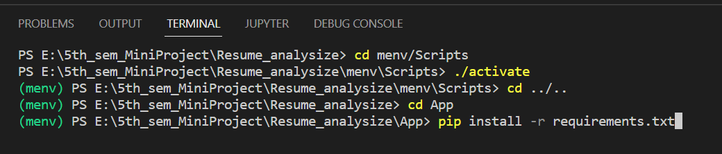

Now go to the App folder which we have created early which contains our main code, and install all the required libraries at once by the command **pip install -r requirements.txt**

After all libraries are installed let’s start with the code:-