**Group 51**

**Member Names: -**

1. **Student ID: - 101398578 Krishna Thakkar**
2. **Student ID: - 101410156 Pratham bavlawala**
3. **Student ID: - 101413772 Ishika Koshiya**
4. **Student ID: - 101413773 Nandani Kevadiya**

**GitHub repo Link: -** [**https://github.com/krishna0718/COMP3104_Group51_Assignment.git**](https://github.com/krishna0718/COMP3104_Group51_Assignment.git)

**Local repo setup**

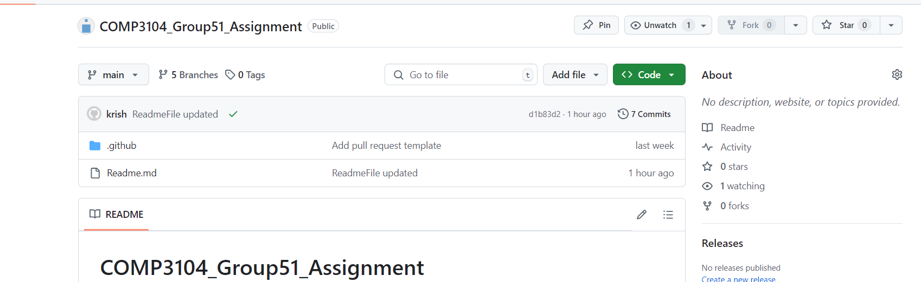

**Git commit history :**

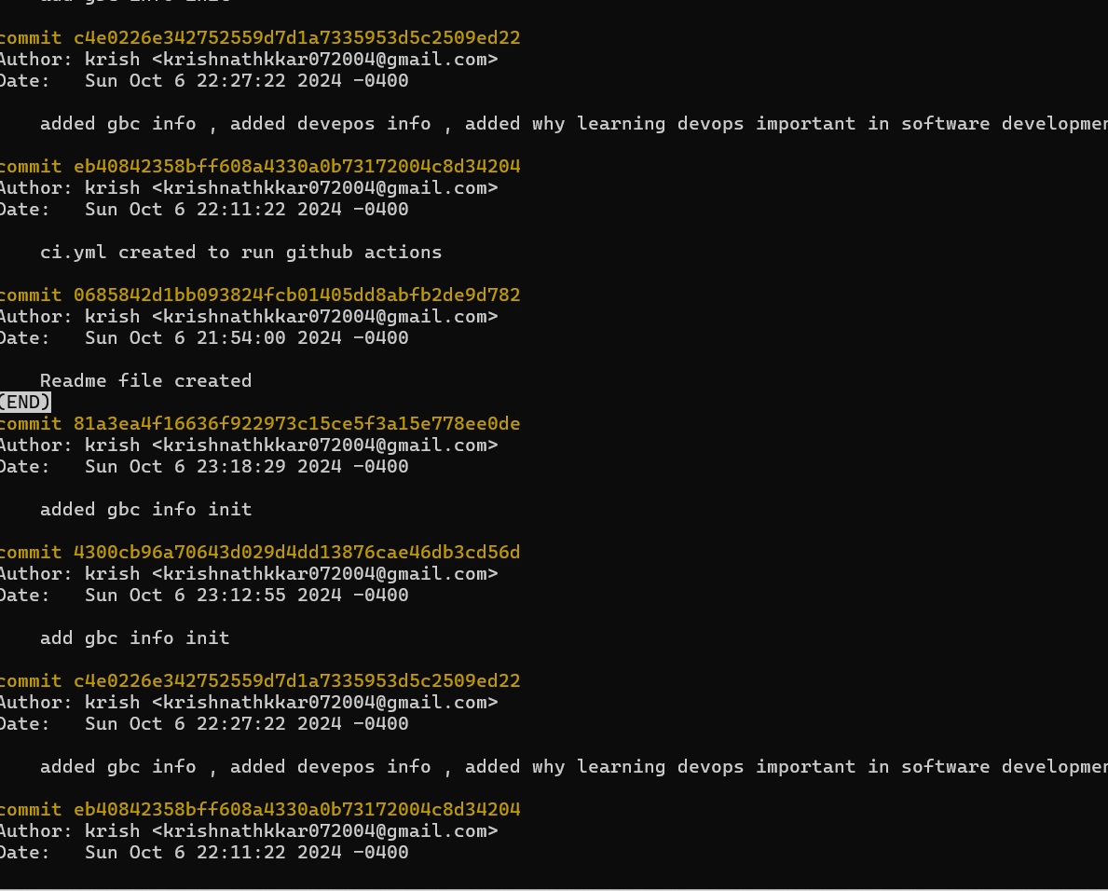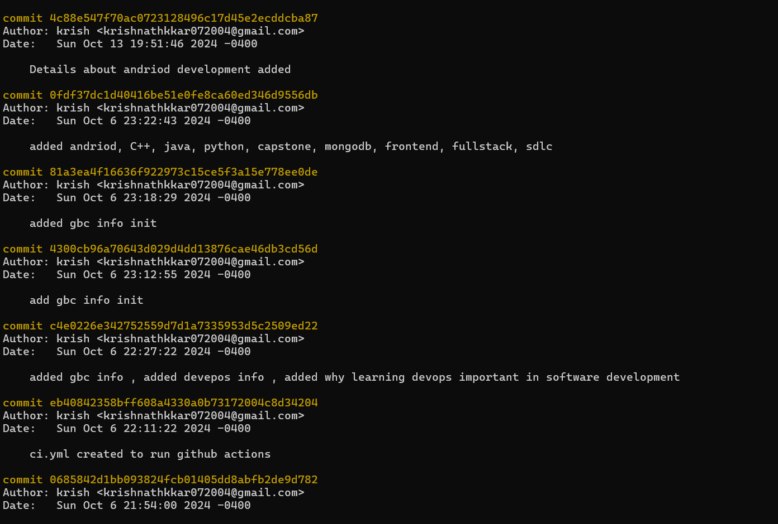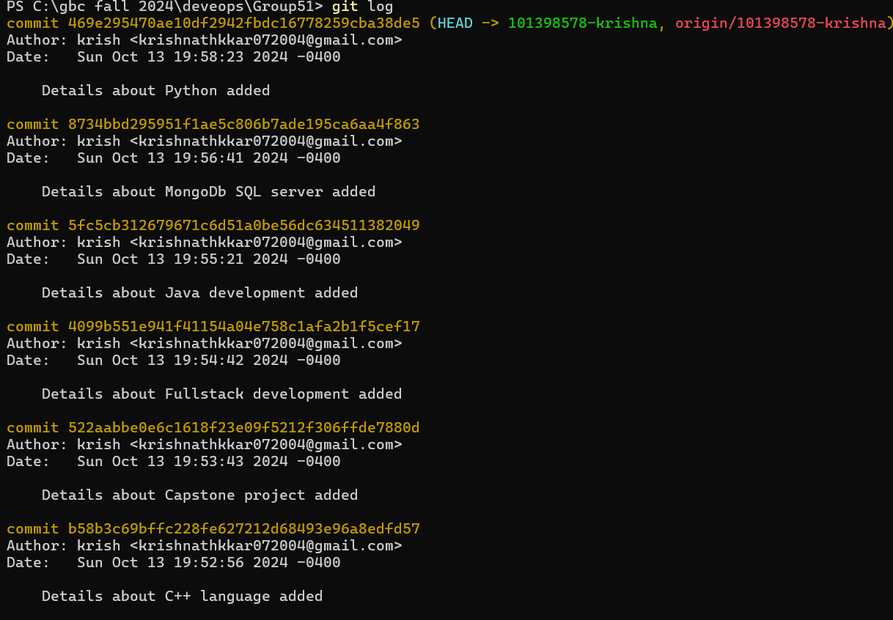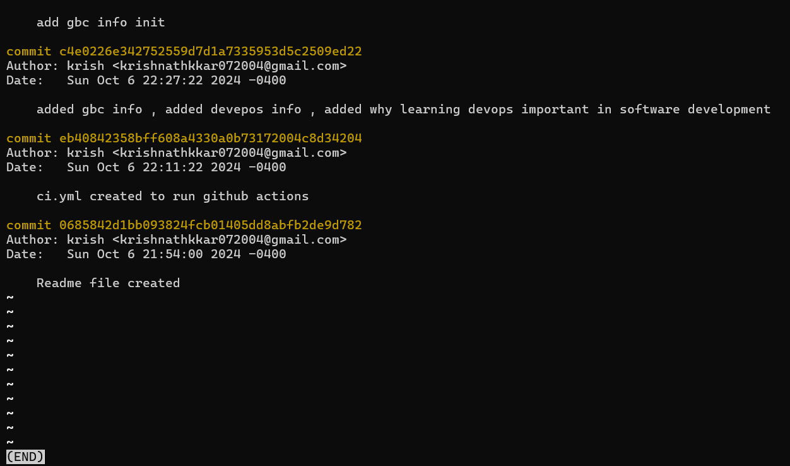

**Branch Structure:-**

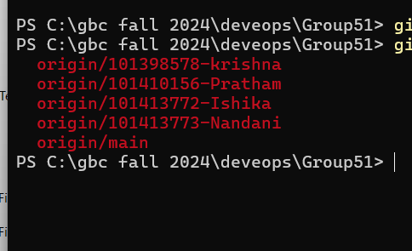

**CI pipeline Status: -**

**Pull template and readme template : -**

