SOFTWARE REQUIREMENTS SPECIFICATION
PowerFit Gym Management System
"Train Hard • Stay Strong • Stay Healthy"
Document Type: Software Requirements Specification (SRS)
IEEE 830 – Inspired Format
Version 1.0
Project Name | PowerFit Gym Management System
Technology | Java EE | JSP | Servlets | MySQL | Apache Tomcat
Database | MySQL 8.x — gym_management
IDE | NetBeans IDE
Prepared By | Krishna Tak
Academic Year | 2025 – 2026
Date | July 2026

Table of Contents
1. Introduction 4
1.1 Purpose 4
1.2 Scope 4
1.3 Definitions, Acronyms and Abbreviations 4
1.4 References 4
1.5 Document Overview 5
2. Overall Description 6
2.1 Product Perspective 6
2.2 Product Functions 6
2.3 User Classes and Characteristics 6
2.4 Operating Environment 7
2.5 Design and Implementation Constraints 7
2.6 Assumptions and Dependencies 7
3. Functional Requirements 8
3.1 Home Page (index.jsp) 8
3.2 Member Registration (register.jsp) 8
3.3 Member Login (login.jsp) 8
3.4 Forgot Password (forgotpassword.jsp) 9
3.5 Member Dashboard (member/dashboard.jsp) 9
3.6 My Profile (member/profile.jsp) 9
3.7 Edit Profile (member/editprofile.jsp) 9
3.8 BMI Calculator (member/bmi.jsp) 9
3.9 Attendance Tracker (member/attendance.jsp) 10
3.10 Workout Plans (member/workout.jsp) 10
3.11 Admin Dashboard (admindashboard.jsp) 10
3.12 Admin Login (adminlogin.jsp) 11
3.13 About Page (about.jsp) 11
4. External Interface Requirements 12
4.1 User Interfaces 12
4.2 Hardware Interfaces 12
4.3 Software Interfaces 12
4.4 Communication Interfaces 12
5. Non-Functional Requirements 13
5.1 Security Requirements 13
5.2 Performance Requirements 13
5.3 Reliability and Availability 13
5.4 Usability 13
5.5 Maintainability 13
6. System Models 14
6.1 Data Flow Diagram — Level 0 (Context Diagram) 14
6.2 Data Flow Diagram — Level 1 (Process Decomposition) 14
6.3 Entity-Relationship Diagram 15
6.4 Database Schema — Table Descriptions 15
7. Conclusion and Future Scope 17

1. Introduction

1.1 Purpose
This Software Requirements Specification (SRS) document describes the functional and non-functional requirements for the PowerFit Gym Management System, a full-stack web application built using Java Server Pages (JSP), Java EE Servlets, MySQL, and Apache Tomcat. The purpose of this document is to provide a complete and unambiguous reference of what the system must do, for use by developers, project evaluators, and academic reviewers. It defines system scope, actors, functional requirements per module, data models, data flow diagrams, and quality attributes the delivered system must satisfy.

1.2 Scope
The PowerFit Gym Management System digitises the day-to-day operations of a fitness centre, replacing manual, paper-based record keeping. The system supports two user roles — Member and Admin — and provides the following broad capabilities:
- Self-service member registration with automatic plan assignment and expiry-date computation.
- Secure, session-based authentication for both members and administrators.
- A member dashboard offering profile management, BMI calculation, daily attendance tracking, and BMI-based personalised workout plans.
- An administrator console for member oversight, membership-plan management, and analytics.
- Email-based password recovery through the JavaMail API (SMTP).
- AES-128 password encryption and SQL-injection-safe database access via PreparedStatement.
Out of scope for the current release: online payment processing, mobile applications, trainer assignment workflows, and multi-branch / multi-tenant operation. These items are captured under Future Scope (Section 7).

1.3 Definitions, Acronyms and Abbreviations
Term | Description
SRS | Software Requirements Specification
JSP | JavaServer Pages — server-side view technology used for rendering dynamic HTML
JDBC | Java Database Connectivity — API used to connect Java applications to MySQL
BMI | Body Mass Index — weight-to-height ratio used as a general health indicator
AES | Advanced Encryption Standard — symmetric encryption algorithm (128-bit key used here)
DFD | Data Flow Diagram — graphical representation of data movement through a system
ER Diagram | Entity-Relationship Diagram — graphical representation of the database schema
SMTP | Simple Mail Transfer Protocol — used for outbound password-recovery email
PK / FK | Primary Key / Foreign Key
MVC | Model-View-Controller architectural pattern

1.4 References
- PowerFit Gym Management System — Project Documentation Report, Krishna Tak, July 2026.
- IEEE Std 830-1998 — IEEE Recommended Practice for Software Requirements Specifications.
- Oracle Java EE 8 / Jakarta EE Specification — JSP and Servlet technology.
- MySQL 8.x Reference Manual.
- Apache Tomcat 10.x Documentation.

1.5 Document Overview
Section 2 describes the overall product context, actors, and constraints. Section 3 enumerates detailed functional requirements grouped by module. Section 4 specifies external interface requirements. Section 5 defines non-functional requirements. Section 6 presents the system models — data flow diagrams, the entity-relationship diagram, and the database schema. Section 7 lists conclusions and future scope.

2. Overall Description

2.1 Product Perspective
The PowerFit Gym Management System is a new, self-contained web application. It follows a three-tier, MVC-inspired architecture native to the JSP/Servlet model: a Presentation Layer of JSP pages, a Business/Logic Layer of embedded Java scriptlets handling encryption, validation and computation, and a Data Layer backed by a MySQL 8.x relational database. The system is deployed on an Apache Tomcat 10.x application server and accessed through any standard web browser.
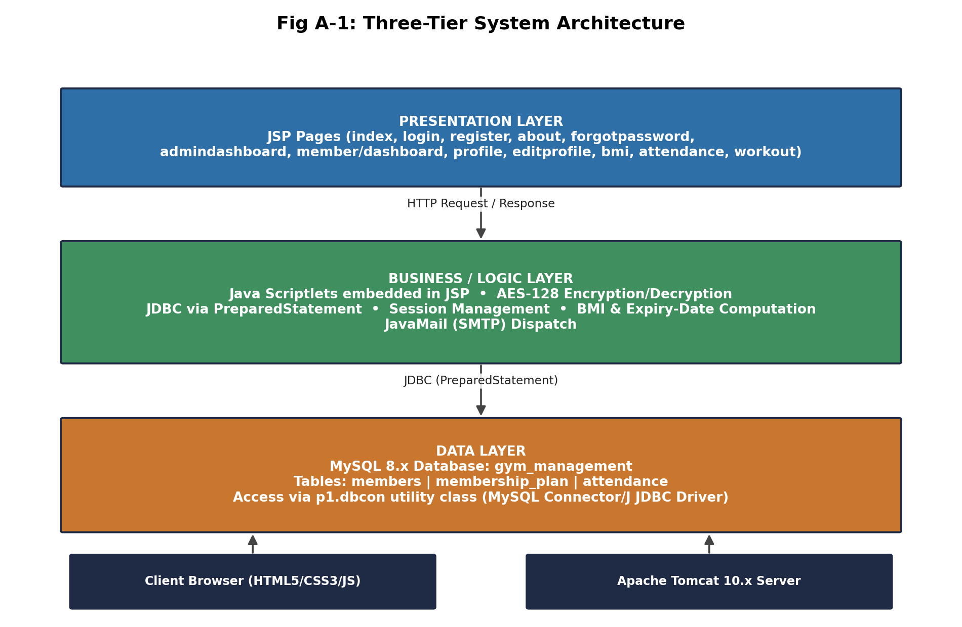
Fig 2-1: Three-Tier System Architecture

2.2 Product Functions
At a high level, the system provides the following major functions:
- Public informational pages: Home and About, presenting gym features and membership plans.
- Member registration, login, and AES-secured credential storage.
- Email-based forgotten-password recovery.
- Member dashboard summarising plan status, BMI, and quick navigation.
- Profile viewing and editing (contact details, height, weight).
- Real-time BMI calculation with health-category classification and persistence.
- Daily attendance check-in with duplicate-entry prevention and history/consistency reporting.
- BMI-driven workout plan recommendation across three tracks (Beginner, Muscle Building, Fat Loss).
- Administrator login, member directory with search/filter/delete, and membership-plan management with analytics cards.

2.3 User Classes and Characteristics
User Class | Description | Technical Expertise
Guest / Visitor | Unauthenticated visitor browsing the Home and About pages prior to registration. | None required
Member | Registered gym member who logs in to track fitness data, attendance, and workouts. | Basic web/browser familiarity
Administrator | Gym staff responsible for member oversight and membership-plan configuration. | Basic web/browser familiarity

2.4 Operating Environment
- Server: Apache Tomcat 10.x Java EE application server.
- Database Server: MySQL 8.x, default host localhost:3306.
- Development IDE: NetBeans IDE with standard Java EE web-project layout.
- Client: Any modern desktop or mobile web browser with JavaScript enabled (Chrome, Edge, Firefox, Safari).
- Build Tool: Apache Ant (build.xml) for compilation and WAR packaging.

2.5 Design and Implementation Constraints
- Must be implemented using JSP/Servlet technology per the academic project brief — no external MVC framework (e.g., Spring) is used.
- Database access is restricted to JDBC via the com.mysql.cj.jdbc.Driver through a shared dbcon utility class.
- Passwords must be encrypted with AES-128 before persistence; plain-text password storage is prohibited.
- SSL is disabled for the local-development MySQL connection; production deployment would require enabling SSL/TLS.
- All SQL access must use PreparedStatement to eliminate SQL-injection risk.

2.6 Assumptions and Dependencies
- A working SMTP account/relay is available for the JavaMail-based password-recovery feature.
- Each member registers with a unique email address, which is used as the login identifier.
- The host machine's system clock is accurate, since join/expiry dates and attendance dates depend on it.
- Only one active plan is associated with a member at any given time.

3. Functional Requirements
This section specifies the functional requirements of the system, organised by module. Each requirement is uniquely identified for traceability.

3.1 Home Page (index.jsp)
Public-facing landing page presenting the gym's hero banner, feature highlights, and membership-plan cards (Basic ₹999, Standard ₹1499, Premium ₹2499), with navigation to Register and About.
Req. ID | Requirement Description
FR-1.1 | The system shall display a public home page with hero content and gym feature highlights without requiring login.
FR-1.2 | The system shall display all available membership plans with pricing on the home page.
FR-1.3 | The system shall provide navigation links to the Registration and About pages.

3.2 Member Registration (register.jsp)
Collects personal and fitness details plus plan selection, performing client- and server-side validation before creating a new member record.
Req. ID | Requirement Description
FR-2.1 | The system shall auto-calculate member age from the entered date of birth.
FR-2.2 | The system shall display a real-time password-strength indicator during registration.
FR-2.3 | The system shall encrypt the member's password using AES-128 before storing it in the database.
FR-2.4 | The system shall reject registration if the entered email already exists in the members table.
FR-2.5 | The system shall automatically compute the membership expiry date based on the selected plan duration (1 / 3 / 12 months) from the join date.
FR-2.6 | The system shall validate age (16–70), mobile number format, and password complexity before submission.

3.3 Member Login (login.jsp)
Authenticates members by comparing AES-encrypted password values and establishes an HTTP session on success.
Req. ID | Requirement Description
FR-3.1 | The system shall authenticate a member by matching the AES-encrypted password against the stored value for the given email.
FR-3.2 | On successful login, the system shall create an HTTP session containing member_id, name, email, plan_id, join_date, and expiry_date.
FR-3.3 | The system shall provide a show/hide toggle for the password field.
FR-3.4 | The system shall allow login submission via the Enter key in addition to the Login button.
FR-3.5 | The system shall redirect an authenticated member to the Member Dashboard.

3.4 Forgot Password (forgotpassword.jsp)
Provides email-based account recovery by generating and dispatching a new random password.
Req. ID | Requirement Description
FR-4.1 | The system shall generate a random 8-character password when a valid registered email is submitted.
FR-4.2 | The system shall AES-encrypt the newly generated password and update the member's database record.
FR-4.3 | The system shall send the plain-text new password to the member's registered email address via SMTP (JavaMail API).

3.5 Member Dashboard (member/dashboard.jsp)
Session-protected landing page shown immediately after login, summarising key member data.
Req. ID | Requirement Description
FR-5.1 | The system shall restrict access to the dashboard to sessions containing a valid member_id attribute.
FR-5.2 | The system shall display the member's current BMI, plan, and membership status (Active/Expired) on the dashboard.
FR-5.3 | The system shall present a full details table and navigation shortcuts to Profile, Edit Profile, BMI Calculator, Attendance, Workout Plans, and Logout.

3.6 My Profile (member/profile.jsp)
Displays the member's full profile including personal information, health statistics, and current plan.
Req. ID | Requirement Description
FR-6.1 | The system shall display the member's personal information: name, gender, date of birth, age, and address.
FR-6.2 | The system shall display health statistics: height, weight, and current BMI.
FR-6.3 | The system shall display the current plan with join date, expiry date, and an Active/Expired status badge.

3.7 Edit Profile (member/editprofile.jsp)
Allows a member to update selected profile fields.
Req. ID | Requirement Description
FR-7.1 | The system shall allow a logged-in member to update mobile number, address, height, and weight.
FR-7.2 | The system shall persist profile updates via a parameterised SQL UPDATE statement.
FR-7.3 | The system shall redirect to the Profile page with a success confirmation after a successful update.

3.8 BMI Calculator (member/bmi.jsp)
Calculates BMI in real time from height and weight and classifies the result into a health category.
Req. ID | Requirement Description
FR-8.1 | The system shall calculate BMI in real time on the client side as height and weight are entered.
FR-8.2 | The system shall classify the computed BMI into Underweight, Normal, Overweight, or Obese, with a colour-coded gauge.
FR-8.3 | The system shall display a personalised recommendation message based on the BMI category.
FR-8.4 | The system shall allow the member to save the computed BMI (and underlying height/weight) to their profile.

3.9 Attendance Tracker (member/attendance.jsp)
Enables one-click daily gym check-in and displays attendance history and consistency metrics.
Req. ID | Requirement Description
FR-9.1 | The system shall allow a member to mark attendance for the current date with a single action.
FR-9.2 | The system shall enforce a database-level UNIQUE constraint on (member_id, attendance_date) to prevent duplicate check-ins on the same day.
FR-9.3 | The system shall display total days present and a monthly consistency percentage.
FR-9.4 | The system shall display a full attendance history table with date, check-in time, and status.

3.10 Workout Plans (member/workout.jsp)
Presents tabbed, BMI-driven workout plans with structured exercise cards.
Req. ID | Requirement Description
FR-10.1 | The system shall automatically recommend a workout track (Beginner, Muscle Building, or Fat Loss) based on the member's current BMI.
FR-10.2 | The system shall allow the member to switch between the three workout tabs regardless of the recommended default.
FR-10.3 | The system shall display each workout day as a card listing exercises, sets/reps, and duration or calorie information.

3.11 Admin Dashboard (admindashboard.jsp)
Administrator control panel for oversight of members and membership plans.
Req. ID | Requirement Description
FR-11.1 | The system shall restrict access to the admin dashboard to sessions containing a valid admin_user attribute.
FR-11.2 | The system shall display analytics cards for Total Members, Active Memberships, Expired Memberships, and total Membership Plans.
FR-11.3 | The system shall display a searchable/filterable table of all registered members with a delete action per row.
FR-11.4 | The system shall display a table of available membership plans and provide a form to create a new plan (name, price, duration).

3.12 Admin Login (adminlogin.jsp)
Dedicated authentication entry point for administrators.
Req. ID | Requirement Description
FR-12.1 | The system shall provide a login form separate from the member login for administrator credentials.
FR-12.2 | On successful authentication, the system shall create an admin_user session attribute and redirect to the Admin Dashboard.

3.13 About Page (about.jsp)
Public informational page describing the gym, its mission/vision, and facilities.
Req. ID | Requirement Description
FR-13.1 | The system shall display gym information, mission/vision statements, a facilities grid, and a call-to-action section without requiring login.

4. External Interface Requirements

4.1 User Interfaces
- A responsive, dark-themed web UI built with HTML5, custom CSS3, and JavaScript ES6+, using Font Awesome 6.5 icons.
- Distinct navigation contexts for public pages, the member area, and the admin area, each with role-appropriate menus.
- Form-level client-side validation with inline feedback (e.g., password-strength meter, real-time BMI gauge).

4.2 Hardware Interfaces
- No specialised hardware is required; the system runs on standard server hardware capable of hosting Apache Tomcat and MySQL, and is accessed from any client device with a modern web browser.

4.3 Software Interfaces
Component | Interface Detail
Database | MySQL 8.x via MySQL Connector/J (com.mysql.cj.jdbc.Driver), accessed through the p1.dbcon utility class.
Mail Service | JavaMail API over SMTP (Emailclass.java) for password-recovery email dispatch.
Application Server | Apache Tomcat 10.x, hosting the compiled WAR package.
Build System | Apache Ant (build.xml) for compilation and packaging.

4.4 Communication Interfaces
- HTTP/HTTPS for all client-server communication between the browser and Apache Tomcat.
- SMTP for outbound password-recovery emails.

5. Non-Functional Requirements

5.1 Security Requirements
Req. ID | Requirement
NFR-SEC-1 | All member passwords shall be encrypted using AES-128 (ECB mode, 16-byte key, Base64-encoded) before storage; plain-text passwords shall never be persisted.
NFR-SEC-2 | All member-area pages shall verify the member_id session attribute; all admin-area pages shall verify the admin_user session attribute. Unauthorised access shall redirect to the appropriate login page.
NFR-SEC-3 | All database queries shall use java.sql.PreparedStatement with parameterised inputs to prevent SQL injection.
NFR-SEC-4 | The registration process shall verify email uniqueness before creating a new member record.
NFR-SEC-5 | Client-side validation shall enforce age (16–70), mobile format (6–9 prefix, 10 digits), and password complexity (minimum 8 characters with uppercase, lowercase, digit, and special character).
NFR-SEC-6 | Password-recovery shall generate a cryptographically random 8-character password and never expose the previous password.
NFR-SEC-7 | The attendance table shall enforce a UNIQUE(member_id, attendance_date) constraint at the database level.

5.2 Performance Requirements
- Standard page interactions (login, dashboard load, BMI calculation) should complete within 2–3 seconds under normal load on the target Tomcat deployment.
- BMI calculation shall be performed client-side in JavaScript for instantaneous feedback.

5.3 Reliability and Availability
- The system shall prevent duplicate attendance entries per member per day through database-enforced uniqueness rather than relying solely on application logic.
- Database transactions for registration, profile updates, and plan creation shall use parameterised statements to avoid partial or malformed writes.

5.4 Usability
- The UI shall provide a consistent dark theme with colour-coded status indicators (Active/Expired badges, BMI gauge colours).
- Forms shall provide real-time, inline validation feedback rather than only on submission.

5.5 Maintainability
- Database access shall be centralised through a single dbcon utility class to simplify configuration changes.
- The project shall be organised as a standard NetBeans Java EE web project and version-controlled with Git.

6. System Models

6.1 Data Flow Diagram — Level 0 (Context Diagram)
The context diagram represents the entire system as a single process, surrounded by three external entities: Member/Guest, Admin, and the Email System (SMTP). It captures all high-level data flows entering and leaving the system.
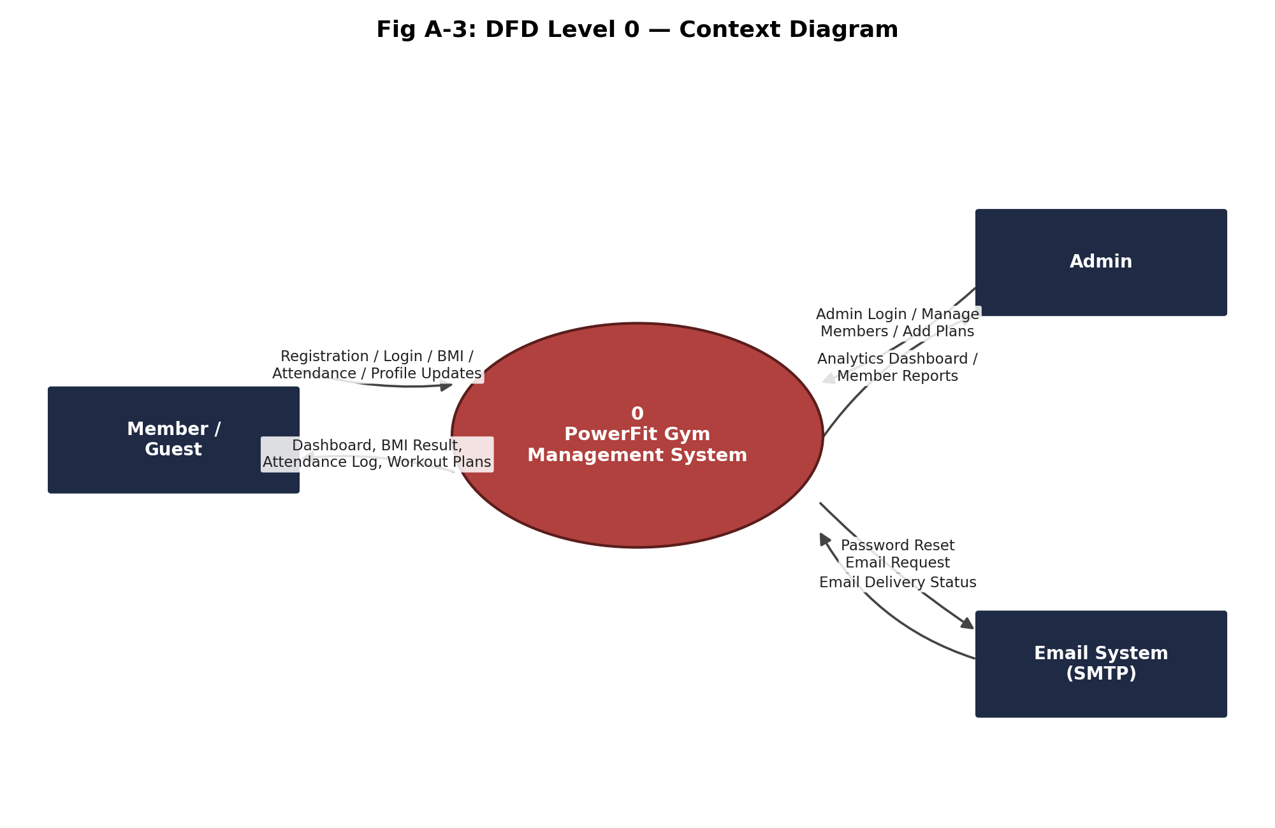
Fig 6-1: DFD Level 0 — Context Diagram

6.2 Data Flow Diagram — Level 1 (Process Decomposition)
The Level 1 DFD decomposes the system into seven sub-processes: 1.0 User Registration, 2.0 User Authentication, 3.0 Admin Management, 4.0 Attendance Tracking, 5.0 BMI Calculation, 6.0 Password Recovery, and 7.0 Workout Plans. Three data stores support these processes: D1 (members table), D2 (membership_plan table), and D3 (attendance table).
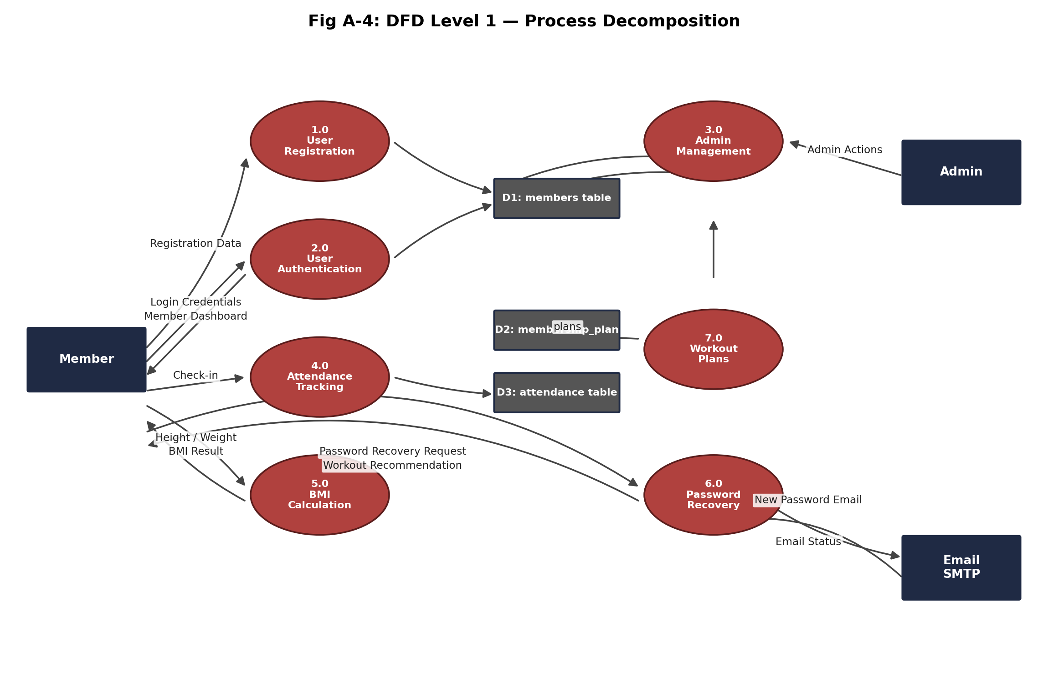
Fig 6-2: DFD Level 1 — Process Decomposition

6.3 Entity-Relationship Diagram
The database consists of three normalised entities. The members table is the central entity, linked to membership_plan via plan_id (many members to one plan) and to attendance via member_id (one member to many attendance records).
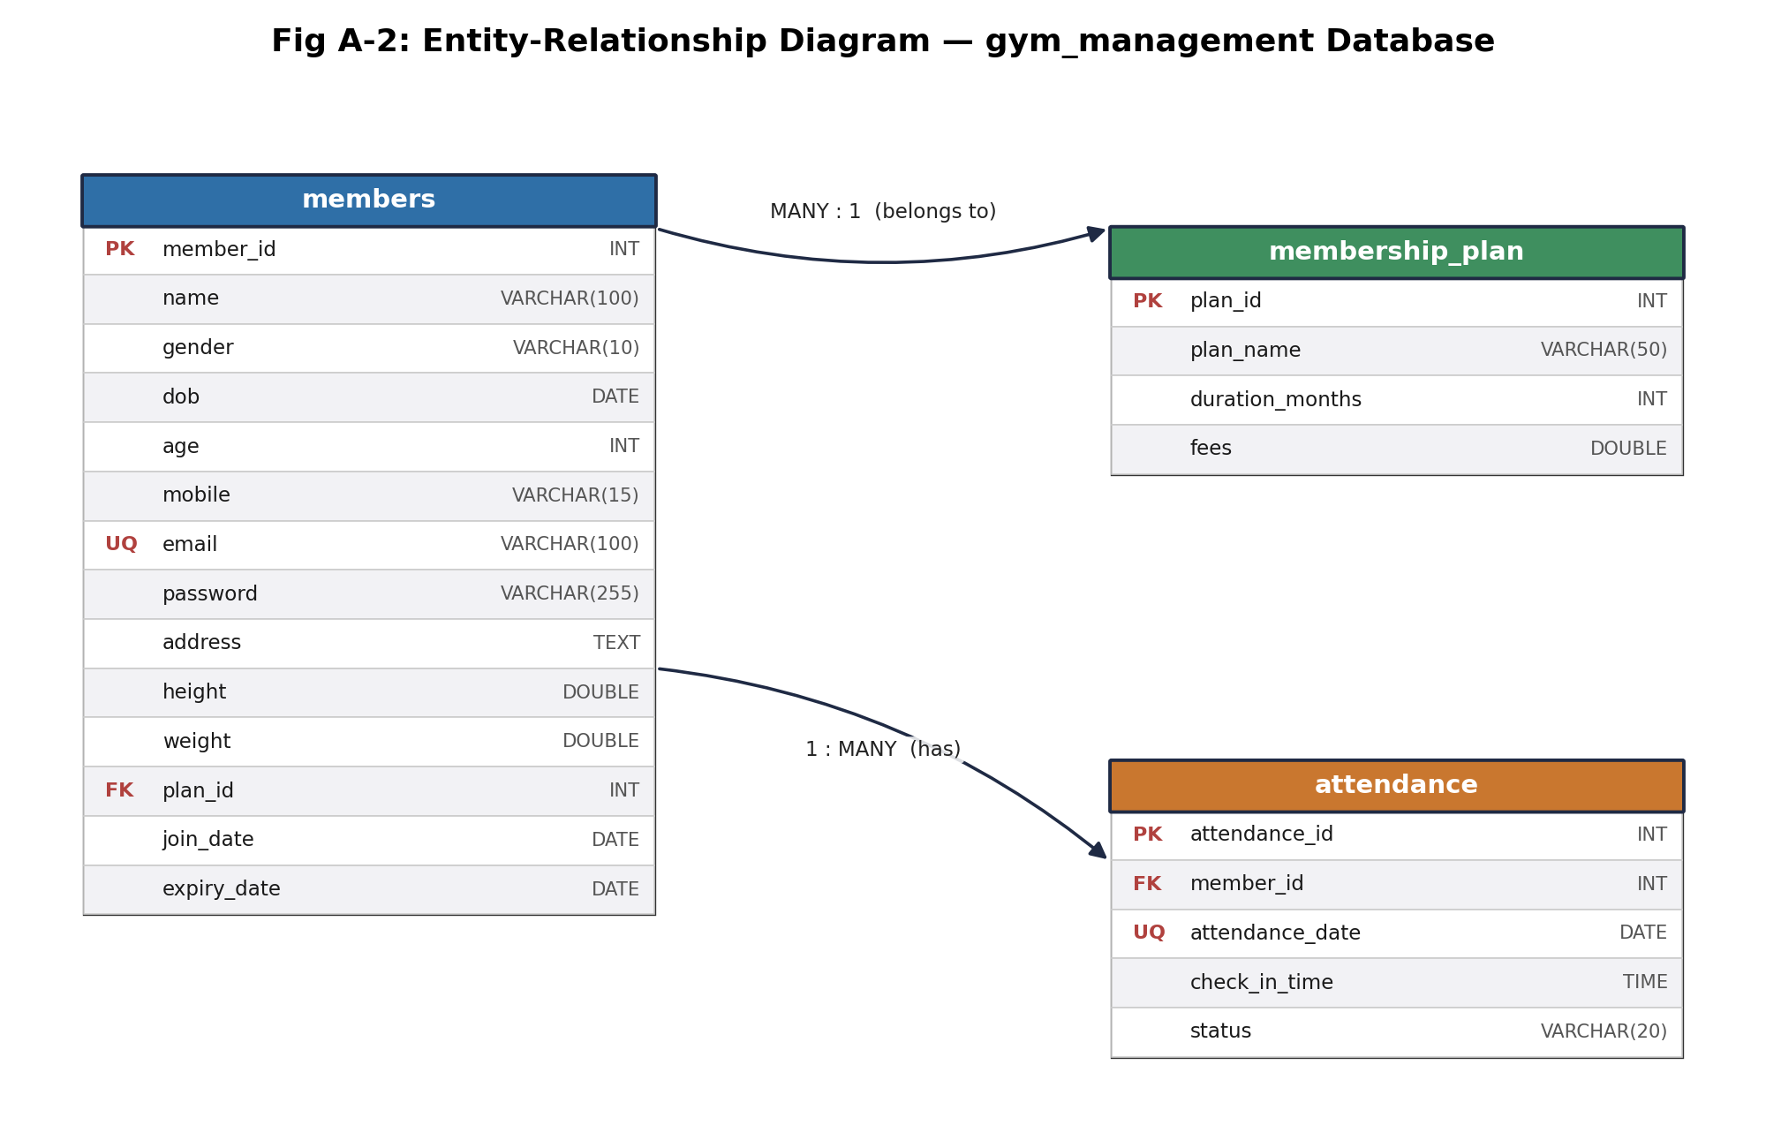
Fig 6-3: Entity-Relationship Diagram — gym_management Database

6.4 Database Schema — Table Descriptions

6.4.1 Table: members
Column | Data Type | Null | Key | Description
member_id | INT | NOT NULL | PK | Auto-increment primary key
name | VARCHAR(100) | NOT NULL |  | Full name of the member
gender | VARCHAR(10) | NOT NULL |  | Male / Female / Other
dob | DATE | NOT NULL |  | Date of birth
age | INT | NOT NULL |  | Age in years (calculated)
mobile | VARCHAR(15) | NOT NULL |  | 10-digit Indian mobile number
email | VARCHAR(100) | NOT NULL | UQ | Unique email — used for login
password | VARCHAR(255) | NOT NULL |  | AES-128 encrypted password
address | TEXT | YES |  | Residential address
height | DOUBLE | YES |  | Height in centimetres
weight | DOUBLE | YES |  | Weight in kilograms
plan_id | INT | YES | FK | References membership_plan.plan_id
join_date | DATE | YES |  | Membership start date
expiry_date | DATE | YES |  | Auto-calculated expiry date

6.4.2 Table: membership_plan
Column | Data Type | Null | Key | Description
plan_id | INT | NOT NULL | PK | Auto-increment primary key
plan_name | VARCHAR(50) | YES |  | e.g. Basic / Standard / Premium
duration_months | INT | YES |  | Plan duration in months
fees | DOUBLE | YES |  | Plan fees in Indian Rupees

6.4.3 Table: attendance
Column | Data Type | Null | Key | Description
attendance_id | INT | NOT NULL | PK | Auto-increment primary key
member_id | INT | NOT NULL | FK | References members.member_id
attendance_date | DATE | NOT NULL | UQ | Part of UNIQUE(member_id, date)
check_in_time | TIME | YES |  | Time of gym check-in
status | VARCHAR(20) | YES |  | "Present" (expandable)

6.4.4 Relationships
- members.plan_id → membership_plan.plan_id — Many-to-One (many members may share one plan).
- attendance.member_id → members.member_id — One-to-Many (one member has many attendance records).
- UNIQUE KEY (member_id, attendance_date) on attendance prevents duplicate daily check-ins.

7. Conclusion and Future Scope

7.1 Conclusion
This SRS defines the complete functional and non-functional requirement set for the PowerFit Gym Management System as implemented: a secure, three-tier JSP/Servlet web application backed by a normalised MySQL schema. The requirements captured here trace directly to the thirteen implemented modules, the AES-128 / PreparedStatement / session-based security model, and the three-entity data model documented in Section 6.

7.2 Future Scope
The following enhancements are identified as candidates for future releases and are explicitly out of scope for the current requirement set:
- Online payment integration (Razorpay / UPI) for membership fee collection.
- Native mobile application (Android / Flutter) for on-the-go member access.
- Trainer module — assignment of personal trainers and workout-progress notes.
- Diet and nutrition tracker with BMI-linked personalised meal plans.
- Advanced admin analytics — revenue charts and membership growth trends.
- Push notifications / SMS alerts for membership-expiry reminders.
- QR-code-based attendance check-in at the gym entrance.
- Role-based access control — Super Admin, Trainer, and Receptionist roles.
- Cloud deployment (AWS / Azure) with load balancing and auto-scaling.
- Two-factor authentication (2FA) for enhanced account security.

