SALES MANAGEMENT APPLICATION

MINI PROJECT REPORT

Submitted by

KRISHNA YADAV[Roll No. 68] BHOLA PRASAD CHILHATE[Roll No. 44]



Department of Computer Science & Engineering

Lakshmi Narain College of Technology, Bhopal (M.P.)

Session
2019

LAKSHMI NARAIN COLLEGE OF TECHNOLOGY, BHOPAL
DEPARTMENT OF COMPUTER SCIENCE & ENGINEERING

CERTIFICATE

This is to certify that the work embodied in this Mini Project work entitled ”SALES MANAGEMENT APPLICATION” has been satisfactorily completed by the KRISHNA YADAV (Roll No. 68), BHOLA PRASAD CHILHATE (Roll No. 44) . It is a bonafide piece of work, carried out under the guidance from Department of Computer Science & Engineering, Lakshmi Narain College of Technology, Bhopal for the partial fulfillment of the Bachelor of Technology during the academic year 2019.

Approved By

Prof. & Head

Department of Computer Science & Engineering

Contents

S. No. | TOPICS | No. of Pages
 | Introduction | 4
 | Objectives | 5
 | Requirements | 6
 | Proposed Method | 7
 | Future Scope | 8
 | Screenshots | 9-10
 | References | 11

CHAPTER 1
INTRODUCTION

This Project Introduces Sales Management System.
Our project helps shopkeepers in performing safe transactions and all the records are kept in an centralized environment on a PC using MySQL DBMS.
Our project have a window in which all the list of items are provided for purchasing any item for the customers which in turn shows total amount to be paid and produces a bill for the given transaction.
There is another window in which shopkeeper can import the items which are empty by selecting them from the list and similarly it provides total amount and keeps a record of imports in database.
The shopkeeper can also add new items to the database and then import the new item through the application.
He/ She can also edit the cost price and selling price to the new values and can also delete the items from the database if they are not required in the shop.
Also there is an interface to check the previous records of transactions in the application and also filter the records if there are a lot of bills and order records in the database by filtering by date or time or both date and time.
Hence the application can be used to manage all the records and transaction on a software and database and use it efficiently without the problem of losing the data.

CHAPTER 2
OBJECTIVES

- All the manual work needs to be computerized so that the load on the shopkeepers can be lessen.
- The database should be stored in a computer rather than a register or a manual.
- Easy storage and faster accessing of information.
- More reliable, accurate and faster transactions and record keeping.
- Centralized management , error reporting and decision support.
CHAPTER 3
REQUIREMENTS

- Hardware Requirements
- Processor : Pentium IV or above
- RAM : 1 GB (min)
- Monitor : Any colored monitor
- Software Requirements
- Latest java runtime environment installed.
- MySQL database installed on system.
CHAPTER 4
PROPOSED METHOD

- We used NETBEANS as application developing environment which is a GUI (Graphical User Interface) and MySQL as a Database Management System for managing the bills and orders for the application.
- Our app runs on java runtime environment for frontend of application and MySQL as backend for application.
- Our app uses latest versions of Java and MySQL version 8.
CHAPTER 5
FUTURE SCOPE

- Recently our application only available to work on desktop computers and must have MySQL to run this application.
- In future we can extend our application to meet the needs of big shop owners to manage the data in very efficient , fast and more reliable.
- We can also make our application available on different platforms such as on mobile phones running Android and iOS to make our app more handy and easy to use for the shop owners and customers, web app, website, etc.
- We can also make our application cloud compatible, means the data can be store and accessed from anywhere using cloud computing technology by using minimal specs and an internet connection.
CHAPTER 6
SCREENSHOTS

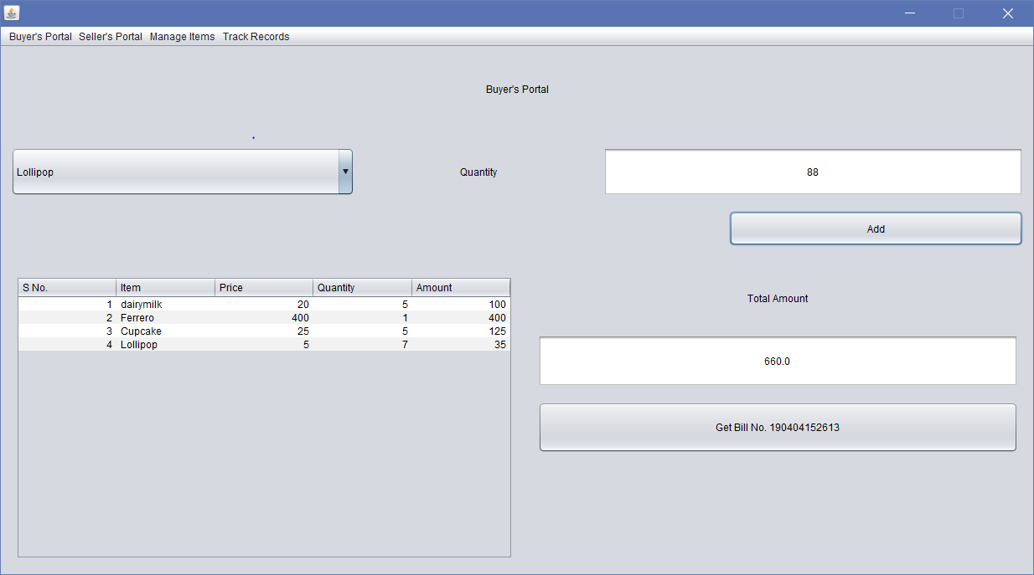
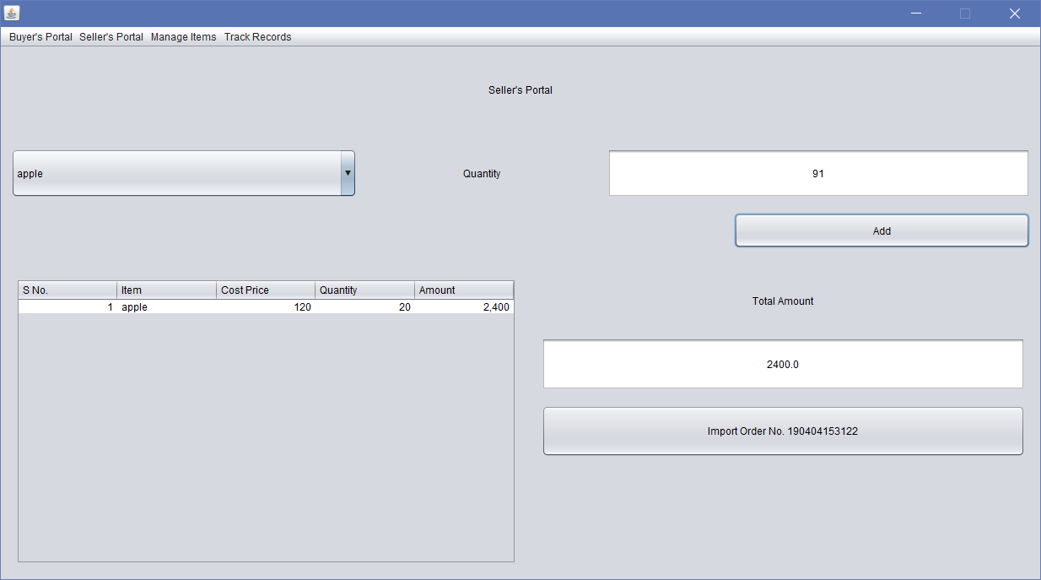
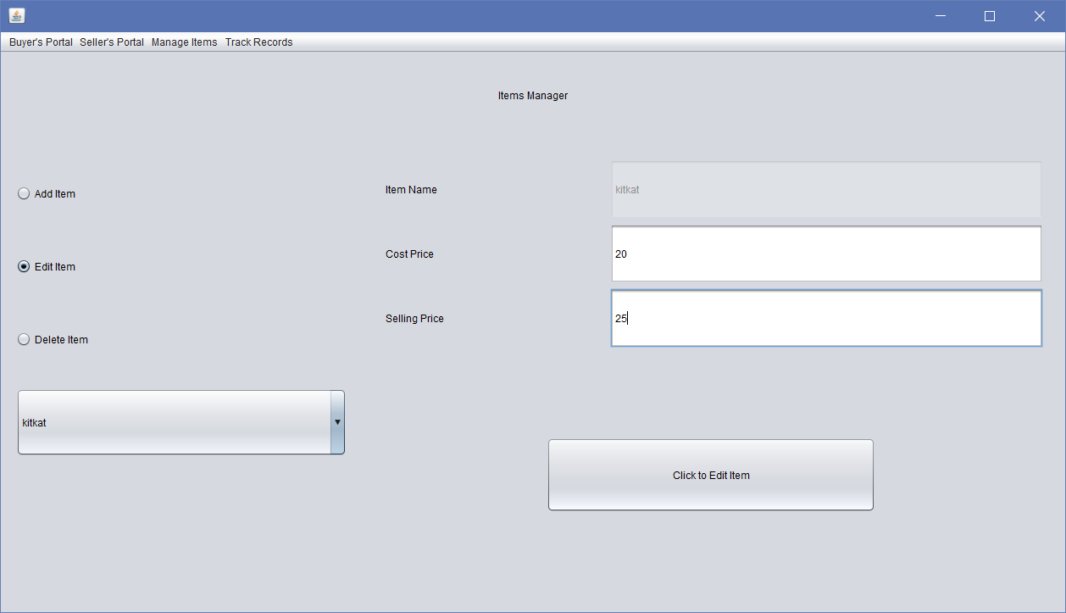
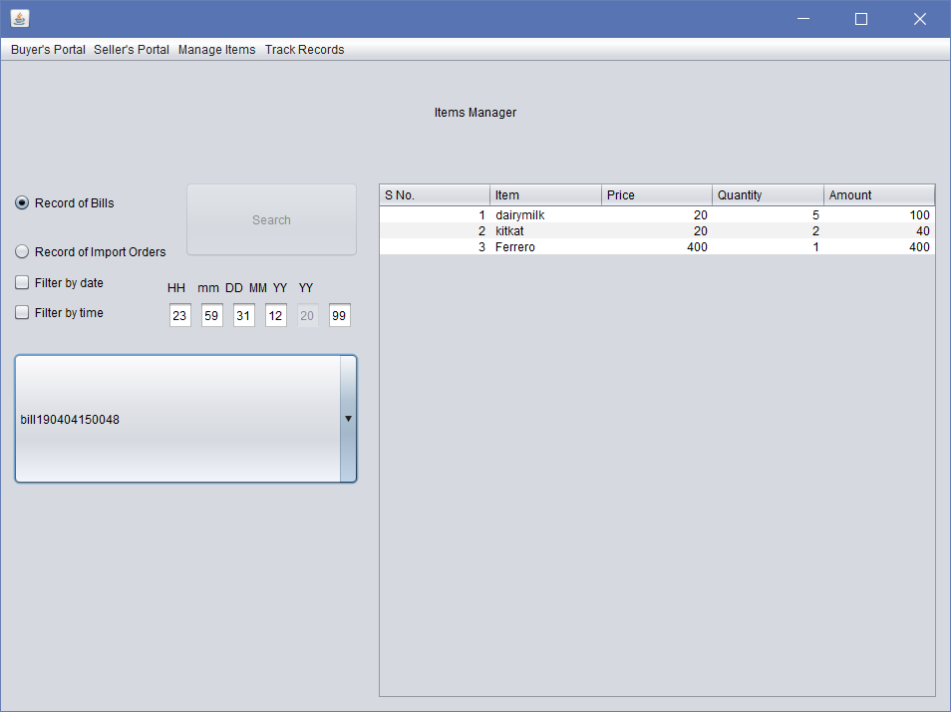
CHAPTER 7
REFERENCES

- NetBeans Reference Manual.
- Java Documentation.
- MySQL Documentation and User Guide.
- Websites like JavaTpoint, GeeksForGeeks, etc.

