**VIDEO GAME SALES 2019**

Coursework for

**7COM1079**

**Team Research and Development Project**

Submitted by – **Group 120**

20006332 19053321

19060040

20004324

19060609

**Abstract. Context:** Video games sales of different genres with critic score of year 2019.

**Problem:** Is the critic score of games varies based on the different genres of games.

**Method:** Within this experiment we have used comparison of means to compare the critic score between different genres of games.

**Results:** The results of comparing the means of critic score of between different genres yielded that the Action and Role-Playing genres have high critic score among the other genres.

**Implications:** We conclude the critic score of every game based on genre. therefore, the critic score of the game varies based on the genre of the game.

**Keywords:** There is no such factor to measure the critic score. The success of a game depends on the sales of the game and the critic score is obtained by the reviews and survey conducted for that game.

**Introduction**

In this report we have presented the research analysis performed on the critic score of games based on various genres. To compare the critic score of various genres, we have taken dataset into consideration fetched from Kaggle. A video game genre is a specific category of games related by similar gameplay characteristics. Video game genres are not usually defined by the setting or story of the game or its medium of play, but by the way the player interacts with the game. Genres may encompass a wide variety of games, leading to even more specific classifications called subgenres. For example, an [action game](https://en.wikipedia.org/wiki/Action_game) can be classified into many subgenres such as [platform games](https://en.wikipedia.org/wiki/Platform_game) and [fighting games](https://en.wikipedia.org/wiki/Fighting_game). Some games, most notably [browser](https://en.wikipedia.org/wiki/Browser_game) and [mobile](https://en.wikipedia.org/wiki/Mobile_game) games, are commonly classified into multiple genres. As video games are increasingly the subject of scientific studies, game genres are themselves becoming a subject of study.

**Background**

The dataset that has been considered is “vgsales-12-4-2019”. There are 55,792 records in the dataset as of April 12th, 2019. It was generated by a scrape of vgchartz.com. The dataset contains total information of a game such as ranking of overall sales, name of the game, platform of the game, genre, critic score, etc, here for the analysis, we consider genre and critic score columns from the dataset.

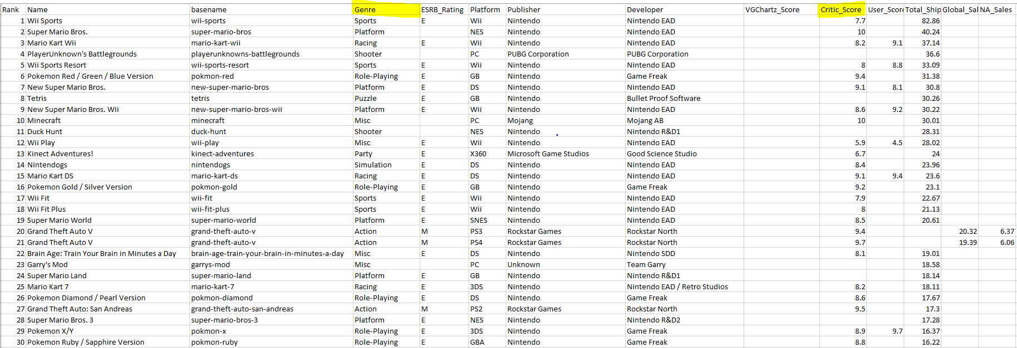

Figure 1. vgsales-12-4-2019 dataset

The same dataset has been represented in different dataset “newdata” by excluding the rows containing null value of critic_score. This was achieved by using R programming language.

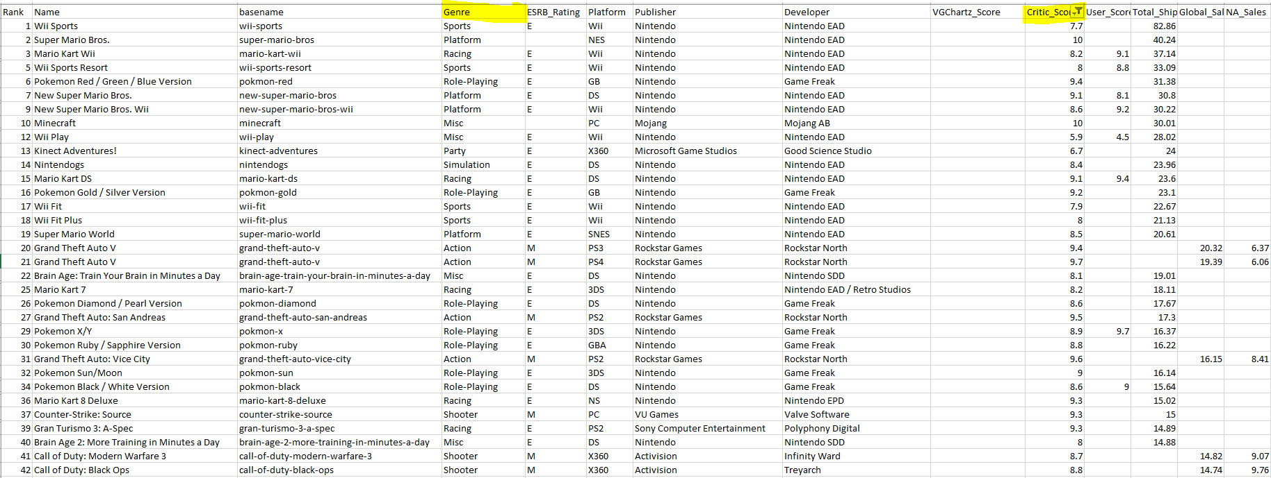

Figure 2. newdata dataset

From the newdata dataset we have selectively taken 10 out of 20 genres into consideration for the better visibility in the plot representation. We named the dataset as boxplotdata.

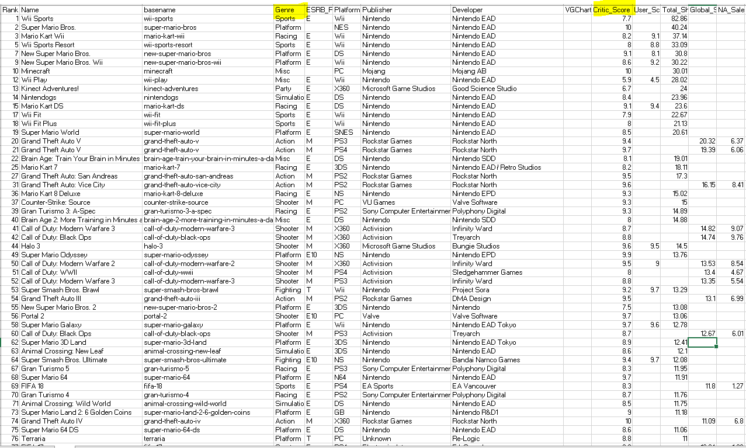

Figure 3. boxplotdata dataset

This report answers the below research question:

**Research Question**: Is there a difference in the mean of critic_score.

between different genres of games.

**Alternative hypothesis**: There is a difference in the mean of critic_score.

between different genres of games.

**Null hypothesis**: There is no difference in the mean of critic_score.

between different genres of games.

**Visualization:**

Here we have taken 10 genres into consideration to check the comparison of critic score. We have conducted comparison of mean test against the independent variable “genres” on x-axis and dependent variable “critic_score” on y-axis. The rectangle box is bounded by the closest range of values generated for critic score of that genre. Based on the bounded rectangle box median was calculated and it was represented using the line across the box. Whiskers represent the minimum and maximum values within 1.5 times the “Interquartile range “. The red dots represent the mean value of the critic score between different genres.

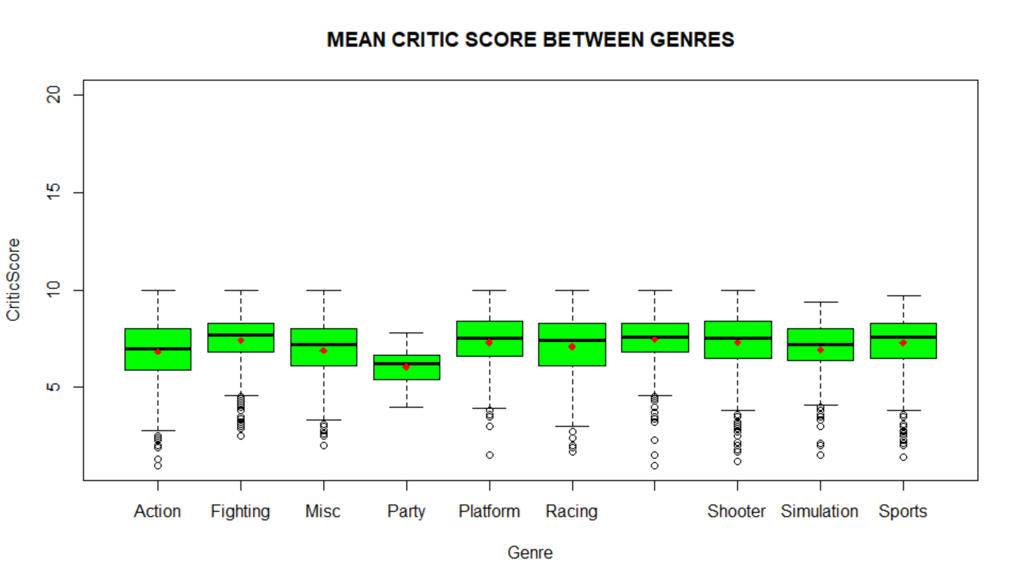

Figure 4. boxplot with points

**Method:** The method we used here is “Independent T-Test”.

**Result:**

As per the visualization performed with reference to the above box plot (Figure 4), it is very clear that the critic score will vary respective of the different genres of games. we have performed the below statistical analysis to test the hypothesis. The results that have been imported from R script are in support of the hypothesis.

**Analysis:**

Describing statistical analysis used to test your hypotheses, and what it means. The analysis method that had been implemented over here is the INDEPENDENT T-TEST, which can determine whether there is a statistical difference between the mean critic score between two different genres (indicated in red points in the Figure 4).

The values that had been shown in the figure 5 clearly gives an inline information that there is a statistically difference in the total critic score between two genres of games. As, the mean value of the genre “Fighting” is said to be 7.388415 and the genre “Action” is 6.840234.The degree of freedom value is 1350 and the p-value is 2.028E-08, which is said to be less than 0.05 and therefore, we can reject Null Hypothesis. Similarly, this analysis had been repeated over number of times for all the different genres and readings had been noted. The below figures show the examples of the reading for different genres.

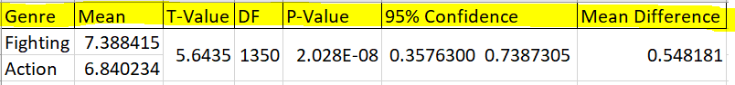

Figure 5. Analysis result for Fighting and Action genres in games.

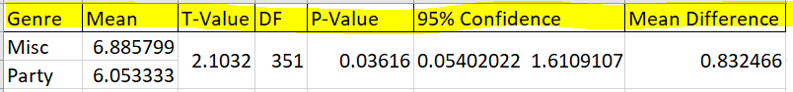

Figure 6. Analysis result for Misc and Party genres in games

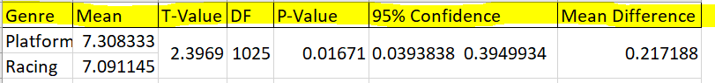

Figure 7. Analysis result for Platform and Racing genres in games

**Conclusion:**

The mean value of critic score between different genres of games is different which is obvious. The test results further show the difference in between two genres which helps us to support the hypothesis.

The critic score of a genre differs from genre to genre because, it mainly depends on the genre of a game. All the results from the recorded readings shows a positive track toward the alternative hypothesis and thus we can finally declare that there is a difference in the mean of critic_score between different genres of games.

**Appendix:**

Bitbucket: https://bitbucket.org/krishna15776/7com1079-group120/src/master/

Trello: https://trello.com/b/AsB57kiW/7com1079-group120

Kaggle Dataset: <https://www.kaggle.com/ashaheedq/video-games-sales-2019?select=vgsales-12-4-2019.csv>

**Reference:**

* <https://www.apa.org/monitor/2014/02/video-game> by Lisa Bowen from the American Psychological Association.
* <https://theconversation.com/video-games-affect-your-moral-development-but-only-until-youre-18-new-study-142769> by Sarah Hodge from The Conversation.
* <https://www.livescience.com/29246-brain-games-slow-mental-decline.html> by Denise Chow from Live Science.