Mode 1 (Changing batch size and alpha(learning rate))

Format in the rest of pdf-

alpha, batch size (no. of epochs =10,000 constant)
plot of profit function,
Confusion matrix
F1 score array
Micro F1 score, Macro F1 score.

Example alpha = 0.25, size = 100
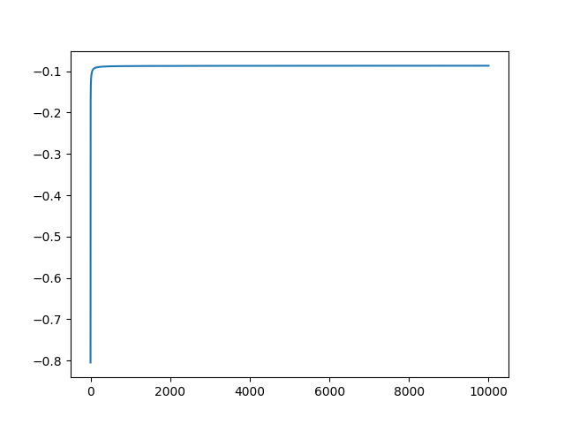
confusion matrix =
[[1.997e+03 0.000e+00 0.000e+00 0.000e+00 0.000e+00]
[0.000e+00 1.000e+00 0.000e+00 0.000e+00 0.000e+00]
[0.000e+00 0.000e+00 1.170e+02 2.800e+01 0.000e+00]
[0.000e+00 0.000e+00 1.900e+01 1.825e+03 1.840e+02]
[0.000e+00 0.000e+00 0.000e+00 2.070e+02 1.622e+03]]

F1 scores = [1.0, 1.0, 0.8327402135231317, 0.8928571428571428, 0.8924346629986245]
Micro F1 score = 0.927
Macro F1 score = 0.9237676777022951

1) 0.01,50
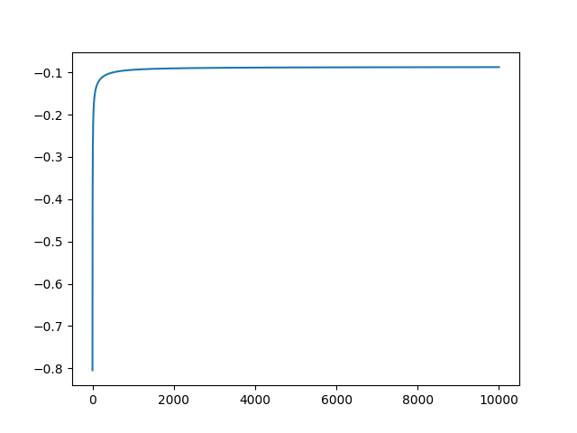
[[1.997e+03 0.000e+00 0.000e+00 0.000e+00 0.000e+00]
[0.000e+00 0.000e+00 1.000e+00 0.000e+00 0.000e+00]
[0.000e+00 0.000e+00 1.150e+02 3.000e+01 0.000e+00]
[0.000e+00 0.000e+00 1.600e+01 1.820e+03 1.920e+02]
[0.000e+00 0.000e+00 0.000e+00 2.010e+02 1.628e+03]]
[1.0, 0, 0.8303249097472925, 0.8923755822505516, 0.8922992600712524]
0.9266666666666667
0.7233007300589878

2) 0.01,200

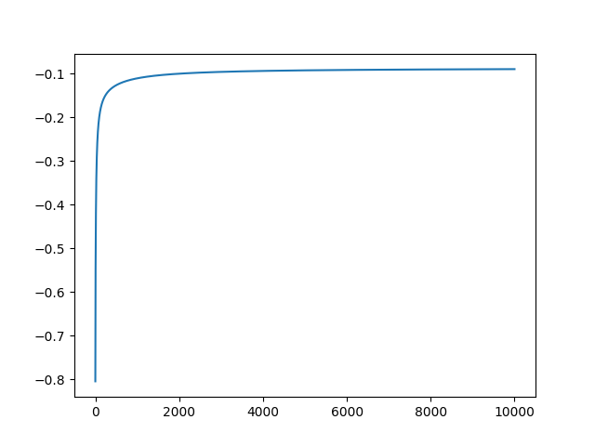
[[1.997e+03 0.000e+00 0.000e+00 0.000e+00 0.000e+00]
[0.000e+00 0.000e+00 1.000e+00 0.000e+00 0.000e+00]
[0.000e+00 0.000e+00 1.040e+02 4.100e+01 0.000e+00]
[0.000e+00 0.000e+00 1.200e+01 1.825e+03 1.910e+02]
[0.000e+00 0.000e+00 0.000e+00 2.010e+02 1.628e+03]]
[1.0, 0, 0.7938931297709924, 0.8913308913308914, 0.8925438596491229]
0.9256666666666666
0.7170506004838424

3) 0.01,500
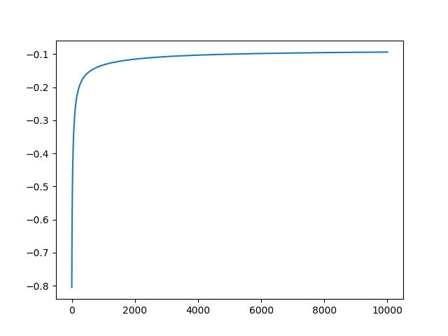
[[1.997e+03 0.000e+00 0.000e+00 0.000e+00 0.000e+00]
[0.000e+00 0.000e+00 1.000e+00 0.000e+00 0.000e+00]
[0.000e+00 0.000e+00 7.600e+01 6.900e+01 0.000e+00]
[0.000e+00 0.000e+00 8.000e+00 1.831e+03 1.890e+02]
[0.000e+00 0.000e+00 0.000e+00 2.000e+02 1.629e+03]]
[1.0, 0, 0.6608695652173914, 0.8871124031007753, 0.893336989306279]
0.9221666666666666
0.6962715465450603

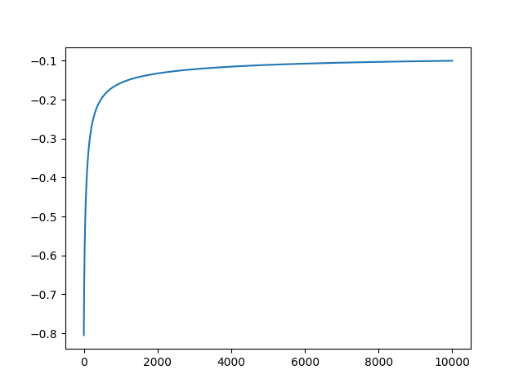
4) 0.01 1000

[[1.997e+03 0.000e+00 0.000e+00 0.000e+00 0.000e+00]
[0.000e+00 0.000e+00 1.000e+00 0.000e+00 0.000e+00]
[0.000e+00 0.000e+00 4.000e+01 1.050e+02 0.000e+00]
[0.000e+00 0.000e+00 2.000e+00 1.844e+03 1.820e+02]
[0.000e+00 0.000e+00 0.000e+00 1.990e+02 1.630e+03]]
[1.0, 0, 0.425531914893617, 0.8831417624521074, 0.8953584180170282]
0.9185000000000001
0.6709237295061639

5) 0.1, 50
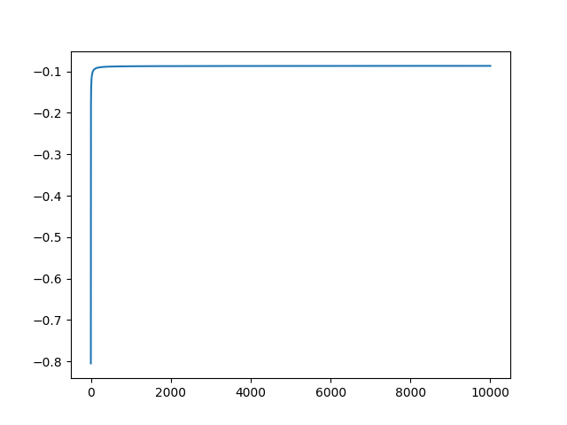
[[1.997e+03 0.000e+00 0.000e+00 0.000e+00 0.000e+00]
[0.000e+00 0.000e+00 1.000e+00 0.000e+00 0.000e+00]
[0.000e+00 0.000e+00 1.170e+02 2.800e+01 0.000e+00]
[0.000e+00 0.000e+00 1.900e+01 1.823e+03 1.860e+02]
[0.000e+00 0.000e+00 0.000e+00 2.030e+02 1.626e+03]]
[1.0, 0, 0.8297872340425531, 0.8931896129348359, 0.8931612194452073]
0.9271666666666667
0.7233455624176374

6) 0.1,200
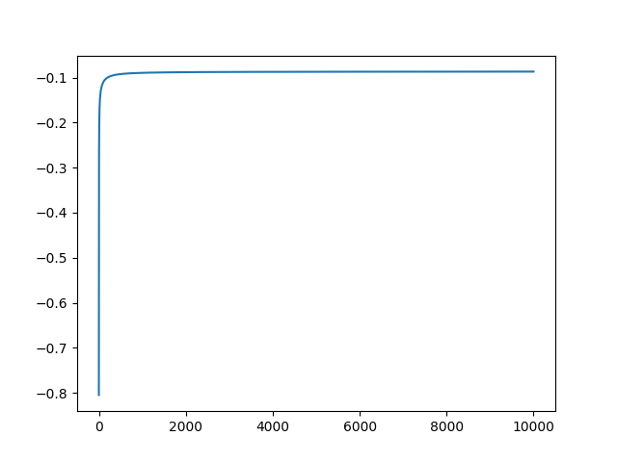
[[1.997e+03 0.000e+00 0.000e+00 0.000e+00 0.000e+00]
[0.000e+00 0.000e+00 1.000e+00 0.000e+00 0.000e+00]
[0.000e+00 0.000e+00 1.170e+02 2.800e+01 0.000e+00]
[0.000e+00 0.000e+00 1.900e+01 1.817e+03 1.920e+02]
[0.000e+00 0.000e+00 0.000e+00 2.010e+02 1.628e+03]]
[1.0, 0, 0.8297872340425531, 0.8919980363279332, 0.8922992600712524]
0.9264999999999999
0.7229288031847249

7) 0.1,500
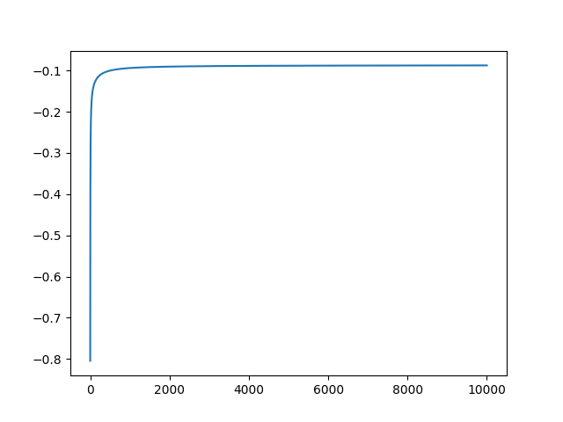
[[1.997e+03 0.000e+00 0.000e+00 0.000e+00 0.000e+00]
[0.000e+00 0.000e+00 1.000e+00 0.000e+00 0.000e+00]
[0.000e+00 0.000e+00 1.150e+02 3.000e+01 0.000e+00]
[0.000e+00 0.000e+00 1.600e+01 1.820e+03 1.920e+02]
[0.000e+00 0.000e+00 0.000e+00 2.010e+02 1.628e+03]]
[1.0, 0, 0.8303249097472925, 0.8923755822505516, 0.8922992600712524]
0.9266666666666667
0.7233007300589878

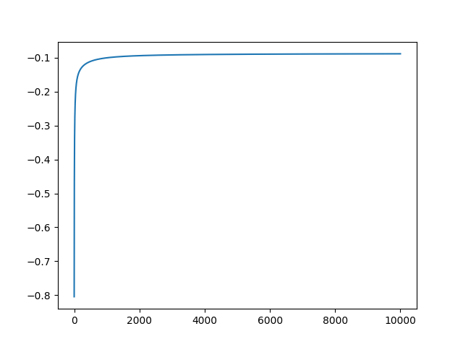
8) 0.1,1000
[[1.997e+03 0.000e+00 0.000e+00 0.000e+00 0.000e+00]
[0.000e+00 0.000e+00 1.000e+00 0.000e+00 0.000e+00]
[0.000e+00 0.000e+00 1.110e+02 3.400e+01 0.000e+00]
[0.000e+00 0.000e+00 1.500e+01 1.821e+03 1.920e+02]
[0.000e+00 0.000e+00 0.000e+00 2.010e+02 1.628e+03]]
[1.0, 0, 0.8161764705882354, 0.8917727717923604, 0.8922992600712524]
0.9261666666666667
0.7206365662057986

9) 0.5,50
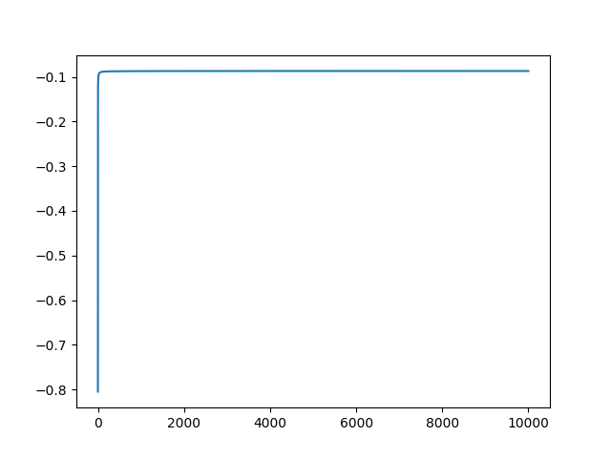
[[1.997e+03 0.000e+00 0.000e+00 0.000e+00 0.000e+00]
[0.000e+00 1.000e+00 0.000e+00 0.000e+00 0.000e+00]
[0.000e+00 0.000e+00 1.160e+02 2.900e+01 0.000e+00]
[0.000e+00 0.000e+00 1.700e+01 1.831e+03 1.800e+02]
[0.000e+00 0.000e+00 0.000e+00 2.040e+02 1.625e+03]]
[1.0, 1.0, 0.8345323741007195, 0.8949169110459433, 0.8943313153549808]
0.9283333333333333
0.9250389993910573

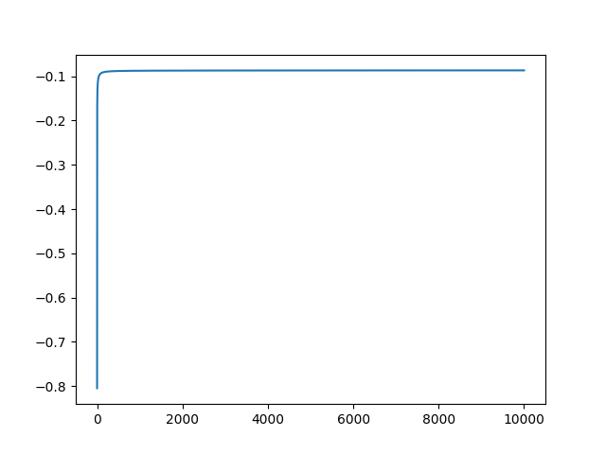
10) 0.5,200
[[1.997e+03 0.000e+00 0.000e+00 0.000e+00 0.000e+00]
[0.000e+00 1.000e+00 0.000e+00 0.000e+00 0.000e+00]
[0.000e+00 0.000e+00 1.170e+02 2.800e+01 0.000e+00]
[0.000e+00 0.000e+00 1.900e+01 1.826e+03 1.830e+02]
[0.000e+00 0.000e+00 0.000e+00 2.070e+02 1.622e+03]]
[1.0, 1.0, 0.8327402135231317, 0.8931279041330399, 0.8926802421574023]
0.9271666666666667
0.9238722170636501

11) 0.5,500
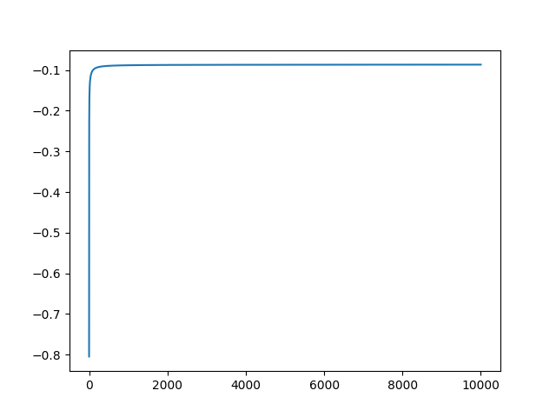
[[1.997e+03 0.000e+00 0.000e+00 0.000e+00 0.000e+00]
[0.000e+00 0.000e+00 1.000e+00 0.000e+00 0.000e+00]
[0.000e+00 0.000e+00 1.170e+02 2.800e+01 0.000e+00]
[0.000e+00 0.000e+00 1.900e+01 1.820e+03 1.890e+02]
[0.000e+00 0.000e+00 0.000e+00 2.010e+02 1.628e+03]]
[1.0, 0, 0.8297872340425531, 0.8928133431444689, 0.8930334613274822]
0.927
0.7232406251003717

12)0.5,1000
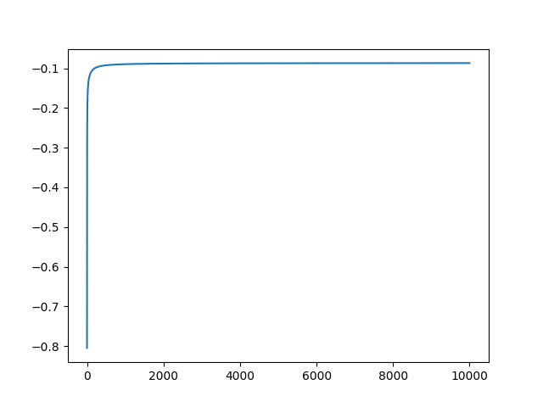
[[1.997e+03 0.000e+00 0.000e+00 0.000e+00 0.000e+00]
[0.000e+00 0.000e+00 1.000e+00 0.000e+00 0.000e+00]
[0.000e+00 0.000e+00 1.170e+02 2.800e+01 0.000e+00]
[0.000e+00 0.000e+00 1.900e+01 1.817e+03 1.920e+02]
[0.000e+00 0.000e+00 0.000e+00 2.010e+02 1.628e+03]]
[1.0, 0, 0.8297872340425531, 0.8919980363279332, 0.8922992600712524]
0.9264999999999999
0.7229288031847249

2) Adaptive Learning (alpha = eta_nought)

13) 0.01,50
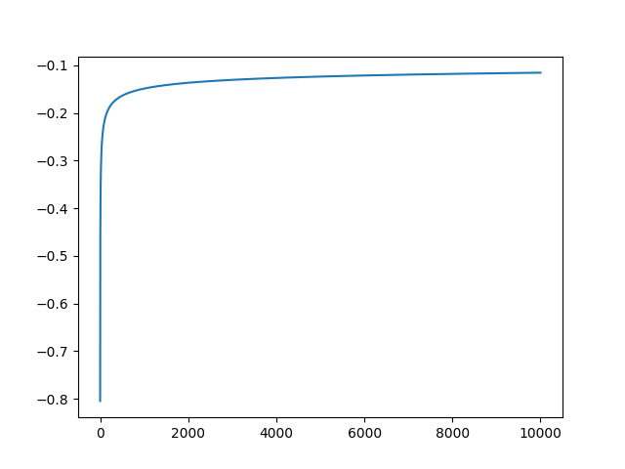
[[1.997e+03 0.000e+00 0.000e+00 0.000e+00 0.000e+00]
[0.000e+00 0.000e+00 0.000e+00 1.000e+00 0.000e+00]
[0.000e+00 0.000e+00 0.000e+00 1.450e+02 0.000e+00]
[0.000e+00 0.000e+00 1.000e+00 1.842e+03 1.850e+02]
[0.000e+00 0.000e+00 0.000e+00 1.900e+02 1.639e+03]]
[1.0, 0, 0, 0.8758915834522111, 0.8973446482343281]
0.9129999999999999
0.5548055799099214

14) 0.01,200
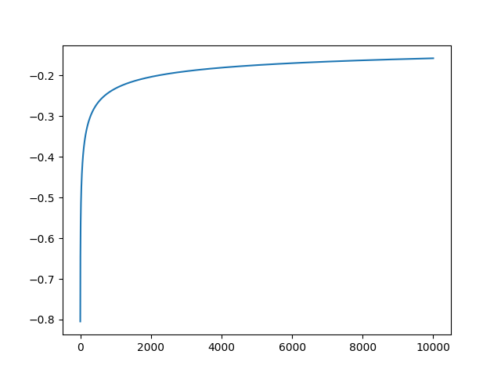
[[1.997e+03 0.000e+00 0.000e+00 0.000e+00 0.000e+00]
[0.000e+00 0.000e+00 0.000e+00 1.000e+00 0.000e+00]
[0.000e+00 0.000e+00 0.000e+00 1.450e+02 0.000e+00]
[0.000e+00 0.000e+00 0.000e+00 1.838e+03 1.900e+02]
[0.000e+00 0.000e+00 0.000e+00 1.830e+02 1.646e+03]]
[1.0, 0, 0, 0.8762812872467223, 0.8982264665757163]
0.9135
0.5550265502748506

15) 0.01, 500
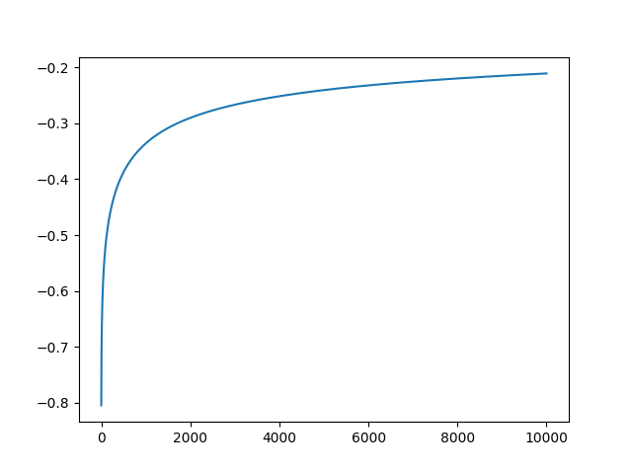
[[1.997e+03 0.000e+00 0.000e+00 0.000e+00 0.000e+00]
[0.000e+00 0.000e+00 0.000e+00 1.000e+00 0.000e+00]
[0.000e+00 0.000e+00 0.000e+00 1.450e+02 0.000e+00]
[0.000e+00 0.000e+00 0.000e+00 1.850e+03 1.780e+02]
[0.000e+00 0.000e+00 0.000e+00 2.010e+02 1.628e+03]]
[1.0, 0, 0, 0.8757396449704142, 0.895735900962861]
0.9125000000000001
0.5545205487816808

16) 0.01,1000
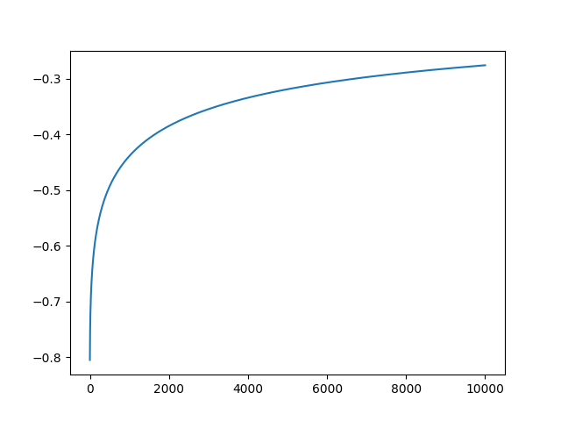
[[1.997e+03 0.000e+00 0.000e+00 0.000e+00 0.000e+00]
[0.000e+00 0.000e+00 0.000e+00 1.000e+00 0.000e+00]
[0.000e+00 0.000e+00 0.000e+00 1.450e+02 0.000e+00]
[0.000e+00 0.000e+00 0.000e+00 1.860e+03 1.680e+02]
[0.000e+00 0.000e+00 0.000e+00 2.530e+02 1.576e+03]]
[1.0, 0, 0, 0.867739678096571, 0.8821718443884691]
0.9055
0.5505388556087015

17) 0.1,50
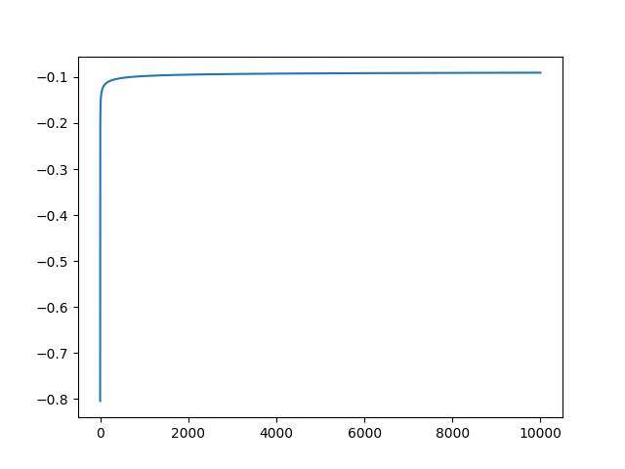
[[1.997e+03 0.000e+00 0.000e+00 0.000e+00 0.000e+00]
[0.000e+00 0.000e+00 1.000e+00 0.000e+00 0.000e+00]
[0.000e+00 0.000e+00 9.700e+01 4.800e+01 0.000e+00]
[0.000e+00 0.000e+00 1.100e+01 1.826e+03 1.910e+02]
[0.000e+00 0.000e+00 0.000e+00 2.010e+02 1.628e+03]]
[1.0, 0, 0.7637795275590551, 0.8900804289544236, 0.8925438596491229]
0.9246666666666667
0.7118445174064763

18) 0.1,200
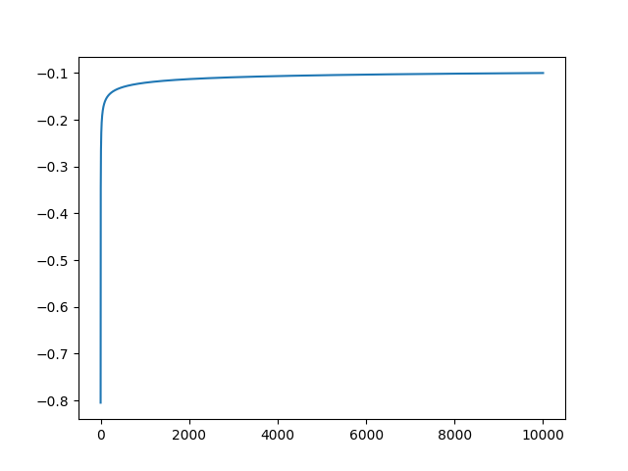
[[1.997e+03 0.000e+00 0.000e+00 0.000e+00 0.000e+00]
[0.000e+00 0.000e+00 1.000e+00 0.000e+00 0.000e+00]
[0.000e+00 0.000e+00 4.000e+01 1.050e+02 0.000e+00]
[0.000e+00 0.000e+00 2.000e+00 1.844e+03 1.820e+02]
[0.000e+00 0.000e+00 0.000e+00 1.990e+02 1.630e+03]]
[1.0, 0, 0.425531914893617, 0.8831417624521074, 0.8953584180170282]
0.9185000000000001
0.6709237295061639

19) 0.1, 500
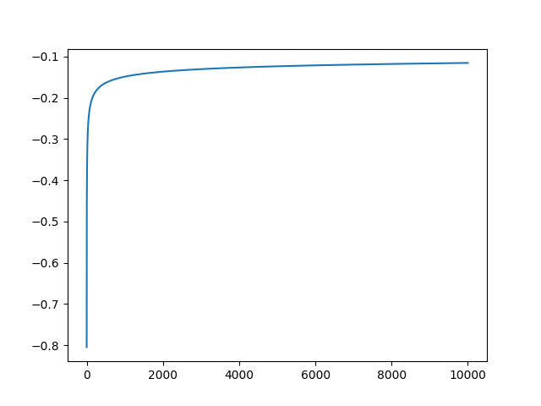
[[1.997e+03 0.000e+00 0.000e+00 0.000e+00 0.000e+00]
[0.000e+00 0.000e+00 0.000e+00 1.000e+00 0.000e+00]
[0.000e+00 0.000e+00 0.000e+00 1.450e+02 0.000e+00]
[0.000e+00 0.000e+00 1.000e+00 1.842e+03 1.850e+02]
[0.000e+00 0.000e+00 0.000e+00 1.900e+02 1.639e+03]]
[1.0, 0, 0, 0.8758915834522111, 0.8973446482343281]
0.9129999999999999
0.5548055799099214

20) 0.1,1000
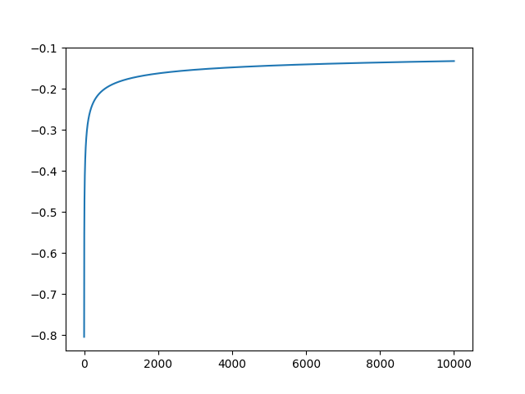
[[1.997e+03 0.000e+00 0.000e+00 0.000e+00 0.000e+00]
[0.000e+00 0.000e+00 0.000e+00 1.000e+00 0.000e+00]
[0.000e+00 0.000e+00 0.000e+00 1.450e+02 0.000e+00]
[0.000e+00 0.000e+00 0.000e+00 1.842e+03 1.860e+02]
[0.000e+00 0.000e+00 0.000e+00 1.840e+02 1.645e+03]]
[1.0, 0, 0, 0.8771428571428571, 0.8989071038251366]
0.914
0.5553490715481842

21) 0.5, 50
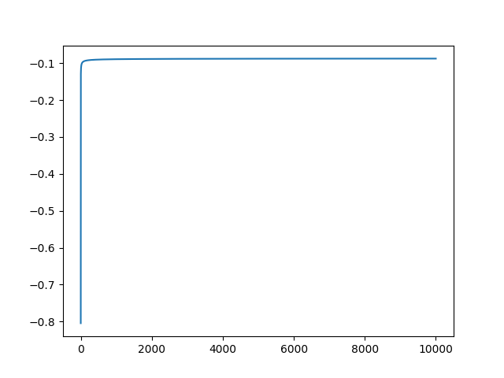
[[1.997e+03 0.000e+00 0.000e+00 0.000e+00 0.000e+00]
[0.000e+00 0.000e+00 1.000e+00 0.000e+00 0.000e+00]
[0.000e+00 0.000e+00 1.150e+02 3.000e+01 0.000e+00]
[0.000e+00 0.000e+00 1.600e+01 1.820e+03 1.920e+02]
[0.000e+00 0.000e+00 0.000e+00 2.010e+02 1.628e+03]]
[1.0, 0, 0.8303249097472925, 0.8923755822505516, 0.8922992600712524]
0.9266666666666667
0.7233007300589878

22) 0.5,200
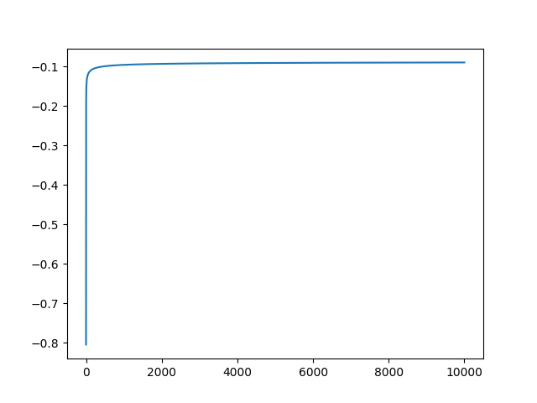
[[1.997e+03 0.000e+00 0.000e+00 0.000e+00 0.000e+00]
[0.000e+00 0.000e+00 1.000e+00 0.000e+00 0.000e+00]
[0.000e+00 0.000e+00 1.040e+02 4.100e+01 0.000e+00]
[0.000e+00 0.000e+00 1.200e+01 1.825e+03 1.910e+02]
[0.000e+00 0.000e+00 0.000e+00 2.010e+02 1.628e+03]]
[1.0, 0, 0.7938931297709924, 0.8913308913308914, 0.8925438596491229]
0.9256666666666666
0.7170506004838424

23) 0.5,500
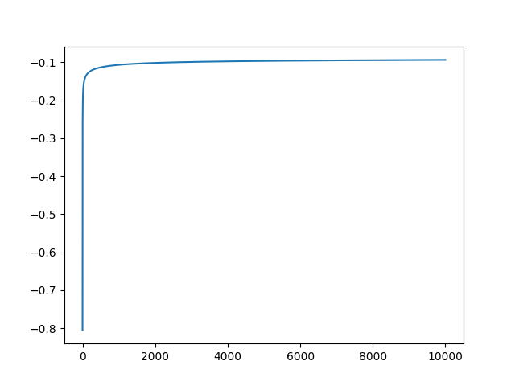
[[1.997e+03 0.000e+00 0.000e+00 0.000e+00 0.000e+00]
[0.000e+00 0.000e+00 1.000e+00 0.000e+00 0.000e+00]
[0.000e+00 0.000e+00 7.600e+01 6.900e+01 0.000e+00]
[0.000e+00 0.000e+00 8.000e+00 1.831e+03 1.890e+02]
[0.000e+00 0.000e+00 0.000e+00 2.010e+02 1.628e+03]]
[1.0, 0, 0.6608695652173914, 0.8868975538871398, 0.8930334613274822]
0.9219999999999999
0.6961686668760222

24) 0.5,1000
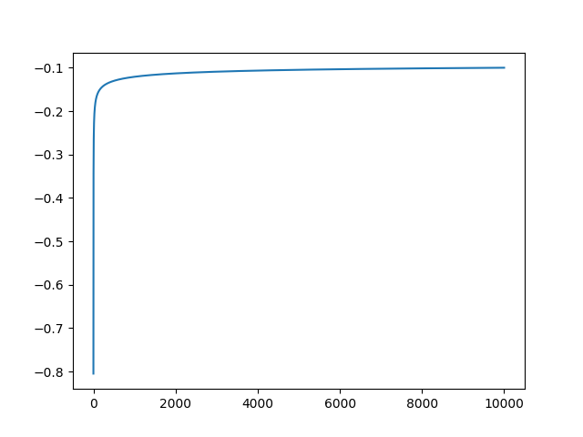
[[1.997e+03 0.000e+00 0.000e+00 0.000e+00 0.000e+00]
[0.000e+00 0.000e+00 1.000e+00 0.000e+00 0.000e+00]
[0.000e+00 0.000e+00 4.000e+01 1.050e+02 0.000e+00]
[0.000e+00 0.000e+00 2.000e+00 1.844e+03 1.820e+02]
[0.000e+00 0.000e+00 0.000e+00 1.990e+02 1.630e+03]]
[1.0, 0, 0.425531914893617, 0.8831417624521074, 0.8953584180170282]
0.9185000000000001
0.6709237295061639

