1st Practical : Create, Insert and Delete a Document from a Collection

1. Create a new database named studentDB.
2. Create a collection named students.

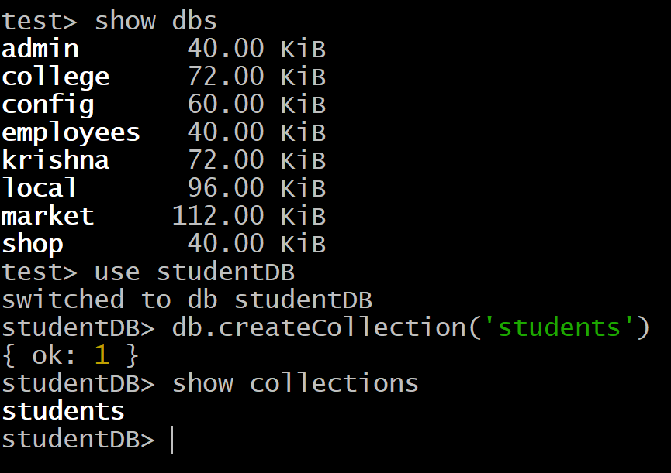  
  
  
  
  
  
  
  
  
  
  
  
  
  
  
  
  
  
  
  
  
  
  
  
  
  
3. Insert multiple documents with fields like name, age, and grade.  
  
  
  
  
  
4. Delete the document where name is Bob.  
  
  
  
  
  
  
  
5. Use deleteOne() to remove the document.

2nd Practical : Retrieve, Query and update Documents

1. Retrieve all documents from the students collection.

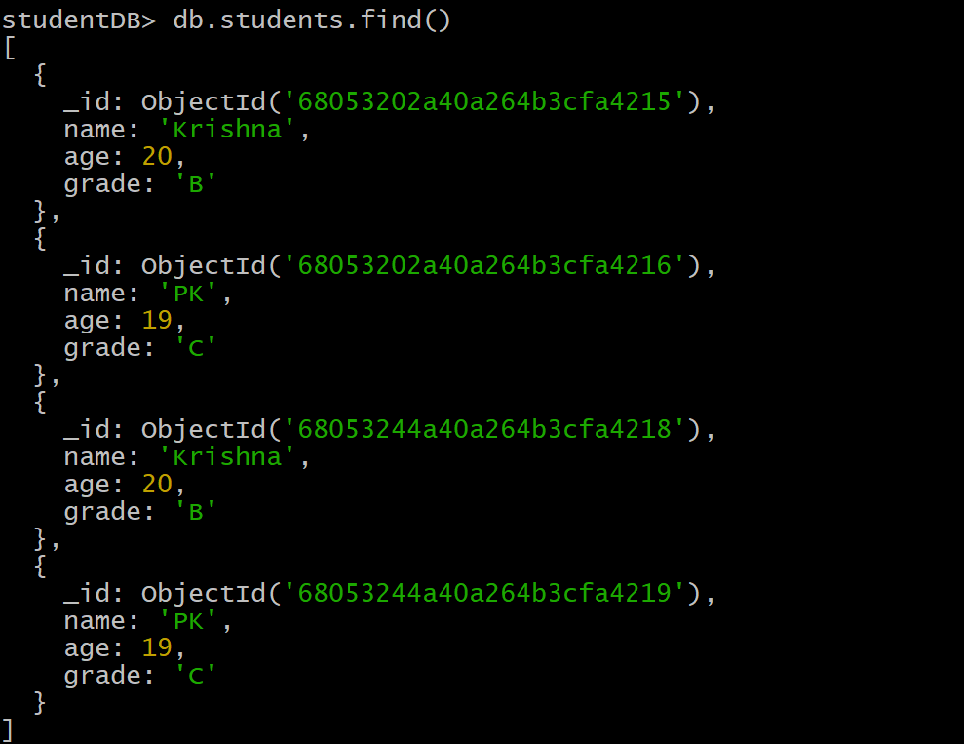  
  
  
  
  
  
  
  
  
  
  
  
  
2. Query documents where grade is A.  


3. Update the age of a student named Alice to 21.  
  
  
  
  
  
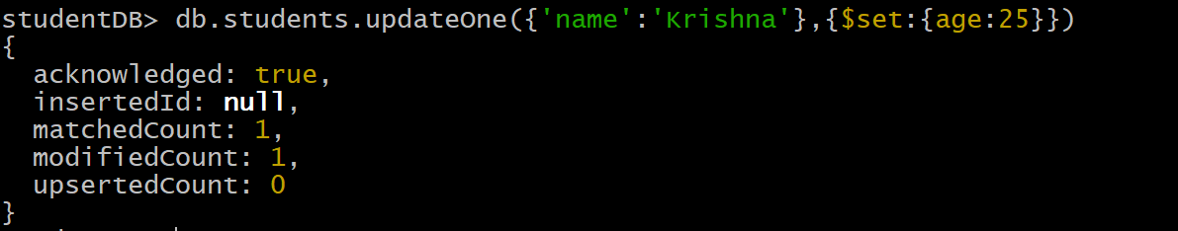4. Use updateOne() to modify the document.   
  
  
  
  
  
  
  
3rd Practical : Create and Apply Indexes for Faster Queries

1. Create an index on the name field for faster sear

 2. Verify the created index using getIndexes().

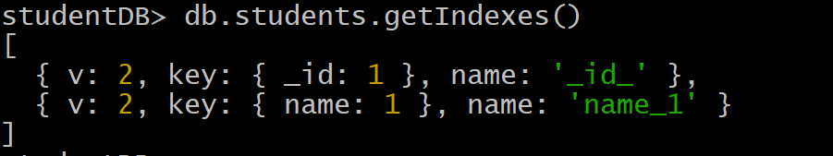

4th Practical : Aggregation and Data Analysis

1. Perform aggregation using $match, $group, and $sort.
2. Generate summarized data reports.

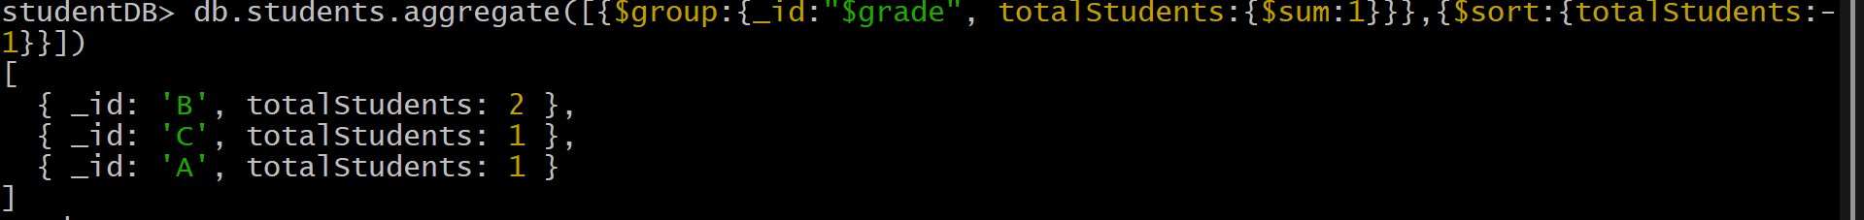

5th Practical : Backup and Restore in MongoDB

1. Perform data backup and restoration using mongodump and mongorestore.



