Shaheed Rajguru College of Applied Sciences for Women



Practical File
Operating System

Title: All Practical Programs

Submitted By:
- Vanshika
- 20231355
- 5th Semester
- Financial Studies

Submitted To:
- Dr. Sandhya

Session: 2025-26
- Execute various LINUX commands for:

- Information Maintenance: wc, clear, cal, who, date, pwd

- wc

Description: Counts number of lines, words and characters in a file.
Command:
wc sample.txt

Output:


- clear

Description: Clears the terminal screen.
Command:
clear

Output:
(Screen clears)
This command clears the terminal screen and resets cursor position.
Screenshot not applicable because the command removes all visible content.

- cal

Description: Displays current month's calendar.
Command:
cal

Output:
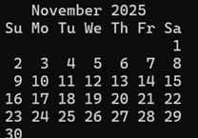

- who

Description: Shows list of logged-in users.
Command:
who

Output:

- date

Description: Shows current date and time.
Command:
date

Output:
Sat, Nov 22, 2025 5:09:41 PM

- pwd

Description: Prints current working directory.
Command:
pwd

Output:
/c/Users/admin

b) File Management: cat, cp, rm, mv, cmp, comm, diff, find, grep, awk

- cat
Description: Used to display file contents, create new files, or merge multiple files.
Command:
cat sample.txt
Output:
Hello OS
I am Vanshika from Finance department
Thank you
- cp
Description: Copies a file from source to destination without modifying the original file.
Command:
cp sample.txt content.txt
Output:
(File copied successfully
- rm

Description: Deletes or removes a file permanently from the system.
Command:
rm content.txt
Output:
(File deleted)
- mv
Description: Used to move a file to another location or rename a file.
Command:
mv sample.txt file.txt
Output:
(File renamed or moved)

- cmp

Description: Compares two files byte by byte and reports the first mismatch.
Command:
cmp file.txt newfile.txt
Output:
file.txt newfile.txt differ: byte 3, line 1

- comm

Description: Compares two sorted files line-by-line; shows lines unique to file1, unique to file2, and common lines.
Command:
comm name.txt newname.txt
Output:
apple banana mango
banana mango grapes

- diff

Description: Displays line-by-line differences between two files; used in programming and patch creation.
Command:
diff name.txt newname.txt
Output:
1c1
< apple banana mango
---
> banana mango grapes

- find

Description: Searches for files/directories based on name, type, size, etc. within the directory tree.
Command:
find . -name "*.txt"

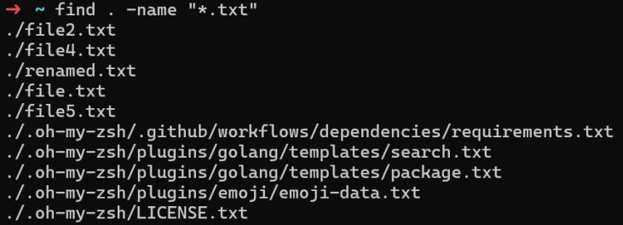
Output:

- grep

Description: Searches for a specific pattern or text inside a file or group of files.
Command:
grep "mango" name.txt

Output:
apple banana mango

- awk

Description: A powerful text-processing tool used to extract fields/columns, format output, and process data.
Command:
awk '{print $1}' data.txt
awk '{print $2}' data.txt

Output:
Happy
Sad
Glad
Upset

Everyone
Anybody
!!
Somebody

c) Directory Management: cd, mkdir, rmdir, ls

- cd

Description: Changes the current working directory to a specified path. Used for navigating the Linux file system.
Command:
cd Documents

Output:
(Directory changed to Documents)

- mkdir

Description: Creates a new directory/folder in the current path.
Command:
mkdir projects

Output:
(Directory named 'projects' created)

- rmdir

Description: Deletes an empty directory. If the directory contains files, it will not be removed.
Command:
rmdir projects

Output:
(Directory removed only if empty)

- ls

Description: Lists files and directories. Options like -l and -a show detailed and hidden items.
Command:
ls

Output:
Data.txt name.txt newname.txt file.txt newfile.txt
2. Execute various LINUX commands for:

a. Process Control: fork, getpid, ps, kill, sleep

- fork

Description: Used in C programs to create a new child process. The child process is a duplicate of the parent process.

Code:
#include <stdio.h>
#include <unistd.h>

int main() {
printf("Before fork\n");
fork();
printf("After fork\n");
return 0;
}

Output:
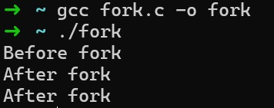

- getpid

Description: Returns the Process ID (PID) of the running process.
(Also used inside C programs)

Code:
#include <stdio.h>
#include <unistd.h>

int main() {
printf("Current Process ID: %d\n", getpid());
return 0;
}

Output:
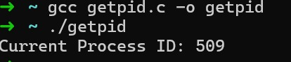
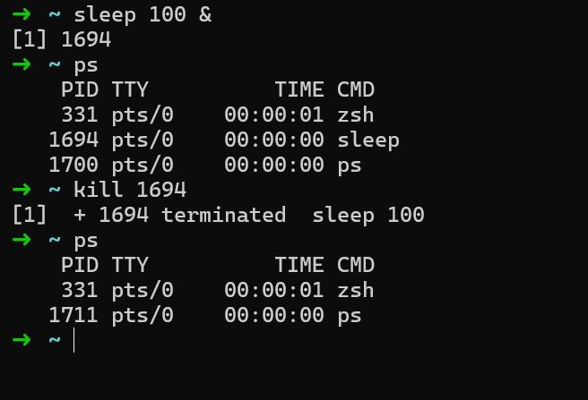
- ps

Description: Shows details of active processes.
Command:
ps

Output:
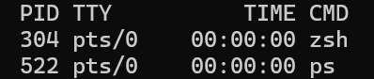

- kill

Description: Terminates a running process using its PID.
Command:

Kill 532

Output:
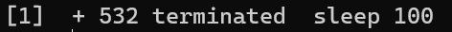

- sleep

Description: Suspends process execution for a specified time in seconds.
Command:

Sleep 100 &

Output:
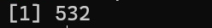

b. Communication: Input-Output redirecion, Pipe

(a) Output Redirection ( > )

Description: Sends output of a command into a file.
Command:
ls > data.txt
cat data.txt

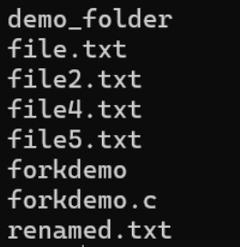
Output:

(b) Input Redirection (<)

Description: Takes input for a command from a file.
Command:

Wc < data.txt

Output:
42 49 694

(c) Pipe:

Description: Sends the output of one command as input to another command.
Command:
ls | wc -l

Output:

42

c. Protection Management: chmod, chown, chgrp

- chmod

Description: Changes file/directory permissions for user, group, and others.

Command:
touch demo.txt
chmod 777 demo.txt

Output:
(Permissions changed to rwxr-xr-x)

- chown

Description: Changes the owner of a file.
Command:
sudo chown user1 file.txt

Output:
(Owner changed to user1)

- chgrp

Description: Changes the group ownership of a file.
Command:
Sudo chgrp sudo demo.txt

Output:
(Group changed to sudo)

3. Write a program (using fork () and/or exec () commands) where parent and child execute:

  - Write a program (using fork () and/or exec () commands) where parent and child execute:

- same program, same code

Code:

#include <stdio.h>
#include <unistd.h>

int main()
{
pid_t pid = fork(); // create child process

if (pid < 0)
{
printf("Fork failed\n");
}
else
{
printf("Process ID: %d running the same code.\n", getpid());
}

return 0;
}

Output:
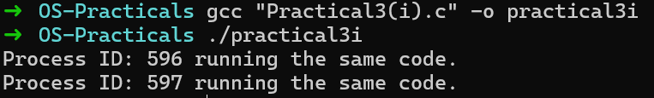

- same program, different code

Code:

#include <stdio.h>
#include <unistd.h>
#include <sys/types.h>
int main()
{
pid_t pid;
pid = fork(); // create child process

if (pid > 0)
{
printf("I am Parent process!My PID:%d,PPID:%d\n",getpid(),getpid());
}
else if (pid == 0)
{
printf("I am Child process!My PID:%d,PPID:%d\n”,getpid(),getpid());
}
else
{
printf("Fork Failed ”);
return 0;
}
}

Output:
“parentchild.c” 22L, 318C written
[ge5112@server ~]$ gcc parentchild.c
[ge5112@server ~]$ ./a.out
I am Parent process!My PID:11295, PPID:9308
I am Child process!My PID:11296, PPID:11295
[ge5112@server ~]$ gcc process.c
[ge5112@server ~]$ ./a.out
PID:11333

PID:11334

- before terminating, the parent waits for the child to finish its task.

Code:

#include <stdio.h>
#include <unistd.h>
#include <sys/wait.h>

int main()
{
pid_t pid = fork();

if (pid < 0)
{
printf("Fork failed\n");
}
else if (pid == 0)
{
// Child executes first
printf("Child Process (PID: %d) is running...\n", getpid());
sleep(2); // delay to show parent waits
printf("Child Process completed.\n");
}
else
{
// Parent waits for child
wait(NULL);
printf("Parent Process (PID: %d) — child has finished, now parent exits.\n", getpid());
}

return 0;
}

Output:
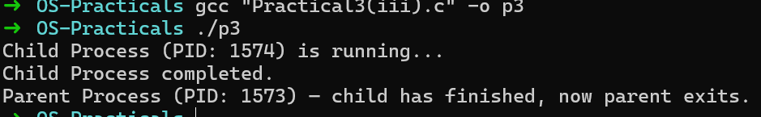

4. Write a program to report behaviour of Linux kernel including kernel version, CPU type and CPU information.

Code:
#include <stdio.h>
#include <sys/utsname.h>

int main() {
struct utsname sysinfo;

if (uname(&sysinfo) == -1) {
perror("uname");
return 1;
}

printf("\n---- Linux Kernel Information ----\n");
printf("Kernel Name : %s\n", sysinfo.sysname);
printf("Node / Host Name : %s\n", sysinfo.nodename);
printf("Kernel Release : %s\n", sysinfo.release);
printf("Kernel Version : %s\n", sysinfo.version);
printf("Machine / CPU : %s\n", sysinfo.machine);
printf("----------------------------------\n\n");

return 0;
}

Output:
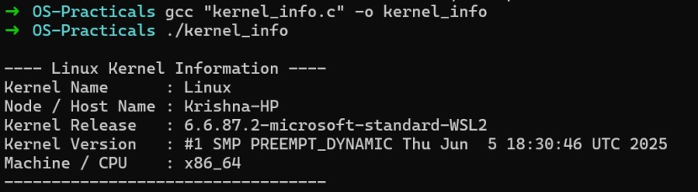

5. Write a program to report behaviour of Linux kernel including information on configured memory, amount of free and used memory. (Memory information)

Code:
#include <stdio.h>
#include <stdlib.h>

int main() {
printf("Configured Memory:\n");
system("cat /proc/meminfo | awk 'NR==1{print $2}'");

printf("\nAmount of Free Memory:\n");
system("cat /proc/meminfo | awk 'NR==2{print $2}'");

printf("\nAmount of Used Memory:\n");
system("cat /proc/meminfo | awk '{if(NR==2) a=$2; if(NR==3) b=$2} END{print a-b}'");
}

Output:
[ges5125@server ~]$ g++ me.c
[ges5125@server ~]$ ./a.out
Configured Memory:
3731980

Amount of Free Memory:
2936088

Amount of Used Memory:
0

6. Write a program to copy files using system calls

Code:
#include <stdlib.h>
#include <stdio.h>
#include <fcntl.h>
#include <unistd.h>

char buffer[2048];

main(argc, argv)
int argc;
char *argv[];
{
int fold, fdnew;
if (argc != 3)
{
printf("need 2 arguments for copy program\n");
exit(1);
}

fold = open(argv[1], O_RDONLY);
if (fold == -1)
{
printf("cannot open file %s\n", argv[1]);
exit(1);
}

fdnew = creat(argv[2], 0666);
if (fdnew == -1)
{
printf("cannot create file %s\n", argv[2]);
exit(1);
}

copy(fold, fdnew);
exit(0);
}

copy(old, new)
int old, new;
{
int count;
while ((count = read(old, buffer, sizeof(buffer))) > 0)
write(new, buffer, count);
}

Output:
$ gcc copy.c -o copy
$ ./copy a.txt b.txt
(successful copy)

7. Write a program to implement FCFS scheduling algorithm.

Code:
#include <stdio.h>

int main() {
int process[] = {1, 2, 3};
int burst[] = {4, 3, 2};
int n = 3;
int wt[3], tat[3];

wt[0] = 0;
for(int i=1; i<n; i++)
wt[i] = wt[i-1] + burst[i-1];

for(int i=0; i<n; i++)
tat[i] = wt[i] + burst[i];

printf("FCFS Scheduling:\n");
for(int i=0; i<n; i++)
printf("P%d -> WT=%d, TAT=%d\n", process[i], wt[i], tat[i]);

return 0;
}

Output:
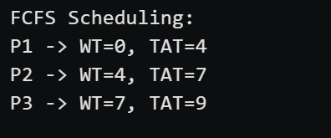

8. Write a program to implement SJF scheduling algorithm.

Code:
#include <stdio.h>

int main() {
int process[] = {1, 2, 3};
int burst[] = {6, 4, 2};
int n = 3, wt[3] = {0}, tat[3];

for(int i=0; i<n-1; i++)
for(int j=i+1; j<n; j++)
if(burst[j] < burst[i]) {
int t = burst[i]; burst[i] = burst[j]; burst[j] = t;
t = process[i]; process[i] = process[j]; process[j] = t;
}

for(int i=1; i<n; i++)
wt[i] = wt[i-1] + burst[i-1];

for(int i=0; i<n; i++)
tat[i] = wt[i] + burst[i];

printf("SJF Scheduling:\n");
for(int i=0; i<n; i++)
printf("P%d -> WT=%d, TAT=%d\n", process[i], wt[i], tat[i]);

return 0;
}

Output:

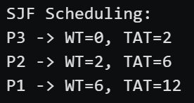

9. Write a program to implement non-preemptive priority-based scheduling algorithm.

Code:
#include <iostream>
using namespace std;

int main() {
int AT[10], BT[10], x[10], PT[10] = {0};
int WT[10], TAT[10], CT[10];
int i, j, smallest, count = 0, time, n;
double avg = 0, tt = 0, end;

cout << "\nEnter the number of Processes: ";
cin >> n;

for (i = 0; i < n; i++) {
cout << "\nEnter arrival time of process P[" << i + 1 << "]: ";
cin >> AT[i];
}

for (i = 0; i < n; i++) {
cout << "\nEnter burst time of process P[" << i + 1 << "]: ";
cin >> BT[i];
}

for (i = 0; i < n; i++) {
cout << "\nEnter priority of process P[" << i + 1 << "]: ";
cin >> PT[i];
}

for (i = 0; i < n; i++)
x[i] = BT[i];

PT[9] = -1;

for (time = 0; count != n; time++) {
smallest = 9;

for (i = 0; i < n; i++) {
if (AT[i] <= time && PT[i] > PT[smallest] && BT[i] > 0)
smallest = i;
}

time += BT[smallest] - 1;
BT[smallest] = -1;
count++;

end = time + 1;
CT[smallest] = end;
WT[smallest] = end - AT[smallest] - x[smallest];
TAT[smallest] = end - AT[smallest];
}

cout << "\nProcess\tBT\tAT\tWT\tTAT\tCT\tPriority\n";
for (i = 0; i < n; i++) {
cout << "P[" << i + 1 << "]\t" << x[i] << "\t" << AT[i] << "\t"
<< WT[i] << "\t" << TAT[i] << "\t" << CT[i] << "\t" << PT[i] << endl;

avg += WT[i];
tt += TAT[i];
}

cout << "\nAverage waiting time = " << avg / n;
cout << "\nAverage Turnaround time = " << tt / n;

return 0;
}

Output:

Enter number of Processes: 4

Enter arrival time of process P[1]: 0
Enter arrival time of process P[2]: 1
Enter arrival time of process P[3]: 2
Enter arrival time of process P[4]: 3

Enter burst time P[1]: 8
Enter burst time P[2]: 4
Enter burst time P[3]: 9
Enter burst time P[4]: 5

Enter priority P[1]: 1
Enter priority P[2]: 2
Enter priority P[3]: 3
Enter priority P[4]: 4

Process BT AT WT TAT CT Priority
P1 8 0 12 20 20 1
P2 4 1 3 7 8 2
P3 9 2 0 9 11 3
P4 5 3 6 11 14 4

Average Waiting Time = 5.25
Average Turnaround Time = 11.75

10. Write a program to implement SRTF scheduling algorithm.

Code:
#include <iostream>
using namespace std;

int main() {
int AT[10], BT[10], x[10];
int WT[10], TAT[10], CT[10];
int i, j, smallest, count = 0, time, n;
double avg = 0, tt = 0, end;

cout << "\nEnter the number of Processes: ";
cin >> n;

for (i = 0; i < n; i++) {
cout << "\nEnter arrival time of process P[" << i + 1 << "]: ";
cin >> AT[i];
}

for (i = 0; i < n; i++) {
cout << "\nEnter burst time of process P[" << i + 1 << "]: ";
cin >> BT[i];
}

for (i = 0; i < n; i++)
x[i] = BT[i];

BT[9] = 9999;

for (time = 0; count != n; time++) {
smallest = 9;

for (i = 0; i < n; i++) {
if (AT[i] <= time && BT[i] < BT[smallest] && BT[i] > 0)
smallest = i;
}

BT[smallest]--;

if (BT[smallest] == 0) {
count++;
end = time + 1;
CT[smallest] = end;
WT[smallest] = end - AT[smallest] - x[smallest];
TAT[smallest] = end - AT[smallest];
}
}

cout << "\nProcess\tBT\tAT\tWT\tTAT\tCT\n";
for (i = 0; i < n; i++) {
cout << "P[" << i + 1 << "]\t" << x[i] << "\t" << AT[i] << "\t"
<< WT[i] << "\t" << TAT[i] << "\t" << CT[i] << endl;

avg += WT[i];
tt += TAT[i];
}

cout << "\nAverage waiting time = " << avg / n;
cout << "\nAverage Turnaround time = " << tt / n;

return 0;
}

Output:

Number of processes: 4

Arrival Times:
P1 = 0
P2 = 1
P3 = 2
P4 = 3

Burst Times:
P1 = 8
P2 = 4
P3 = 9
P4 = 5

Process BT AT WT TAT CT
P1 8 0 9 17 17
P2 4 1 0 4 5
P3 9 2 15 24 26
P4 5 3 2 7 10

Average waiting time = 6.5
Average Turnaround time = 13

11. Write a program to calculate sum of n numbers using Pthreads. A list of n numbers is divided into two smaller list of equal size, two separate threads are used to sum the sub lists.

Code:
#include <pthread.h>
#include <stdio.h>
#include <stdlib.h>

int sum; /* shared by threads */

void *runner(void *param); /* thread function */

int main(int argc, char *argv[])
{
pthread_t tid; /* thread identifier */
pthread_attr_t attr; /* thread attributes */

if (argc != 2) {
printf("Error : 2 arguments must be there\n");
exit(-1);
}

if (atoi(argv[1]) < 0) {
printf("Argument , %d must be >= 0 \n", atoi(argv[1]));
return -1;
}

/* get default thread attributes */
pthread_attr_init(&attr);

/* create the thread */
pthread_create(&tid, &attr, runner, argv[1]);

/* wait for the thread to exit */
pthread_join(tid, NULL);

printf("Sum = %d\n", sum);
return 0;
}

void *runner(void *param)
{
int i, upper = atoi(param);
sum = 0;

for (i = 1; i <= upper; i++)
sum = sum + i;

pthread_exit(0);
}

Output:
cc -lpthread ques7case1.c -o q7case1
./q7case1 5
./q7case1
Error : 2 arguments must be there
./q7case1 -7Argument , -7 must be >= 0

12. Write a program to implement first-fit, best-fit and worst-fit allocation strategies.

Code:

First Fit

#include <stdio.h>

int main()
{
int blockSize[10], processSize[10], allocation[10];
int bno, pno, i, j;

printf("Enter number of blocks: ");
scanf("%d", &bno);
printf("Enter size of each block: ");
for (i = 0; i < bno; i++)
scanf("%d", &blockSize[i]);

printf("Enter number of processes: ");
scanf("%d", &pno);
printf("Enter size of each process: ");
for (i = 0; i < pno; i++)
scanf("%d", &processSize[i]);

for (i = 0; i < pno; i++)
allocation[i] = -1;

for (i = 0; i < pno; i++)
for (j = 0; j < bno; j++)
if (blockSize[j] >= processSize[i])
{
allocation[i] = j;
blockSize[j] -= processSize[i];
break;
}

printf("\nProcess No.\tProcess Size\tBlock No.");
for (i = 0; i < pno; i++)
{
printf("\n%d\t\t%d\t\t", i + 1, processSize[i]);
if (allocation[i] != -1)
printf("%d", allocation[i] + 1);
else
printf("Not Allocated");
}
return 0;
}

Output:
gcc firstfit.c -o first
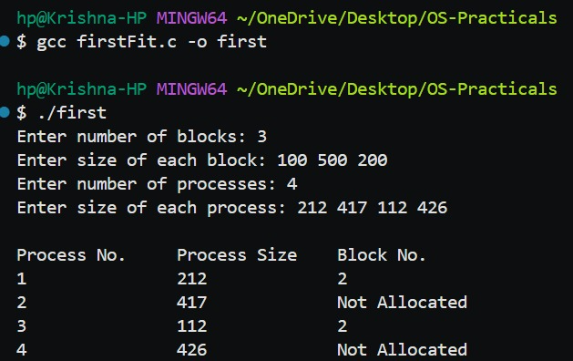
./first

Best Fit
Code:

#include <stdio.h>

int main()
{
int blockSize[10], processSize[10], allocation[10];
int bno, pno, i, j, bestIdx;

printf("Enter number of blocks: ");
scanf("%d", &bno);
printf("Enter size of each block: ");
for (i = 0; i < bno; i++)
scanf("%d", &blockSize[i]);

printf("Enter number of processes: ");
scanf("%d", &pno);
printf("Enter size of each process: ");
for (i = 0; i < pno; i++)
scanf("%d", &processSize[i]);

for (i = 0; i < pno; i++)
allocation[i] = -1;

for (i = 0; i < pno; i++)
{
bestIdx = -1;
for (j = 0; j < bno; j++)
if (blockSize[j] >= processSize[i])
if (bestIdx == -1 || blockSize[j] < blockSize[bestIdx])
bestIdx = j;

if (bestIdx != -1)
{
allocation[i] = bestIdx;
blockSize[bestIdx] -= processSize[i];
}
}

printf("\nProcess No.\tProcess Size\tBlock No.");
for (i = 0; i < pno; i++)
{
printf("\n%d\t\t%d\t\t", i + 1, processSize[i]);
if (allocation[i] != -1)
printf("%d", allocation[i] + 1);
else
printf("Not Allocated");
}
return 0;
}

Output:
gcc bestfit.c -o best
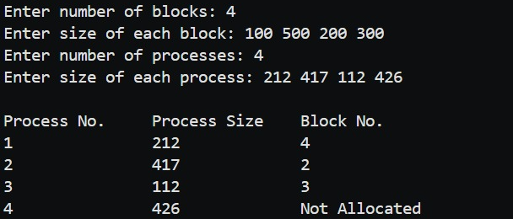
./best

Worst Fit
Code:

#include <stdio.h>

int main()
{
int blockSize[10], processSize[10], allocation[10];
int bno, pno, i, j, worstIdx;

printf("Enter number of blocks: ");
scanf("%d", &bno);
printf("Enter size of each block: ");
for (i = 0; i < bno; i++)
scanf("%d", &blockSize[i]);

printf("Enter number of processes: ");
scanf("%d", &pno);
printf("Enter size of each process: ");
for (i = 0; i < pno; i++)
scanf("%d", &processSize[i]);

for (i = 0; i < pno; i++)
allocation[i] = -1;

for (i = 0; i < pno; i++)
{
worstIdx = -1;
for (j = 0; j < bno; j++)
if (blockSize[j] >= processSize[i])
if (worstIdx == -1 || blockSize[j] > blockSize[worstIdx])
worstIdx = j;

if (worstIdx != -1)
{
allocation[i] = worstIdx;
blockSize[worstIdx] -= processSize[i];
}
}

printf("\nProcess No.\tProcess Size\tBlock No.");
for (i = 0; i < pno; i++)
{
printf("\n%d\t\t%d\t\t", i + 1, processSize[i]);
if (allocation[i] != -1)
printf("%d", allocation[i] + 1);
else
printf("Not Allocated");
}
return 0;
}

Output:
gcc worstfit.c -o worst
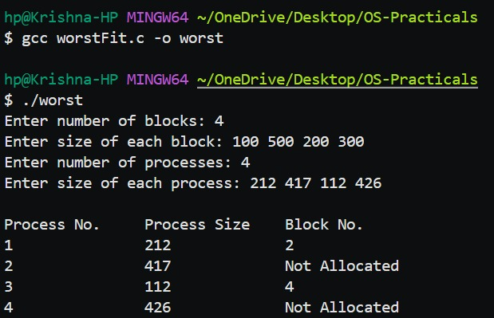
./worst

