**Problem Statement:** Create an application (Web/Mobile) which reads out News/Top news from any News websites/New Sites for the current day. Voice enabled search which picks out and reads the news when triggered with (Todays news or similar).

* Initials stages of work:
* Creation and call out API’s i.e. Everything would be with API responses. Whenever the voice enables search is triggered the API will call out the web scraping model and data is collected and reads out the top headlines.
* Voice enable Search:
  + Searching options:
    - Categories of News
    - News of a specific date. (This requires the data to be stored. - DB)
* Further stages of work:
  + Text Summarization of News
  + Based on the user interest News classified and similar news to be read out. (Recommendation System.)

**Developer details:**

|  |  |
| --- | --- |
| **Name** | **Contact details** |
| Ajinkya Bhide | [Ajinkyabhide96@gmail.com](mailto:Ajinkyabhide96@gmail.com)  <GitHub Details> |
| V Krishna Mohan | [Krishna1711mohan@gmail.com](mailto:Krishna1711mohan@gmail.com)  <https://github.com/krishna1711> |

**Work Plan**

***4/18/2020***

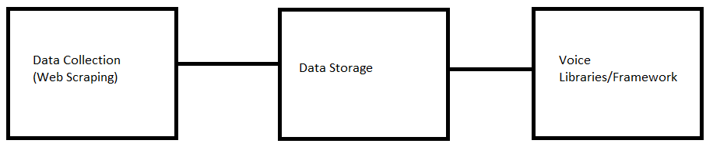

Questions to address (**Time duration**: **1/2weeks**)

Data Collection/Web scraping:

What are the news sites for data source? – News sites selection

Details of the news sites in terms of scraping like number of requests, number of news content, percentage of fakeness in the news websites?

Data Storage

Which data base and why?

Pros and cons over others and how suitable for the problem statement?

Data/storage limit of the DB?

Accessibility and fastness in accessing the data.

Synchronous or asynchronous request? (optional)

As data has to be computed how and where to compute the data, from client machine on where the data is stored?

Where to keep the database server?

Voice libraries

Which framework or software to use?

Use a framework or develop from scratch and why(reason)?

Different options and pros and cons over others for problem statement?

**Initial Architecture diagram**

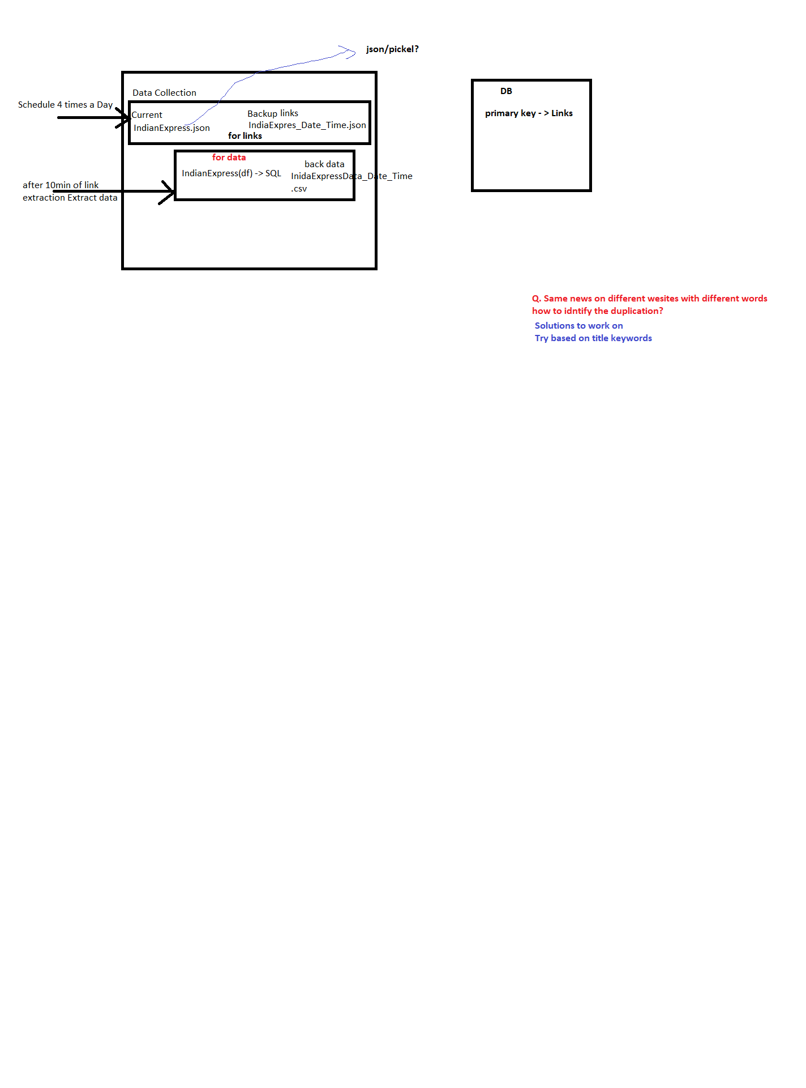

**Database Schema**

|  |  |  |  |  |  |
| --- | --- | --- | --- | --- | --- |
| **Title** | **Content** | **Location** | **Date** | **Time** | **Link** |