ELECTRICA

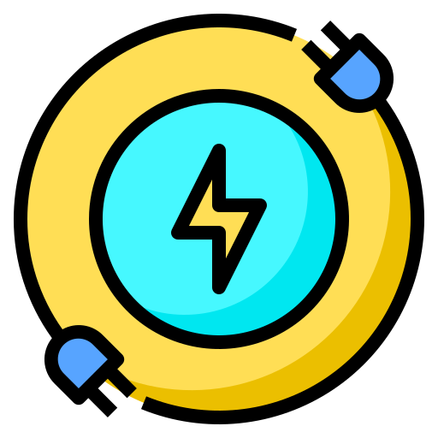



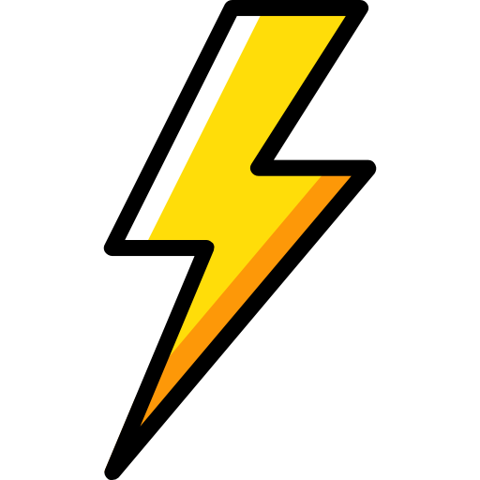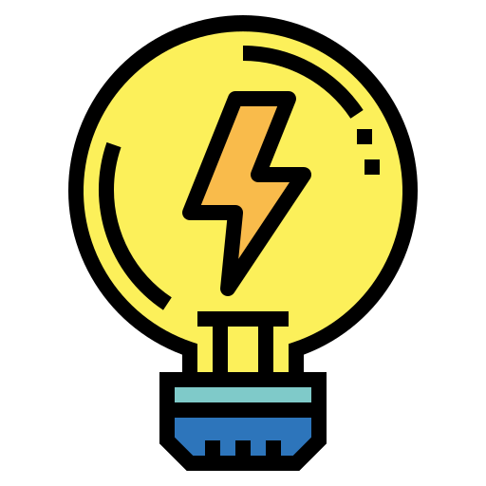

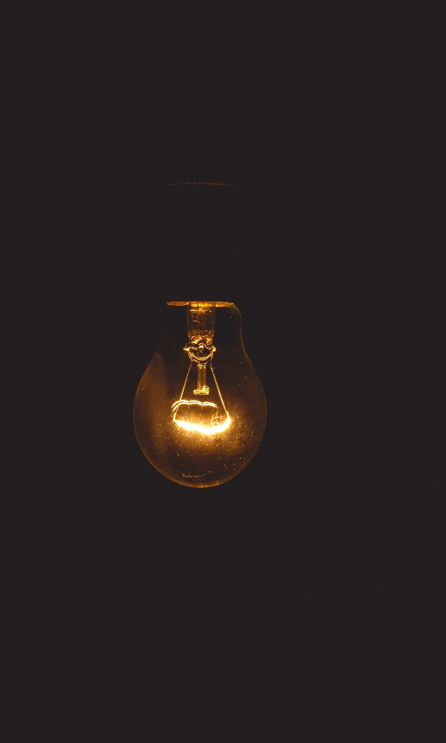

**ELECTRICA  
 - Save Electriciy**

Your Electric  
 connection is just a click away

**Charges:**

**SP (SINGLE PHASE)**

**Up to 5 kW : ₹ 50  
 CC : ₹ 2000**

**5 - 10 kW : ₹ 50  
 CC : ₹ 2000**

**TP (THREE PHASE)**

**10 - 20 kW : ₹ 75  
 CC : ₹ 4500**

**20 - 50 kW : ₹ 75  
 CC : ₹ 6500**

**50 – 150 kW : ₹ 75  
 CC : ₹ 12000**

**Above 150 kW : ₹ 75  
 CC : ₹ 250000**

**Connection charges   
   
 Supply Type  
 CHARGES : ₹   
 Requiement  
 CHARGES : ₹**

**TOTAL : ₹**

  
  
  
  
  
  
  
  
  
  
  


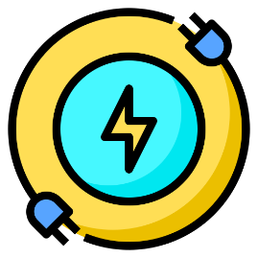

**Contact us :  
Phone: 02227894738 Email: electrica.org@gmail.com  
© 2021 Electrica**

**ADD NEW CONSUMER**

**ELECTRICA -Save Electricity   
 s**



**Contact us :  
Phone: 02227894738 Email: electrica.org@gmail.com  
© 2021 Electrica**

**ELECTRICA -Save Electricity   
 s**

**READINGS**



**Contact us :  
Phone: 02227894738 Email: electrica.org@gmail.com  
© 2021 Electrica**

**ELECTRICA -Save Electricity   
 s**

Warning free iconWarning free icon

**SEND ALERT**

**BILL OF SUPPLY**

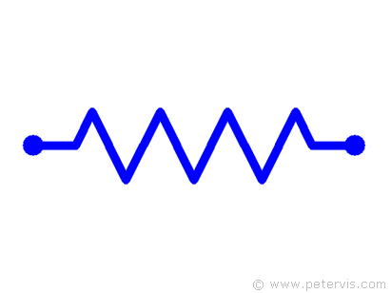

To update your email id and mobile no call us on 19122