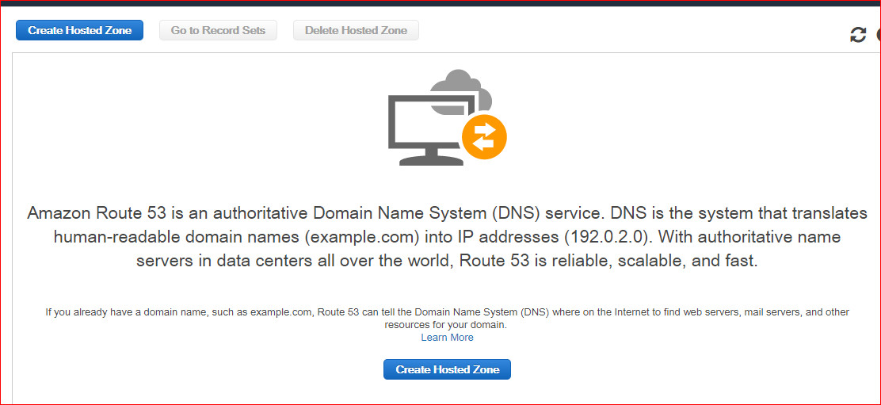

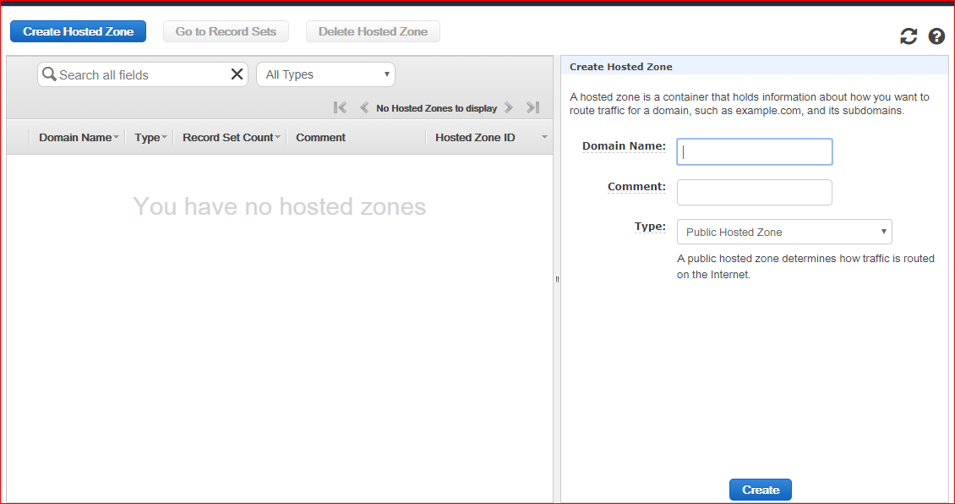

test17m.tk - give this domain in hosted hzone

before that you have to go to freenorm and create the website "test17m.tk"

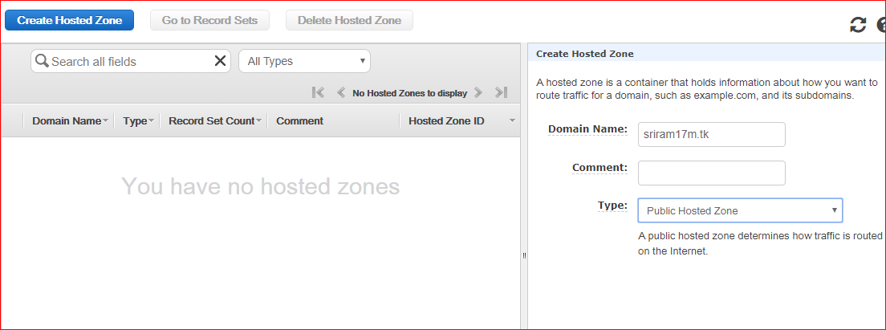

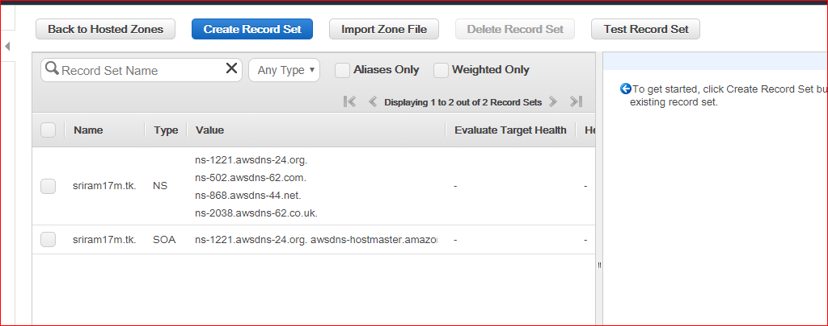

copy the above name servers(NS) to the freenom

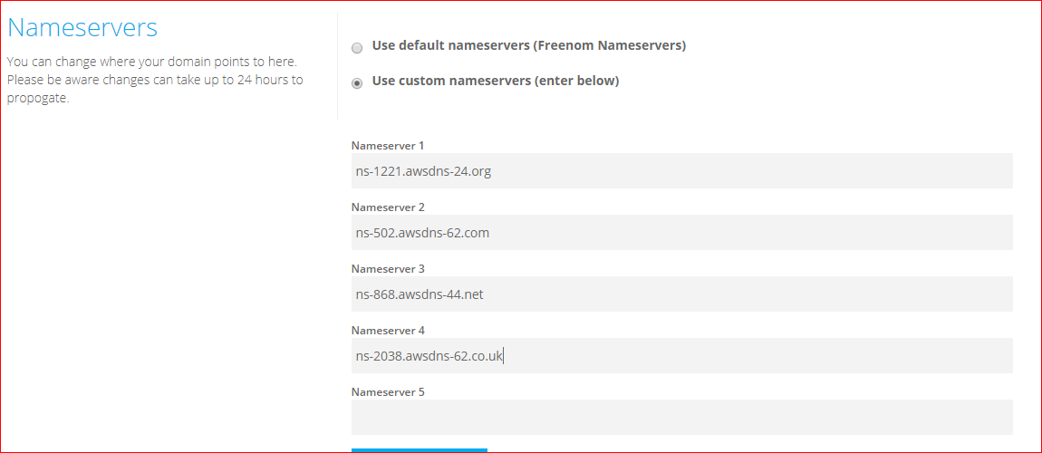

then click the {NAMESERVER} button

STep 0:-

Create domain from free websites dot.tk
Create Hosted Zone under AWS Route 53, Hosted Zone name must match with domain you created in previous step
Takse DNS servers and update them in dot.tk under your domain name servers

step1:- Create a new IAM role for EC2 with admin access.
Attache IAM role to EC2 instance

step 2:- aws configure and configure the IAM user access key and secret key with region
[ec2-user@ip-172-31-88-175 ~]$ aws configure
AWS Access Key ID [****************QMEE]:
AWS Secret Access Key [****************ceOh]:
Default region name [us-east-1]:
Default output format [None]:
[ec2-user@ip-172-31-88-175 ~]$

step 3:- Install KOPS

curl -LO https://github.com/kubernetes/kops/releases/download/$(curl -s https://api.github.com/repos/kubernetes/kops/releases/latest | grep tag_name | cut -d '"' -f 4)/kops-linux-amd64
chmod +x kops-linux-amd64
sudo mv kops-linux-amd64 /usr/local/bin/kops
kops version

Step 4:- Install kubectl :-

curl -LO https://storage.googleapis.com/kubernetes-release/release/$(curl -s https://storage.googleapis.com/kubernetes-release/release/stable.txt)/bin/linux/amd64/kubectl
curl -LO https://storage.googleapis.com/kubernetes-release/release/v1.12.0/bin/linux/amd64/kubectl
chmod +x ./kubectl
sudo mv ./kubectl /usr/local/bin/kubectl
kubectl version

step 5:-Create an AWS S3 bucket for kops to persist its state.
bucket_name=sample-kops-state-storetest17m
aws s3 mb s3://${bucket_name} --region us-east-1

Step 6:- Provide a name for the Kubernetes cluster and set the S3 bucket URL in the following environment variables.
export KOPS_CLUSTER_NAME=test17m.tk
export KOPS_STATE_STORE=s3://${bucket_name}

step 7:- Create a Kubernetes cluster definition using kops by providing the required fields
kops create cluster --state=${KOPS_STATE_STORE} --node-count=2 --master-size=t2.micro --node-size=t2.micro --zones=us-east-1a --name=${KOPS_CLUSTER_NAME}

step 8:- Now create the Kubernetes cluster on AWS by executing kops update command
kops get cluster
kops update cluster --name=${KOPS_CLUSTER_NAME} --state=${KOPS_STATE_STORE} --yes

step 9:- Above command may take some time to create the required infrastructure resources on AWS. Execute the validate command to check its status and wait until the cluster becomes ready
kops validate cluster --state=${KOPS_STATE_STORE} --name=${KOPS_CLUSTER_NAME}

step 10:-Execute the below command to find the Kubernetes master hostname using kubectl

$kubectl cluster-info

step 11:- To connect to the master and check the connection
ssh -i ~/.ssh/id_rsa admin@api.test17m.tk

you will land into the container now exit out of it

step 12:-

[ec2-user@ip-172-31-88-175 ~]$ cat pods.yml --> create one vi pods.yml
apiVersion: v1
kind: ReplicationController
metadata:
name: nodeapp
labels:
app: nodeapp
spec:
replicas: 8
selector:
app: nodeapp
template:
metadata:
labels:
app: nodeapp
spec:
containers:
- name: nodeapp
image: kammana/nodeapp:v1
ports:
- containerPort: 8080

[ec2-user@ip-172-31-88-175 ~]$

step 13:- kubectl create -f pods.yml

step 14:- kubectl get pods
[ec2-user@ip-172-31-88-175 ~]$ kubectl get pods
NAME READY STATUS RESTARTS AGE
nodeapp 1/1 Running 0 46m
nodeapp-6qjl2 1/1 Running 0 41m
nodeapp-74qhw 1/1 Running 0 41m
nodeapp-bzct5 1/1 Running 0 41m
nodeapp-jnvp4 1/1 Running 0 41m
nodeapp-ldjbq 1/1 Running 0 41m
nodeapp-s69p5 1/1 Running 0 41m
nodeapp-w45jv 1/1 Running 0 41m

step 15:-

[ec2-user@ip-172-31-88-175 ~]$ kubectl describe pods nodeapp
Name: nodeapp
Namespace: default
Priority: 0
PriorityClassName: <none>
Node: ip-172-20-52-116.ec2.internal/172.20.52.116
Start Time: Sun, 16 Jun 2019 05:25:45 +0000
Labels: app=nodeapp
Annotations: kubernetes.io/limit-ranger: LimitRanger plugin set: cpu request for container nodeapp
Status: Running
IP: 100.96.1.2
Controlled By: ReplicationController/nodeapp
Containers:
nodeapp:
Container ID: docker://fbe30ada3c0e006ffd07d10a2fae144d233fb8c5404b3196fa2de502fbaf6430
Image: kammana/nodeapp:v1
Image ID: docker-pullable://kammana/nodeapp@sha256:2353f9003fb48fb162df6bf8cbd90823c0f0a90e68c87086ae4f1478010a70bb
Port: 8080/TCP
Host Port: 0/TCP
State: Running

step 16:- Now expose the port 8080 which is shown by below command

kubectl expose pods nodeapp --type="NodePort" --port 8080

step 17:-
[ec2-user@ip-172-31-88-175 ~]$ kubectl get service
NAME TYPE CLUSTER-IP EXTERNAL-IP PORT(S) AGE
kubernetes ClusterIP 100.64.0.1 <none> 443/TCP 71m
nodeapp NodePort 100.67.57.241 <none> 8080:31750/TCP 49m

step 18:- now go inside the container:-

[ec2-user@ip-172-31-88-175 ~]$ kubectl get service
NAME TYPE CLUSTER-IP EXTERNAL-IP PORT(S) AGE
kubernetes ClusterIP 100.64.0.1 <none> 443/TCP 71m
nodeapp NodePort 100.67.57.241 <none> 8080:31750/TCP 49m

[ec2-user@ip-172-31-88-175 ~]$ ssh -i ~/.ssh/id_rsa admin@api.test17m.tk
Linux ip-172-20-47-224 4.9.0-9-amd64 #1 SMP Debian 4.9.168-1 (2019-04-12) x86_64

The programs included with the Debian GNU/Linux system are free software;
the exact distribution terms for each program are described in the
individual files in /usr/share/doc/*/copyright.

Debian GNU/Linux comes with ABSOLUTELY NO WARRANTY, to the extent
permitted by applicable law.
Last login: Sun Jun 16 05:31:58 2019 from 3.90.3.235

admin@ip-172-20-47-224:~$ curl http://100.67.57.241:8080
<h1>Java Home - Version 1 - Running on Kubernetes!!!!!</h1>
admin@ip-172-20-47-224:~$

step 19:-
Now go to the EC2- master INSTANCe created by Kubernetes and make the SECURITY GROUP INBOUNDS and outbounds rule so that it will allow all.

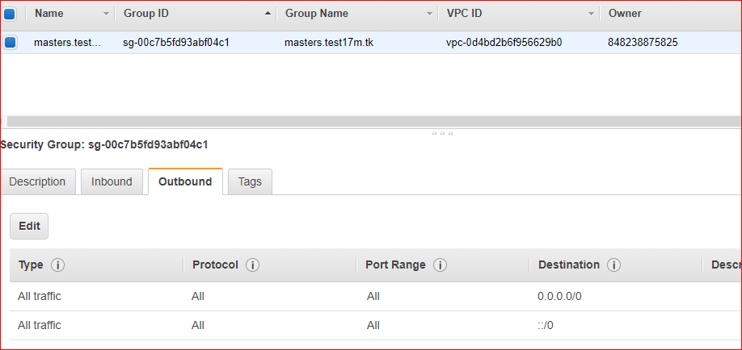
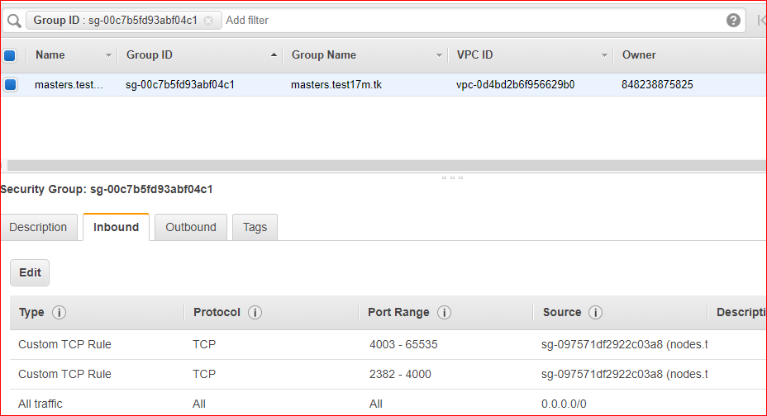

step 20:-
Now take the public ip of EC2-MASTER instance and take port "31750"
[ec2-user@ip-172-31-88-175 ~]$ kubectl get service
NAME TYPE CLUSTER-IP EXTERNAL-IP PORT(S) AGE
kubernetes ClusterIP 100.64.0.1 <none> 443/TCP 71m
nodeapp NodePort 100.67.57.241 <none> 8080:31750/TCP 49m

