step 1:-go to route 53 and create record host and add the same in above in freenorm DNS.
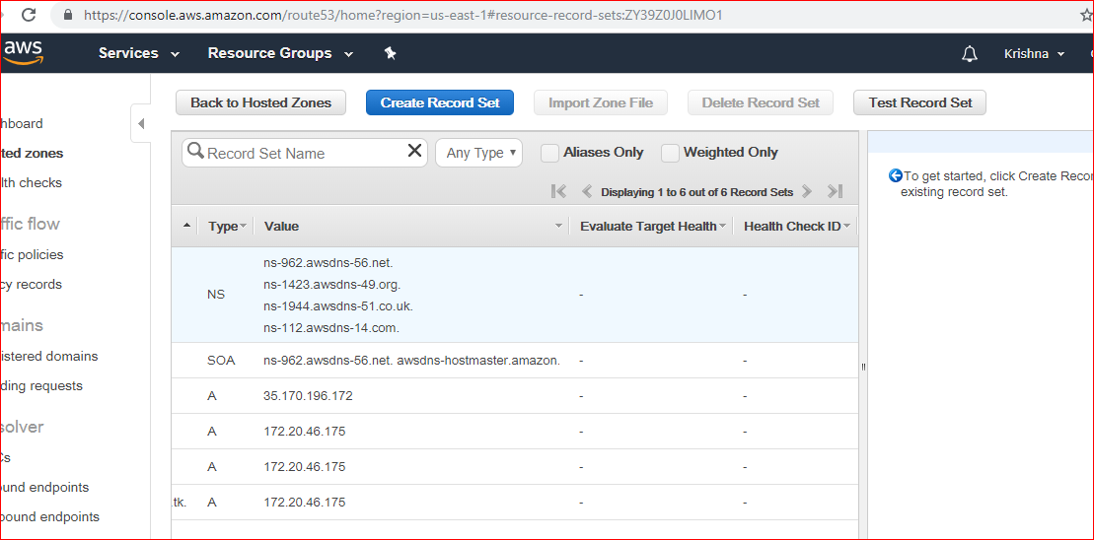

step 2:-
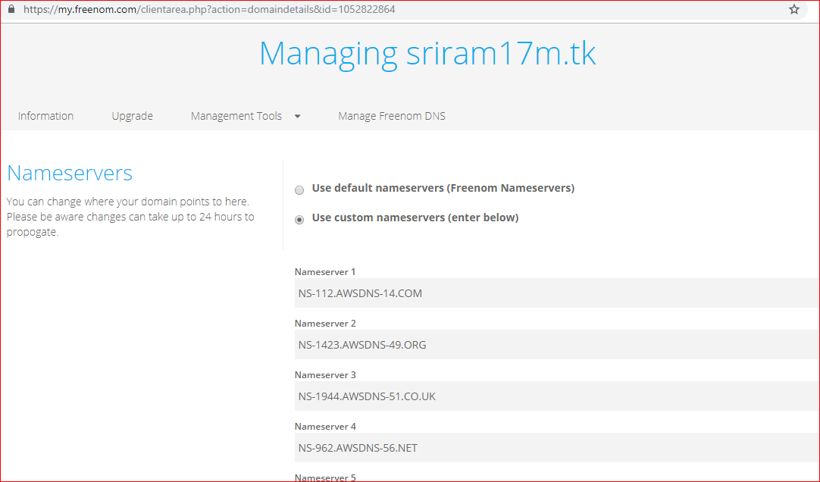

1) first go to freenom and get the domain

2) then you need to add the domain to aws route-53

3) follow Hari's document of Kubernetes change the region and s3 bucket wrt to yours
https://github.com/javahometech/kubernetes -

4) then follow Hari's document of pods
https://github.com/javahometech/kubernetes/tree/master/pods

admin@ip-172-20-46-175:~$ kubectl get service nodeapp
NAME TYPE CLUSTER-IP EXTERNAL-IP PORT(S) AGE
nodeapp NodePort 100.65.74.48 <none> 8080:31347/TCP 1h
admin@ip-172-20-46-175:~$

go to master instance and route-association - all (anywhere) make the gatewall all

admin@ip-172-20-46-175:~$ curl http://100.96.1.4:8080
<h1>Java Home - Version 1 - Running on Kubernetes!!!!!</h1>
admin@ip-172-20-46-175:~$

https://<master instance>:31347 it should run the webpage

kubectl get service /nodeapp - it will give exposed port

then go to master ip and
Liux
admin@ip-172-20-46-175:~$ kubectl describe pods/nodeapp ------------run this command and get the ip
Name: nodeapp
Namespace: default
Priority: 0
PriorityClassName: <none>
Node: ip-172-20-49-136.ec2.internal/172.20.49.136
Start Time: Sat, 23 Feb 2019 14:19:40 +0000
Labels: app=nodeapp
Annotations: kubernetes.io/limit-ranger=LimitRanger plugin set: cpu request for container nodeapp
Status: Running
IP: 100.96.1.4

[ec2-user@ip-172-31-85-168 ~]$ ssh -i ~/.ssh/id_rsa admin@api.sriram17m.tk
Linux ip-172-20-46-175 4.9.0-7-amd64 #1 SMP Debian 4.9.110-3+deb9u2 (2 018-08-13) x86_64

The programs included with the Debian GNU/Linux system are free softwa re;
the exact distribution terms for each program are described in the
individual files in /usr/share/doc/*/copyright.

Debian GNU/Linux comes with ABSOLUTELY NO WARRANTY, to the extent
permitted by applicable law.
Last login: Sat Feb 23 16:41:50 2019 from 54.85.101.234
admin@ip-172-20-46-175:~$ curl http://100.96.1.4:8080
<h1>Java Home - Version 1 - Running on Kubernetes!!!!!</h1>
admin@ip-172-20-46-175:~$ kubectl get service nodeapp
NAME TYPE CLUSTER-IP EXTERNAL-IP PORT(S) AGE
nodeapp NodePort 100.65.74.48 <none> 8080:31347/TCP 1h
admin@ip-172-20-46-175:~$ kubectl expose pods/nodeapp --type="NodePort " --port 8080
Error from server (AlreadyExists): services "nodeapp" already exists

