**PORTFOLIO**

ASSIGNMENT OF CSE111

(ORIENTATION TO COMPUTING-1)

# COMPUTER SCIENCE AND ENGINEERING

Submitted by: Krishna

Name: Krishna

Registration number: 12419827

Roll No.: 43

Section: K24DW

Submitted to : Sweta Panday



**LOVELY PROFESSIONAL UNIVERSITY**

# DECLARATION

I,Krishna, a student of Bachelor of Technology under CSE discipline at Lovely Professional University, Punjab, hereby declare that all the information furnished in this project report is based on my own work and is genuine

Registrartion Number: 12419827

|  |  |  |
| --- | --- | --- |
| Platforms for profile creation | Link to student profile | Screenshot |
| Figma | https://www.figma.com/files/team/1438833188444665862/user/1438833186754442592?fuid=1438833186754442592 | **1** |
| Quora and Linkedin | https://www.quora.com/profile/Krishna-Arora-82 | **2** |
| Stack overflow | https://stackoverflow.com/users/28296484/krishna-arora | **3** |
| Hacker Rank | https://www.hackerrank.com/profile/krishnaarora673 | **4** |
| Hacker Earth | https://www.hackerearth.com/@krishnaarora673/ | **5-6** |
| Geeks for Geeks | https://www.geeksforgeeks.org/user/krishnaaxp8v/ | **7** |
| Github | https://github.com/krishna2027 | **8** |
| Git |  | **9** |
| CV | https://krishna2027.github.io/CVVDOC/ | **10** |
| Technical mooc registration Link and screenshot | https://risingtechpro.com/Prep-master/WebD.html | **11** |

## FIGMA

**Profile:**

**Figma internal profile with project**

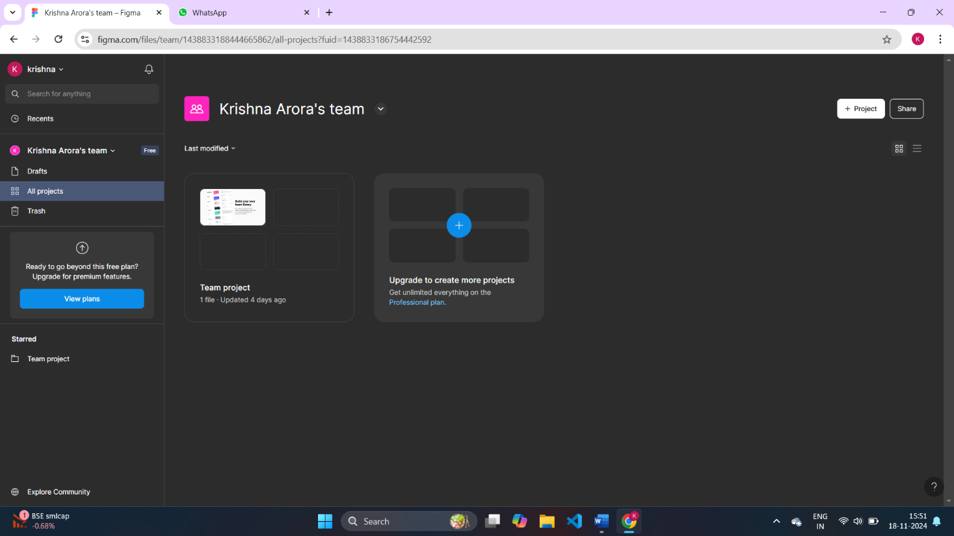

## QUORA

**PROFILE AND ACCOMPLISHMENT:**

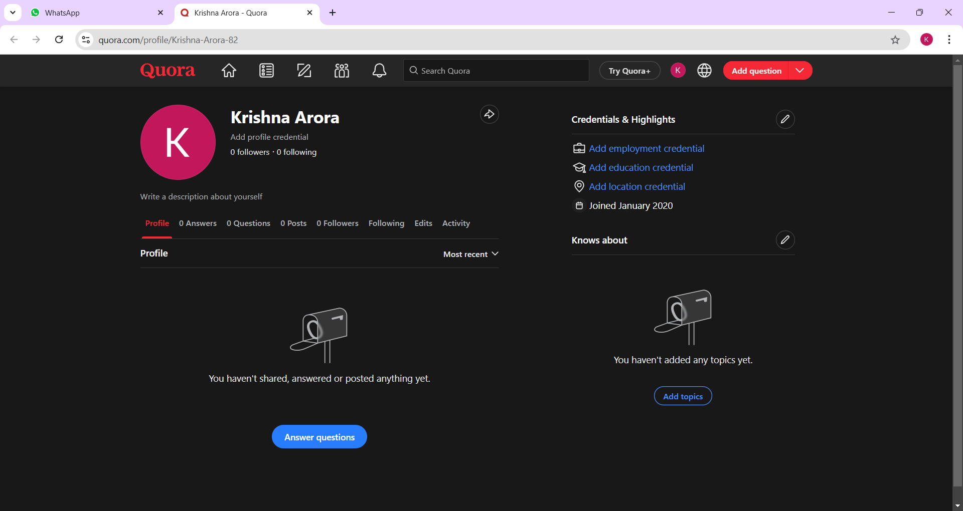

## STACKOVERFLOW

**PROFILE:**

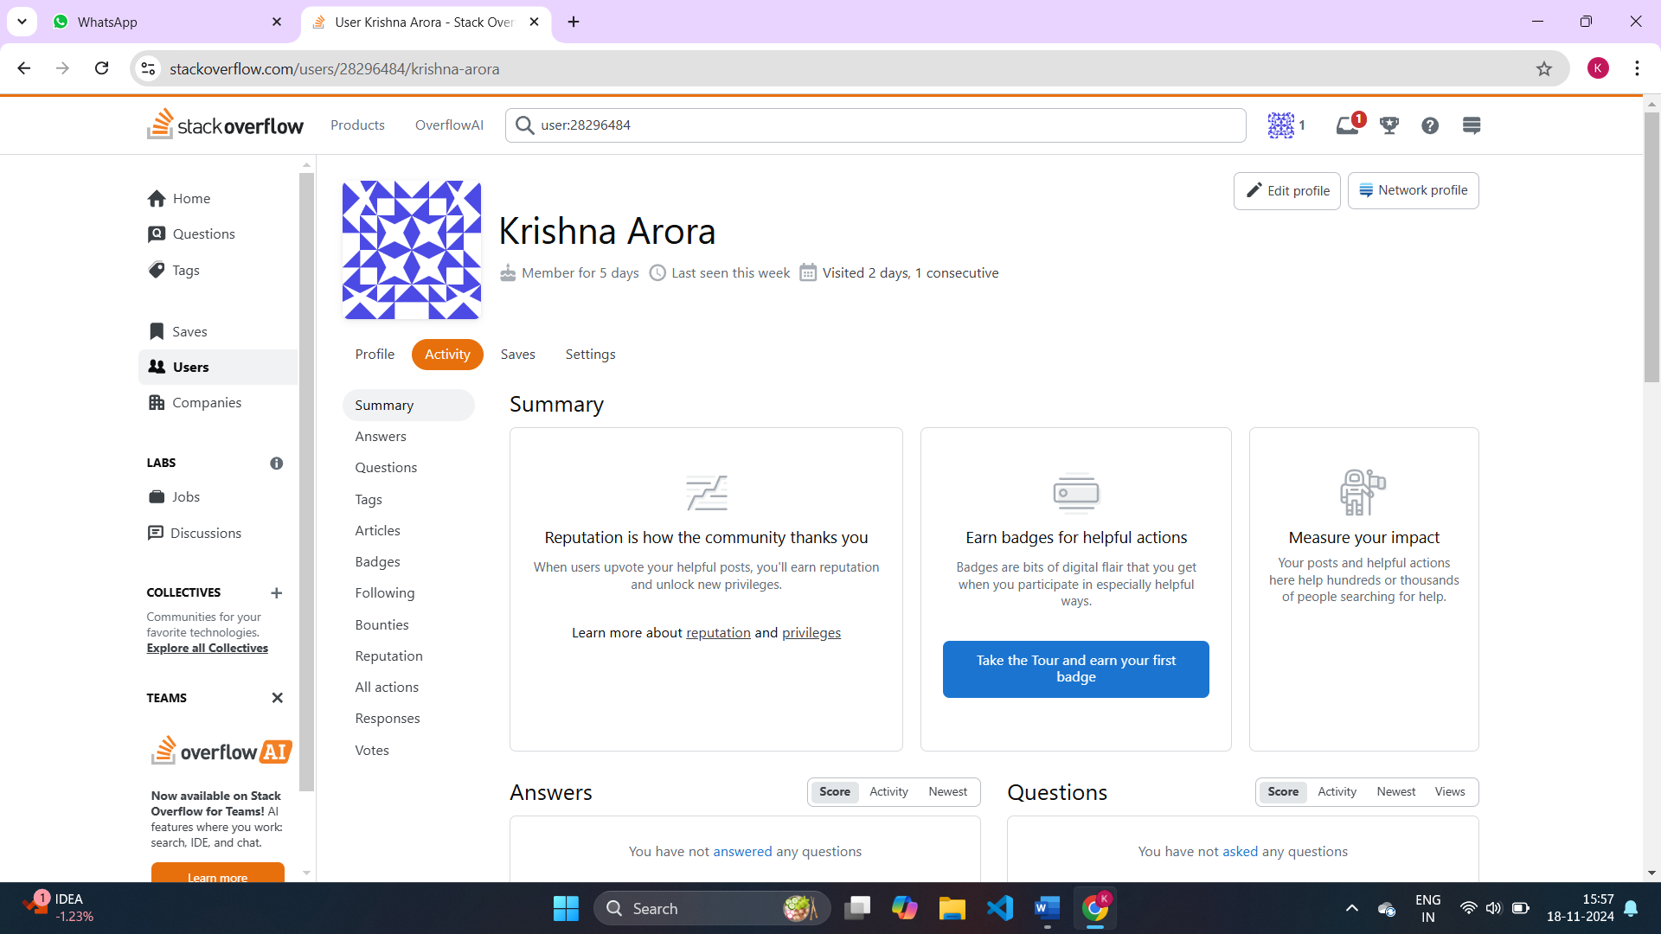

## HACKER RANK

**Profile:**

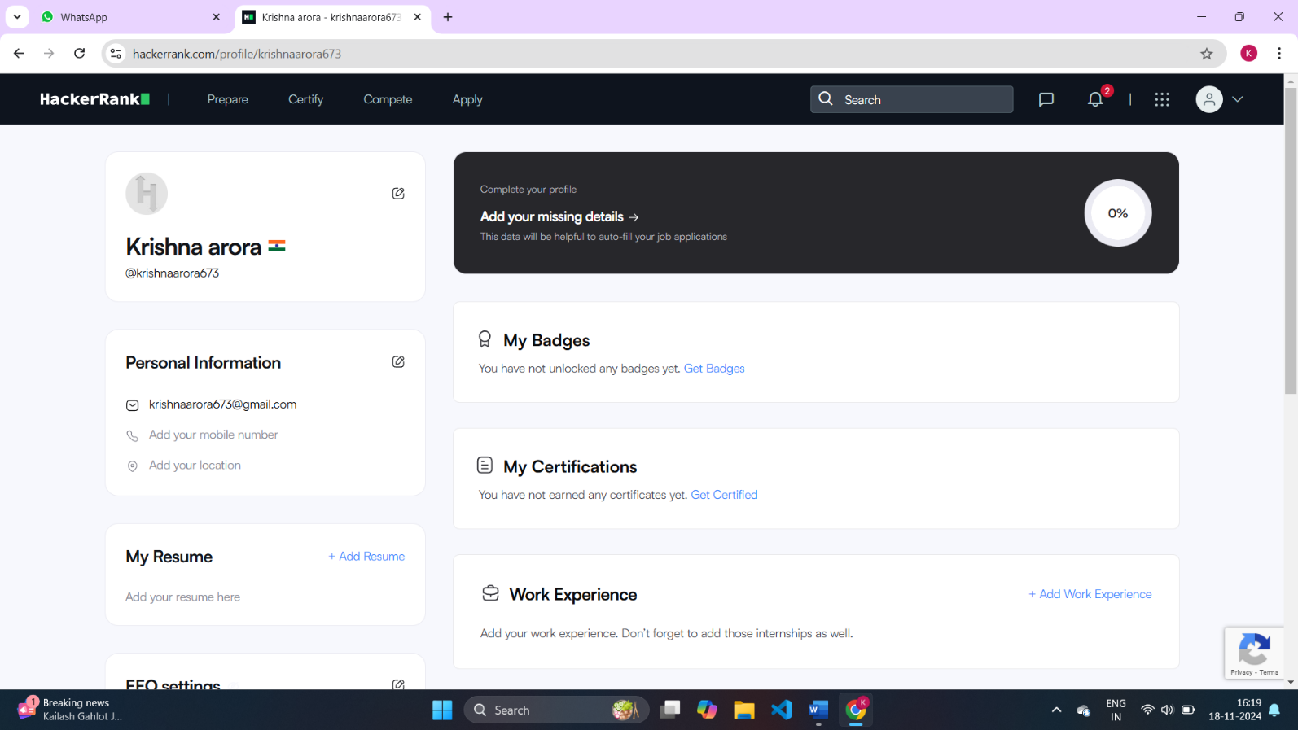

## HACKER EARTH

**Profile:**

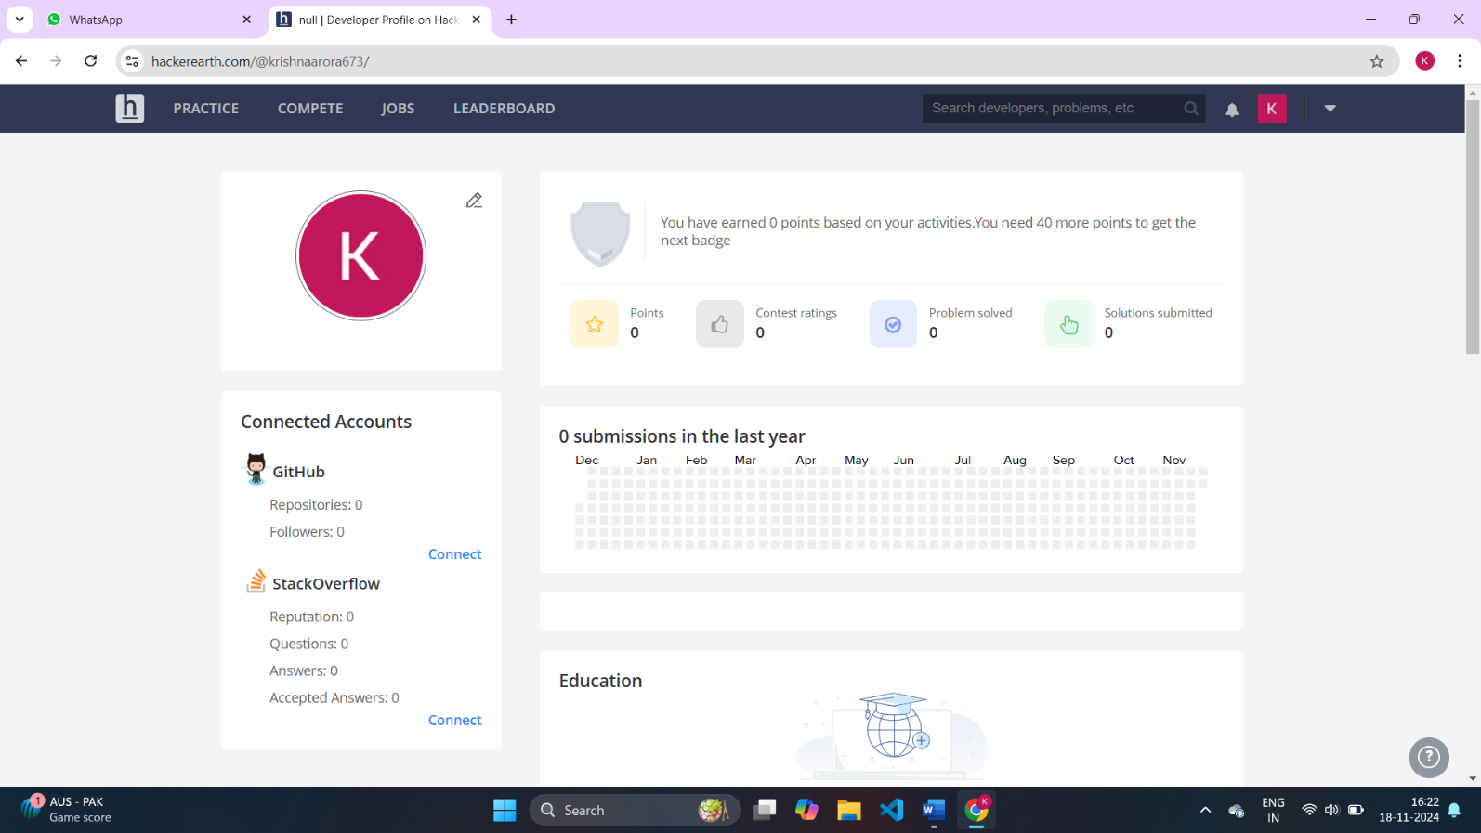

**6**

## GEEKS FOR GEEKS

**Profile:**

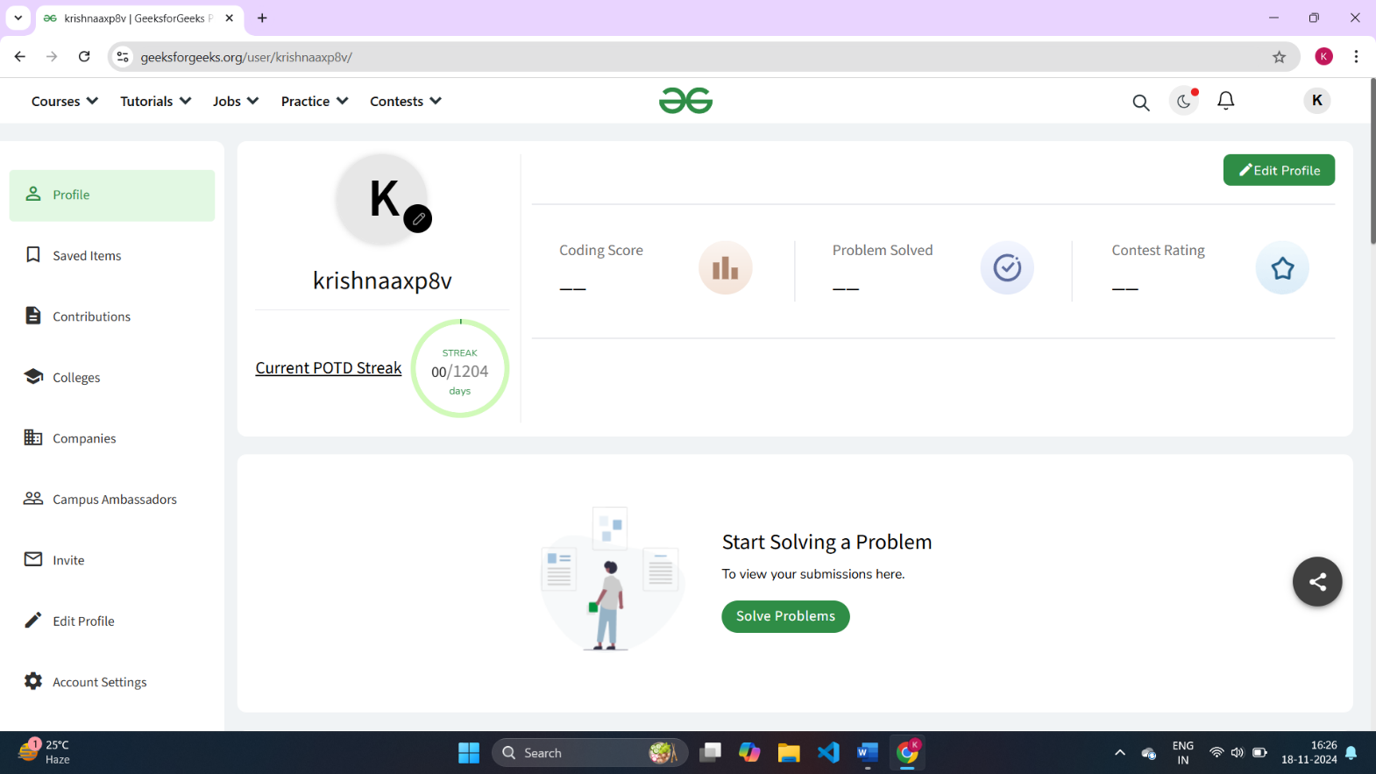

## GITHUB

**Profile:**

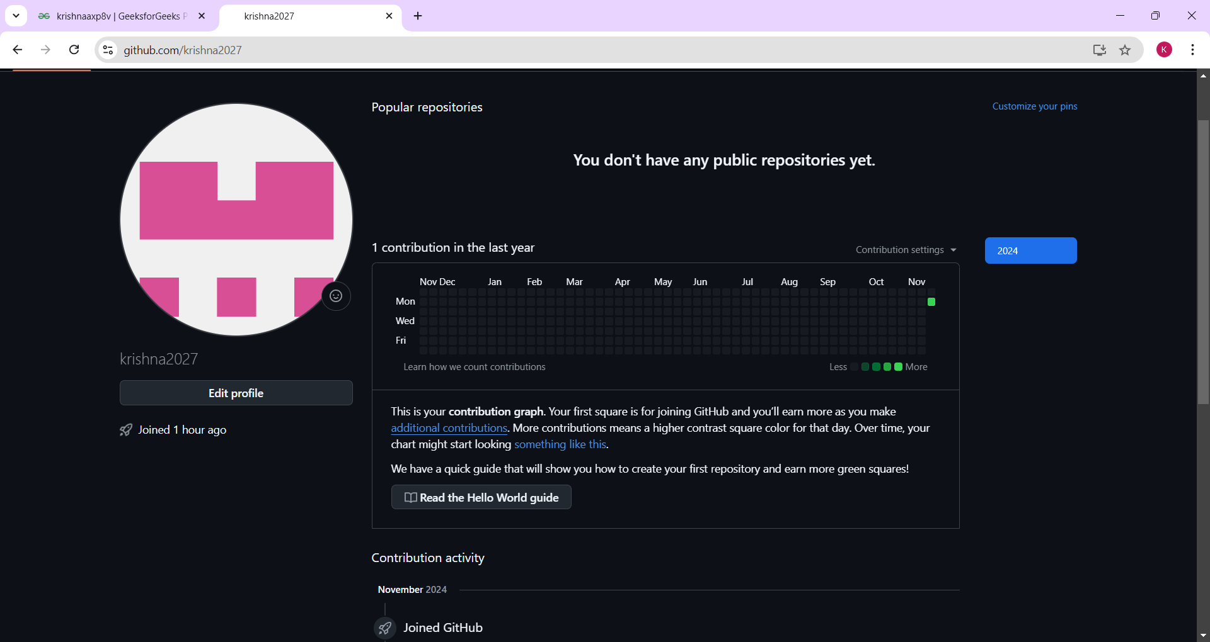

**CV**

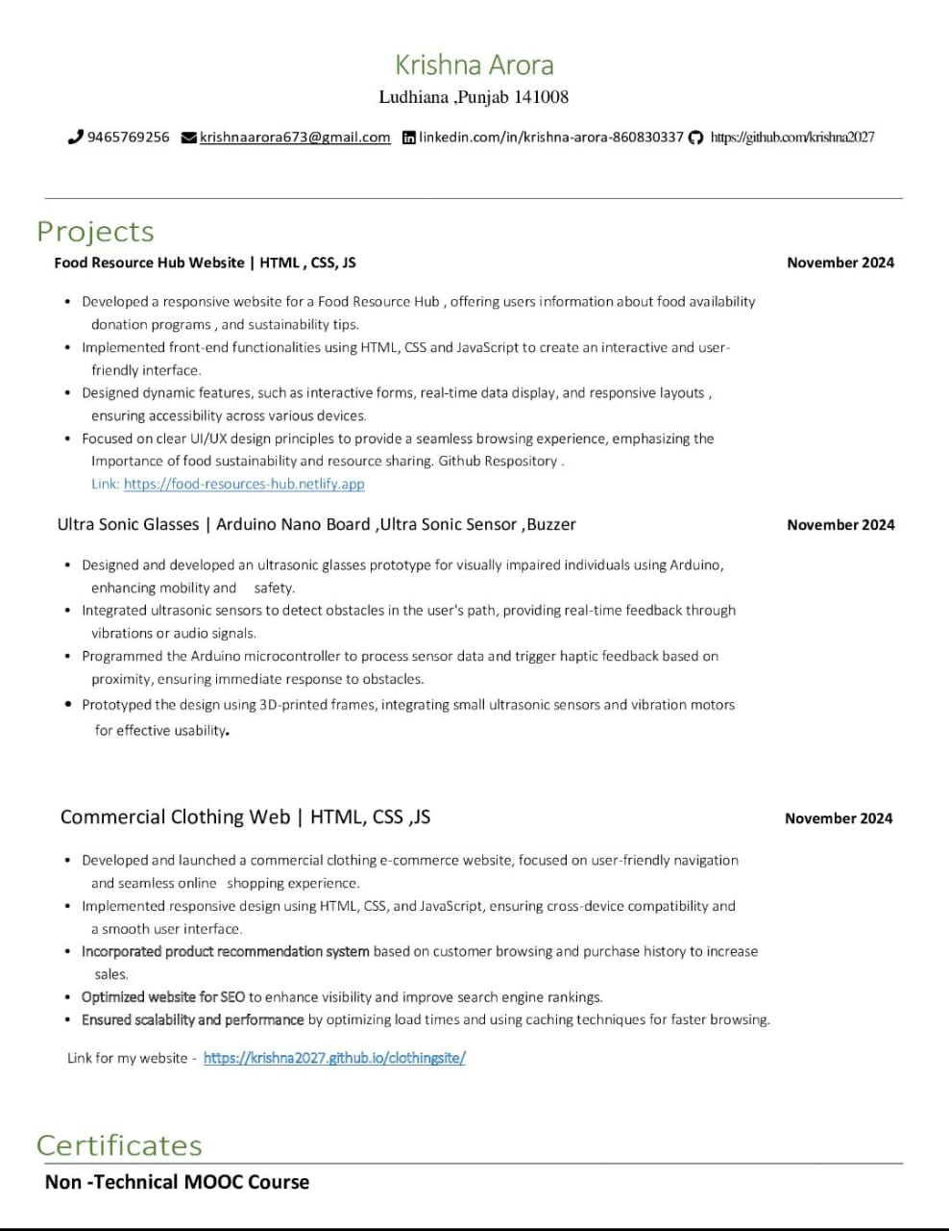

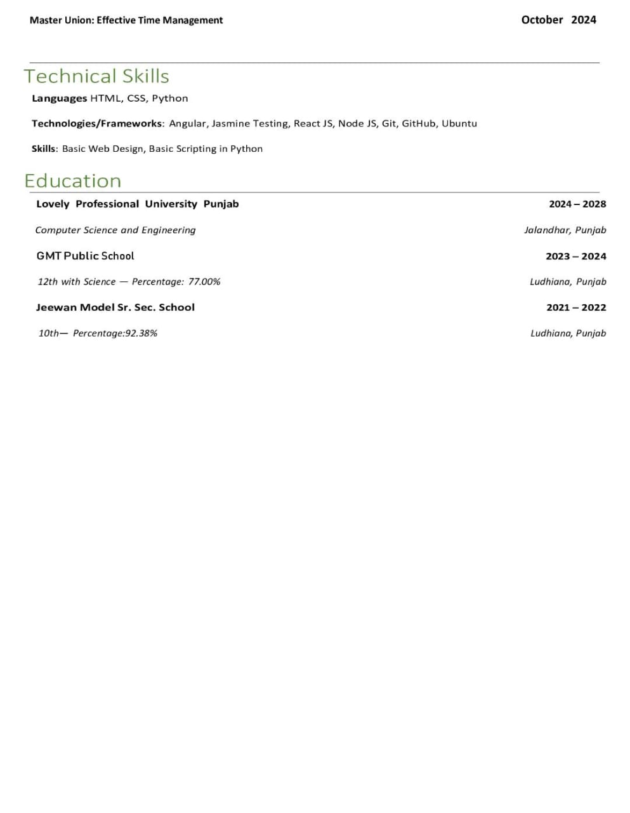

## Technical MOOCS registration Link and screenshot:-

