Alvin Jeng
Nitay Joffe
April 19, 2005
CSE 140L

Lab 1:
Combinational Circuit Design:
Hierarchical Ripple Adder and MUX

We worked on the lab together instead of splitting it up, so our contributions were equal.
Part I: Tutorial
Intro/Tutorial to Xilinx:
With Xilinx, you build your project via a number of different parts, and combining those parts into one larger circuit design. By insuring that the smaller parts function correct, one can eliminate the possibility of running into simulation errors. Testing each part individually first prevents possible mistakes.

Part II: Adders
Half Adder Design - the Sum is XOR, Carry out is AND:

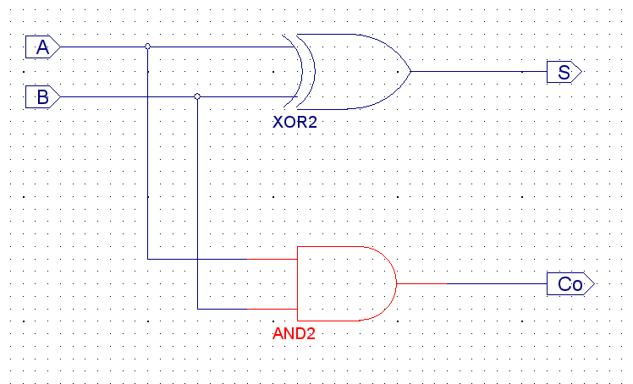

Full Adder Design – using two half adders together:
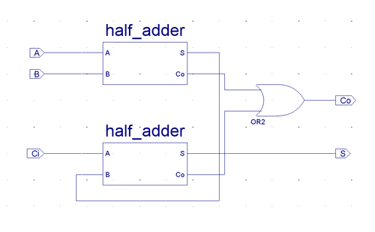

4bit Adder Design - the carry outs are routed to the carry in of the next full adder:
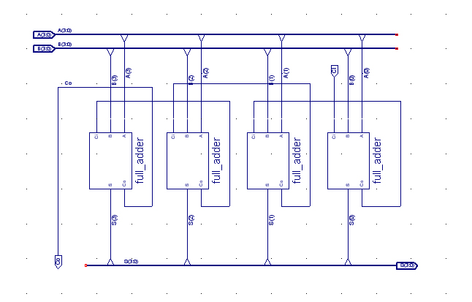

Random values (using random waveforms) testing of the 4bit Adder:

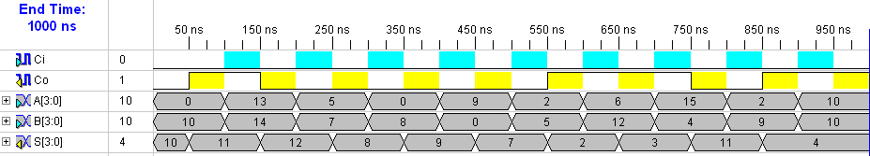

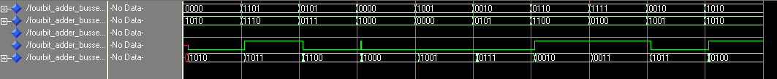

The results are correct. Our 4bit adder functions as expected.

Critical Path Delay of 4bit Adder:

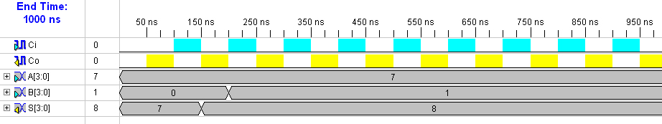

Data Sheet report:  -----------------  All values displayed in nanoseconds (ns)  Pad to Pad  ---------------+---------------+---------+  Source Pad |Destination Pad| Delay |  ---------------+---------------+---------+  A<0> |Co | 8.792|  A<0> |S<0> | 6.077|  A<0> |S<1> | 7.145|  A<0> |S<2> | 7.612|  A<0> |S<3> | 9.148|  A<1> |Co | 8.581|  A<1> |S<1> | 7.361|  A<1> |S<2> | 6.822|  A<1> |S<3> | 8.937|  A<2> |Co | 6.040|  A<2> |S<2> | 7.841|  A<2> |S<3> | 6.195|  A<3> |Co | 5.869|  A<3> |S<3> | 6.641|  B<0> |Co | 9.044|  B<0> |S<0> | 5.974|  B<0> |S<1> | 7.263|  B<0> |S<2> | 7.864|  B<0> |S<3> | 9.400|  B<1> |Co | 8.924|  B<1> |S<1> | 7.841|  B<1> |S<2> | 6.876|  B<1> |S<3> | 9.280|  B<2> |Co | 6.551|  B<2> |S<2> | 7.927|  B<2> |S<3> | 6.340|  B<3> |Co | 5.816|  B<3> |S<3> | 6.588|  Ci |Co | 9.006|  Ci |S<0> | 6.187|  Ci |S<1> | 7.362|  Ci |S<2> | 7.826|  Ci |S<3> | 9.362|  ---------------+---------------+---------+  Analysis completed Mon Apr 18 20:57:36 2005  The Longest amount of time is from the B[0] bit to the S[3] bit being set. 9.400 is the amount of time and is verified when JUST the b[0] bit is set at 200ns after A[0]-A[2] are set in order to JUST HAVE the S[3] bit set after all of the adding is complete | 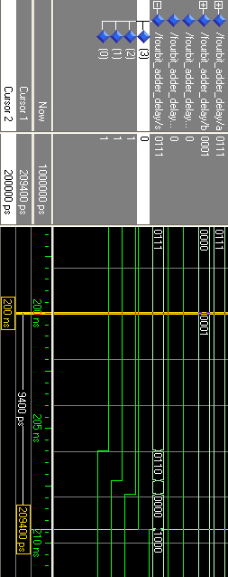

16bit Adder Design – using chaining of 4bit Adders, carry outs routed to next carry in:

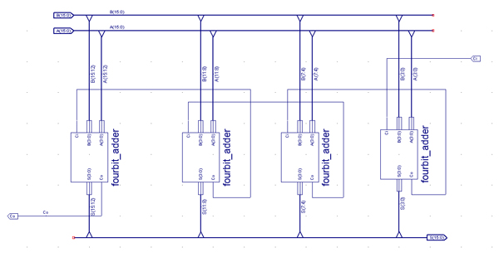
Random values (using random waveforms) testing of 16bit Adder:

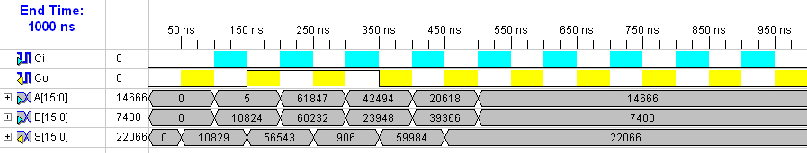

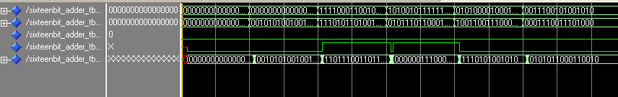

The results are correct. Our 16it Adder functions as expected.

Critical Path Delay of 16bit Adder:

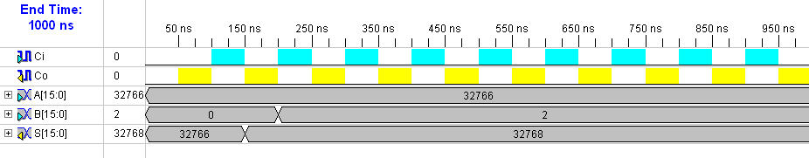

Data Sheet report:  -----------------  All values displayed in nanoseconds (ns)  Pad to Pad  ---------------+---------------+---------+  Source Pad |Destination Pad| Delay |  ---------------+---------------+---------+  A<0> |Co | 18.227|  A<0> |S<0> | 6.194|  A<0> |S<10> | 14.169|  A<0> |S<11> | 14.854|  A<0> |S<12> | 15.010|  A<0> |S<13> | 17.503|  A<0> |S<14> | 17.719|  A<0> |S<15> | 18.281|  …  A<1> |Co | 17.887|  A<1> |S<10> | 13.829|  A<1> |S<11> | 14.514|  A<1> |S<12> | 14.670|  A<1> |S<13> | 17.163|  A<1> |S<14> | 17.379|  A<1> |S<15> | 17.941|  …  B<1> |S<10> | 14.232|  B<1> |S<11> | 14.917|  B<1> |S<12> | 15.073|  B<1> |S<13> | 17.566|  B<1> |S<14> | 17.782|  B<1> |S<15> | 18.344|  B<1> |S<1> | 6.884|  B<1> |S<2> | 6.370|  B<1> |S<3> | 7.391|  B<1> |S<4> | 8.651|  B<1> |S<5> | 9.684|  B<1> |S<6> | 10.311|  B<1> |S<7> | 12.167|  B<1> |S<8> | 11.693|  B<1> |S<9> | 12.290|  …  Analysis completed Mon Apr 18 21:11:05 2005  The same is done like the 4-bit adder. The B[1] was set at 200 ns in order to verify the amount of time before the S[15] bit is set. It has been verified | 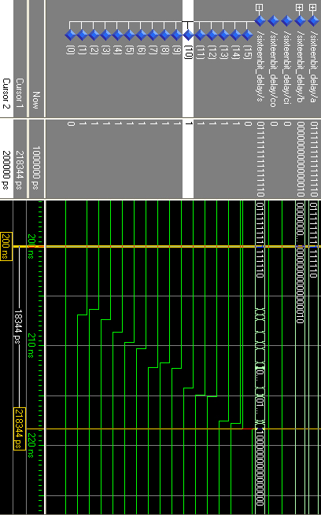

Part III: Multiplexers
2to1 Multiplexer Design – Output is OR of inputs ANDed with their corresponding address:
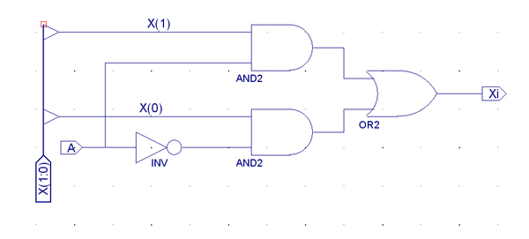
4to1 Multiplexer Design – using chaining of 2to1 Multiplexers:
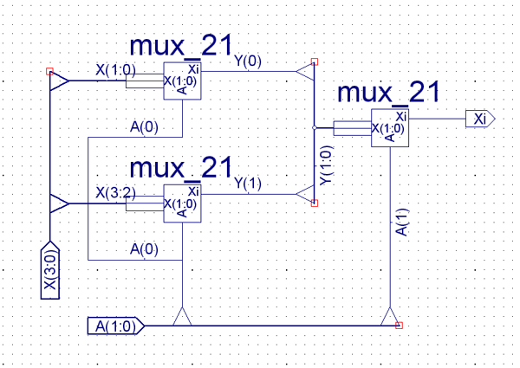
The key to our multiplexer design is using divide-and-conquer to split up the inputs into 2-bit segments that the 2to1 Multiplexer can handle and then chaining 2to1 Multiplexers together to simplify the problem. The first level reduces the number of input from four to two, and the second level chooses one input from those two. This uses a similar chaining technique as the adders in the previous portion of the lab.
Test 4to1 Multiplexer to ensure every possible address retrieves a different input channel:

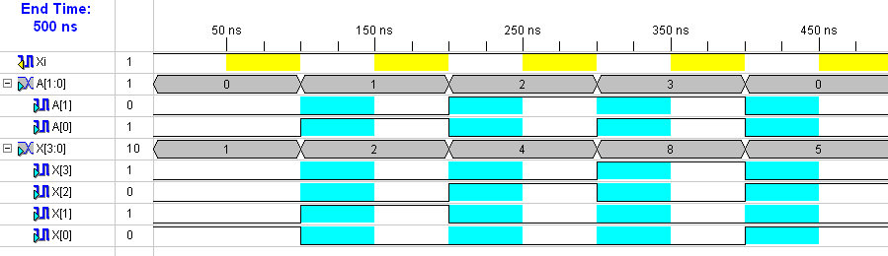
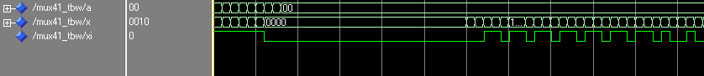

Data Sheet report:  -----------------  All values displayed in nanoseconds (ns)  Pad to Pad  ---------------+---------------+---------+  Source Pad |Destination Pad| Delay |  ---------------+---------------+---------+  A<0> |Xi | 7.286|  A<1> |Xi | 7.430|  X<0> |Xi | 7.544|  X<1> |Xi | 7.464|  X<2> |Xi | 7.077|  X<3> |Xi | 7.446|  ---------------+---------------+---------+  Analysis completed Mon Apr 18 22:56:42 2005 | 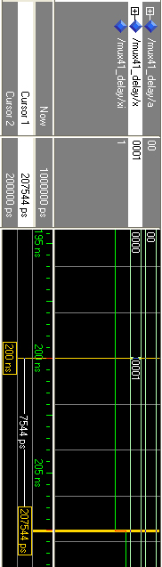

Each possible address maps to a different input signal so our 4to1 Multiplexer works as expected.

16to1 Multiplexer – using chaining of 4to1 Multiplexers:
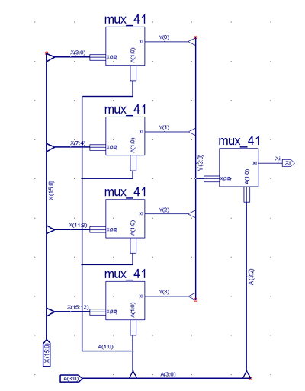

The 16to1 multiplexer design uses the same idea as the 4to1 Multiplexer. It divides the inputs into segments of four and uses 4to1 Multiplexers to choose from each of those. Then it accumulates each chosen input into another four bit channel, and uses another 4to1 Multiplexer to select and input from that. The net effect is one input chosen from 16 possibilities.

Test 16to1 Multiplexer to ensure every possible address retrieves a different input channel:

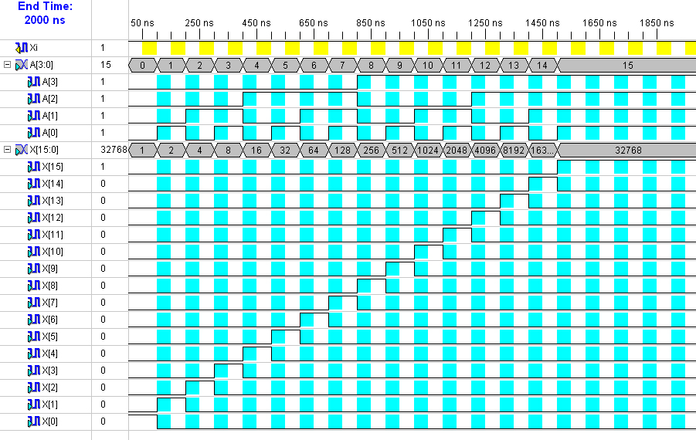

Each unique address maps to a different input channel so our 16to1 Multiplexer works as expected.

Critical Path Delay of 16to1 Multiplexer:
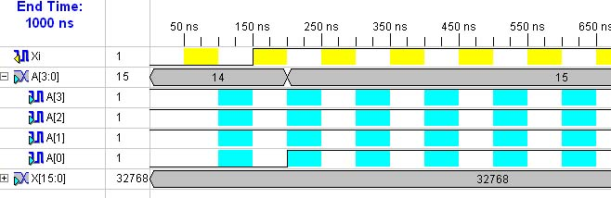
Data Sheet report:  -----------------  All values displayed in nanoseconds (ns)  Pad to Pad  ---------------+---------------+---------+  Source Pad |Destination Pad| Delay |  ---------------+---------------+---------+  A<0> |Xi | 11.319|  A<1> |Xi | 10.795|  A<2> |Xi | 8.893|  A<3> |Xi | 7.302|  X<0> |Xi | 8.517|  X<10> |Xi | 9.484|  X<11> |Xi | 9.430|  X<12> |Xi | 9.311|  X<13> |Xi | 9.483|  X<14> |Xi | 9.611|  X<15> |Xi | 9.405|  X<1> |Xi | 8.820|  X<2> |Xi | 8.065|  X<3> |Xi | 8.279|  X<4> |Xi | 9.588|  X<5> |Xi | 9.302|  X<6> |Xi | 7.923|  X<7> |Xi | 7.813|  X<8> |Xi | 9.848|  X<9> |Xi | 9.859|  ---------------+---------------+---------+  Analysis completed Mon Apr 18 23:06:33 2005 | 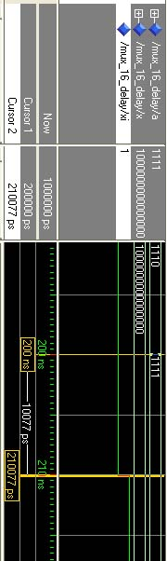
For some reason we couldn’t get the simulation to match the expected delay no matter what combinations we tried. This is the closest we were able to get to our expected delay.

