Alvin Jeng
Nitay Joffe
May 3, 2005
CSE 140L

Lab 2:
The Specification and Usage of Flip-Flops
I. Serial to Parallel Shift Register

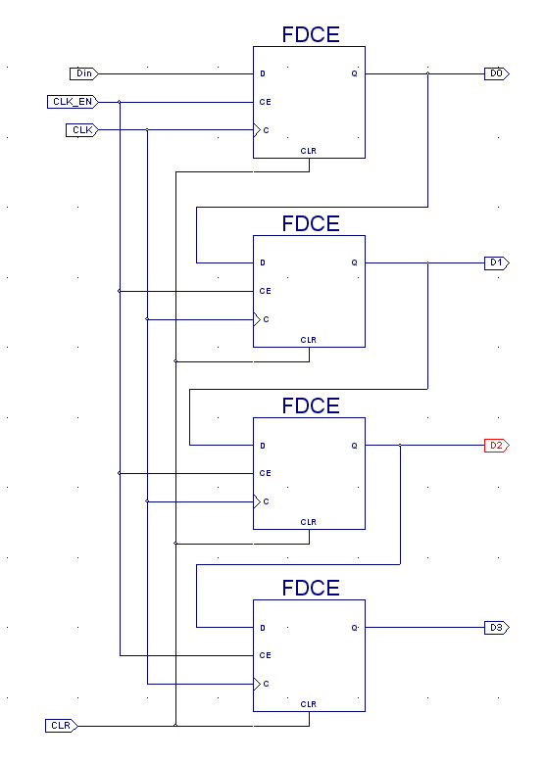 | 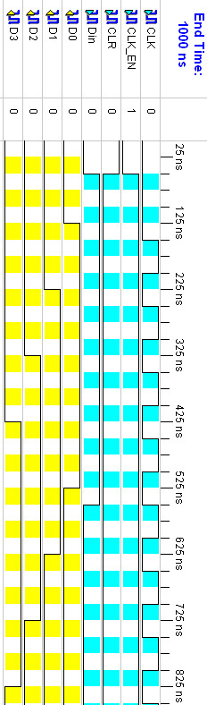

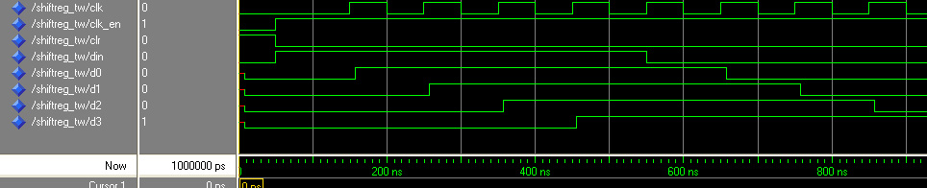
The Parallel shift register toggle bits and the output
All values displayed in nanoseconds (ns)

Setup/Hold to clock CLK
------------+------------+------------+------------------+--------+
| Setup to | Hold to | | Clock |
Source | clk (edge) | clk (edge) |Internal Clock(s) | Phase |
------------+------------+------------+------------------+--------+
CLK_EN | -0.184(R)| 0.851(R)|CLK_BUFGP | 0.000|
Din | 1.657(R)| -0.448(R)|CLK_BUFGP | 0.000|
------------+------------+------------+------------------+--------+

Clock CLK to Pad
------------+------------+------------------+--------+
| clk (edge) | | Clock |
Destination | to PAD |Internal Clock(s) | Phase |
------------+------------+------------------+--------+
D0 | 7.508(R)|CLK_BUFGP | 0.000|
D1 | 7.387(R)|CLK_BUFGP | 0.000|
D2 | 7.107(R)|CLK_BUFGP | 0.000|
D3 | 6.155(R)|CLK_BUFGP | 0.000|
------------+------------+------------------+--------+

Clock to Setup on destination clock CLK
---------------+---------+---------+---------+---------+
| Src:Rise| Src:Fall| Src:Rise| Src:Fall|
Source Clock |Dest:Rise|Dest:Rise|Dest:Fall|Dest:Fall|
---------------+---------+---------+---------+---------+
CLK | 2.236| | | |
---------------+---------+---------+---------+---------+

Analysis completed Tue May 03 01:34:28 2005

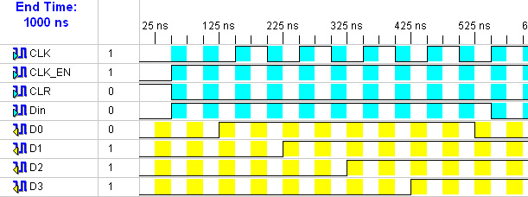

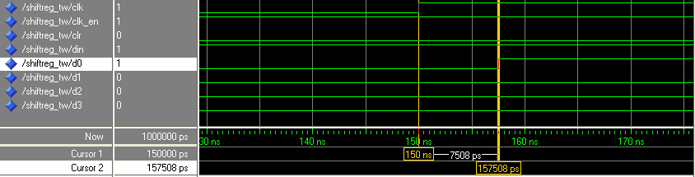

As you can see, the CLK to D0 destination was the longest time (7.508 seconds). We isolated the pulse and found the timing difference to be exactly how it was stated in the text output.
II. Asynchronous Counter

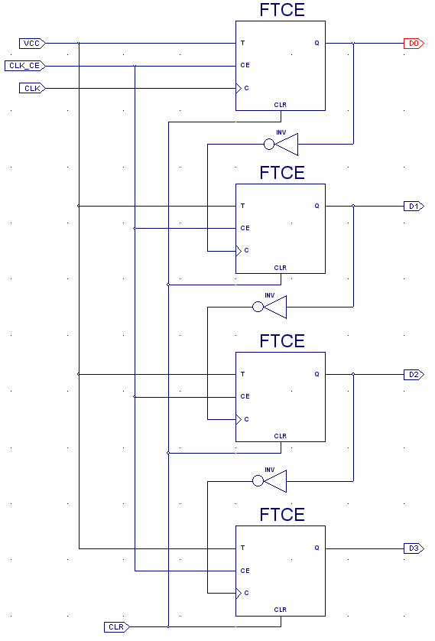 | 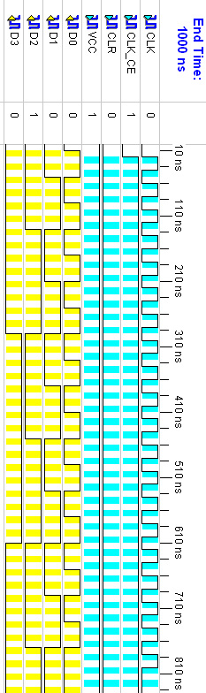
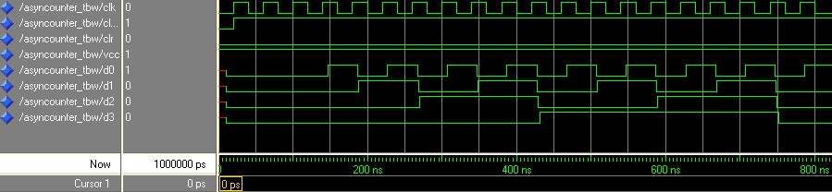

The counting works as planned. The toggle bits and the wave output match the verification and count slowly to 15 from 0.
Data Sheet report:
-----------------
All values displayed in nanoseconds (ns)

Setup/Hold to clock CLK
------------+------------+------------+------------------+--------+
| Setup to | Hold to | | Clock |
Source | clk (edge) | clk (edge) |Internal Clock(s) | Phase |
------------+------------+------------+------------------+--------+
CLK_CE | -0.611(R)| 0.746(R)|CLK_BUFGP | 0.000|
VCC | -0.103(R)| 0.340(R)|CLK_BUFGP | 0.000|
------------+------------+------------+------------------+--------+

Clock CLK to Pad
------------+------------+------------------+--------+
| clk (edge) | | Clock |
Destination | to PAD |Internal Clock(s) | Phase |
------------+------------+------------------+--------+
D0 | 7.110(R)|CLK_BUFGP | 0.000|
------------+------------+------------------+--------+

Clock to Setup on destination clock CLK
---------------+---------+---------+---------+---------+
| Src:Rise| Src:Fall| Src:Rise| Src:Fall|
Source Clock |Dest:Rise|Dest:Rise|Dest:Fall|Dest:Fall|
---------------+---------+---------+---------+---------+
CLK | 1.499| | | |
---------------+---------+---------+---------+---------+

Analysis completed Tue May 03 02:54:40 2005

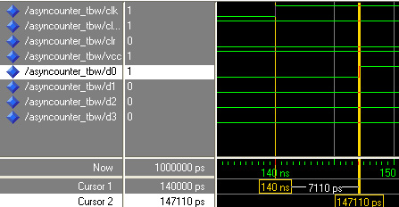

8 Bit

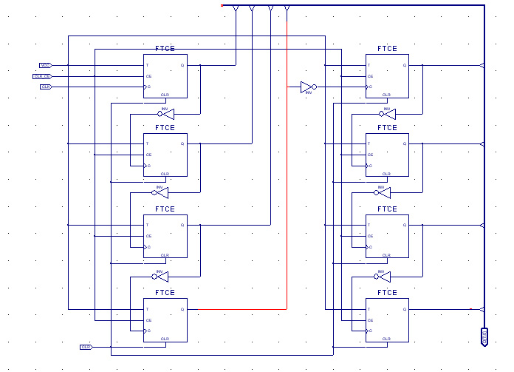

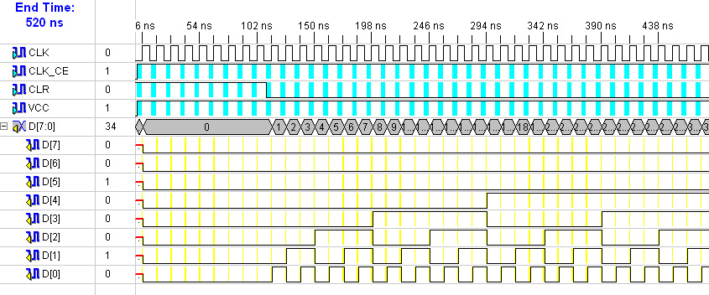
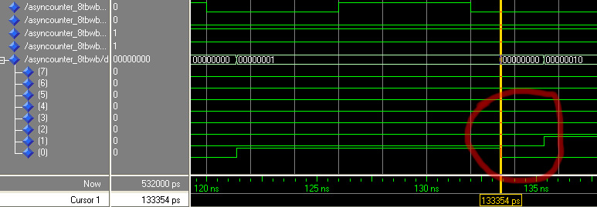
This is Unstable because the outputs do not change at the same time. They are clearly off and it is evident from the transition between the number 1 and 2.

III. Synchronous Counter
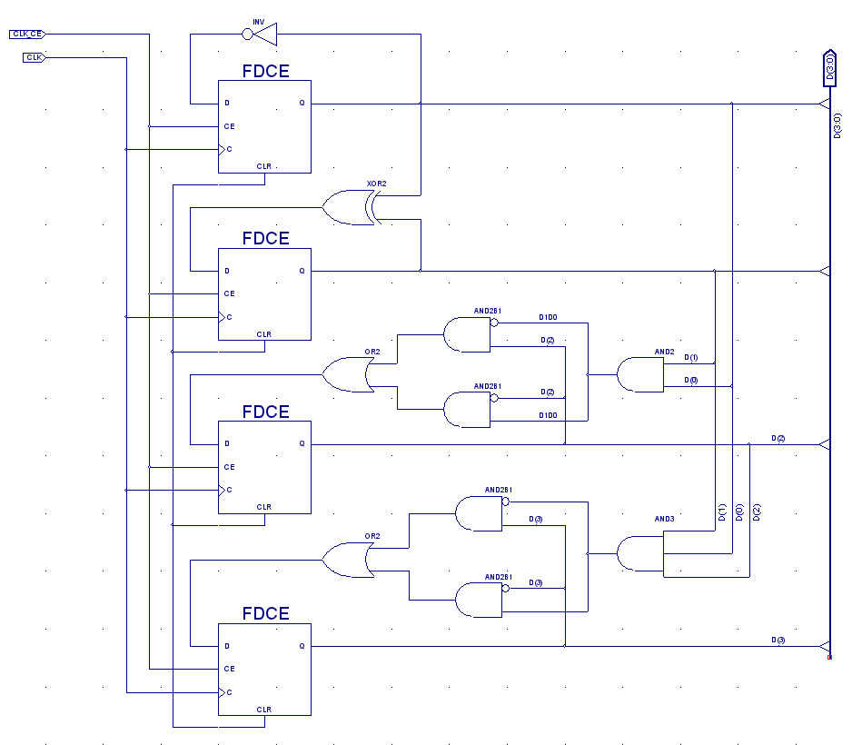

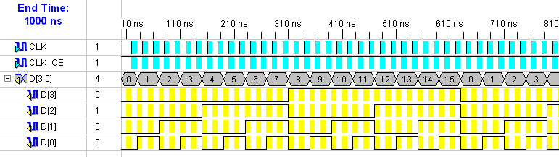

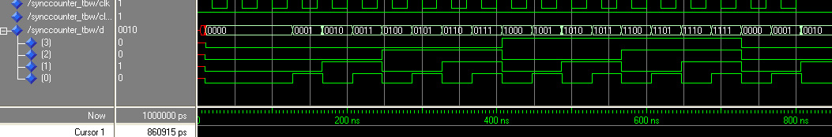
The Sync. Counter also counts. This time we made it with busses in order to see the count function. It worked perfectly.
Data Sheet report:
-----------------
All values displayed in nanoseconds (ns)

Setup/Hold to clock CLK
------------+------------+------------+------------------+--------+
| Setup to | Hold to | | Clock |
Source | clk (edge) | clk (edge) |Internal Clock(s) | Phase |
------------+------------+------------+------------------+--------+
CLK_CE | -0.611(R)| 0.746(R)|CLK_BUFGP | 0.000|
------------+------------+------------+------------------+--------+

Clock CLK to Pad
------------+------------+------------------+--------+
| clk (edge) | | Clock |
Destination | to PAD |Internal Clock(s) | Phase |
------------+------------+------------------+--------+
D<0> | 7.120(R)|CLK_BUFGP | 0.000|
D<1> | 6.849(R)|CLK_BUFGP | 0.000|
D<2> | 7.120(R)|CLK_BUFGP | 0.000|
D<3> | 7.360(R)|CLK_BUFGP | 0.000|
------------+------------+------------------+--------+

Clock to Setup on destination clock CLK
---------------+---------+---------+---------+---------+
| Src:Rise| Src:Fall| Src:Rise| Src:Fall|
Source Clock |Dest:Rise|Dest:Rise|Dest:Fall|Dest:Fall|
---------------+---------+---------+---------+---------+
CLK | 1.912| | | |
---------------+---------+---------+---------+---------+

Analysis completed Tue May 03 21:05:43 2005

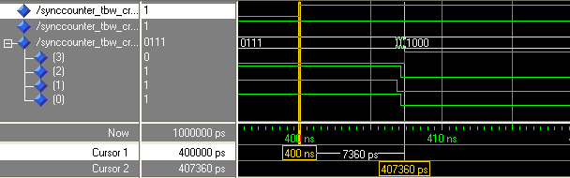

Here we have isolated the response to the CLK when the D3 pad is activated, because this is the longest costing time. This response shows to lie exactly in the same amount of time as expected.

IV. Gray Counter
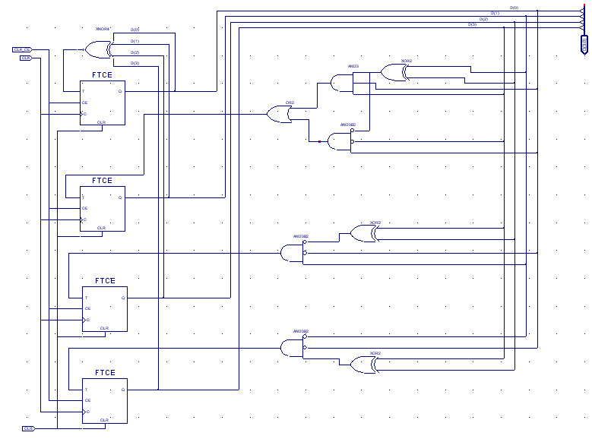

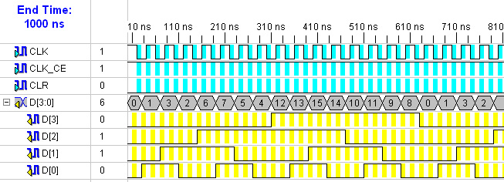

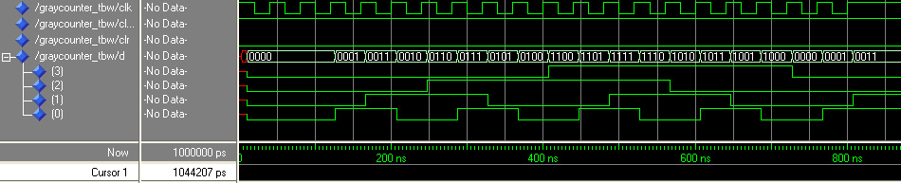

Data Sheet report:
-----------------
All values displayed in nanoseconds (ns)

Setup/Hold to clock CLK
------------+------------+------------+------------------+--------+
| Setup to | Hold to | | Clock |
Source | clk (edge) | clk (edge) |Internal Clock(s) | Phase |
------------+------------+------------+------------------+--------+
CLK_CE | -0.353(R)| 0.500(R)|CLK_BUFGP | 0.000|
------------+------------+------------+------------------+--------+

Clock CLK to Pad
------------+------------+------------------+--------+
| clk (edge) | | Clock |
Destination | to PAD |Internal Clock(s) | Phase |
------------+------------+------------------+--------+
D<0> | 7.084(R)|CLK_BUFGP | 0.000|
D<1> | 6.847(R)|CLK_BUFGP | 0.000|
D<2> | 7.375(R)|CLK_BUFGP | 0.000|
D<3> | 7.113(R)|CLK_BUFGP | 0.000|
------------+------------+------------------+--------+

Clock to Setup on destination clock CLK
---------------+---------+---------+---------+---------+
| Src:Rise| Src:Fall| Src:Rise| Src:Fall|
Source Clock |Dest:Rise|Dest:Rise|Dest:Fall|Dest:Fall|
---------------+---------+---------+---------+---------+
CLK | 1.695| | | |
---------------+---------+---------+---------+---------+

Analysis completed Tue May 03 22:46:24 2005

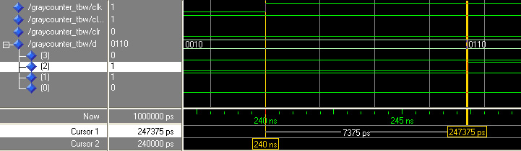

V. Random Sequencer

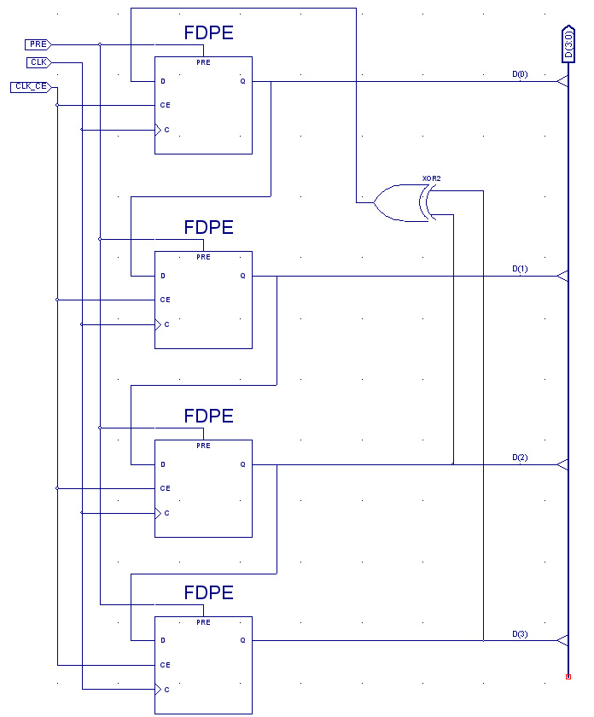

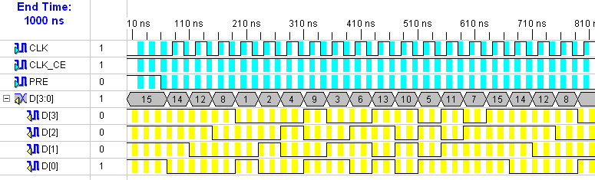

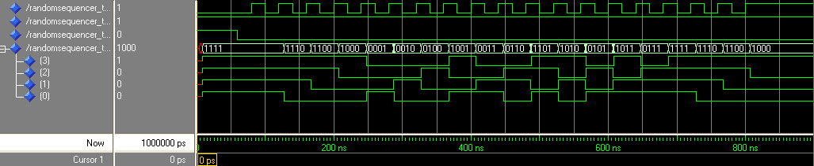

Data Sheet report:
-----------------
All values displayed in nanoseconds (ns)

Setup/Hold to clock CLK
------------+------------+------------+------------------+--------+
| Setup to | Hold to | | Clock |
Source | clk (edge) | clk (edge) |Internal Clock(s) | Phase |
------------+------------+------------+------------------+--------+
CLK_CE | -0.363(R)| 0.498(R)|CLK_BUFGP | 0.000|
------------+------------+------------+------------------+--------+

Clock CLK to Pad
------------+------------+------------------+--------+
| clk (edge) | | Clock |
Destination | to PAD |Internal Clock(s) | Phase |
------------+------------+------------------+--------+
D<0> | 7.873(R)|CLK_BUFGP | 0.000|
D<1> | 7.125(R)|CLK_BUFGP | 0.000|
D<2> | 7.345(R)|CLK_BUFGP | 0.000|
D<3> | 7.641(R)|CLK_BUFGP | 0.000|
------------+------------+------------------+--------+

Clock to Setup on destination clock CLK
---------------+---------+---------+---------+---------+
| Src:Rise| Src:Fall| Src:Rise| Src:Fall|
Source Clock |Dest:Rise|Dest:Rise|Dest:Fall|Dest:Fall|
---------------+---------+---------+---------+---------+
CLK | 1.926| | | |
---------------+---------+---------+---------+---------+

Analysis completed Tue May 03 23:16:01 2005

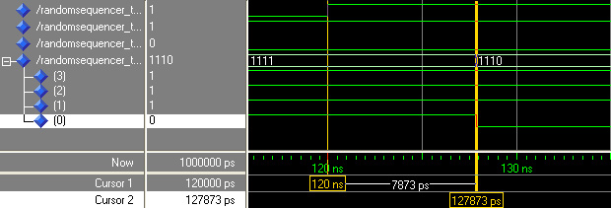

 | II. Asyn. Counter | III. Syn. Counter | IV. Gray Counter
Advantages | Fastest | Know when all of the events happens  Can be controlled with the clock | Only one bit changes between each
Disadvantages | Cannot be controlled with the clock, once fed, it ripples through | Slower | Slowest  Most Complex and is not in order

