Alvin Jeng
Nitay Joffe
May 31, 2005
CSE 140L

Lab 4:
System Design using Datapath
and Control Subsystems

Schematics

Machine – Top Level Design putting it all together
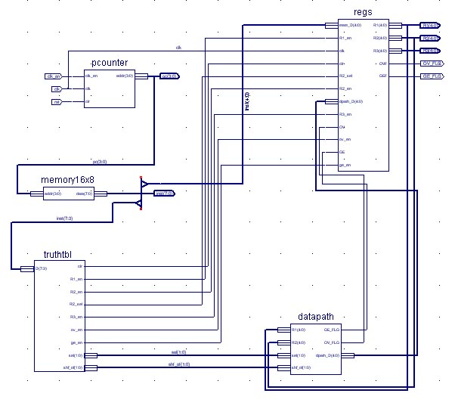

Datapath – 5 Bit Computations using the three Registers
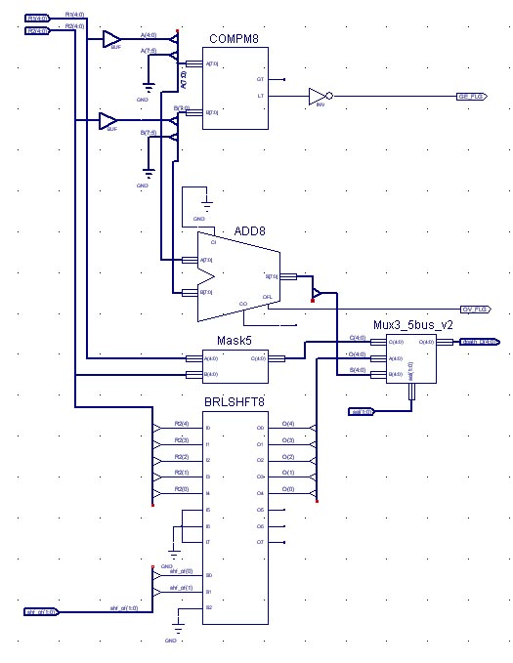
Mask5 – AND each individual bit
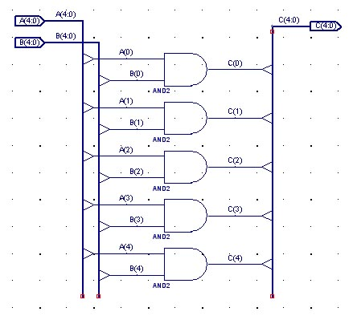
Mux3_5busv2 – Using two steps of 5 bit bus multiplexer
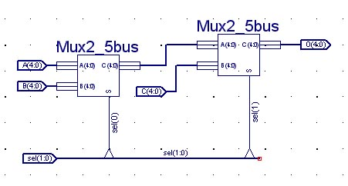
Mux2_5bus – Use 2to1 Mux on each bit
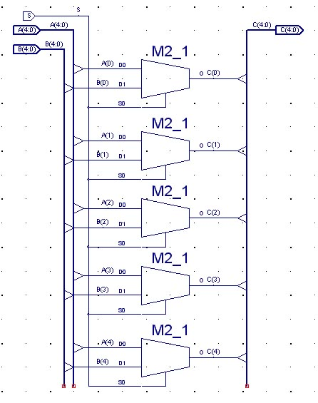
Memory16x8 – Array of 16x1 memories
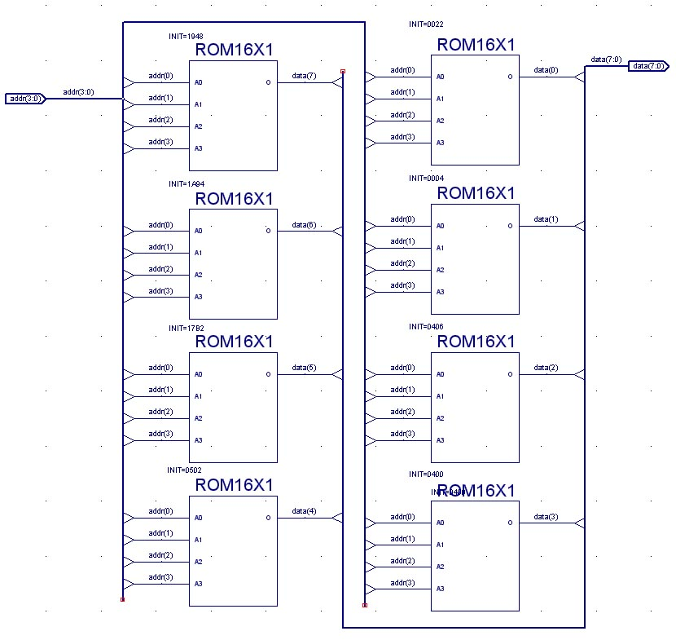
Pcounter – A Four bit counter
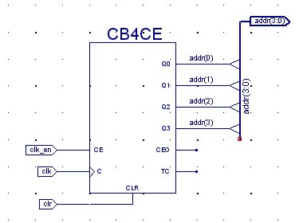
Regs – Storage for r1, r2, r3 and bit flags
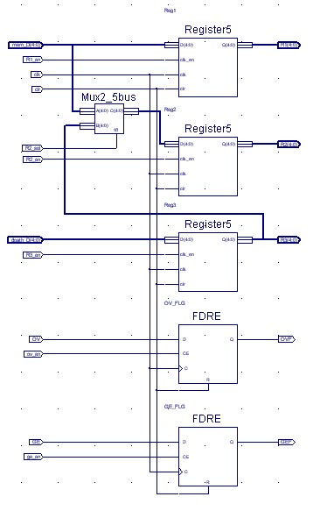
Register5 – Five bit bus storage using array of flip flops
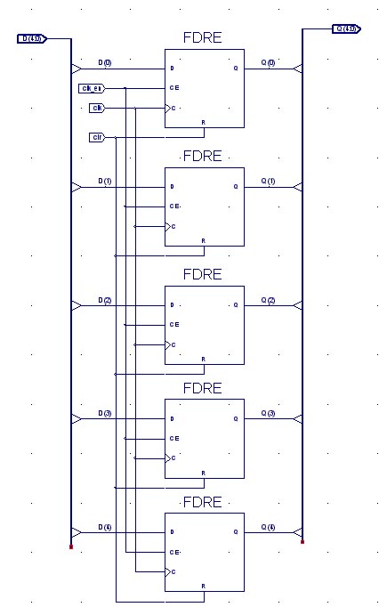
VHDL Truth table implementation

The VHDL Code implements the truth table by sectioning off the table into its 8 possible values. Using if statements, each value gets its own set of instructions, and is implemented in the following.

--------------------------------------------------------------------------------
-- Company:
-- Engineer:
--
-- Create Date: 23:04:23 05/31/05
-- Design Name:
-- Module Name: truthtbl - Behavioral
-- Project Name:
-- Target Device:
-- Tool versions:
-- Description:
--
-- Dependencies:
--
-- Revision:
-- Revision 0.01 - File Created
-- Additional Comments:
--
--------------------------------------------------------------------------------
library IEEE;
use IEEE.STD_LOGIC_1164.ALL;
use IEEE.STD_LOGIC_ARITH.ALL;
use IEEE.STD_LOGIC_UNSIGNED.ALL;

---- Uncomment the following library declaration if instantiating
---- any Xilinx primitives in this code.
--library UNISIM;
--use UNISIM.VComponents.all;

entity truthtbl is
PORT (D : IN STD_LOGIC_VECTOR(7 DOWNTO 3);
clr, R1_en, R2_en, R2_sel, R3_en, ov_en, ge_en : OUT STD_LOGIC;
sel, shf_of : OUT STD_LOGIC_VECTOR(1 DOWNTO 0));
end truthtbl;

architecture Behavioral of truthtbl is

begin
process(D)
begin
if(D(7 downto 5) = "000") then
clr <= '1';
R1_en <= '0';
R2_en <= '0';
R2_sel <= '0';
R3_en <= '0';
ov_en <= '0';
ge_en <= '0';
sel(1 downto 0) <= "00";
shf_of(1 downto 0) <= "00";
end if;
if(D(7 downto 5) = "001") then
clr <= '0';
R1_en <= '1';
R2_en <= '0';
R2_sel <= '0';
R3_en <= '0';
ov_en <= '0';
ge_en <= '0';
sel(1 downto 0) <= "00";
shf_of(1 downto 0) <= "00";
end if;
if(D(7 downto 5) = "010") then
clr <= '0';
R1_en <= '0';
R2_en <= '1';
R2_sel <= '0';
R3_en <= '0';
ov_en <= '0';
ge_en <= '0';
sel(1 downto 0) <= "00";
shf_of(1 downto 0) <= "00";
end if;
if(D(7 downto 5) = "011") then
clr <= '0';
R1_en <= '0';
R2_en <= '1';
R2_sel <= '1';
R3_en <= '0';
ov_en <= '0';
ge_en <= '0';
sel(1 downto 0) <= "00";
shf_of(1 downto 0) <= "00";
end if;
if(D(7 downto 5) = "100") then
clr <= '0';
R1_en <= '0';
R2_en <= '0';
R2_sel <= '0';
R3_en <= '1';
ov_en <= '1';
ge_en <= '0';
sel(1 downto 0) <= "01";
shf_of(1 downto 0) <= "00";
end if;
if(D(7 downto 5) = "101") then
clr <= '0';
R1_en <= '0';
R2_en <= '0';
R2_sel <= '0';
R3_en <= '1';
ov_en <= '0';
ge_en <= '0';
sel(1 downto 0) <= "00";
shf_of(1 downto 0) <= D(4 downto 3);
end if;
if(D(7 downto 5) = "110") then
clr <= '0';
R1_en <= '0';
R2_en <= '0';
R2_sel <= '0';
R3_en <= '0';
ov_en <= '0';
ge_en <= '1';
sel(1 downto 0) <= "11";
shf_of(1 downto 0) <= "00";
end if;
if(D(7 downto 5) = "111") then
clr <= '0';
R1_en <= '0';
R2_en <= '0';
R2_sel <= '0';
R3_en <= '1';
ov_en <= '0';
ge_en <= '0';
sel(1 downto 0) <= "10";
shf_of(1 downto 0) <= "00";
end if;
end process;
end Behavioral;

Floorplans
Machine Floorplan  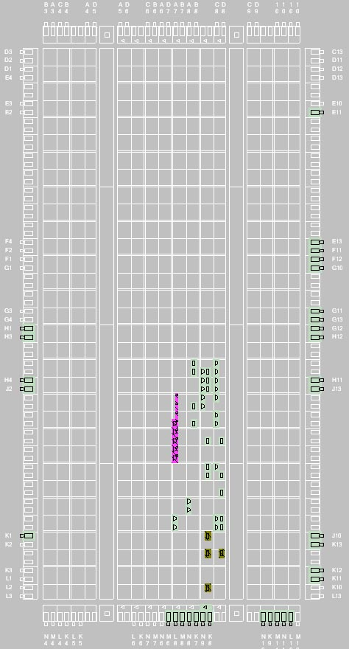 | VHDL Floorplan  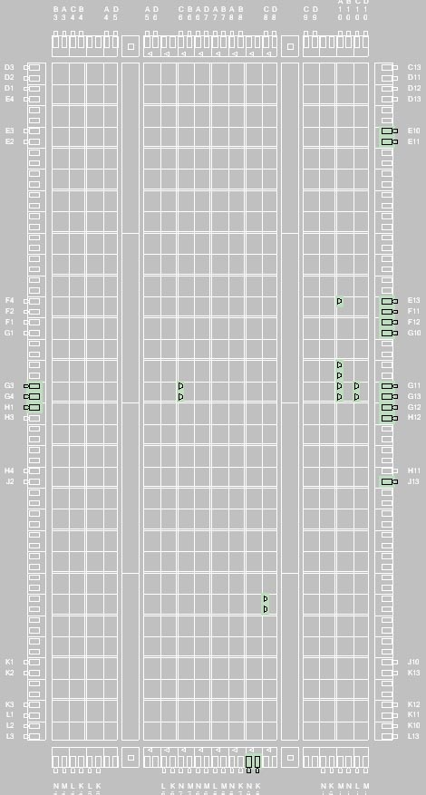

Instructions in memory
0 init  1 mov1 10101  2 mov2 00110  3 add  4 stor  5 mov1 00001  6 add  7 stor  8 shift 10  9 stor  10 mov1 00111  11 comp  12 mask  13 Init  14 Init  15 Init | 0 0 0 0 0 0 0 0  0 0 1 1 0 1 0 1  0 1 0 0 0 1 1 0  1 0 0 0 0 0 0 0  8 4 2 2 0 6 4 2  0 1 1 0 0 0 0 0  0 0 1 0 0 0 0 1  1 0 0 0 0 0 0 0  0 1 1 0 0 0 0 0  4 9 B 0 0 0 0 2  1 0 1 1 0 0 0 0  0 1 1 0 0 0 0 0  0 0 1 0 0 1 1 1  1 1 0 0 0 0 0 0  9 A 7 1 0 4 4 4  1 1 1 0 0 0 0 0  0 0 0 0 0 0 0 0  0 0 0 0 0 0 0 0  0 0 0 0 0 0 0 0  1 1 1 0 0 0 0 0

Final Instructions stored in memory

Correct Errored
0422 0022
0404 0004
0406 0406
0000 0400
0102 0502
17B2 17B2
1A94 1A94
1948 1948

The Errored instructions are to match the lab output in the tutorial.
Testbench Simulation
Matching the Errored output that is provided in tutorial
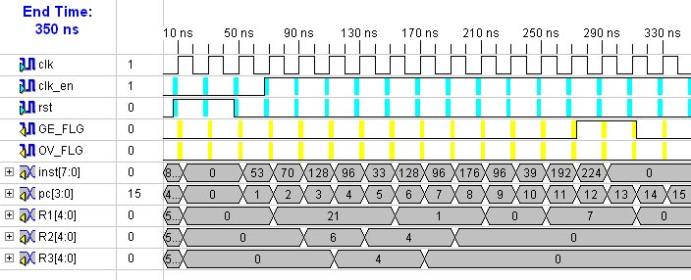

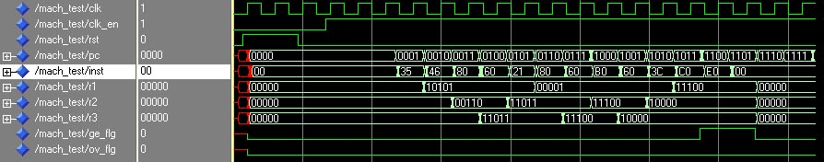

Right output with corrected instruction in memory
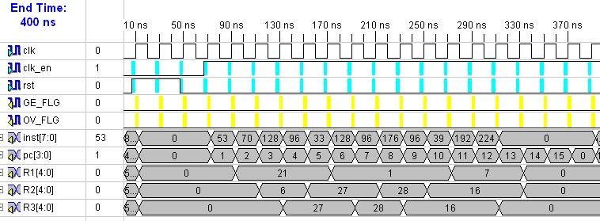
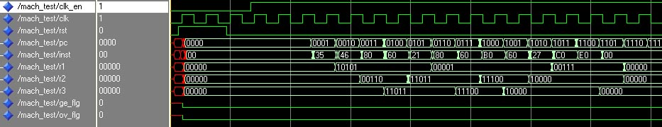

Verification
In order to verify that the machine works, each module can be individually tested in order to ensure that each part works properly. For example, the shifter can be taken on its own and be made to perform its instructions based on test input (with theoretical values already calculated). If the output matches, then it works. When each is tested individually, putting them all together and testing values <and analyzing that each part works by looking at the simulation> ensures that the machine is in proper working order. We are confident because we have matched existing output for a machine that does the same instructions, while also obtaining values that make sense.

Worst Delay Path for Registers
Timing Report
Clock clk to Pad
------------+------------+------------------+--------+
| clk (edge) | | Clock |
Destination | to PAD |Internal Clock(s) | Phase |
------------+------------+------------------+--------+
GE_FLG | 6.147(R)|clk_BUFGP | 0.000|
OV_FLG | 6.147(R)|clk_BUFGP | 0.000|
R1<0> | 7.384(R)|clk_BUFGP | 0.000|
R1<1> | 7.906(R)|clk_BUFGP | 0.000|
R1<2> | 7.389(R)|clk_BUFGP | 0.000|
R1<3> | 7.875(R)|clk_BUFGP | 0.000|
R1<4> | 7.537(R)|clk_BUFGP | 0.000|
R2<0> | 8.192(R)|clk_BUFGP | 0.000|
R2<1> | 7.768(R)|clk_BUFGP | 0.000|
R2<2> | 8.179(R)|clk_BUFGP | 0.000|
R2<3> | 8.413(R)|clk_BUFGP | 0.000|
R2<4> | 7.512(R)|clk_BUFGP | 0.000|
R3<0> | 7.725(R)|clk_BUFGP | 0.000|
R3<1> | 7.897(R)|clk_BUFGP | 0.000|
R3<2> | 7.357(R)|clk_BUFGP | 0.000|
R3<3> | 7.998(R)|clk_BUFGP | 0.000|
R3<4> | 7.715(R)|clk_BUFGP | 0.000|

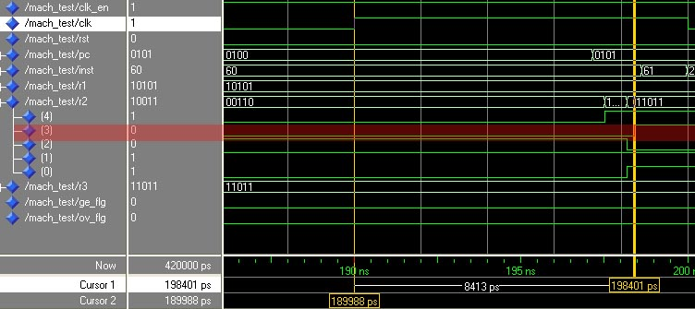

The longest (critical) path is from CLK to R2<3> and is demonstrated in the simulation. When the clk is toggled it takes 8413 ps to reach and toggle the R2<3> destination.

