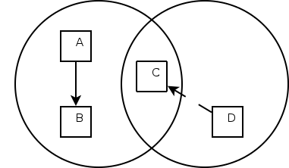
Nitay Joffe
CSE123A
11/16/2006
Homework 4

- Hidden terminal and exposed terminal problems do not occur in Ethernet because everyone on a LAN is connected to each other. This means when a message is sent, everyone can hear it.

The hidden terminal is avoided because C will hear B send a CTS to B and wait for enough time until B sends its ddata before it tries to send. The sequence of events starts with A sending an RTS to B. B will send a CTS to A. C also wants to send data, but since it heard B send a CTS, it will wait for a long enough period of time, then send an RTS.

The exposed terminal problem is avoided because of the RTS. When B is communicating with A, C will hear B send an RTS and wait long enough for a CTS. A CTS will be sent from A to B, but C will not hear it because it is too far away. At this point, when C's timer runs out, it can safely start transmitting, even though B is sending data to A, without causing collision problems.

Yes, collisions are still possible. For example, take the diagram below:

In this diagram, A is communicating with B, and D wants to send a message to C. The RTS-CTS communication setup of A-B does not get to D, but everything they send to each other does get to C. Since D does not know anything about A-B, it will think the coast is clear and send an RTS to C. This will cause a collision at C, and it should ignore D's RTS. Sending an RTS is still a good idea though because it is a small packet, and it establishes a link that is known by others in your local wireless area.

The are several reasons that a station will not get a CTS after sending an RTS. The two most obvious ones are that either the RTS or CTS is simply lost along the way, and that there is a collision at the station you are trying to send to. The sender of the RTS should first wait long enough for the RTS to travel and a CTS to arrive so that it knows for sure that there is no CTS coming. Once this has happened it can resend its RTS. Because a collision may be occuring at the receiving end, the sender should wait more after each additional failure using exponential backoff.
- Take the network topology given below:
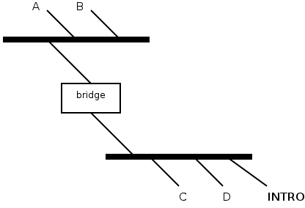

Assume the bridge is in a state where it already knows the locations of all the stations in the network. Now let's say A wants to look up C's address. A will send a packet to INTRO with C's IP address in the data. The INTRO server will replace the destination with C and send it out. At this point, since the source of the frame is still A (the INTRO server does not change the source), the bridge learns that A is from below. Now when C wants to send it's address to A, the bridge will not forward it because it thinks A has moved to the lower port. Not only is the bridge's information corrupt, but A never actually gets C's address.

There are two fixes that I can see for this situation. The first one is to have the INTRO server replace the source address with it's own address, so that no bridge information will change. This maintains the behavior of the INTRO server as described. Another solution is to just have the INTRO server send C's address to A directly in the data section of a packet. This cuts C out of the picture, meaning it won't get A's address, but at the same time it makes things simpler because there is less overhead.

- Since B does not know A's address, B sends a broadcast asking A's address. A responds, saying that his address is all 1s (the broadcast). B sends data to A. Since A's address is the broadcast, everyone on the LAN gets this packet. The IP address of this packet sent by B is A's unicast IP address. All the other nodes in the network that get this packet pass it up to their IP layer which sees that the unicast IP belongs to their neighbor. These nodes do the neighborly thing and pass the packet they got to A. This creates another broadcast packet, which will also be received and forwarded by all the other nodes, and the process repeats exponentially.

Replacing the bridge with a router helps to localize the problem because the router will not forward data link layer broadcast messages. The problem still exists inside the LAN containing A, but all the LAN's outside, with different network masks, will not be effected.

- When a station sends data, it sets the bit field of that frame to one. All routers, whenever they forward any packets, set the bit to zero. Whenever a packet is received by a node in the network, if the bit field is still one than we know it was not touched by any router, which means that the sender it came from is on the local network. On the flip side, if the bit field is zero than the packet was touched by a router, meaning the packet was routed to us on the IP layer, and therefore the sender cannot be on the local network.

