Problem 1 – Filtered Noise
Part A
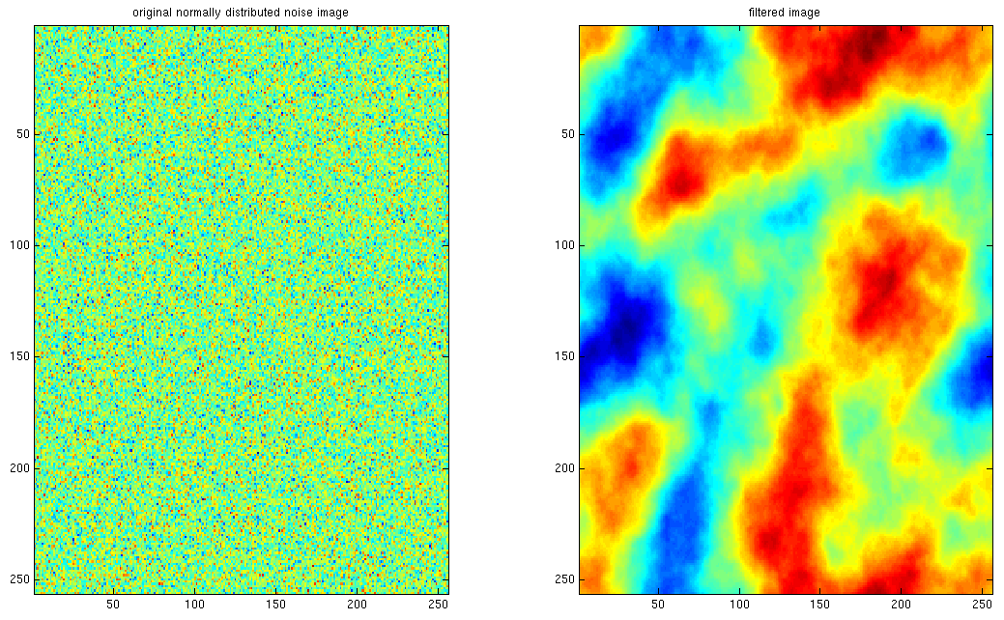

Problem 2 – Filtering in the Frequency Domain
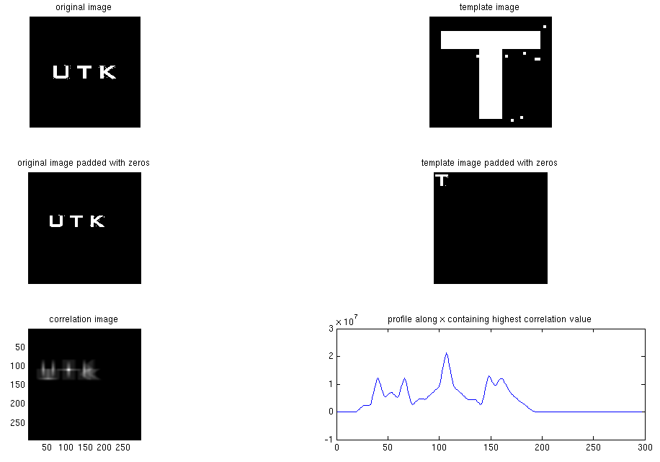
Part A
Problem 2 – Filtering in the Frequency Domain
Part B
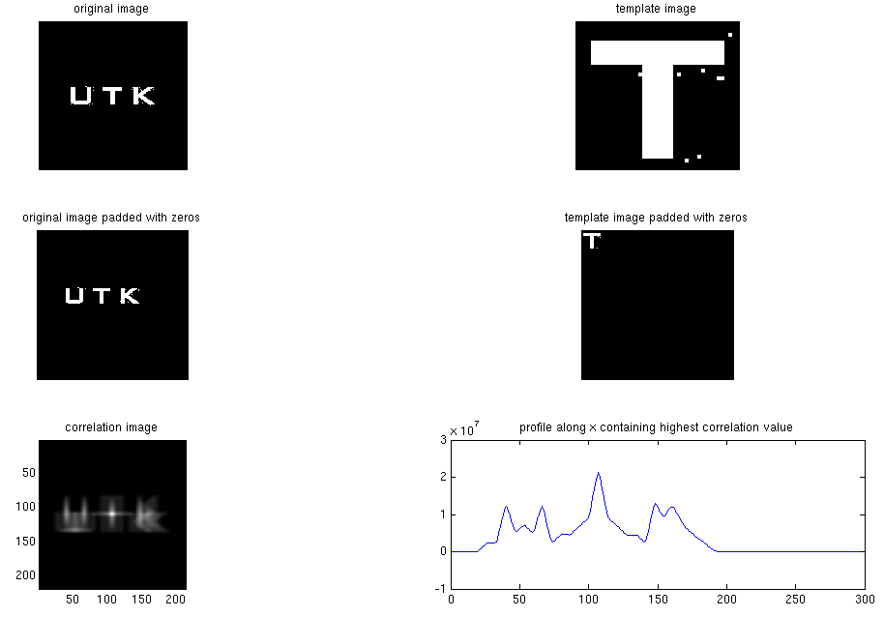
% Author: <njoffe@ucsd.edu> Nitay Joffe
% Date: 10/19/2006
% Class: CSE 166 - Image Processing
% Homework: 3
% Problem: 1 - Filtered Noise
clear;

% (a) Consider the filter with Fourier transform H(u,v) = 1/(u^2+v^2) on the
% interval [-127, 128] x [-127, 128]. This is known as a 1/f^2 transfer
% function. Since it blows up at the origin, replace that value with zero.
% Apply this filter to a 256x256 image of normally distributed random
% noise (use _randn_). For practical reasons, it is best to perform this
% operation in the frequency domain. Hint: you will need to use _meshgrid_,
% _fft2_, _ifft2_, and _fftshift_. Also, due to numerical error, you will
% need to use _real_ to look at the real part of the filtered image in the
% spatial domain.
u_range = -127:128;
v_range = u_range;

% Evaluate filter function over a grid of values.
[u,v] = meshgrid(u_range,v_range);
filter_kernel_frequency = 1 ./ (u.^2 + v.^2);
filter_kernel_frequency(filter_kernel_frequency == inf) = 0;

% Generate image of normally distributed random noise.
noise_image = randn(256,256);
noise_image_frequency = fft2(noise_image);

% Run filter on noise image.
filtered_noise_image_frequency = filter_kernel_frequency.*noise_image_frequency;
filtered_noise_image_frequency_shifted=fftshift(filtered_noise_image_frequency);

% Use inverse fourier transform to get filtered noise image in spatial domain.
filtered_noise_image = ifft2(filtered_noise_image_frequency_shifted);
filtered_noise_image_real = real(filtered_noise_image);

% (b) Display the filtered image along with the original noise image. Quite
% remarkably, the filtered image should look like a "natural" texture, such
% as clouds or terrain. What does this suggest about the statistics of
% natural images vs. that of images of manmade objects?
figure;
subplot(1,2,1);
imagesc(noise_image);
title('original normally distributed noise image');
subplot(1,2,2);
imagesc(filtered_noise_image_real);
title('filtered image');

% Author: <njoffe@ucsd.edu> Nitay Joffe
% Date: 10/19/2006
% Class: CSE 166 - Image Processing
% Homework: 3
% Problem: 2 - Filtering in the Frequency Domain
clear;

% (a) Write an m-file to reproduce Figure 4.41(a-f) using Frequency domain
% filtering. Note: the Matlab command for the complex conjugate is conj.
original_image = double(imread('Fig4.41(a).jpg'));
template_image = double(imread('Fig4.41(b).jpg'));

% Compute minimum size of images padded with zeros.
[image_x_size, image_y_size] = size(original_image);
[template_x_size, template_y_size] = size(template_image);
padded_image_x_size = image_x_size + template_x_size - 1;
padded_image_y_size = image_y_size + template_y_size - 1;

% Pad images with zeros so they are the same size and frequencies don't corrupt
% the fourier transform computations.
image_padded = zeros(padded_image_x_size, padded_image_y_size);
image_padded(1:image_x_size,1:image_y_size) = original_image;
template_padded = zeros(padded_image_x_size, padded_image_y_size);
template_padded(1:template_x_size,1:template_y_size) = template_image;

% Run discrete fourier transform on images to get frequencies.
image_padded_frequency = fft2(image_padded);
template_padded_frequency = fft2(template_padded);

% Compute conjugate of template. Use it to get correlation in frequency domain.
template_padded_frequency_conjugate = conj(template_padded_frequency);
correlation_image_frequency = template_padded_frequency_conjugate.*image_padded_frequency;
correlation_image_real = real(ifft2(correlation_image_frequency));

% Find row containing highest value in correlation image, get profile of it.
[max_per_column, max_per_column_indices] = max(correlation_image_real);
[max_overall, max_overall_index_in_columns] = max(max_per_column);
highest_value_row = max_per_column_indices(max_overall_index_in_columns);
profile_highest_value_along_x = correlation_image_real(highest_value_row,:);

% Display results.
figure;
subplot(3,2,1);
imshow(original_image);
title('original image');
subplot(3,2,2);
imshow(template_image);
title('template image');
subplot(3,2,3);
imshow(image_padded);
title('original image padded with zeros');
subplot(3,2,4);
imshow(template_padded);
title('template image padded with zeros');
subplot(3,2,5);
imagesc(correlation_image_real);
% Set aspect ratio so that x and y increments are equal, and make plot box fit
% tightly around the data.
axis image;
title('correlation image');
subplot(3,2,6);
plot(profile_highest_value_along_x);
title('profile along x containing highest correlation value');

% (b) Repeat the previous step using operations in the spatial domain and show
% that the results are the same. Hint: use conv2 and rot90.

%----- IMPORTANT -----
% NOTE: The code for reading and padding the images in the spatial domain is
% _exactly_ the same, so rather than copying it I just used the results.

% Compute conjugate of original image for spatial correlation computation.
image_conjugate = conj(original_image);

% Need to rotate the template image 180 degrees since correlation does not flip
% the image. This is to undo the 180 degrees flip that convolution does.
template_rotated = rot90(rot90(template_image));

% Compute spatial correlation between images using 2D convolution.
correlation_image = conv2(image_conjugate, template_rotated, 'valid');

% Find row containing highest value in correlation image, get profile of it.
[max_per_column, max_per_column_indices] = max(correlation_image);
[max_overall, max_overall_index_in_columns] = max(max_per_column);
highest_value_row = max_per_column_indices(max_overall_index_in_columns);
profile_highest_value_along_x = correlation_image_real(highest_value_row,:);

% Display results.
figure;
subplot(3,2,1);
imshow(original_image);
title('original image');
subplot(3,2,2);
imshow(template_image);
title('template image');
subplot(3,2,3);
imshow(image_padded);
title('original image padded with zeros');
subplot(3,2,4);
imshow(template_padded);
title('template image padded with zeros');
subplot(3,2,5);
imagesc(correlation_image);
% Set aspect ratio so that x and y increments are equal, and make plot box fit
% tightly around the data.
axis image;
title('correlation image');
subplot(3,2,6);
plot(profile_highest_value_along_x);
title('profile along x containing highest correlation value');

