1a – 1D Gabor even functions and their frequencies
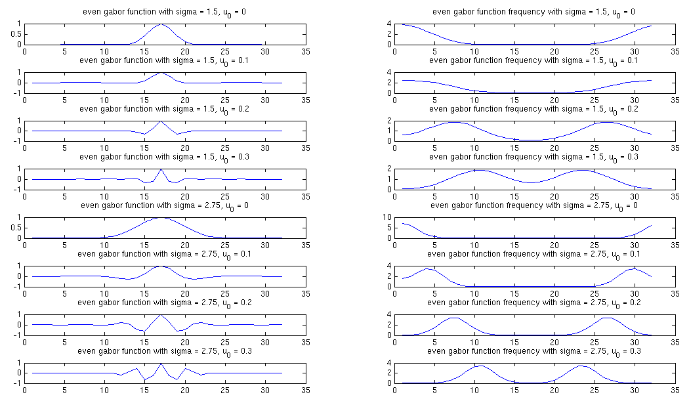
1a – 1D Gabor odd functions and their frequencies

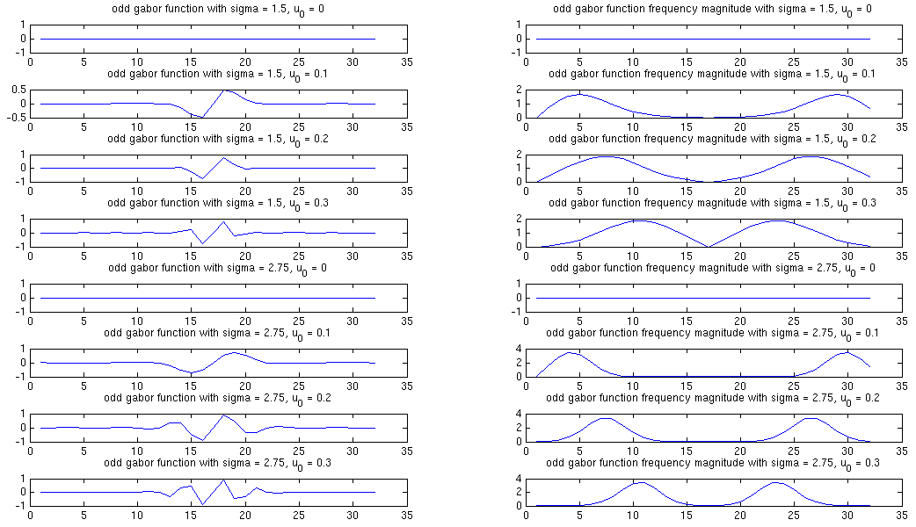
1b – 2D Gabor functions and their frequencies

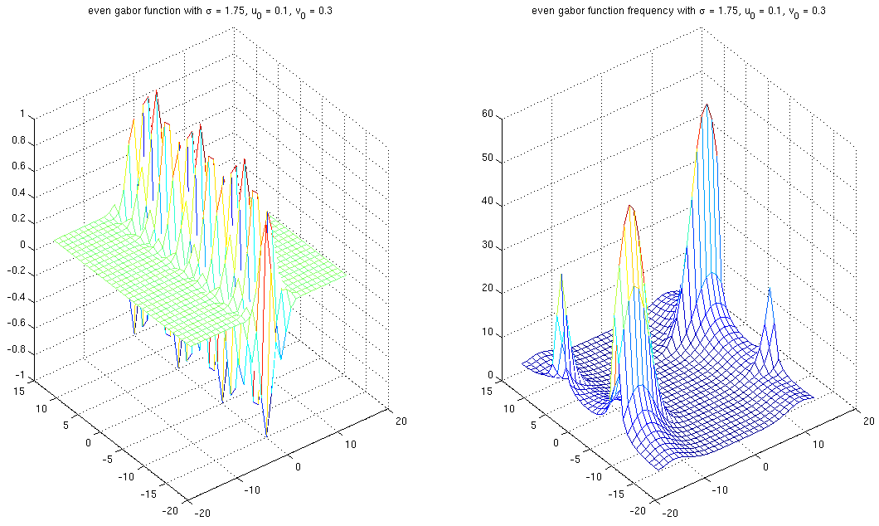
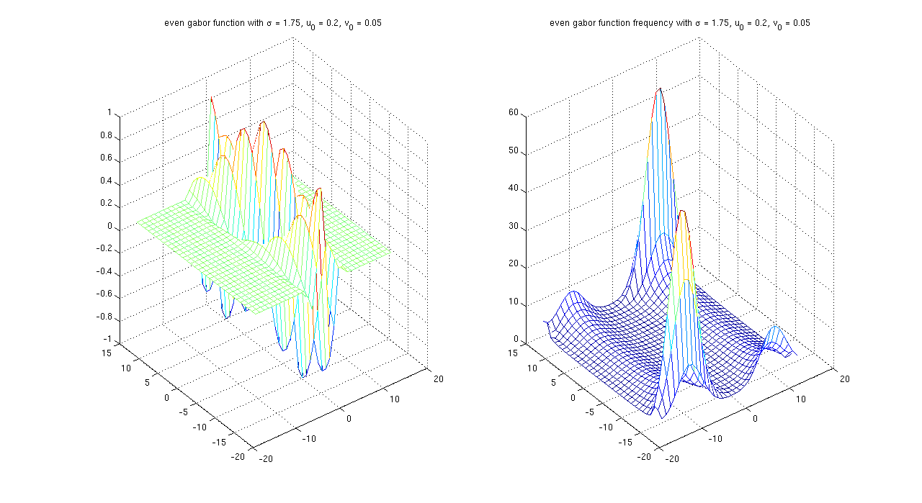
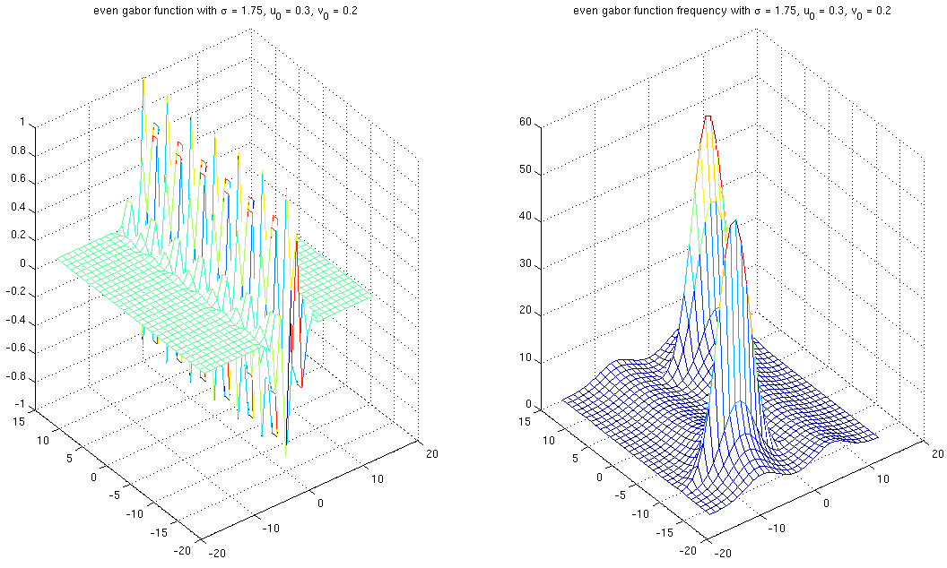
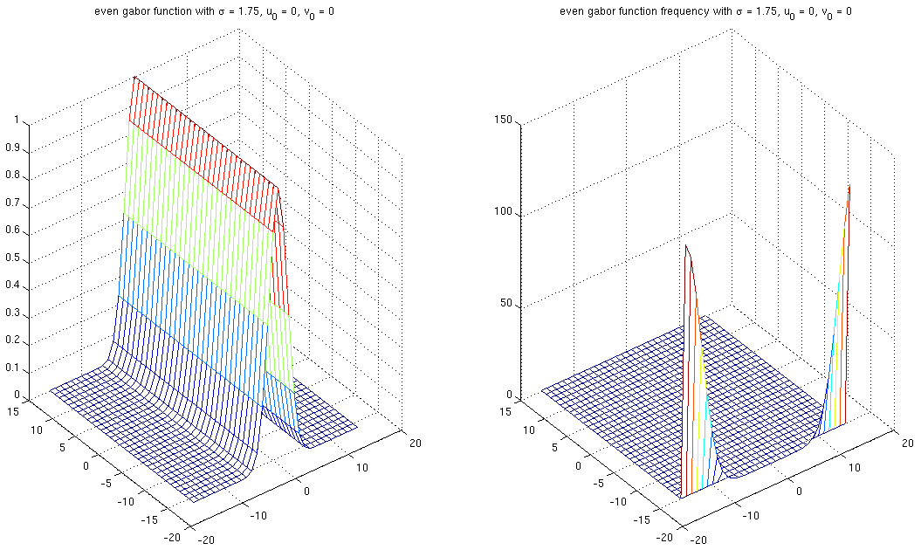
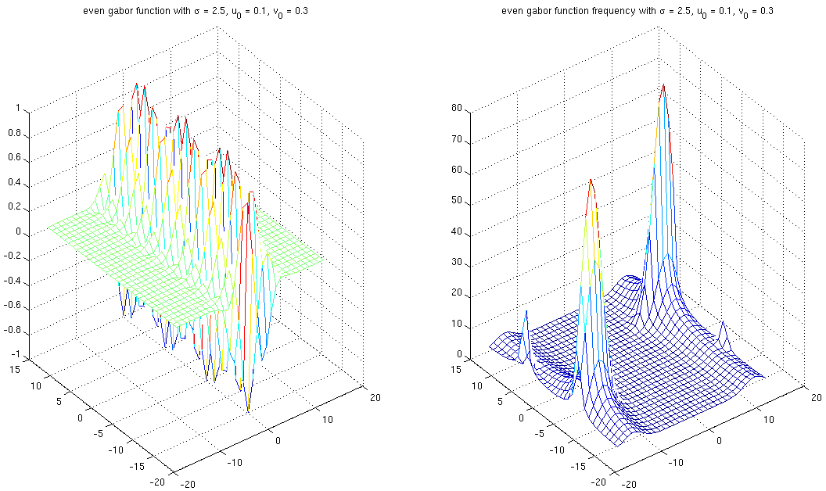
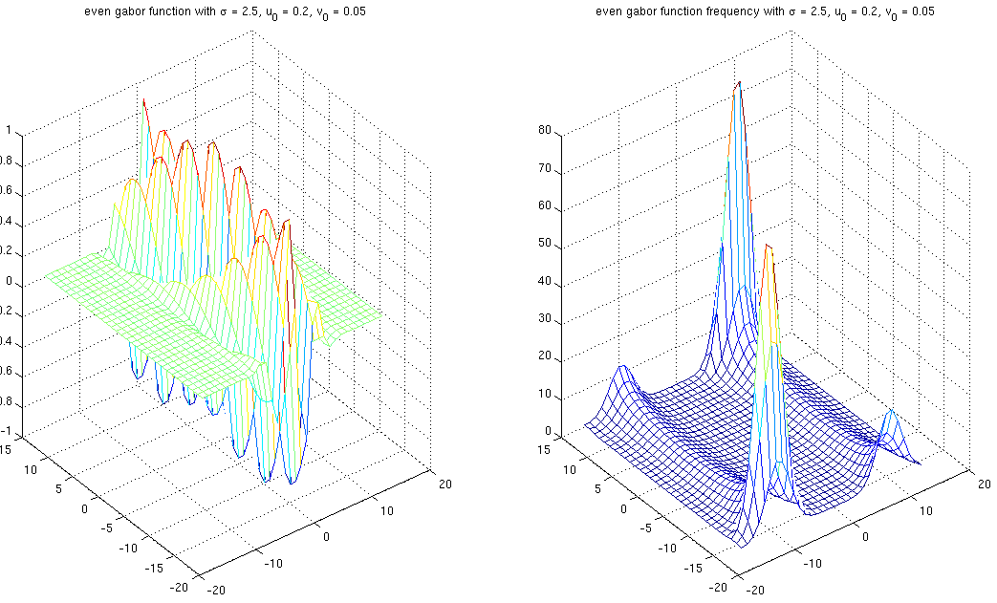
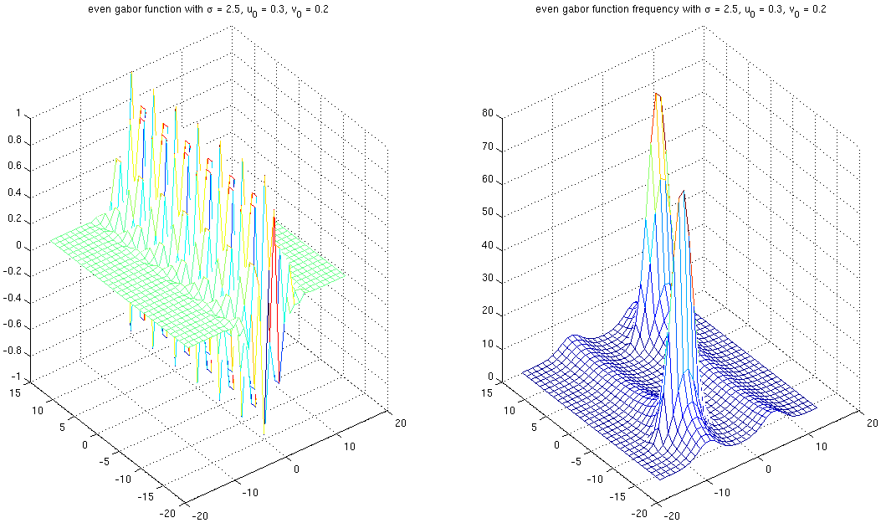
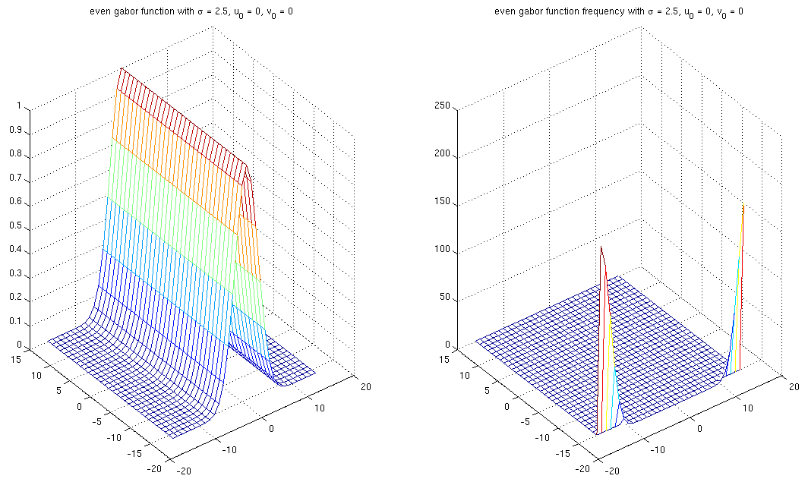
2a – 1D Gaussian Third Derivative

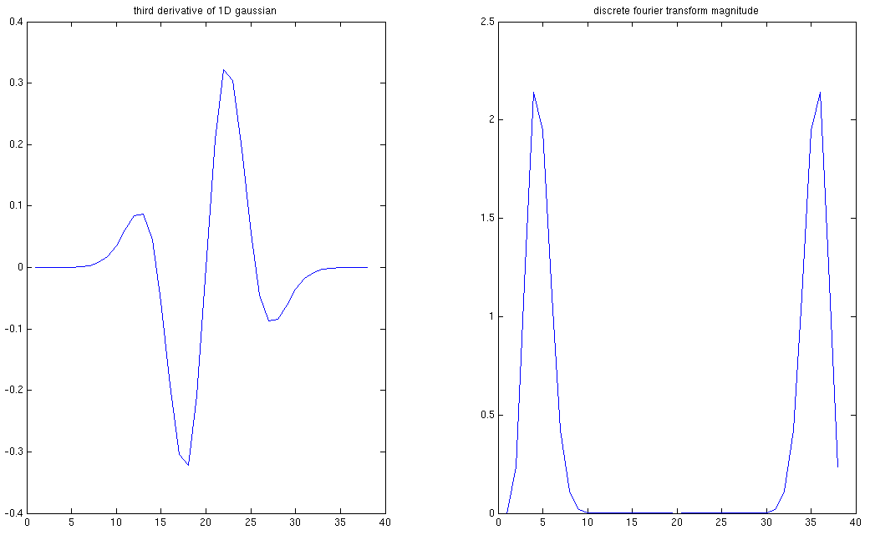
2b – Approximation of Gaussian with Gabor

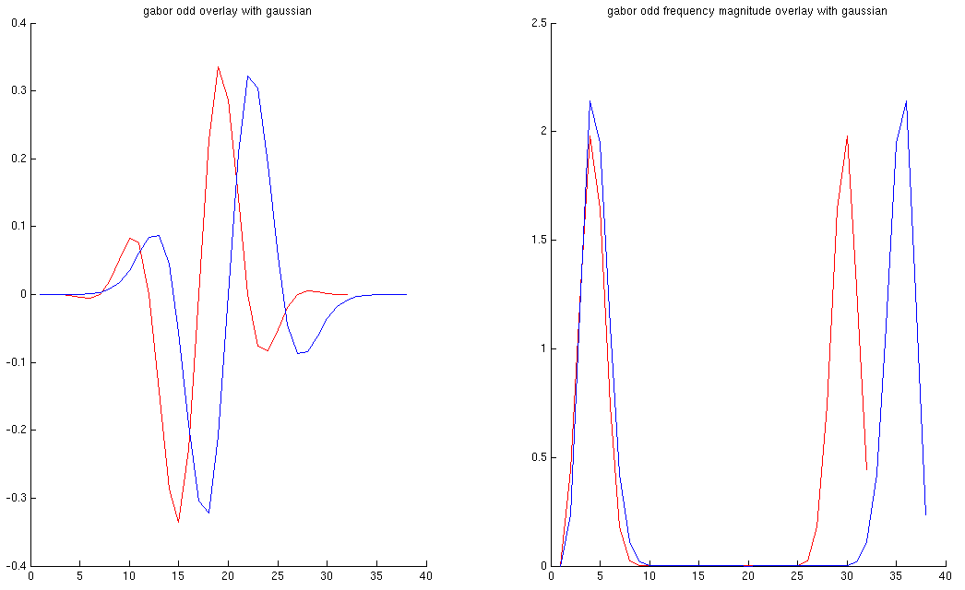
3b – Color Histograms
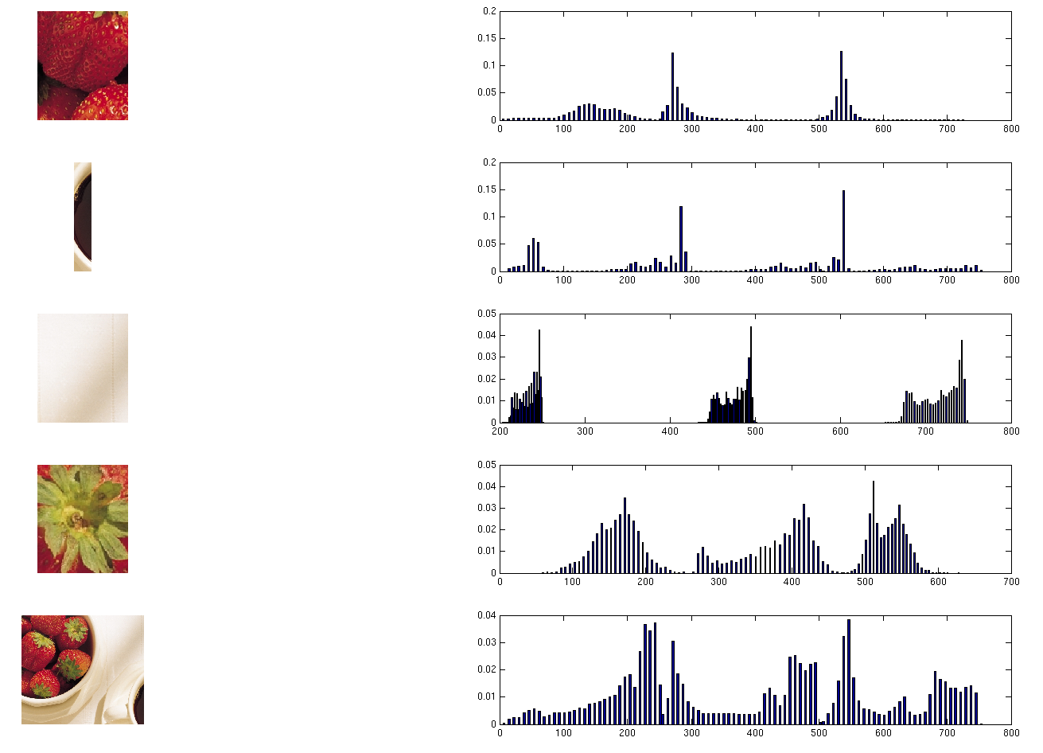

3c – Chi Squared Distance

0 0.5291 0.6130 0.4293 0.3900
0.5291 0 0.5313 0.6083 0.3101
0.6130 0.5313 0 0.2852 0.1965
0.4293 0.6083 0.2852 NaN 0.3755
0.3900 0.3101 0.1965 0.3755 0

% Author: <njoffe@ucsd.edu> Nitay Joffe
% Date: 10/24/2006
% Class: CSE 166 - Image Processing
% Homework: 1
% Problem: 1 - Gabor Functions
clear;

% 1. Gabor Functions
% In 1D, the Gabor function of width sigma and spatial frequency u_o is given
% by the following complex-valued function:
% h(x) = e^{-x^2 / 2\sigma^2} e^{j2\pi u_o x}
% In 2D, the corresponding expression is
% h(x) = e^{-||X||^2 / 2\sigma^2} e^{j2\pi U_o X}
% where X = (x, y) and U_o = (u_o , v_o), and it serves as an oriented
% bandpass filter. The even and odd Gabor functions are equal to the real and
% imaginary parts of h, respectively.

% (a) Compute eight examples of even and/or odd 1D Gabor functions on the
% interval x: [-16, 15] using parameters chosen in the following ranges:
% sigma: [1, 3] and u_o: [0, 0.3]. For each example, plot the function and
% its Fourier transform magnitude.
x = -16:15;
sigma_values = [1.5 2.75];
u_0_values = [0.0 0.1 0.2 0.3];
number_of_items = numel(sigma_values) * numel(u_0_values);

plot_even_function = true;
i = 1;

figure;
for sigma = sigma_values
for u_0 = u_0_values
gabor_function = exp(-x.*x/(2*sigma^2)).*exp(j*2*pi*u_0*x);
even_gabor_function = real(gabor_function);
odd_gabor_function = imag(gabor_function);

gabor_function_frequency = fft(gabor_function);
even_gabor_function_frequency_magnitude = abs(fft(even_gabor_function));
odd_gabor_function_frequency_magnitude = abs(fft(odd_gabor_function));

subplot(number_of_items,2,i);
if plot_even_function
plot(even_gabor_function);
title(['even gabor function with sigma = ' num2str(sigma) ', u_0 = ' num2str(u_0)]);
else
plot(odd_gabor_function);
title(['odd gabor function with sigma = ' num2str(sigma) ', u_0 = ' num2str(u_0)]);
end

subplot(number_of_items,2,i+1);
if plot_even_function
plot(even_gabor_function_frequency_magnitude);
title(['even gabor function frequency with sigma = ' num2str(sigma) ', u_0 = ' num2str(u_0)]);
else
plot(odd_gabor_function_frequency_magnitude);
title(['odd gabor function frequency magnitude with sigma = ' num2str(sigma) ', u_0 = ' num2str(u_0)]);
end
i = i + 2;
end
end

% (b) Compute eight examples of even and/or odd 2D Gabor functions on the
% interval x: [-16, 15]x[-16, 15] using parameters chosen in the following
% ranges: \sigma: [1, 3] and u_o = [0, 0.3]x[0, 0.3]. For each example,
% display the function (either as an image or a surface plot) and its
% Fourier transform magnitude.
[x,y] = meshgrid(-16:15,-16:15);
sigma_values = [1.75 2.5];
u_0_values = [0 0; 0.1 0.3; 0.3 0.2; 0.2 0.05];
number_of_u_0_rows = size(u_0_values,1);

plot_even_function = true;

for sigma = sigma_values
for u_0_row_index = 1:number_of_u_0_rows
u_0 = u_0_values(u_0_row_index,1);
v_0 = u_0_values(u_0_row_index,2);

u_0_x_dot_product = u_0 * x + v_0 * y;
gabor_function = exp(-abs(x.*x)/(2*sigma^2)).*exp(j*2*pi*u_0_x_dot_product);
even_gabor_function = real(gabor_function);
odd_gabor_function = imag(gabor_function);

gabor_function_frequency = fft2(gabor_function);
even_gabor_function_frequency_magnitude = abs(fft2(even_gabor_function));
odd_gabor_function_frequency_magnitude = abs(fft2(odd_gabor_function));

figure;
subplot(1,2,1);
if plot_even_function
mesh(x,y,even_gabor_function);
title(['even gabor function with \sigma = ' num2str(sigma) ', u_0 = ' num2str(u_0), ', v_0 = ' num2str(v_0)]);
else
mesh(x,y,odd_gabor_function);
title(['odd gabor function with \sigma = ' num2str(sigma) ', u_0 = ' num2str(u_0), ', v_0 = ' num2str(v_0)]);
end

subplot(1,2,2);
if plot_even_function
mesh(x,y,even_gabor_function_frequency_magnitude);
title(['even gabor function frequency with \sigma = ' num2str(sigma) ', u_0 = ' num2str(u_0), ', v_0 = ' num2str(v_0)]);
else
mesh(x,y,odd_gabor_function_frequency_magnitude);
title(['odd gabor function frequency magnitude with \sigma = ' num2str(sigma) ', u_0 = ' num2str(u_0), ', v_0 = ' num2str(v_0)]);
end
end
end

% Author: <njoffe@ucsd.edu> Nitay Joffe
% Date: 10/24/2006
% Class: CSE 166 - Image Processing
% Homework: 1
% Problem: 2 - Gaussian derivatives vs. Gabor functions
clear;

% Gaussian derivatives vs. Gabor functions
% (a) Evaluate the 1D Gaussian function e^{-x^2/2\sigma^2} on the interval
% x: [-16, 15] using \sigma = 3. Compute its approximate third derivative
% by repeated application of the centered first difference kernel. Plot the
% resulting function and its DFT magnitude.

x = -16:15;
sigma = 3;
y = exp(-x.^2/(2*sigma^2));
centered_first_difference_kernel = [1 0 -1];

first_derivative = conv(centered_first_difference_kernel, y);
second_derivative = conv(centered_first_difference_kernel, first_derivative);
third_derivative = conv(centered_first_difference_kernel, second_derivative);
third_derivative_frequency_magnitude = abs(fft(third_derivative));

figure;
subplot(1,2,1);
plot(third_derivative);
title('third derivative of 1D gaussian');
subplot(1,2,2);
plot(third_derivative_frequency_magnitude);
title('discrete fourier transform magnitude');

% (b) Experimentally find parameter values for an even or odd 1D Gabor function
% that closely matches the Gaussian 3rd derivative. Note: you may also need
% to apply an amplitude scaling factor. Once you have found a good match,
% make plots showing the quality of the match in both the spatial domain and
% the frequency domain.

x = -16:15;
sigma = 4;
u_o = 1.1;
amplitude_scaling_factor = 0.4;

gabor = amplitude_scaling_factor * exp(-x.^2 / (2*sigma^2)).*exp(j*2*pi*u_o*x);
gabor_odd = imag(gabor);
gabor_odd_frequency_magnitude = abs(fft(gabor_odd));

figure;
subplot(1,2,1);
hold on;
plot(gabor_odd,'r');
plot(third_derivative);
title('gabor odd overlay with gaussian');
subplot(1,2,2);
hold on;
plot(gabor_odd_frequency_magnitude,'r');
plot(third_derivative_frequency_magnitude);
title('gabor odd frequency magnitude overlay with gaussian');

% Author: <njoffe@ucsd.edu> Nitay Joffe
% Date: 10/24/2006
% Class: CSE 166 - Image Processing
% Homework: 1
% Problem: 3 - Color Histograms
% Question: a

% (a) Make a function in Matlab that computes the RGB color histogram for a
% user-selected rectangular region in an arbitrary color image. Use 32 bins
% for each color channel, spaced equally between 0 and 255. Concatenate the
% three histograms together to make a combined histogram of length
% 3x32 = 96. Hint: to get the histogram for the red channel,
% use rh=hist(R(:),32), where R is an array containing the red slice of an
% RGB image. Once you have computed the combined histogram, normalize it so
% that it sums to 1.
function [rgb_image_rectangle,combined_histogram,combined_position] = rgb_histogram(rgb_image)
number_of_bins = 32;

% We assume imshow(rgb_image) has already been displayed by the caller.
rgb_image_rectangle = getrect;
xmin = rgb_image_rectangle(1);
ymin = rgb_image_rectangle(2);
xmax = xmin + rgb_image_rectangle(3);
ymax = ymin + rgb_image_rectangle(4);

rgb_image_rectangle = rgb_image(ymin:ymax,xmin:xmax,:);

red_layer_double = double(rgb_image_rectangle(:,:,1));
[red_histogram,red_position] = hist(red_layer_double(:), number_of_bins);

green_layer_double = double(rgb_image_rectangle(:,:,2));
[green_histogram,green_position] = hist(green_layer_double(:), number_of_bins);
green_position = green_position + red_position(end);

blue_layer_double = double(rgb_image_rectangle(:,:,3));
[blue_histogram,blue_position] = hist(blue_layer_double(:), number_of_bins);
blue_position = blue_position + green_position(end);

combined_histogram = [red_histogram green_histogram blue_histogram];
combined_histogram = combined_histogram ./ sum(combined_histogram);

combined_position = [red_position green_position blue_position];
end
% Author: <njoffe@ucsd.edu> Nitay Joffe
% Date: 10/24/2006
% Class: CSE 166 - Image Processing
% Homework: 1
% Problem: 3 - Color Histograms
% Question: c

% (c) Implement a function to compute the \chi^2 distance between a pair of
% normalized histograms h_i(k) and h_j(k), which is defined as:
%
% \chi^2(i,j) =
% \frac{1}{2}\sum_{k=1}^{K}\frac{[h_i(k)-h_j(k)]^2}{h_i(k)+h_j(k)}
function distance = chi_squared(normalized_histogram_1, normalized_histogram_2)
numerator = (normalized_histogram_1 - normalized_histogram_2) .^ 2;
denominator = normalized_histogram_1 + normalized_histogram_2;
distance = 0.5 * sum(sum(numerator ./ denominator));
end
% Author: <njoffe@ucsd.edu> Nitay Joffe
% Date: 10/24/2006
% Class: CSE 166 - Image Processing
% Homework: 1
% Problem: 3 - Color Histograms
clear;

% (b) Using the above function, compute and display the color histogram for each
% of five different rectangular regions of your choice for Figure 6.30(a)
% (a bowl of strawberries). Use bar to plot each histogram, and clearly mark
% the x-axis to indicate the division between the R, G, and B intervals.
% Annotate your plot (use gtext or just mark it by hand) to explain the
% significance of the various peaks you observe. Along with each histogram,
% display the corresponding region of the image used to compute it.
number_of_regions = 5;

rgb_image = imread('Fig6.30(a).jpg');

figure;
imshow(rgb_image);
region_images = {};
region_histograms = {};
region_positions = {};
for i = 1:number_of_regions
[region_images{i},region_histograms{i},region_positions{i}] = rgb_histogram(rgb_image);
end

figure;
for i = 1:number_of_regions
subplot(number_of_regions,2,i*2-1);
imshow(region_images{i});
subplot(number_of_regions,2,i*2);
bar(region_positions{i},region_histograms{i});
end

% (c) Use this function to compare all pairs of the five histograms you computed
% in the previous step. Output the values in a 5 by 5 matrix; because of
% symmetry, only the upper triangular portion of this matrix is needed.
% Choose at least three representative entries in this matrix and explain
% their values in terms of the color distributions you compared to obtain
% them.
chi_squared_distance = [];
for i=1:number_of_regions
for j=1:number_of_regions
chi_squared_distance(i,j) = chi_squared(region_histograms{i},region_histograms{j});
end
end
chi_squared_distance

