CSE 111
Prof. Sujit Dey
Winter 2007
Project 3

Alvin Jeng
A05409996

Nitay Joffe
A05229402

The following was conducted through the given tutorial. Packet sizes for the project are 48, 64, 128, and 256. We added the 96 column simply for extra data to further verify the accuracy of the “trend” for a growing packet size vs. MAC time.

All times are measured in NS

Packet size -> | 48 | 64 | 96 | 128 | 256
Before 1st CRC | 35,470 | 37,550 | 40,110 | 42,710 | 52,950
After 1st CRC | 234,510 | 301,230 | 433,070 | 564,950 | 1,092,310
Before SBOX | 237,190 | 303,910 | 435,750 | 567,630 | 1,094,990
After SBOX | 3,284,350 | 3,351,070 | 3,482,910 | 3,614,790 | 4,142,150
Before Cipher | 3,285,550 | 3,352,270 | 3,484,110 | 3,615,990 | 4,143,350
1 byte cipher | 3,303,870 | 3,370,590 | 3,502,430 | 3,634,310 | 4,161,670
End if cipher | 4,164,710 | 4,524,550 | 5,242,630 | 5,960,750 | 8,833,070
Before 2nd CRC | 4,168,670 | 4,528,510 | 5,246,590 | 5,964,710 | 8,837,030
After 2nd CRC | 4,383,870 | 4,808,350 | 5,655,710 | 6,503,110 | 9,892,550

Now we subtract the BEFORE times from the AFTER, to get the amount of time for that one process. Example, take the “After 1st CRC” time and subtract the “Before 1st CRC” time from it, to get the amount of time taken for the 1st CRC computation.

Packet size -> | 48 | 64 | 96 | 128 | 256
1st CRC | 199,040 | 263,680 | 392,960 | 522,240 | 1,039,360
Sbox | 3,047,160 | 3,047,160 | 3,047,160 | 3,047,160 | 3,047,160
Encrypt per byte | 18,320 | 18,320 | 18,320 | 18,320 | 18,320
Encryption time | 879,160 | 1,172,280 | 1,758,520 | 2,344,760 | 4,689,720
2nd CRC | 215,200 | 279,840 | 409,120 | 538,400 | 1,055,520
MAC time | 4,348,400 | 4,770,800 | 5,615,600 | 6,460,400 | 9,839,600

The data rate is calculated as (Packet size)(8)/(MAC time)

Packet size -> | 48 | 64 | 96 | 128 | 256
Data rate | 88,308 | 107,319 | 136,761 | 158,504 | 208,138

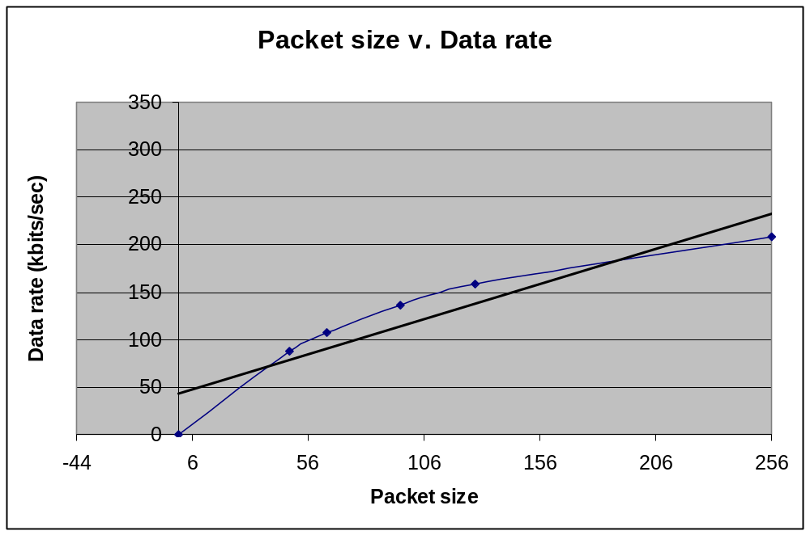

The following was graphed using the MAC time’s that we have computed from our observed data. The points represent 48, 64, 96, 128, and 256. The graph is fairly linear, with only a slight curve. The linear line added is a TREND LINE that shows the line of best fit for the graph.
Original data recorded

all NS

breakpoint line # time (48) time (64) time (96) time (128) time (256)

first crc 141 35,470 37,550 40,110 42,710 52,950
wep_encrypt() 144 234,510 301,230 433,070 564,950 1,092,310

/\ first crc computation task

sbox_setup() 73 237,190 303,910 435,750 567,630 1,094,990
after sbox() 75 3,284,350 3,351,070 3,482,910 3,614,790 4,142,150

/\ sbox_setup()

ciphertext 77 3,285,550 3,352,270 3,484,110 3,615,990 4,143,350
after 1 byte 77 3,303,870 3,370,590 3,502,430 3,634,310 4,161,670

/\ enrypt each byte

end of function 79 4,164,710 4,524,550 5,242,630 5,960,750 8,833,070

/\ finish encrypting bytes

second crc b4 153 4,168,670 4,528,510 5,246,590 5,964,710 8,837,030
after 2nd crc 156 4,383,870 4,808,350 5,655,710 6,503,110 9,892,550

/\ second CRC computation

