CSE 111
Prof. Sujit Dey
Winter 2007
Project 4

Alvin Jeng
A05409996

Nitay Joffe
A05229402

Performance estimates | 3
Performance measurements | 4
Appendix A – C Code | 7
Appendix B – Verilog Code | 10
Appendix C – Wave output | 17
Performance estimates from analysis

Hardware design with a 25ns constraint:

No. clock cycles | 1293
Clock cycle time | 25ns
Delay  No. cycles * cycle time | 43425ns
Area occupied | Ports: 246  Nets: 15675  Cells: 13216  References: 32  Combinational area: 35120.0  Noncombinational area: 15568.0  Total cell area: 50688.0
Area * Delay | 2201126400

Software implementation timing:
Packet size -> | 48
1st CRC | 199,040
Sbox | 3,047,160
Encrypt per byte | 18,320
Encryption time | 879,160
2nd CRC | 215,200
MAC time | 4,348,400

The delay of the hardware is calculated to be 43425ns. This would replace the Sbox and encryption of the software. Therefore, the software/hardware implementation would carry the following:

Packet size -> | 48
1st CRC | 199,040
Encryption (Hardware) | 43,425
2nd CRC | 215,200
MAC time | 457,665

The MAC time is the combination of all of the times during the process (CRC, Encryption via hardware, and 2nd CRC). The sum of the 3 is above, 457,665ns
Software implementation times

Packet size -> | 48 | 64 | 96 | 128 | 256
1st CRC | 199,040 | 263,680 | 392,960 | 522,240 | 1,039,360
Sbox | 3,047,160 | 3,047,160 | 3,047,160 | 3,047,160 | 3,047,160
Encrypt per byte | 18,320 | 18,320 | 18,320 | 18,320 | 18,320
Encryption time | 879,160 | 1,172,280 | 1,758,520 | 2,344,760 | 4,689,720
2nd CRC | 215,200 | 279,840 | 409,120 | 538,400 | 1,055,520
MAC time | 4,348,400 | 4,770,800 | 5,615,600 | 6,460,400 | 9,839,600

The data rate is calculated as (Packet size)(8)/(MAC time)

Packet size -> | 48 | 64 | 96 | 128 | 256
Data rate | 88,308 | 107,319 | 136,761 | 158,504 | 208,138

Hardware/Software implementation times

Packet size -> | 48 | 64 | 96 | 128 | 256
1st CRC | 199,040 | 263,680 | 392,960 | 522,240 | 1,039,360
Sbox | - | - | - | - | -
Encrypt per byte | - | - | - | - | -
Encryption time | 27,880 | 30,280 | 33,880 | 37,480 | 50,680
2nd CRC | 215,200 | 279,840 | 409,120 | 538,400 | 1,055,520
MAC time | 768,600 | 1,003,960 | 1,473,800 | 1,943,320 | 3,819,880

The data rate is calculated as (Packet size)(8)/(MAC time)

Packet size -> | 48 | 64 | 96 | 128 | 256
Data rate | 499,609 | 509,980 | 521,101 | 526,933 | 536,142

It is clear from the above data that the data rate and efficiency has gone way up with the integration of hardware to conduct the encryption processing. The data rate with hardware/software more than multiplied by a factor of 6 for a packet size of 48. Other packet sizes experienced similar increases, but with less of a factor (due to the stability of the data rate of the hardware/software implementation).

Since the Sbox setup and encryption all occur in the hardware, it is not possible to set a breakpoint in order to analyze the amount of time they take in the code. However, the encryption time overall was measured, and shows to be the majority difference between the timings of the software implementation and the hardware/software implementation. Clearly the hardware is extremely efficient in this case.
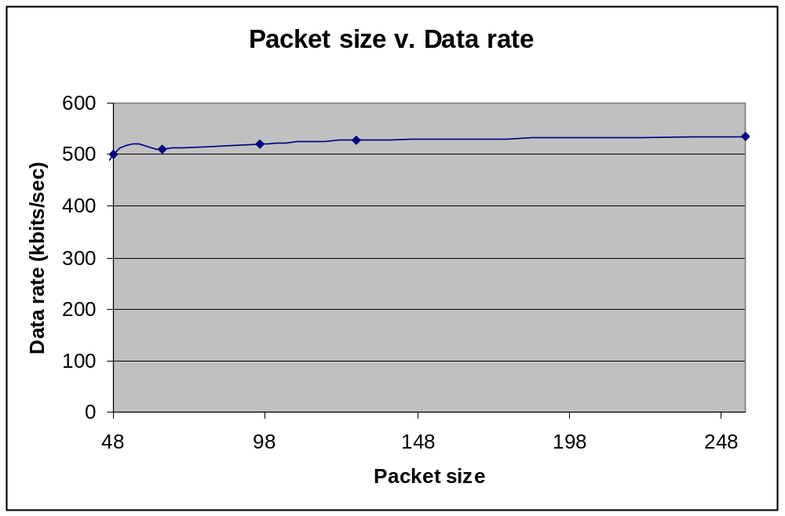

The following was graphed using the MAC time’s that we have computed from our observed data. The points represent 48, 64, 96, 128, and 256. The graph is fairly linear and mostly horizontal around the low 500 range.

Comparison with estimation

The estimation and actual was extremely close. Our estimation for the MAC time of the 48 packet size was 457,665ns. The actual measured time during simulation came out to be 499,609 ns.
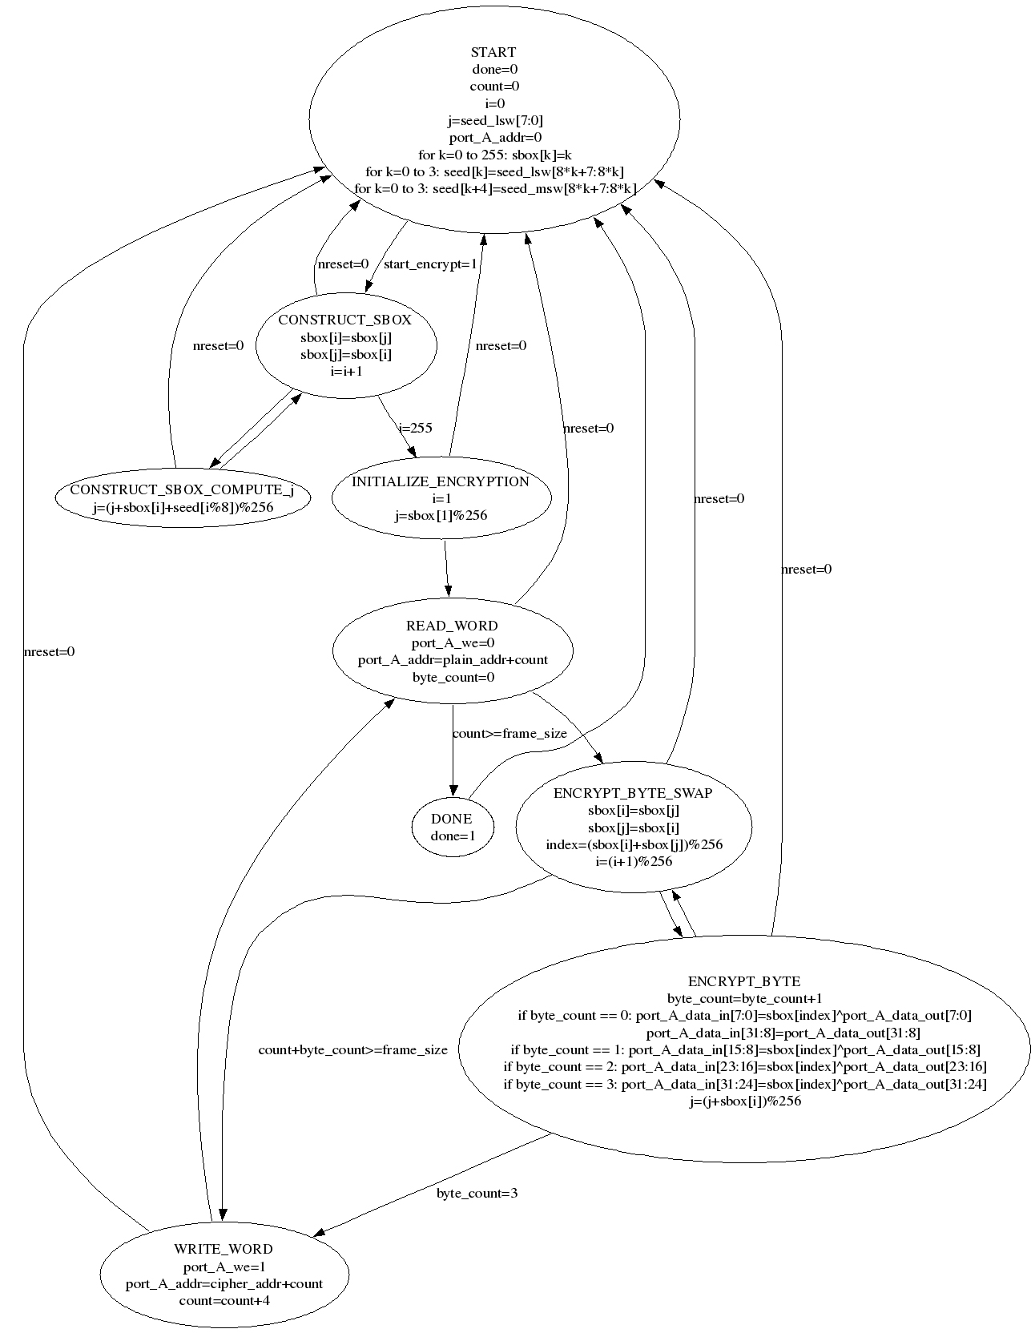

Appendix A

0 /* This is the complete MAC program for doing: encryption and CRC.
1
2 The steps are:
3 1. The CRC of the frame is calculated.
4 2. The frame is encrypted.
5 3. The CRC from Step1. is appended to the encrypted frame from Step2.
6 4. The CRC of this whole payload is calculated and appended to the frame.
7 */
8
9 #include "crc_table.h"
10
11 // Function declarations
12
13 void wep_encrypt(int plaintext_len, unsigned char plaintext[],
14 unsigned char ciphertext[], unsigned char seed[]);
15 unsigned long get_crc(int no_of_bytes, unsigned char data[]);
16 extern void WriteDebuggerWindow(unsigned long*, unsigned int);
17
18
19 void wep_encrypt(int plaintext_len, unsigned char plaintext[],
20 unsigned char ciphertext[], unsigned char seed[]) {
21 int i;
22
23 unsigned int *start_encrypt_register = (unsigned int *) 0x01000004;
24 unsigned int *plain_address_register = (unsigned int *) 0x01000008;
25 unsigned int *frame_size_register = (unsigned int *) 0x0100000C;
26 unsigned int *cipher_address_register = (unsigned int *) 0x01000010;
27 unsigned char *seed_lsw_register = (unsigned char *) 0x01000014;
28 unsigned char *seed_msw_register = (unsigned char *) 0x01000018;
29 unsigned int *done_register = (unsigned int *) 0x0100001C;
30 unsigned char *plaintext_address = (unsigned char *) 0x01000100;
31 unsigned char *cipher_address = (unsigned char *) 0x01000200;
32
33 for (i = 0; i < plaintext_len; ++i)
34 plaintext_address[i] = plaintext[i];
35
36 *plain_address_register = (unsigned int)plaintext_address;
37
38 *frame_size_register = plaintext_len;
39
40 *cipher_address_register = (unsigned int)cipher_address;
41
42 seed_lsw_register[0] = seed[0];
43 seed_lsw_register[1] = seed[1];
44 seed_lsw_register[2] = seed[2];
45 seed_lsw_register[3] = seed[3];
46 seed_msw_register[0] = seed[4];
47 seed_msw_register[1] = seed[5];
48 seed_msw_register[2] = seed[6];
49 seed_msw_register[3] = seed[7];
50
51 *start_encrypt_register = 1;
52 *start_encrypt_register = 0;
53
54 while (*done_register != 1)
55 ;
56
57 for (i = 0; i < plaintext_len; ++i)
58 ciphertext[i] = cipher_address[i];
59 }
60
61
62 unsigned long get_crc(int no_of_bytes, unsigned char data[]) {
63 unsigned long crc_temp = 0xFFFFFFFF;
64 int i, index;
65
66 index = ((int)(crc_temp >> 24)) & 0xFF;
67 crc_temp = (crc_temp << 8) ^ crc_table[index];
68
69 for (i = 0; i < no_of_bytes; i++) {
70 index = ((int)(crc_temp >> 24) ^ data[i]) & 0xFF;
71 crc_temp = (crc_temp << 8) ^ crc_table[index];
72 }
73 crc_temp = crc_temp ^ 0xFFFFFFFF;
74
75 return crc_temp;
76 }
77
78
79 int TestMain() {
80 // ensure that no functions using semihosting SWIs are linked in from the
81 // C library
82 #pragma import(__use_no_semihosting_swi)
83
84 // Initialize the plaintext data
85 unsigned char plaintext[48] = {
86 0x01, 0x02, 0x03, 0x04, 0x05, 0x06, 0x07, 0x08,
87 0x10, 0x20, 0x30, 0x40, 0x50, 0x60, 0x70, 0x80,
88 0x00, 0x09, 0x0A, 0x0B, 0x0C, 0x0D, 0x0E, 0x0F,
89 0x00, 0x90, 0xA0, 0xB0, 0xC0, 0xD0, 0xE0, 0xF0,
90 0x12, 0x23, 0x34, 0x45, 0x56, 0x67, 0x78, 0x89,
91 0x28, 0x47, 0x37, 0x86, 0x31, 0x7F, 0x4D, 0x86 };
92
93 // Declare the ciphertext array. It has 8 more bytes for 4+4 bytes of CRC data
94 unsigned char ciphertext[48+8];
95 unsigned long crc;
96 int no_of_bytes = 48;
97 int i;
98 unsigned char seed[8];
99
100 // The 5 MSBs of the seed do not change with the frame
101 // The 3 LSBs change with each new frame (part of specification)
102 seed[3] = 0x67;
103 seed[4] = 0x89;
104 seed[5] = 0xAB;
105 seed[6] = 0xCD;
106 seed[7] = 0xEF;
107
108 // For project-3 we're applying the MAC protocol to only one frame
109 // to have manageable simulation time
110 for (i = 0; i< 1; i++) {
111 seed[0] = 0x01;
112 seed[1] = 0x23;
113 seed[2] = 0x45;
114
115 // Compute the CRC of the plaintext
116 crc = get_crc(no_of_bytes, plaintext);
117
118 // Encrypt the plaintext
119 wep_encrypt(no_of_bytes, plaintext, ciphertext, seed);
120
121 // Append the CRC to the ciphertext
122 ciphertext[no_of_bytes] = (unsigned char)(crc >> 24);
123 ciphertext[no_of_bytes+1] = (unsigned char)(crc >> 16);
124 ciphertext[no_of_bytes+2] = (unsigned char)(crc >> 8);
125 ciphertext[no_of_bytes+3] = (unsigned char)(crc);
126
127 // Compute the CRC of the whole payload
128 crc = get_crc(no_of_bytes+4, ciphertext);
129
130 // Append the CRC to the payload
131 ciphertext[no_of_bytes+4] = (unsigned char)(crc >> 24);
132 ciphertext[no_of_bytes+4+1] = (unsigned char)(crc >> 16);
133 ciphertext[no_of_bytes+4+2] = (unsigned char)(crc >> 8);
134 ciphertext[no_of_bytes+4+3] = (unsigned char)(crc);
135
136 // Display the final frame which would be transmitted
137 // Cannot have printf statements in code
138 //fprintf(stdout, "%x\n", ciphertext[j]);
139
140 // Display is handled by XRAY debugger
141 // You'll have to single step through the code for this function
142 // There is some bug in XRAY which causes it to crash if you
143 // just run through this.
144 // Set a breakpoint to just before this function and then single step
145 // through the code to display the final frame which would be transmitted
146 // Alternately, you can also view the appropriate memory location
147 // of ciphertext to see the final data.
148 WriteDebuggerWindow((unsigned long*) ciphertext, no_of_bytes+8);
149 }
150 return 1;
151 }
Appendix B

module wep_encrypt (clk, nreset,
start_encrypt, plain_addr, frame_size, cipher_addr,
seed_msw, seed_lsw, done,
port_A_clk, port_A_data_in, port_A_data_out,
port_A_addr, port_A_we
);

input clk;
input nreset;
// Initializes the wep_encrypt_v3 module

// input start_encrypt;
input [31:0] start_encrypt;
// Tells wep_encrypt_v3 to start encrypting the given frame

input [31:0] plain_addr;
// Starting address of the plaintext frame
// i.e., specifies from where wep_encrypt_v3 must read the plaintext frame

input [31:0] frame_size;
// Length of the frame in bytes

input [31:0] cipher_addr;
// Starting address of the ciphertext frame
// i.e., specifies where wep_encrypt_v3 must write the ciphertext frame

input [31:0] seed_msw;
// Contains the 4 most significant bytes of the 64 bit seed

input [31:0] seed_lsw;
// Contains the 4 least significant bytes of the 64 bit seed

input [31:0] port_A_data_out;
// read data from the dpsram (plaintext)

output [31:0] port_A_data_in;
// write data to the dpsram (ciphertext)

// output [15:0] port_A_addr;
output [31:0] port_A_addr;
// address of dpsram being read/written

output port_A_clk;
// clock to dpsram (drive this with the input clk)

output port_A_we;
// read/write selector for dpsram

output done;
// done is a signal to indicate that encryption of the frame is complete

wire [31:0] start_encrypt;
wire [31:0] plain_addr;
wire [31:0] cipher_addr;
wire [31:0] frame_size;
wire [31:0] seed_lsw;
wire [31:0] seed_msw;
wire [31:0] port_A_data_out;

reg [31:0] port_A_data_in;
reg done;
// reg [15:0] port_A_addr;
reg [31:0] port_A_addr;
reg port_A_clk;
reg port_A_we;

reg [7:0] sbox [0:255];
reg [7:0] seed [0:7];
reg [3:0] current_state;
reg [31:0] count;
reg [1:0] byte_count;
reg [7:0] i;
reg [7:0] j;
reg [7:0] index;

parameter s0 = 4'b0000,
s1 = 4'b0001,
s2 = 4'b0010,
s3 = 4'b0011,
s4 = 4'b0100,
s5 = 4'b0101,
s6 = 4'b0110,
s7 = 4'b0111,
s8 = 4'b1000,
s9 = 4'b1001,
s10 = 4'b1010,
s11 = 4'b1011,
s12 = 4'b1100,
s13 = 4'b1101,
s14 = 4'b1110,
s15 = 4'b1111;

always@ (clk) begin
port_A_clk <= clk;
end

always@ (posedge clk) begin
if (nreset == 1'b0)
current_state <= s0;
else begin
case (current_state)
// start
s0: begin
done <= 1'b0;
count <= 32'h0;
i <= 8'h0;
j <= seed_lsw[7:0];
port_A_addr <= 32'h0;

sbox[0] <= 8'h0;
sbox[1] <= 8'h1;
sbox[2] <= 8'h2;
sbox[3] <= 8'h3;
sbox[4] <= 8'h4;
sbox[5] <= 8'h5;
sbox[6] <= 8'h6;
sbox[7] <= 8'h7;
sbox[8] <= 8'h8;
sbox[9] <= 8'h9;
sbox[10] <= 8'ha;
sbox[11] <= 8'hb;
sbox[12] <= 8'hc;
sbox[13] <= 8'hd;
sbox[14] <= 8'he;
sbox[15] <= 8'hf;
sbox[16] <= 8'h10;
sbox[17] <= 8'h11;
sbox[18] <= 8'h12;
sbox[19] <= 8'h13;
sbox[20] <= 8'h14;
sbox[21] <= 8'h15;
sbox[22] <= 8'h16;
sbox[23] <= 8'h17;
sbox[24] <= 8'h18;
sbox[25] <= 8'h19;
sbox[26] <= 8'h1a;
sbox[27] <= 8'h1b;
sbox[28] <= 8'h1c;
sbox[29] <= 8'h1d;
sbox[30] <= 8'h1e;
sbox[31] <= 8'h1f;
sbox[32] <= 8'h20;
sbox[33] <= 8'h21;
sbox[34] <= 8'h22;
sbox[35] <= 8'h23;
sbox[36] <= 8'h24;
sbox[37] <= 8'h25;
sbox[38] <= 8'h26;
sbox[39] <= 8'h27;
sbox[40] <= 8'h28;
sbox[41] <= 8'h29;
sbox[42] <= 8'h2a;
sbox[43] <= 8'h2b;
sbox[44] <= 8'h2c;
sbox[45] <= 8'h2d;
sbox[46] <= 8'h2e;
sbox[47] <= 8'h2f;
sbox[48] <= 8'h30;
sbox[49] <= 8'h31;
sbox[50] <= 8'h32;
sbox[51] <= 8'h33;
sbox[52] <= 8'h34;
sbox[53] <= 8'h35;
sbox[54] <= 8'h36;
sbox[55] <= 8'h37;
sbox[56] <= 8'h38;
sbox[57] <= 8'h39;
sbox[58] <= 8'h3a;
sbox[59] <= 8'h3b;
sbox[60] <= 8'h3c;
sbox[61] <= 8'h3d;
sbox[62] <= 8'h3e;
sbox[63] <= 8'h3f;
sbox[64] <= 8'h40;
sbox[65] <= 8'h41;
sbox[66] <= 8'h42;
sbox[67] <= 8'h43;
sbox[68] <= 8'h44;
sbox[69] <= 8'h45;
sbox[70] <= 8'h46;
sbox[71] <= 8'h47;
sbox[72] <= 8'h48;
sbox[73] <= 8'h49;
sbox[74] <= 8'h4a;
sbox[75] <= 8'h4b;
sbox[76] <= 8'h4c;
sbox[77] <= 8'h4d;
sbox[78] <= 8'h4e;
sbox[79] <= 8'h4f;
sbox[80] <= 8'h50;
sbox[81] <= 8'h51;
sbox[82] <= 8'h52;
sbox[83] <= 8'h53;
sbox[84] <= 8'h54;
sbox[85] <= 8'h55;
sbox[86] <= 8'h56;
sbox[87] <= 8'h57;
sbox[88] <= 8'h58;
sbox[89] <= 8'h59;
sbox[90] <= 8'h5a;
sbox[91] <= 8'h5b;
sbox[92] <= 8'h5c;
sbox[93] <= 8'h5d;
sbox[94] <= 8'h5e;
sbox[95] <= 8'h5f;
sbox[96] <= 8'h60;
sbox[97] <= 8'h61;
sbox[98] <= 8'h62;
sbox[99] <= 8'h63;
sbox[100] <= 8'h64;
sbox[101] <= 8'h65;
sbox[102] <= 8'h66;
sbox[103] <= 8'h67;
sbox[104] <= 8'h68;
sbox[105] <= 8'h69;
sbox[106] <= 8'h6a;
sbox[107] <= 8'h6b;
sbox[108] <= 8'h6c;
sbox[109] <= 8'h6d;
sbox[110] <= 8'h6e;
sbox[111] <= 8'h6f;
sbox[112] <= 8'h70;
sbox[113] <= 8'h71;
sbox[114] <= 8'h72;
sbox[115] <= 8'h73;
sbox[116] <= 8'h74;
sbox[117] <= 8'h75;
sbox[118] <= 8'h76;
sbox[119] <= 8'h77;
sbox[120] <= 8'h78;
sbox[121] <= 8'h79;
sbox[122] <= 8'h7a;
sbox[123] <= 8'h7b;
sbox[124] <= 8'h7c;
sbox[125] <= 8'h7d;
sbox[126] <= 8'h7e;
sbox[127] <= 8'h7f;
sbox[128] <= 8'h80;
sbox[129] <= 8'h81;
sbox[130] <= 8'h82;
sbox[131] <= 8'h83;
sbox[132] <= 8'h84;
sbox[133] <= 8'h85;
sbox[134] <= 8'h86;
sbox[135] <= 8'h87;
sbox[136] <= 8'h88;
sbox[137] <= 8'h89;
sbox[138] <= 8'h8a;
sbox[139] <= 8'h8b;
sbox[140] <= 8'h8c;
sbox[141] <= 8'h8d;
sbox[142] <= 8'h8e;
sbox[143] <= 8'h8f;
sbox[144] <= 8'h90;
sbox[145] <= 8'h91;
sbox[146] <= 8'h92;
sbox[147] <= 8'h93;
sbox[148] <= 8'h94;
sbox[149] <= 8'h95;
sbox[150] <= 8'h96;
sbox[151] <= 8'h97;
sbox[152] <= 8'h98;
sbox[153] <= 8'h99;
sbox[154] <= 8'h9a;
sbox[155] <= 8'h9b;
sbox[156] <= 8'h9c;
sbox[157] <= 8'h9d;
sbox[158] <= 8'h9e;
sbox[159] <= 8'h9f;
sbox[160] <= 8'ha0;
sbox[161] <= 8'ha1;
sbox[162] <= 8'ha2;
sbox[163] <= 8'ha3;
sbox[164] <= 8'ha4;
sbox[165] <= 8'ha5;
sbox[166] <= 8'ha6;
sbox[167] <= 8'ha7;
sbox[168] <= 8'ha8;
sbox[169] <= 8'ha9;
sbox[170] <= 8'haa;
sbox[171] <= 8'hab;
sbox[172] <= 8'hac;
sbox[173] <= 8'had;
sbox[174] <= 8'hae;
sbox[175] <= 8'haf;
sbox[176] <= 8'hb0;
sbox[177] <= 8'hb1;
sbox[178] <= 8'hb2;
sbox[179] <= 8'hb3;
sbox[180] <= 8'hb4;
sbox[181] <= 8'hb5;
sbox[182] <= 8'hb6;
sbox[183] <= 8'hb7;
sbox[184] <= 8'hb8;
sbox[185] <= 8'hb9;
sbox[186] <= 8'hba;
sbox[187] <= 8'hbb;
sbox[188] <= 8'hbc;
sbox[189] <= 8'hbd;
sbox[190] <= 8'hbe;
sbox[191] <= 8'hbf;
sbox[192] <= 8'hc0;
sbox[193] <= 8'hc1;
sbox[194] <= 8'hc2;
sbox[195] <= 8'hc3;
sbox[196] <= 8'hc4;
sbox[197] <= 8'hc5;
sbox[198] <= 8'hc6;
sbox[199] <= 8'hc7;
sbox[200] <= 8'hc8;
sbox[201] <= 8'hc9;
sbox[202] <= 8'hca;
sbox[203] <= 8'hcb;
sbox[204] <= 8'hcc;
sbox[205] <= 8'hcd;
sbox[206] <= 8'hce;
sbox[207] <= 8'hcf;
sbox[208] <= 8'hd0;
sbox[209] <= 8'hd1;
sbox[210] <= 8'hd2;
sbox[211] <= 8'hd3;
sbox[212] <= 8'hd4;
sbox[213] <= 8'hd5;
sbox[214] <= 8'hd6;
sbox[215] <= 8'hd7;
sbox[216] <= 8'hd8;
sbox[217] <= 8'hd9;
sbox[218] <= 8'hda;
sbox[219] <= 8'hdb;
sbox[220] <= 8'hdc;
sbox[221] <= 8'hdd;
sbox[222] <= 8'hde;
sbox[223] <= 8'hdf;
sbox[224] <= 8'he0;
sbox[225] <= 8'he1;
sbox[226] <= 8'he2;
sbox[227] <= 8'he3;
sbox[228] <= 8'he4;
sbox[229] <= 8'he5;
sbox[230] <= 8'he6;
sbox[231] <= 8'he7;
sbox[232] <= 8'he8;
sbox[233] <= 8'he9;
sbox[234] <= 8'hea;
sbox[235] <= 8'heb;
sbox[236] <= 8'hec;
sbox[237] <= 8'hed;
sbox[238] <= 8'hee;
sbox[239] <= 8'hef;
sbox[240] <= 8'hf0;
sbox[241] <= 8'hf1;
sbox[242] <= 8'hf2;
sbox[243] <= 8'hf3;
sbox[244] <= 8'hf4;
sbox[245] <= 8'hf5;
sbox[246] <= 8'hf6;
sbox[247] <= 8'hf7;
sbox[248] <= 8'hf8;
sbox[249] <= 8'hf9;
sbox[250] <= 8'hfa;
sbox[251] <= 8'hfb;
sbox[252] <= 8'hfc;
sbox[253] <= 8'hfd;
sbox[254] <= 8'hfe;
sbox[255] <= 8'hff;

seed[0] <= seed_lsw[7:0];
seed[1] <= seed_lsw[15:8];
seed[2] <= seed_lsw[23:16];
seed[3] <= seed_lsw[31:24];
seed[4] <= seed_msw[7:0];
seed[5] <= seed_msw[15:8];
seed[6] <= seed_msw[23:16];
seed[7] <= seed_msw[31:24];
if (start_encrypt & 32'b1 == 1)
current_state <= s1;
end

// construct sbox
s1: begin
sbox[i] <= sbox[j];
sbox[j] <= sbox[i];
i <= i + 8'h1;

if (i == 8'hff)
current_state <= s3;
else
current_state <= s2;
end

// compute j
s2: begin
j <= (j + sbox[i] + seed[i % 8]) % 256;

current_state <= s1;
end

// initialize encryption
s3: begin
i <= 8'h1;
j <= sbox[1] % 256;

current_state <= s9;
end

// delay for writing of last word
s9: begin
current_state <= s4;
end

// read word
s4: begin
port_A_we <= 8'h0;
port_A_addr <= plain_addr + count;
byte_count <= 2'b0;

if (count >= frame_size)
current_state <= s8;
else
current_state <= s5;
end

// swap
s5: begin
sbox[i] <= sbox[j];
sbox[j] <= sbox[i];
index <= (sbox[i] + sbox[j]) % 256;
i <= (i + 1) % 256;

if (count + byte_count >= frame_size)
current_state <= s7;
else
current_state <= s6;
end

// encrypt byte
s6: begin
byte_count <= byte_count + 1;
case (byte_count)
2'b00: begin
port_A_data_in[7:0] <= sbox[index] ^ port_A_data_out[7:0];
port_A_data_in[31:8] <= port_A_data_out[31:8];
end
2'b01: begin
port_A_data_in[15:8] <= sbox[index] ^ port_A_data_out[15:8];
end
2'b10: begin
port_A_data_in[23:16] <= sbox[index] ^ port_A_data_out[23:16];
end
2'b11: begin
port_A_data_in[31:24] <= sbox[index] ^ port_A_data_out[31:24];
end
endcase

j <= (j + sbox[i]) % 256;

if (byte_count == 2'b11)
current_state <= s7;
else
current_state <= s5;
end

// write word
s7: begin
port_A_we <= 1'b1;
port_A_addr <= cipher_addr + count;
count <= count + 4;

current_state <= s9;
end

// done
s8: begin
done <= 1'b1;

current_state <= s0;
end

default: begin
current_state <= s0;
end
endcase
end
end
endmodule
Appendix C
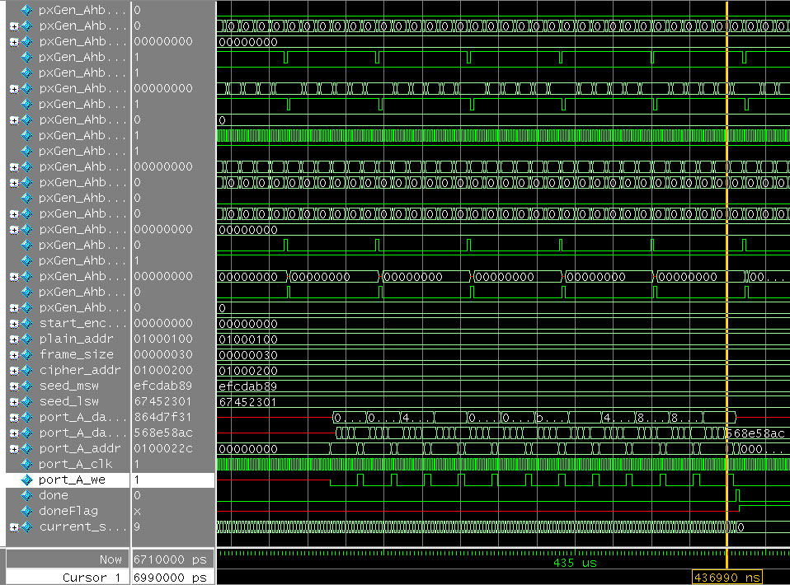

The wave output shows the last ciphertext calculated. The entire block prior is the ciphering of the plaintext. The data shown is 56 8e 58 ac stored in the address 0100022c. This correctly matches the ciphertext (of course the block pairs are reversed at this point): ac 58 8e 56

Initial Plaintext array:

{ 0x01, 0x02, 0x03, 0x04, 0x05, 0x06, 0x07, 0x08,
0x10, 0x20, 0x30, 0x40, 0x50, 0x60, 0x70, 0x80,
0x00, 0x09, 0x0A, 0x0B, 0x0C, 0x0D, 0x0E, 0x0F,
0x00, 0x90, 0xA0, 0xB0, 0xC0, 0xD0, 0xE0, 0xF0,
0x12, 0x23, 0x34, 0x45, 0x56, 0x67, 0x78, 0x89,
0x28, 0x47, 0x37, 0x86, 0x31, 0x7F, 0x4D, 0x86 };

Value of first CRC:
0x01bcf7be

Value of second CRC:
0x604899cd

Final ciphertext array ( encryption of plaintext + CRC1 + CRC2 )

75 96 c1 e3 15 4d f 71
1d 6b e5 13 62 ef 6e 7c
9b 13 e2 43 82 8d 32 78
52 a5 e8 7 b6 5c 2b 29
d4 a8 b8 6f fe ca 1f 80
74 48 65 52 ac 58 8e 56
1 bc f7 be 60 48 99 cd

