Project Title: Smart Fitness Tracker & Diet Orchestrator Engine
Student Name: Krishna Shivhare
Current Status: Phase 1 Complete (Backend Storage & Relational Connection)
STEP 1: INITIAL COMPILATION & BASE STORAGE INFRASTRUCTURE
In this initial progressive phase, the execution routine tests the core connection to the local MongoDB server engine. Once connected successfully at port 27017, it automatically creates the base structural namespaces (collections) required for the schema.
- Operation: Seed Base Database Infrastructure Entities
- Collections Initialized: Fitness_Departments, Gym_Staff
- Current Achievement: Connection established; base static parameters written to cluster storage.
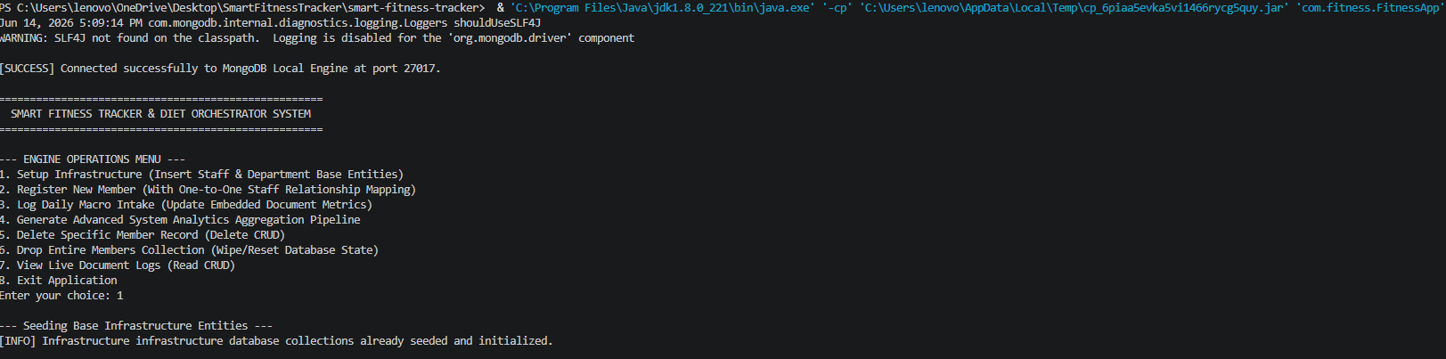
STEP 2: REGISTER NEW MEMBER WITH ONE-TO-ONE RELATIONAL MAPPING
After verifying the infrastructural backbone, the system moves to data population. In this step, human profiles are entered into the database, dynamically verifying relational bounds.
- Operation: Member Onboarding with Relational Constraint Check
- Collection Affected: Members
- Relational Logic: The module tracks data integrity by verifying that the input assignedStaffId matches a valid reference in the Gym_Staff collection before permitting the document write operation.
