**Mahesh Khulbe**

**8587894460**

**Cloud Solution Architect**

[Mahesh08khulbe@gmail.com](mailto:Mahesh08khulbe@gmail.com)

Linkedin: <https://www.linkedin.com/in/cloudchef/>

Youtube : https://www.youtube.com/channel/UCDz4iUrJmAoJL_rCJwEoniQ

Clients: NIIT Technologies, Nvidia, LinkedIN ,

Capgemini, Microsoft, CB&I , Honda etc.

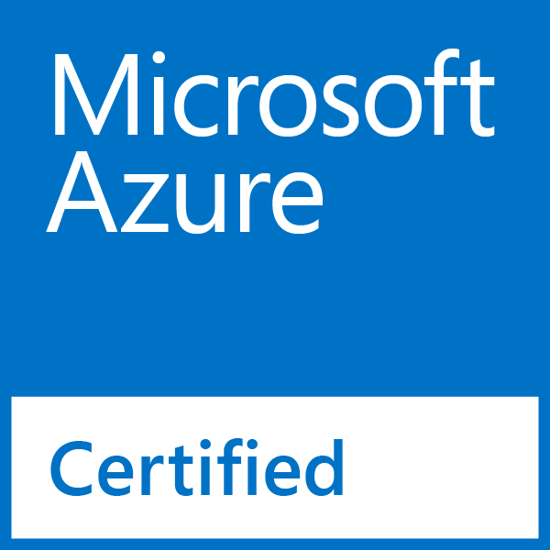



[This Photo](https://commons.wikimedia.org/wiki/File:MCT_logo.png) by Unknown Author is licensed under [CC BY-SA](https://creativecommons.org/licenses/by-sa/3.0/)

|  |
| --- |
| **PROFESSIONAL SUMMARY:** |

* Around 7 Years of Experience in **Solution Architecting. Corporate Trainings, Pre-Sales and Project management** in Microsoft Azure Cloud Computing and Office 365
* Working as a **Principal Consultant** with **Genpact** on Azure Migration Project.
* Extensively worked with Azure related project and trained over **1000+** people on Azure.
* Hands on experience with Microsoft Azure, Cloud Services, Storage/Storage Accounts, **Azure Traffic Manager.**
* Installing windows roles, features and deploying applications using **Power Shell scripting**.
* Created user accounts, modified and deleted according to the environment using user administration in **Azure Active Directory.**
* Experienced in Provisioning of **IAAS & PAAS** Virtual Machines and **Web\Worker roles** on Microsoft **Azure Classic and Azure Resource Manager.**
* Experienced in Moving VMs between the **Azure Subscriptions** and between Hosted Services within the same subscription and between Vent’s.
* Working experience in setting up cluster environment for **load balancing** and high availability of **Windows servers**.
* Good working experience with **Power Shell on windows server 2012/2008 r2 environments.**
* **Azure Expertise IaaS, PaaS, VM Migrations, VNet, Traffic Manager, Azure Cloud Services, SQL Azure, Active Directory, Express Route, Power Shell, Security Center, Service bus, blob storages.**
* Hands on experience in Configuring Internal **Load Balancing** for SQL Always ON and **IIS** for **Azure IAAS VMs**.
* Experienced in **Reconfiguring, Recreating and troubleshooting** issues for the VMs in Azure.
* Experience in building highly scalable cloud services Virtual machines, virtual networks with **web & Worker Roles.**
* Experience on installing and configuring **SSL certificates** in web servers and enabled **secured (https) transactions.**
* Knowledge in software deployment of web based applications using **visual studio 2017/20015.**
* Designed and Deployed **Microsoft azure** for multitude applications utilizing the azure stack including compute, **web and mobile, blobs, resource groups, azure SQL and cloud services, Focusing** on high-availability, fault tolerance and auto scaling. .
* Implemented **Agile** and **Waterfall** methodologies for different projects.
* Hands on experience in **Bug fixing and Reporting.**
* **Self-motivated** and dedicated to work
* **Task-oriented** and **committed** to deliver work products within the established timeline

|  |
| --- |
| **CERTIFICATIONS:** |

Certified in AZ-104, AZ-900

Certified in AI-100

Certified in 20347 and 20346 : Enabling and Managing Office 365

Certified in System Center Config Manager

|  |
| --- |
| **TECHNICAL SKILLS:** |

|  |  |
| --- | --- |
| Cloud Technologies | Microsoft Azure (Windows Azure),AWS |
| Programming Languages | Python, .Net , |
| Scripting Languages | Powershell. JSON |
| Markup | XML, HTML5, |
| Microsoft Technologies | System Center Config Manager, SCOM, Exchange Server , SharePoint Server, Windows Server |
| Development Tools | Visual Studio 2015/2013/2012/2010/2008, SQL Server Managing Studio. |
| Monitoring tools | NewRelic,Pingdom,Nagios |
| Ticketing Tools | BMC Remedy,JIRA,ServiceNow |
| Database | SQL Server 2014/2012/2008 , Azure SQL |
| Reporting Tools | SQL Server Reporting Services |
| Web Servers | Microsoft Internet information Services (IIS 8.0/7.0). |
| Methodologies | Agile, Water fall. |
| Version Controls | GitHub,Mercurial,BitBucket |
| Protocols | HTTP, TCP/IP, FTP. |

|  |
| --- |
| **PROFESSIONAL JOURNEY** |

**Genpact India Pvt Ltd**  **Mar 2019 – Present**

**Role : Principal Consultant**

* Working as Principal Consultant and managing Projects of one of our banking client dedicatedly.
* Worked with Database, Security, Apps and other related to team to provide a secure and robust infrastructure on Azure.
* Primarily working on Automation using **Logic Apps, Log Analytics, Terraform, Azure DevOps Portal, Azure Data factory, Azure Batch Services** and other related Azure PAAS services.

**Projects:**

1. **Rackspace to Azure Migration using WebApps and Self Hosted IR.**
2. **Automatic Shutdown/Start of VM for Cost saving using Powershell.**
3. **Automated Cost Reporting using Log Analytics and Logic Apps**
4. **SFTP to SharePoint Encrypted File Move using Logic Apps and Batch Service**
5. **Current Project : Machine Learning Algorithm for efficient use of Customer’s data.**

**Freelance Microsoft Trainer**  **May 2018 – Mar 2019**

* Worked as a freelance Consultant with many well known names such as **Netcom learning, Edureka, SimpliLearn** and helped in providing end to end project support.
* Trained various people on Azure from Basic to Intermediate till Advanced Level.
* Done Pre-Sales for customer understanding of the Azure Services and their benefits.
* Handled complete architecture and end to end deployment of complex infrastructure as per customer’s needs.

**Bold Technologies**  **Jan 2018– May 2018**

**Role: Azure System Administrator**

**Responsibilities:**

* Involved in migration from **on-premises to Azure Cloud**.
* VM in Azure – Managed Azure services and subscriptions using Azure portals and Power Shell, managed Azure resources to Azure Resource Manager Azure Virtual Networking - Implemented Virtual Networks using deployment template, Azure portals and Power Shell, configured intersite connectivity, **point to site VPN, site to siteVPN, VNet to VNet**
* Provided high availability for IaaS VMs and PaaS role instances for access from other services in the VNet with Azure Internal Load Balancer.
* Implemented high availability with Azure Resource Manager deployment models.
* Designed Network Security Groups (NSGs) to control inbound and outbound access to network interfaces (NICs), VMs and subnets.
* Configured connectivity between **IaaS v1 VNets and IaaS v2 VNets.**
* Involved in **P-S Connectivity, VM agents& Extensions.**
* Azure Availability and Scalability - Configured VMs availability sets using Azure portal to provide resiliency for IaaS based solution and scale sets using **Azure Resource Manager** to manage network traffic.
* Deploying Cloud & Mobile apps using **Power Shell, Management portal & Visual Studio.**
* Azure Storage Planning - Migrated **Blob Storage for document and media file Table storage** for structured datasets, **Queue storage** for reliable messaging for **workflow processing and file storage to share file data.**
* Smoothly created pre-production environments and manage the portion of traffic going to them. Debug in the Cloud when needed and roll back if issues are found.
* **Azure Network Configuration** - Created resource groups using resource manager which allow seeing cost/billing and monitoring information for resources within a resource group and managing access to those resources as a set for individual customer.
* Azure SQL Services – Created **Azure SQL database**, performed monitoring and restoring of **AzureSQL database**. Performed migration of **Microsoft SQL server to AzureSQL database.**

**Koenig Solutions Dec 2015-Dec 2017**

**Role: Senior Corporate Trainer**

**Responsibilities:**

• In Office 365, provided multiple batches to both National and International clients covering a wide variety of topics including **Creation of Users and Groups, Administering Exchange Online and SharePoint Online as well as Skype for Business Online, Deployment of Office 365 Pro Plus, SSO using ADFS along with Directory Synchronization.**

• In SCCM, trained clients on deployment of **SCCM 2012/2016**, upgrade from SCCM 2007, **Application Packaging**, **OS deployment using Zero-Touch**, **Software and Hardware Inventory** and also using Configuration Items.

• In Exchange, covered **Exchange deployment, Mail Flow, making a Highly Available Exchange Environment using DAG, Hybrid migration with Office 365** and many more topics.

• In Azure, covered topics like Storage, Networking, Azure AD, Azure Web Apps and Automation thoroughly.

• Advanced Knowledge of **Active Directory, DNS, and DHCP** in an enterprise environment.

• Deployed Active Directory environment including file shares and DNS to replace workgroup based infrastructure.

• Implementation of PowerShell scripts to efficiently fix errors found through the Active Directory environment.

• In AWS, provided training on AWS Technical Essentials, Solutions-Architect and SysOps Training covering a wide variety of topics **including VPC, S3 buckets, EC2, EBS, EFS, AMI, AWS lambda, SNS, SQS** and many more.

• Added user accounts, fixed issues with users and the monitored usage on multiple applications.

• Configured **ADFS Server for single sign-on** functionality.

• Ability to make decisions and manage time effectively to a deliver plan on schedule.

• Strong perseverance and diligence towards attaining challenging goals and effective time management.

**Dell International May 2014 – Dec 2015**

**Role: Azure Cloud Engineer**

**Responsibilities:**

• As an L2 associate worked with Enterprise Automation and Monitoring Team to provide with automated workflows and monitoring implemented with tools like BMC Patrol.

• Worked With **Azure Classic Portal** and troubleshooted various issues..

• BMC Performance Manager Express and Remote Service Monitor Server Installation: Assisted in the installation of BPMP and RSM servers for our client Apria Healthcare

• Service Improvement Plan: Helped various accounts to challenge current workflow and provided a new and smarter way to implement server

monitoring.

• Constantly received awards and appreciations from DELL as well as clients from external accounts.

• Handled various Severity 1 and Severity 2 incidents diligently and provided resolution in defined SLA.