Hospital Management CRUD Project

Name: Krishna Raj Kumar

Reg No: 25BHI10130

Course : CSE

(Introduction to Problem Solving And Programming)

Flipped Course: Vityarthi

Hospital Management System (CRUD Project)
A simple console-based Python project implementing Create, Read, Update, Delete operations.

1. Project Objective
The main goal of this project is to help students apply subject concepts in a real-world context by:

- Identifying a meaningful problem (managing hospital patient records)
- Designing a technical solution (a simple management system)
- Implementing it using programming tools learned in the course
- Demonstrating understanding through documentation and evaluation

2. Scope & Requirement
2.1 Functional Requirements
These are the features the project must provide.
Your Hospital Management System includes at least three major functional modules:

Major Functional Modules

1. Patient Management

- Add patient details

- View all patients

- Update patient information

- Delete patient records

2. Data Input/Output Structure

- User enters patient name, age, disease
- System displays structured data output

3. Logical Workflow
- User interacts with menu options
- System performs CRUD operations and shows results clearly

CRUD Operations Implemented
C – Create: Add a new patient
R – Read: View all patient records
U – Update: Modify existing patient details
D – Delete: Remove a patient based on ID

Python Code and Output:
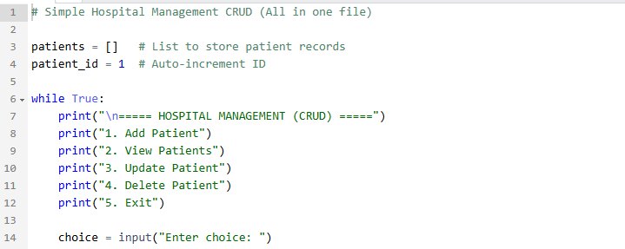
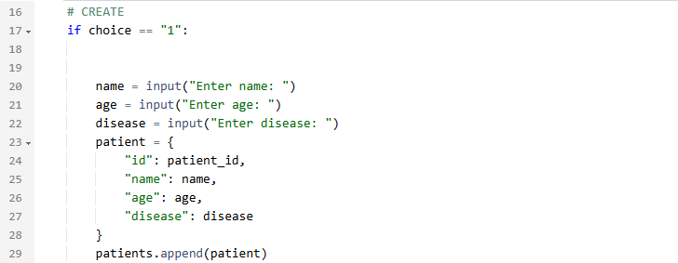
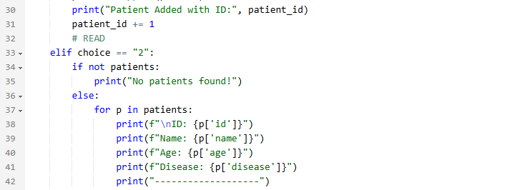
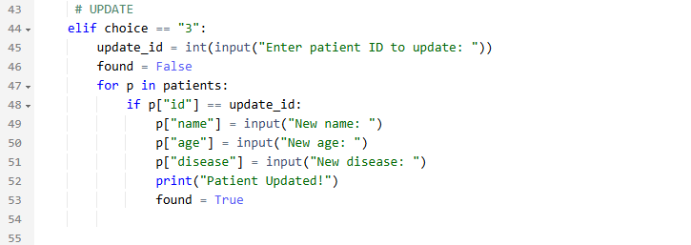
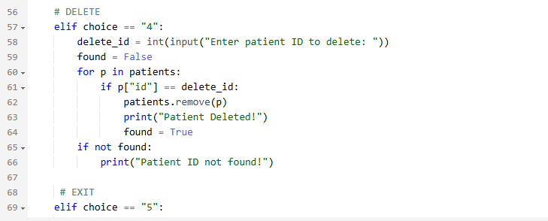
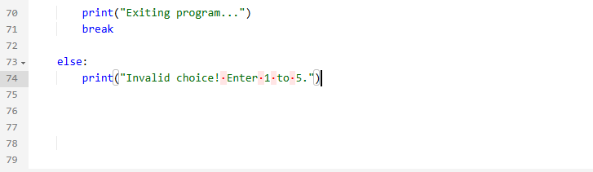
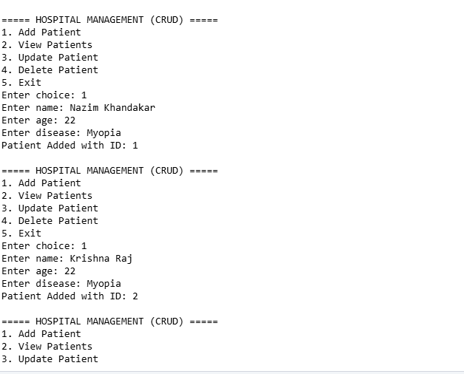
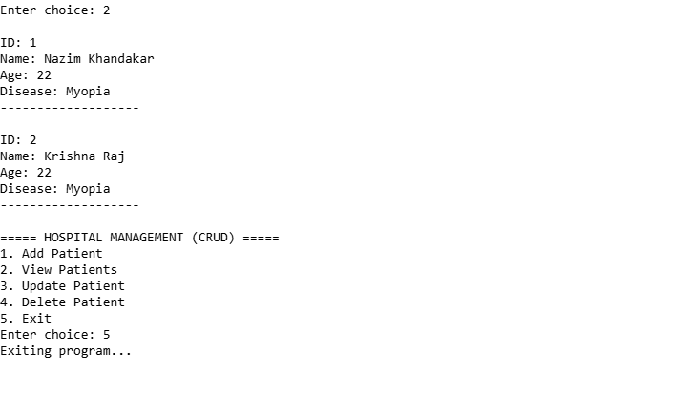
2.2 Non-Functional Requirements
The project meets at least four (4) non-functional requirements:
Chosen Non-Functional Requirements
1. Performance
Operations are executed instantly with minimal delay
2. Usability
- Simple text-based menu
- Clear instructions for users

3. Reliability
- Patient IDs auto-increment correctly
- Data stored during program execution without errors
4. Maintainability
- Code is clean and separated into logical modules
- Easy to extend (e.g., doctor module, billing module)
5. Error Handling
Prevents invalid inputs during updates/deletion
6. Scalability (Optional)
Easily extendable to databases later

3. System Features Overview

Feature Description
Add Patient Enter patient name, age, disease
- View Patients Display all stored patient records
- Update Patient Modify details of an existing patient
- Delete Patient Remove patient using ID
- Auto ID System Every new patient gets a unique ID
- Menu-Driven UI Easy navigation for user

4. Project Workflow
┌──────────────────────┐
│ Hospital System │
└──────────┬───────────┘
│
┌────────────┼─────────────┐
▼ ▼ ▼
Add Patient View Patients Update/Delete
│ │ │
▼ ▼ ▼
Stored in Displayed Modified/
List (DB) on UI Removed

5. Technologies Used
- Python (Core Language)
- Lists & Dictionaries (Data Storage)
- Loops, Conditions, Functions
- Console-based Menu System

6. Conclusion
The Hospital Management System successfully demonstrates how CRUD operations can be used to manage real-world data.
- It meets academic guidelines by delivering:
- A meaningful problem
- A complete functional solution
- Proper documentation
- Expandability for future improvements

