Part-A

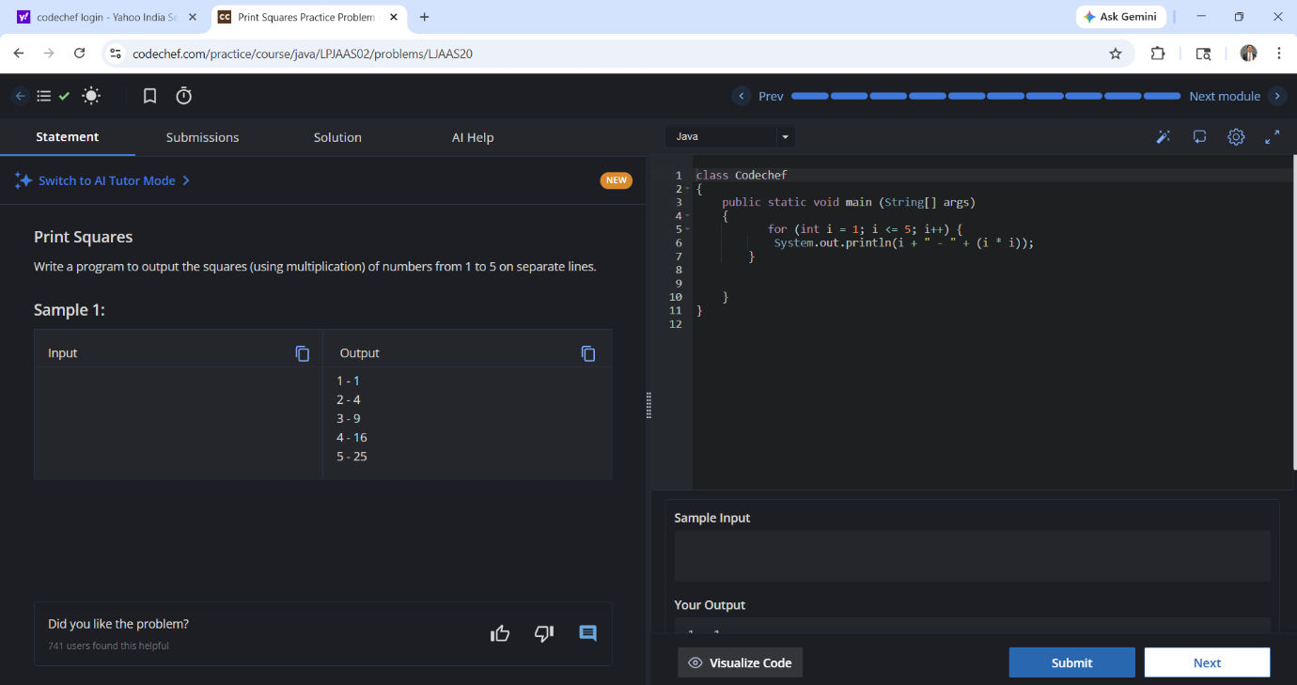

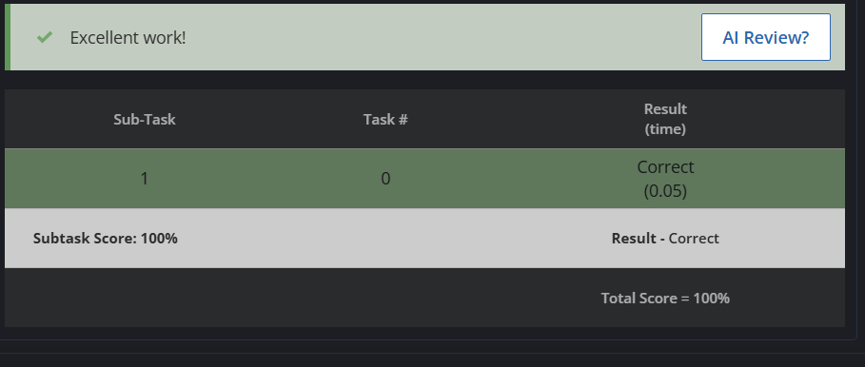

Part-B
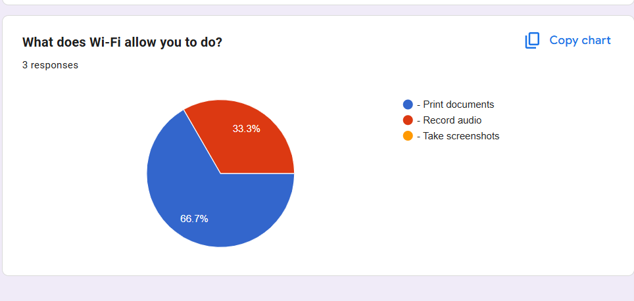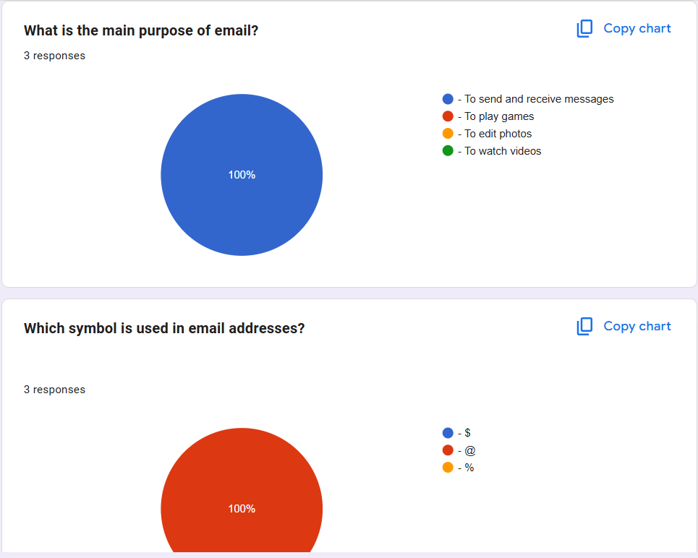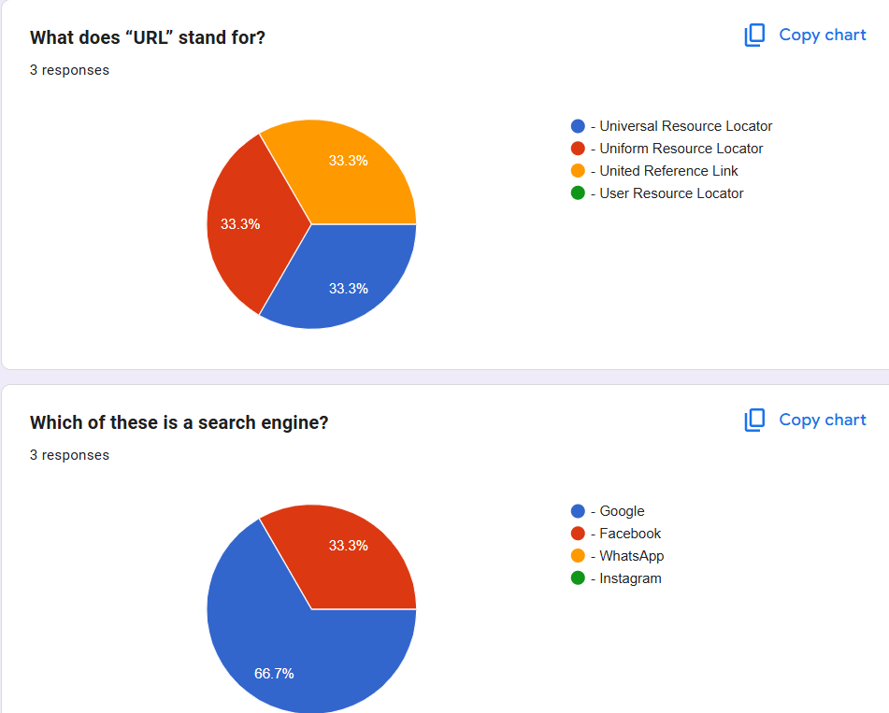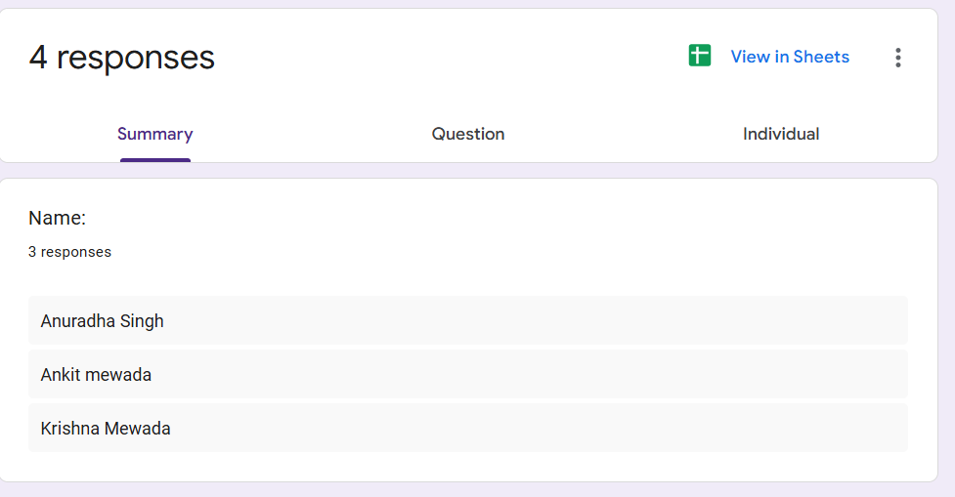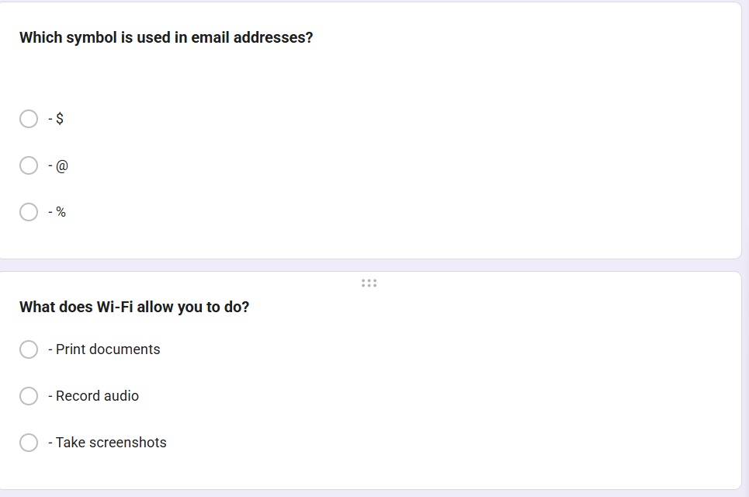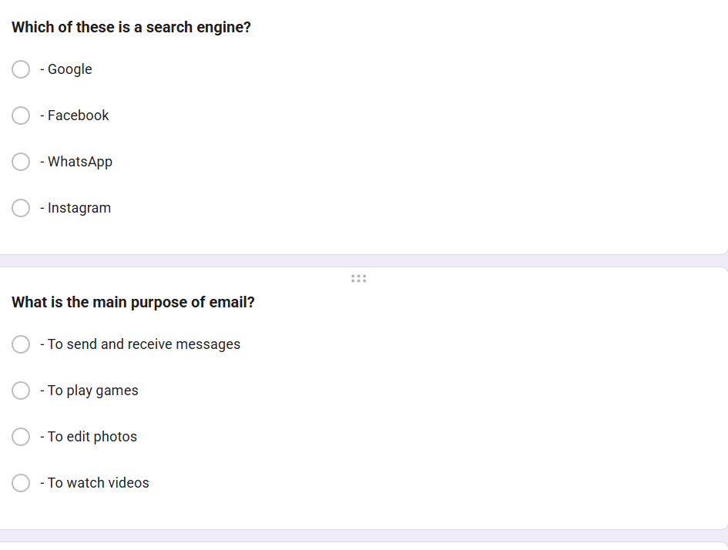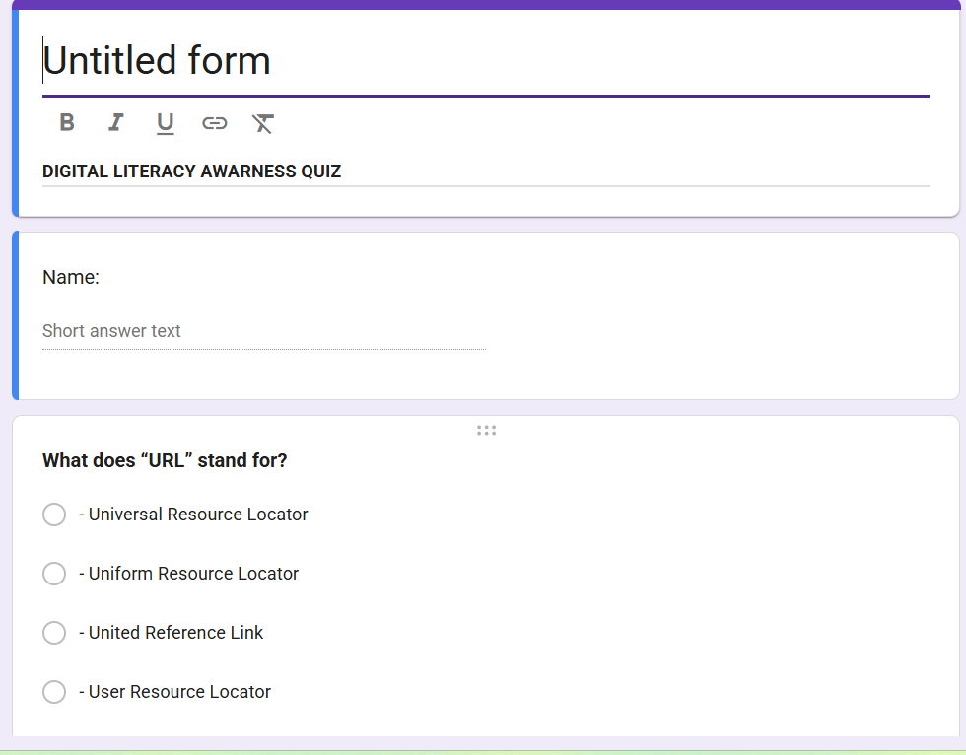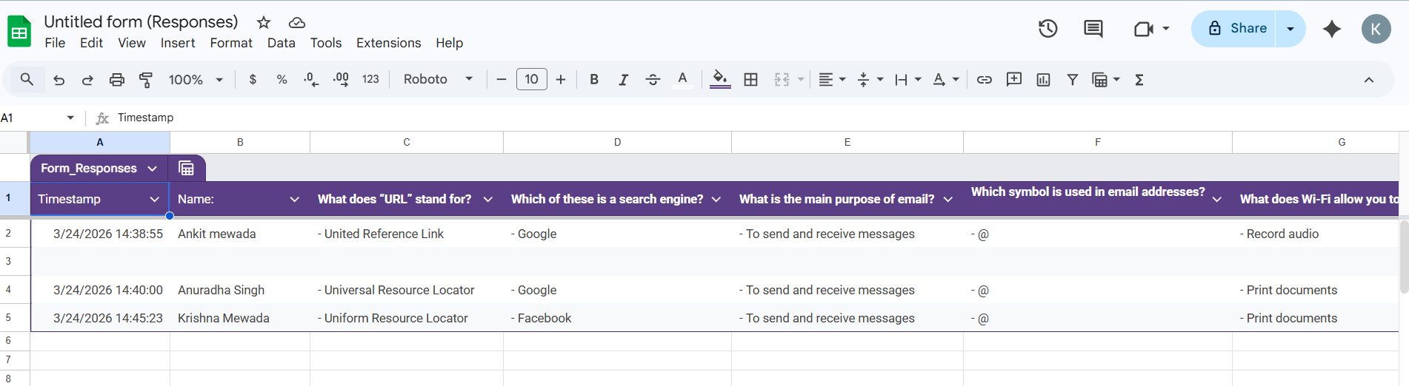

Project Report
For this task, I worked with two platforms: a coding practice site and Google Workspace. In Part A, I created an account on HackerRank and completed a beginner-level challenge. This helped me strengthen my problem-solving skills and gave me exposure to competitive programming environments. I also took a screenshot of my completed challenge and badge to document my progress.
In Part B, I used Google Forms to design a Digital Literacy Awareness Quiz with five questions, including multiple-choice and short-answer formats. I then linked the form to a Google Sheet to automatically collect responses. This exercise gave me hands-on experience with collaborative tools, as the form can be shared with batchmates for real participation.
These platforms are academically valuable because coding practice builds logical thinking and technical confidence, while Google Workspace enhances collaboration, data collection, and communication. Together, they support both individual skill development and teamwork. The Google Form is not just an exercise—it can serve as a real deliverable for digital literacy awareness among peers, aligning with the role of a Digital Ambassador.

