SSIS Project Screenshots

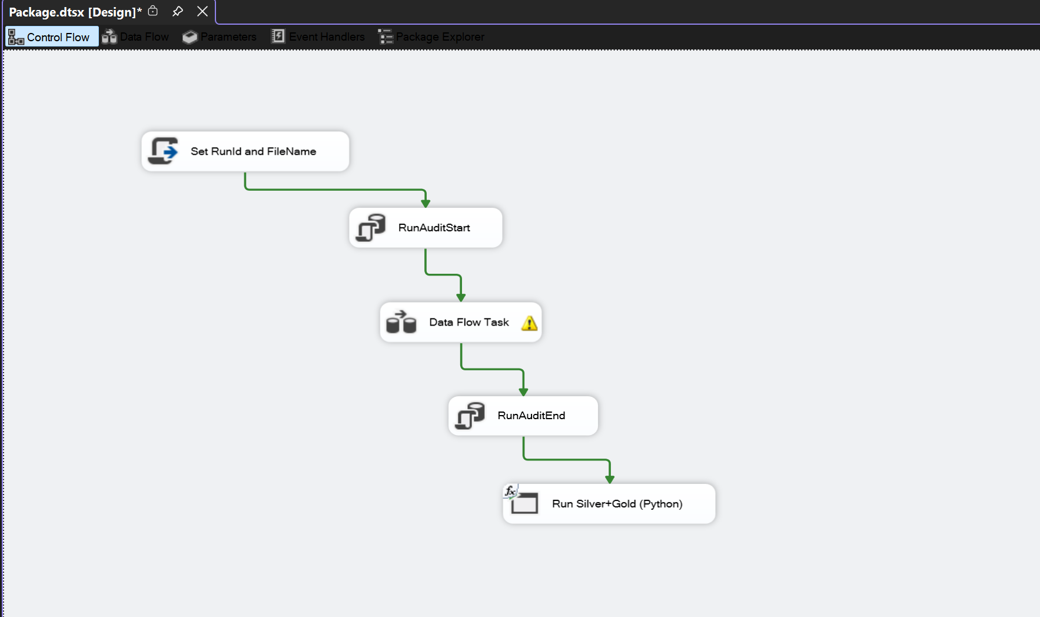

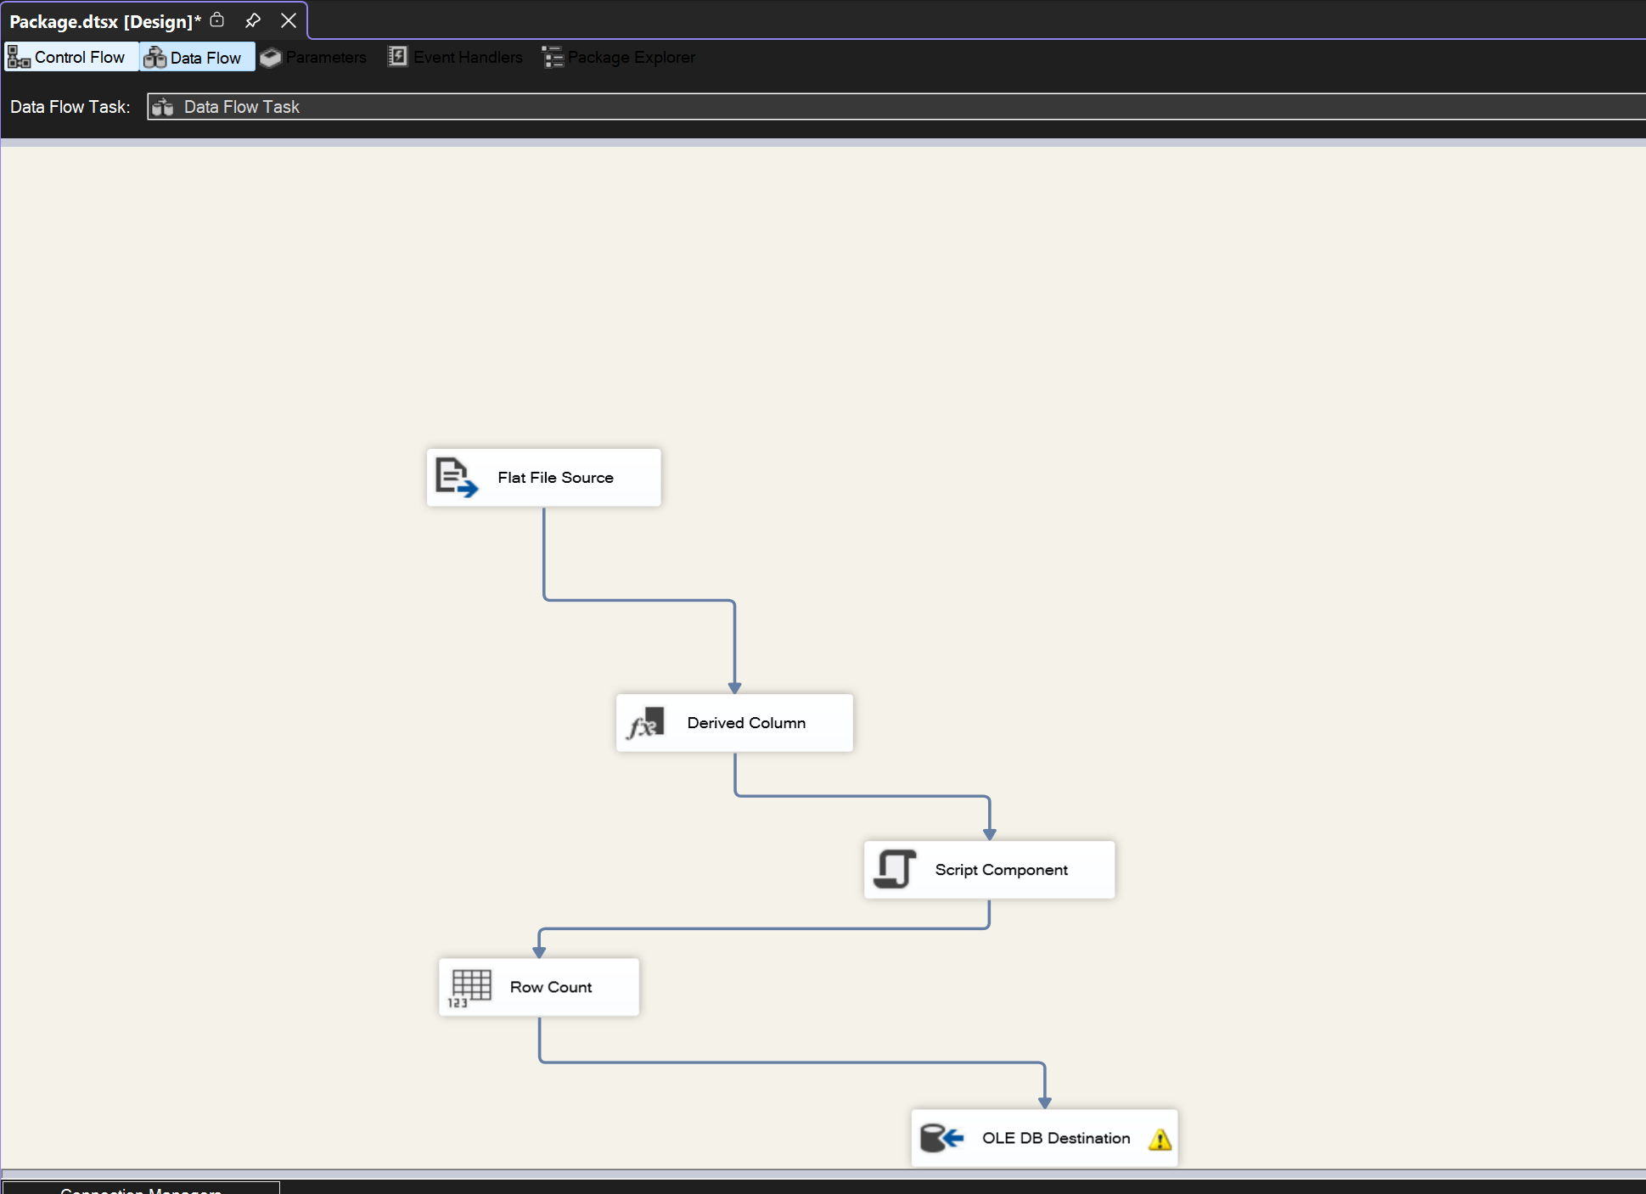
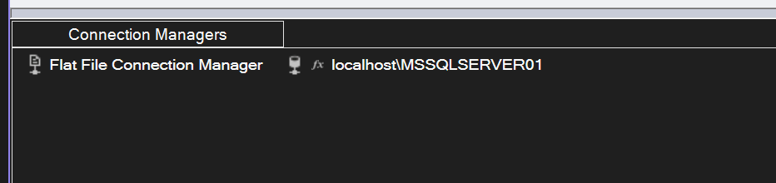

DB Results

Sample data from all tables
- Etl_run_audit
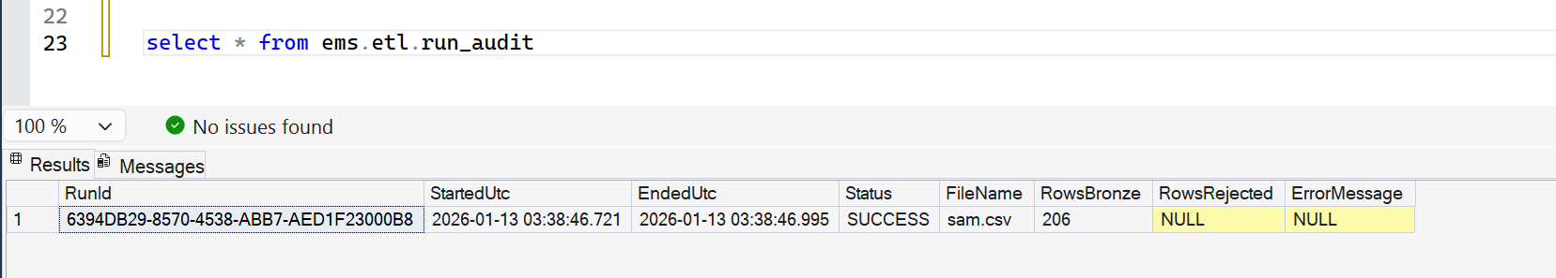

- Bronze load ( raw csv data )
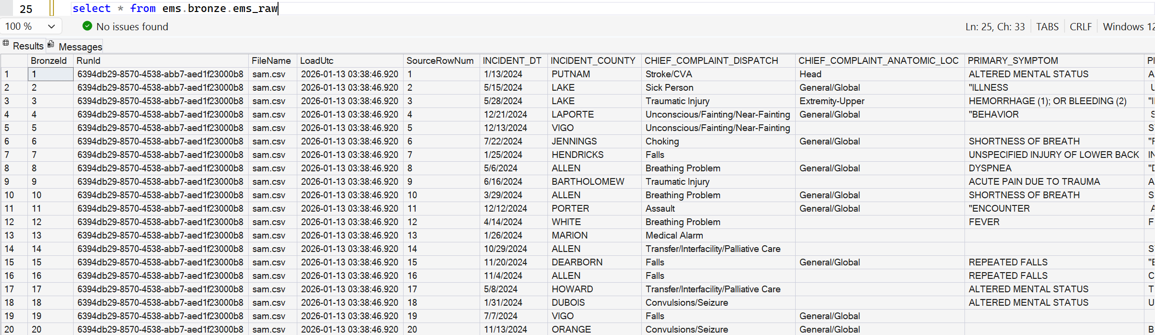
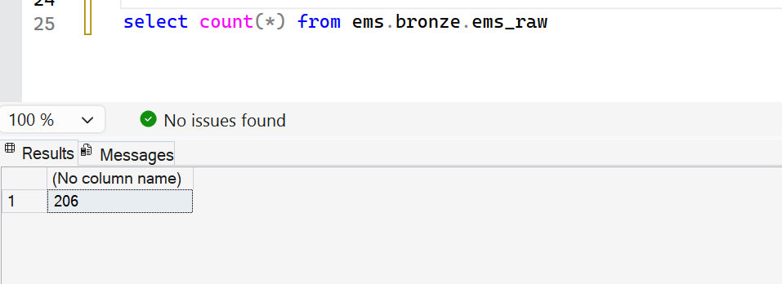

- Silver Load ( cleaned data )
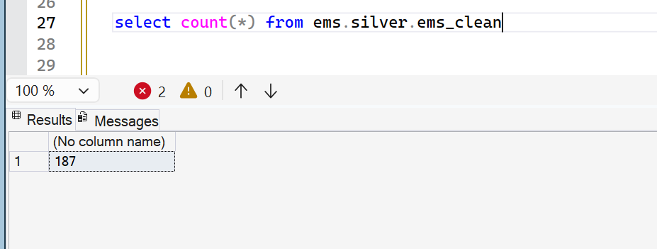

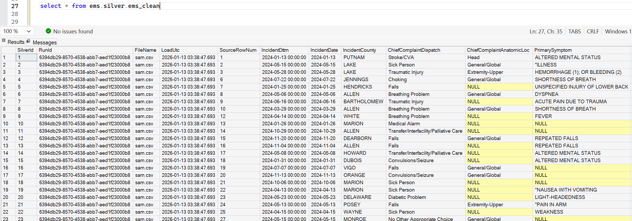

- Silver Rejects ( rejected data from bronze table )
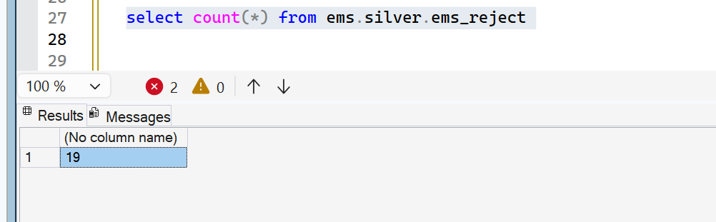

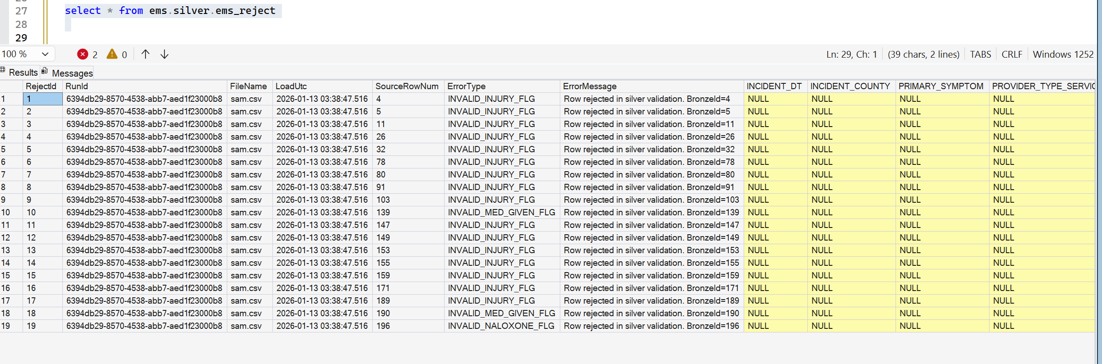

- Etl.run_step_log

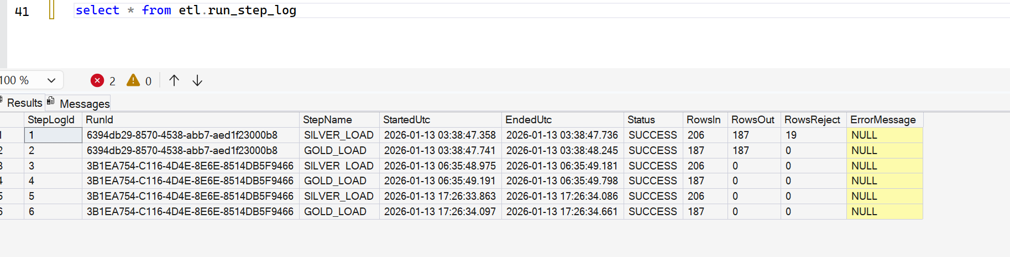

- Watermark table ( used for incremental processing )
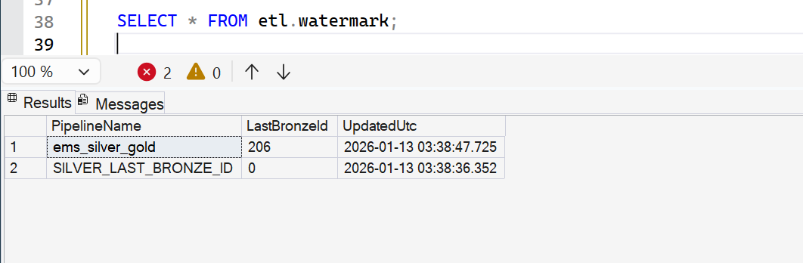

- Sample data from dimension tables

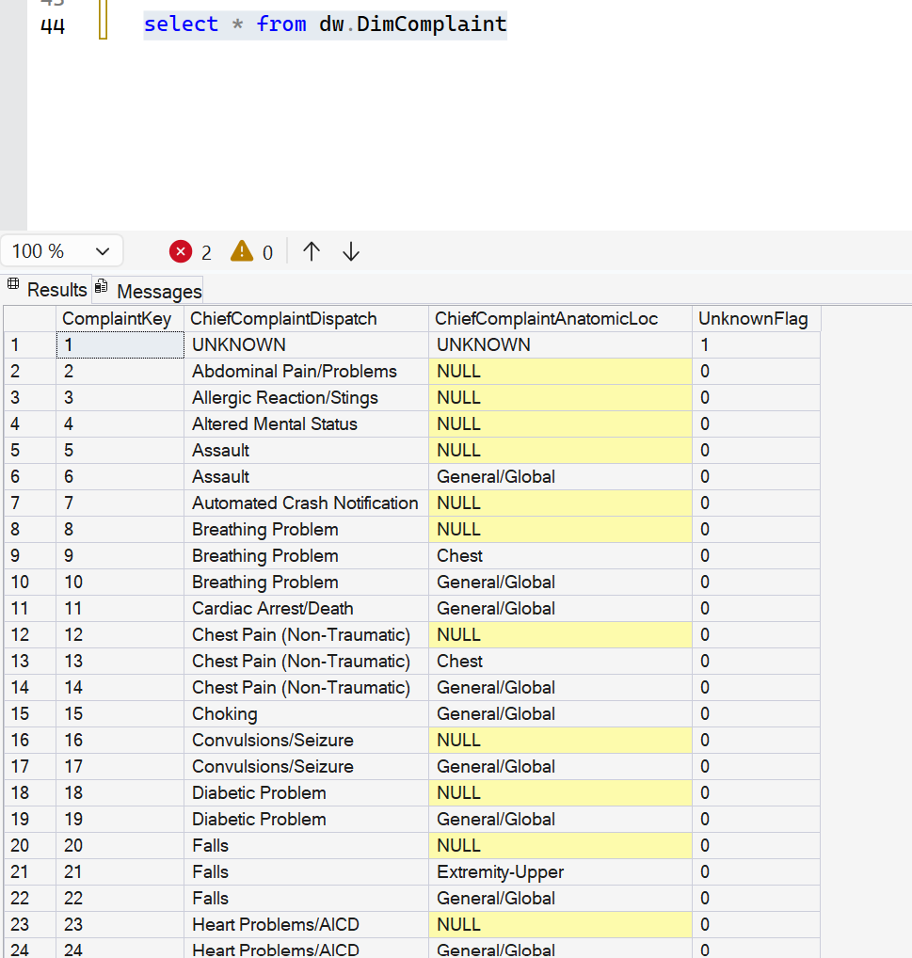

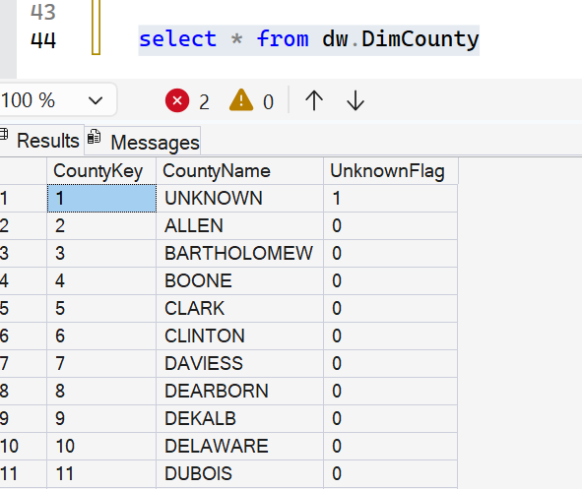

Dw.DimProvider ( SCD2 enabled )
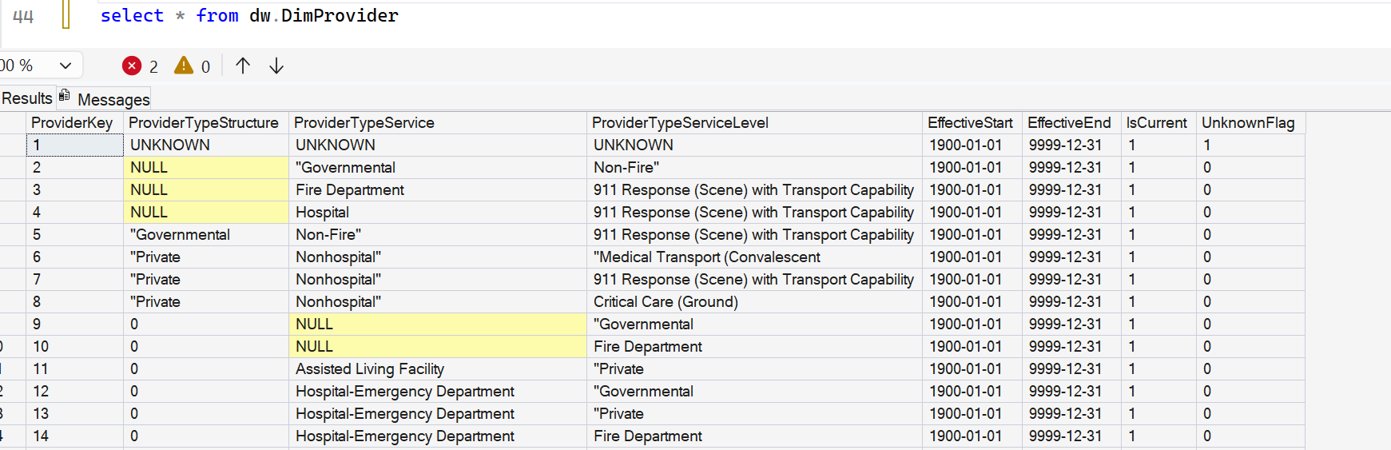

Main table ( FACT )
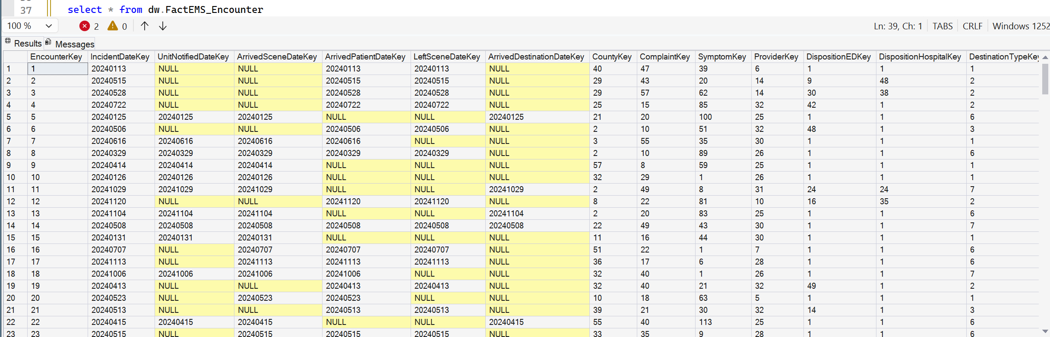
aggregated summary per file ( bi-friendly with aggregated values and sample KPI’s )
