Software Engineering Lab 1
Problem Statement #05 | Campus & Academic Operations
Academic Elective Bidding & Allocation System

1. Scenario
University clubs need an automated platform where members can browse and propose discussion topics, and Discussion Leads can review proposals, schedule discussion meetups, and track attendance.
The system must allow Club Members to search discussion topics, propose new topics for approval, and RSVP to scheduled meetups (with automatic waitlisting once capacity is reached). Discussion Leads review and approve/reject proposed topics, schedule meetups with date, time, venue and capacity, and view attendance reports. The system automatically notifies members whenever a meetup is scheduled.
Target Actors: Club Member (Primary), Discussion Lead (Primary), Notification Service (Secondary)

2. Deliverable 1 — Requirements Table
5 Functional Requirements (FR-001–FR-005) and 2 Non-Functional Requirements (NFR-001, NFR-002).
Req ID | Type | Description | Priority | Acceptance Criteria | Rationale
FR-001 | Functional | The system shall allow a Club Member to search and browse discussion topics by club and category. | High | Pass: search results return matching topics within 2s. Fail: irrelevant or no results for a valid keyword. | Lets members quickly find topics relevant to their interests.
FR-002 | Functional | The system shall allow a Club Member to propose a new discussion topic for Discussion Lead review. | High | Pass: proposed topic is saved with status 'Pending' and visible to the Discussion Lead. Fail: proposal is lost or not routed for review. | Enables member-driven content and keeps discussions relevant.
FR-003 | Functional | The system shall allow a Club Member to RSVP to a scheduled discussion meetup, automatically placing them on a waitlist if capacity is full. | High | Pass: confirmed RSVP when seats remain; automatic waitlist entry when capacity = 0. Fail: RSVP accepted beyond stated capacity. | Prevents overbooking of meetup venues.
NFR-001 | Nonfunctional | The system shall support at least 500 concurrent RSVP submissions during peak registration windows with a response time under 2 seconds. | High | Pass: load test with 500 concurrent users shows 95th-percentile response time < 2s. Fail: response time exceeds 2s or requests are dropped. | Ensures the system stays responsive when meetup registration opens campus-wide.
FR-004 | Functional | The system shall allow a Discussion Lead to schedule a discussion meetup by specifying date, time, venue, and capacity. | Medium | Pass: scheduled meetup appears in the topic listing with all specified details. Fail: meetup is created with missing or invalid details. | Gives Discussion Leads control over meetup logistics.
FR-005 | Functional | The system shall allow a Discussion Lead to approve or reject a proposed topic and automatically notify the proposing Club Member of the decision. | Medium | Pass: topic status updates to Approved/Rejected and a notification is sent within 1 minute. Fail: status changes without a notification being sent. | Closes the feedback loop for members who propose topics.
NFR-002 | Nonfunctional | The system shall ensure that only authenticated club members and discussion leads can propose topics, RSVP, or manage meetups. | High | Pass: all propose/RSVP/schedule actions require a valid session token; unauthenticated requests are rejected with a 401 error. Fail: any such action succeeds without authentication. | Protects the platform from spam proposals and fraudulent RSVPs.

3. Deliverable 2 — UML Use-Case Diagram
Actors: Club Member and Discussion Lead (primary), Notification Service (secondary). Use cases include Browse Discussion Topics, Propose Discussion Topic, RSVP to Discussion Meetup, Approve/Reject Proposed Topic, Schedule Discussion Meetup, and View Attendance Report. «include»: Schedule Discussion Meetup includes Send Notification. «extend»: Join Waitlist extends RSVP to Discussion Meetup (only when capacity is full).
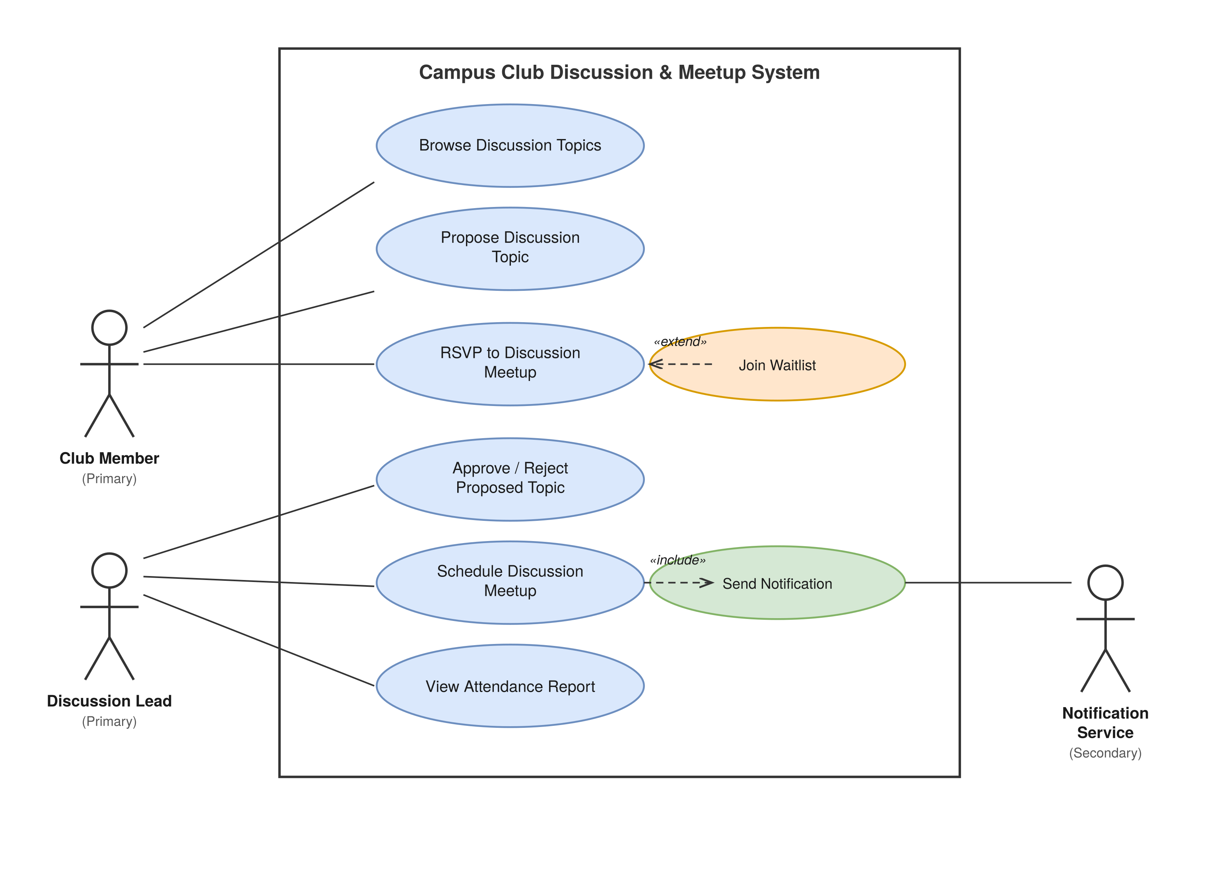
Figure 1: Use-Case Diagram — Campus Club Discussion & Meetup System (draw.io style)

4. Deliverable 3 — Use-Case Flow Specification
Use Case: RSVP to Discussion Meetup
Preconditions: Club Member is authenticated and logged in; a discussion meetup has been scheduled and is open for RSVP.
Postconditions: Club Member's RSVP is recorded against the meetup with status 'Confirmed' or 'Waitlisted', and the meetup's remaining-seat count is updated accordingly.
Main Success Scenario:
- Club Member selects a scheduled discussion meetup from the topic listing.
- System displays meetup details: date, time, venue, and remaining capacity.
- Club Member selects "RSVP".
- System verifies the Club Member is authenticated and has not already RSVP'd.
- System checks remaining capacity for the meetup.
- System records the RSVP with status "Confirmed" and decrements the remaining-seat count.
- System sends a confirmation notification to the Club Member.
- Use case ends successfully.
Alternate Flow:
5a. Meetup at Full Capacity
- 5a1. System detects remaining capacity is zero.
- 5a2. System records the RSVP with status "Waitlisted" instead of "Confirmed".
- 5a3. System notifies the Club Member of their waitlist position.
- 5a4. If a confirmed attendee cancels, the system automatically promotes the next waitlisted member to "Confirmed" and notifies them.

