**Report**

**On**

**Summer Internship**

**Student Name Faculty Mentor**

KUSHVANSHI KRISHNA. (180160116041) Prof.Nilesh Maltare

**Submitted to**

**Department of Computer Engineering & Information Technology**

**Government Engineering College, Modasa**



**Year:2021**

**CERTIFICATE**

This is to certify **KUSHVANSHI KRISHNA. (180160116041)**, IT Branch from Government Engineering College, Modasa has successfully completed the Summer Internship at Brainy Beam Pvt Ltd company during **26/05/2021 to 15/06/2021.**

Signature of Faculty Mentor Signatureof Head of Department

**(Prof.Nilesh Maltare) (Prof. M B Chaudhari )**

**Summer Internship Completion Certificate Provided by Brainy Beam Pvt Ltd Company**

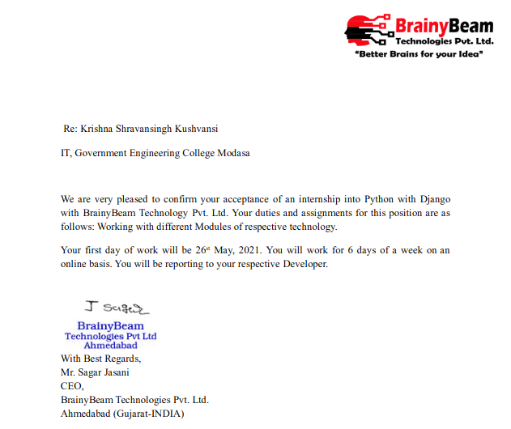

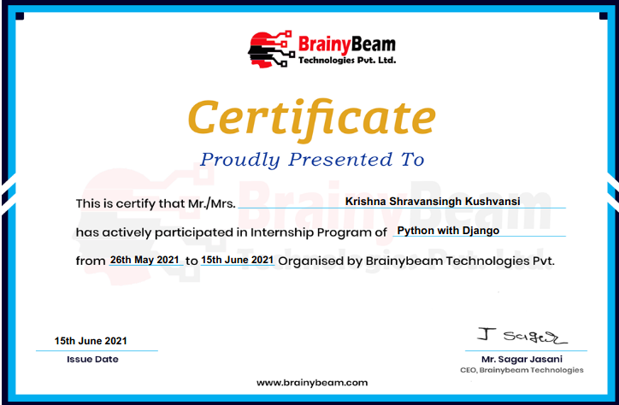

This is to certify **KUSHVANSHI KRISHNA. (180160116041), IT Branch** from Government Engineering College, Modasa has successfully completed the Summer Internship at Brainy Beam Pvt Ltd company during **26/05/2021** to **15/06/2021.**

Project /Work done: **During this Summer Internship I am Create Bus booking system, Social media website.**

Tools/Technology used/learnt: **I used Pycharm and virtual code to develop django website**

The organization has found him/her hard working and sincere during this period.

[Authority signature]

**MR. SAGAR JASANI**

**ACKNOWLEDGEMENT**

I wish to express our sincere gratitude to our External guide **MR. SAGAR JASANI SIR** for continuously

Guiding me at the company and answering all my doubts with patience. I would also like to thank my

Internal Guide **Prof. NILESH MALTARE** for helping us through our internship by giving us the necessary suggestion and advice along with their valuable co-ordination in completing this Internship.

We also thank you our parent’s friends and all the members of the family for their precious support and encouragement which they had provided in completion of our work. In addition to that, we would also

Like to mention the company personal who gave us the permission to use and experience the valuable resource required for the internship

Thus, in conclusion to the above said, we once again thank the staff members of **Brainy Beam Pvt. Ltd**

for their valuable support in completion of the internship.

Signature of Student

**KUSHVANSHI KRISHNA.**

**Enroll No: 180160116041**

**DECLARATION**

I, hereby declare that the project/work submission is my own work and that, to the best of my knowledge and belief, it contains no code/material previously published or written by another person as a part of the completion of the Summer Internship.

**Place: Government Engineering College, Modasa**

**Date:**

Signature of the Student

**KUSHVANSHI KRISHNA.**

**Enroll No: 180160116041**

**Abstract**

In these 14 days Summer Internship sir taught me an **company user’s details** web application in which first there Given introduction of django how much useful django app on the web industry. then they taught how django moduls as well as version in python what is sqlite and how we includes files to create our project/web app they made us simple web application is which has a login page if someone does not have an account then below the login page there is a button of sign-up page so that any new user can create his/her id and open the web application in this web application it have already connected sqlite database where the user's data will be saved, in this web application I have explained about company user’s name address image email id when they had joined company.

I finished this internship from **Brainy Beam Pvt Ltd**, here I was taught by Darpan sir, which was of 1:30 hours every day, in that he taught me to make **company user’s details** web application in django, he used to learn every day first, then what we would have taught, we had to do that same day earlier. From day one, if there was any problem or error in any program, he used to fix it by taking any desk id of mine.

**Index**

|  |  |  |
| --- | --- | --- |
| **Sr.No** | **Content** | **Page. No** |
| **1** | **Introduction** | **7** |
| **2** | **Problem Statement/Definition** | **8** |
| **3** | **Tools/Technologies** | **10** |
| **4** | **Timeline Chart** | **12** |
| **5** | **Module Development/Implementation** | **14** |
| **6** | **Conclusion** | **17** |
| **7** | **References** |  |

**CHAPTER-1**

**INTRODUCTION**

**The company Brainy Beam Private Limited** in which I have completed my summer internship Programmed Brainy Beam is an innovate web and mobile apps development company in India &USA

That has the specialization and expertise in developing web and mobile applications for organizations in various verticals – Retail Travel construction, Entertainment, Lifestyle, Social Networking and Education etc.

At Brainy Beam, we see Innovation as a clear differentiator. Innovation, along with focus on deep, long-lasting client relationships and strong domain expertise, drives every facet of our day-to-day operations.

Brainy Beam Technologies was founded with a vision to address growing businesses' needs of reducing the time to market and cost effectiveness required to develop and maintain unique and customized web and mobile solutions. We are uniquely and strategically positioned to partner with startups and leading brands to help them expand their business and offer the most effective and cost-efficient solutions that provide revenues and value to their business needs.

They are a well-coordinated team and work like a well-oiled machine. In fact, we work on a human scale and build long lasting businesses with our clients. Our firmness affords us the required room and flexibility to manage our future and independence. Apart from this, it also provides us a strong platform to protect our ethics and core values.

They have experience working with a wide range of products and brands, from small start-ups dipping their toes into the app space to large FMCG companies wanted to extend their brand presence and customer touch points.

I have completed my internship under the guidance of **MR. SAGAR JASANI SIR** who have a Co-Ordinator

Of the company. He has a relevant Experience in Programming. their website given below

[http://brainybeam.com](http://brainybeam.com/) for information of the company.

**CHAPTER-2**

**PROBLEM STATEMENT/DEFINATION**

I was doing to make projects. Then lots of problem come from code. Sir and groups people were doing help during in internship. I have some problems mentions in report.

**(1) OperationlError at *admin*/task5/registraion/add –> that is my error of code**

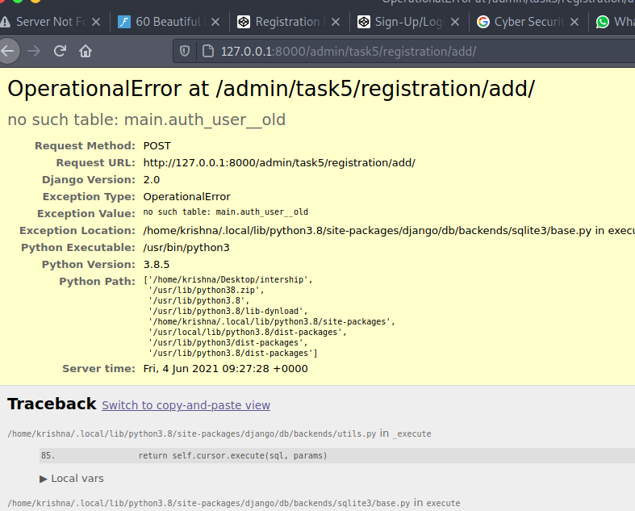

I have share my problems in group and my problems solved immediately. The error occurring only for version of django and python… I have used to pyhon3.9.5 and django old version 2.7 then error occurring after I had used to new version of django so error is removed.

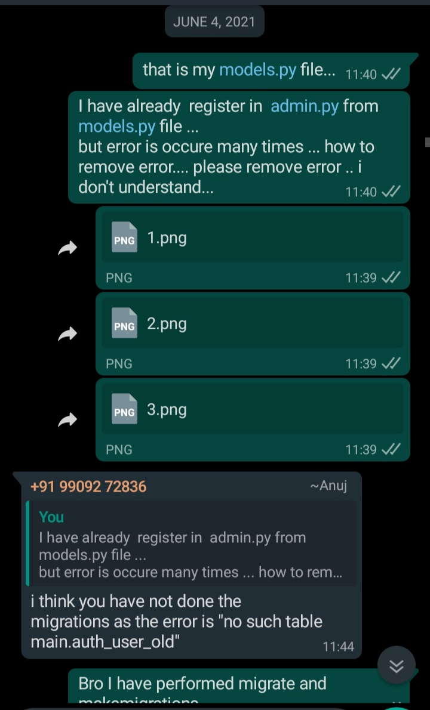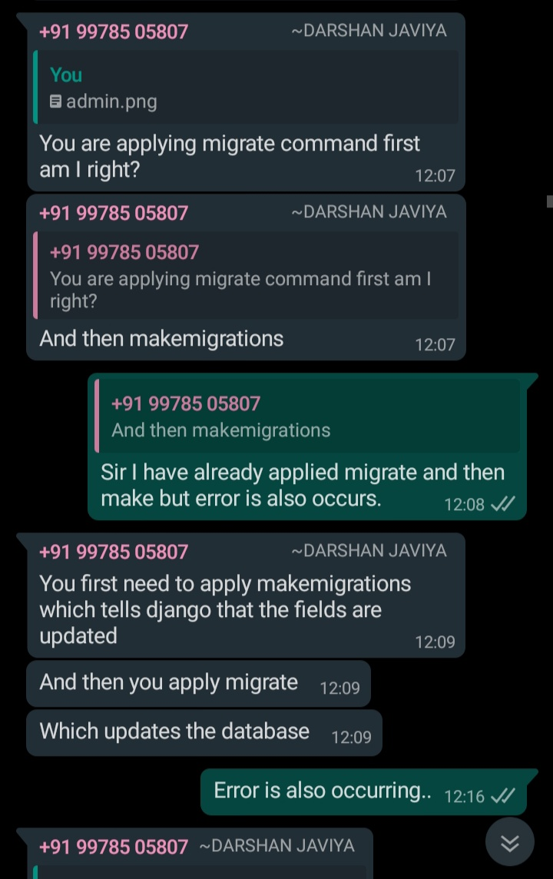

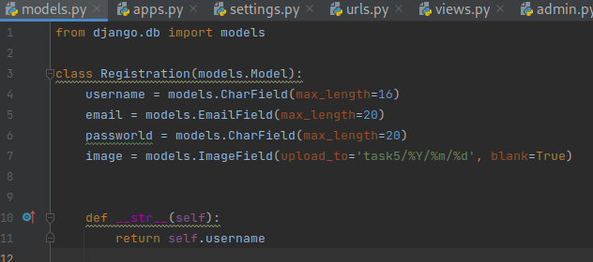

**CHAPTER-3**

**TOOL&TECHNOLOGIES**

In this Summer Internship I used Many Tools Like **Pycharm & virtual code and sqllite Database**

I perform Daily task on **Pycharm** Because I am in **Pycharm and virtual code** Technology

**TOOLS:**



**Pycharm:**

**Version: 2021.1.2**

**For Develop Web application, Desktop application, Mobile Application.**

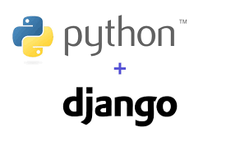

**Django :**

**version : 3.2.4**

**For Develop Web application.**

**TECHNOLOGY: PYCHARM P & DJANGO**

**PyCharm** is a dedicated Python Integrated Development Environment (IDE) providing a wide range of essential tools for Python developers, tightly integrated to create a convenient environment for productive Python, web, and data science development. **PyCharm** is cross-platform, with Windows, macOS and Linux versions. It is written in python and java.

## Features

* Coding assistance and analysis, with code completion, syntax and error highlighting, [linter integration](https://en.wikipedia.org/wiki/Lint_(software)), and quick fixes
* Project and code navigation: specialized project views, file structure views and quick jumping between files, classes, methods and usages
* Python [refactoring](https://en.wikipedia.org/wiki/Refactoring): includes rename, extract method, introduce variable, introduce constant, pull up, push down and others
* Support for web frameworks: Django, web2py and Flask.
* Integrated Python debugger
* Integrated unit testing, with line-by-line code coverage
* [Google App Engine](https://en.wikipedia.org/wiki/Google_App_Engine) Python development [professional edition only]
* Version control integration: unified user interface for [Mercurial](https://en.wikipedia.org/wiki/Mercurial), [Git](https://en.wikipedia.org/wiki/Git_(software)), [Subversion](https://en.wikipedia.org/wiki/Apache_Subversion), [Perforce](https://en.wikipedia.org/wiki/Perforce) and [CVS](https://en.wikipedia.org/wiki/Concurrent_Versions_System) with change lists and merge
* Support for scientific tools like matplotlib, numpy and scipy.

It competes mainly with a number of other Python-oriented IDEs, including [Eclipse](https://en.wikipedia.org/wiki/Eclipse_(software))'s [PyDev](https://en.wikipedia.org/wiki/PyDev), and the more broadly focused [Komodo IDE](https://en.wikipedia.org/wiki/Komodo_IDE).



**Django :**

Django is a high-level Python Web framework that encourages rapid development and clean, pragmatic design. Built by experienced developers, it takes care of much of the hassle of Web development, so you can focus on writing your app without needing to reinvent the wheel. It’s free and open source.



**CHAPTER-4**

**TIMELINE CHART**

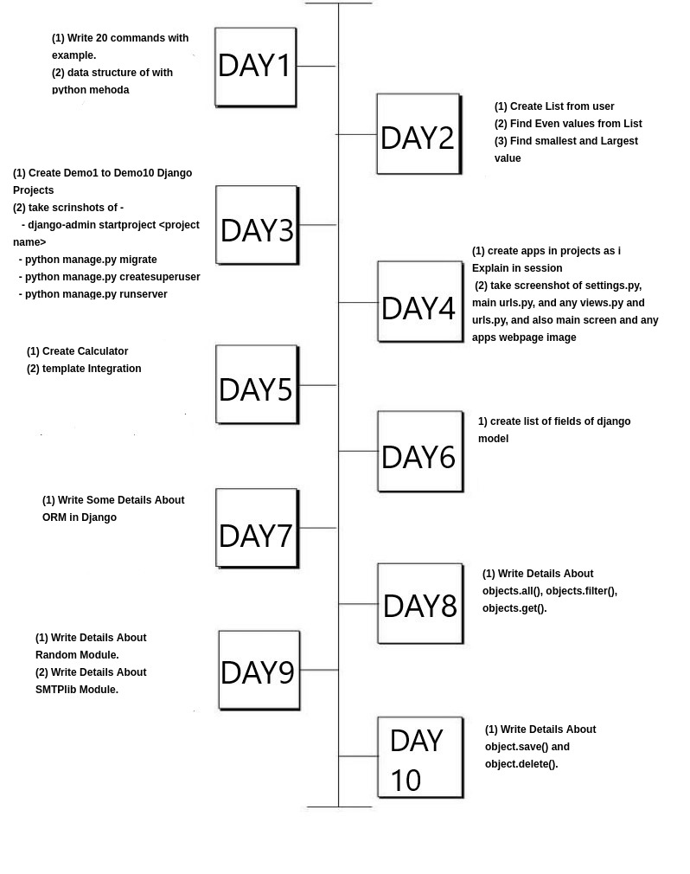

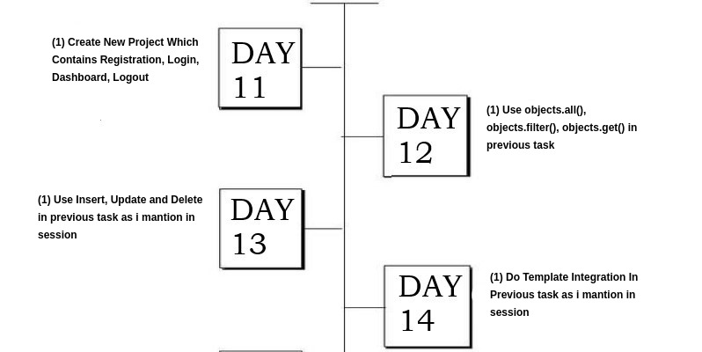

**CHAPTER-5**

**MODULE DEVELOPMENT/IMPLEMENTATON**

**Registration page**

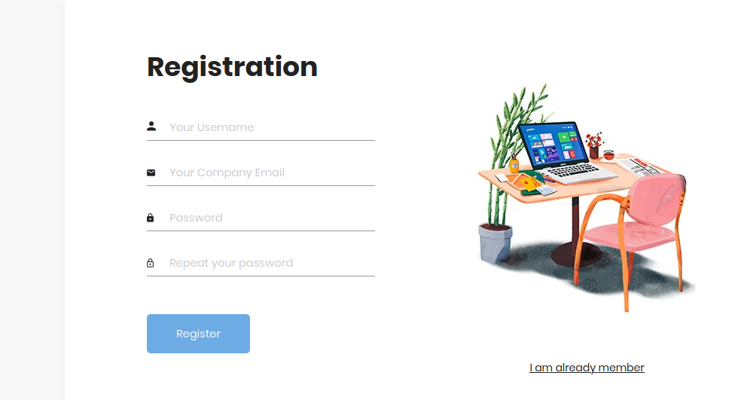

**Login page**

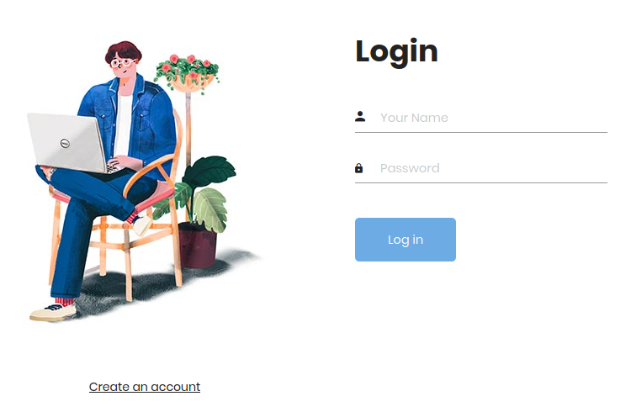

**Profile**

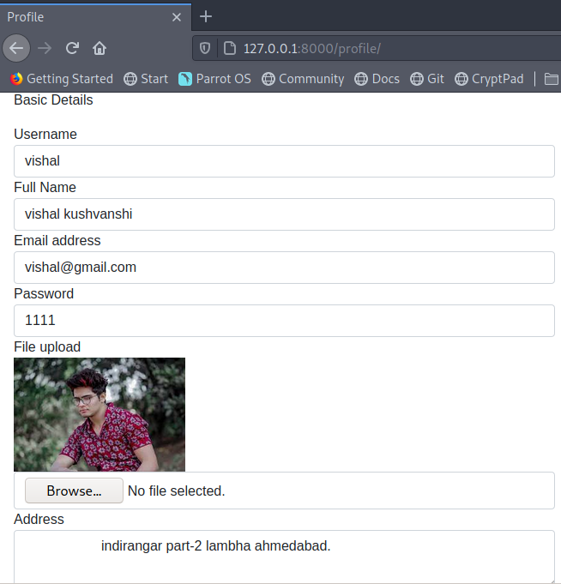 **Posts**

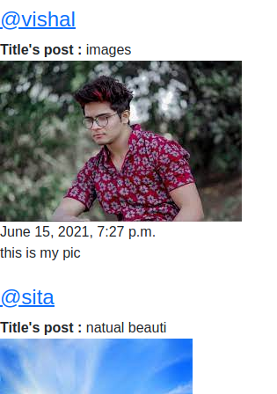

**Dashboard**

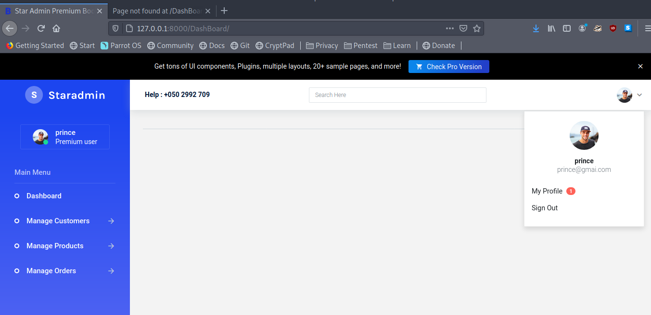

**Insert Update Delete Account**

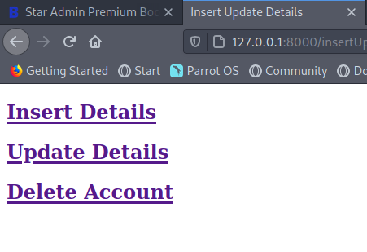

**Delete user Account**

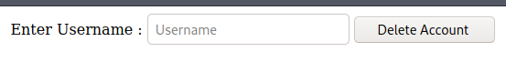

**Update details**

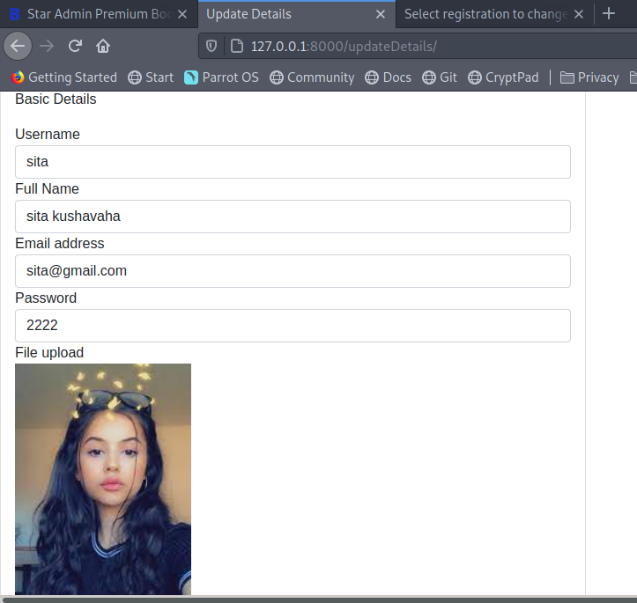

**CHAPTER-6**

**Conclusion**

In **conclusion**, the **internship** was a useful experience. I have find out what my strengths and weaknesses are; I gained new knowledge and skills . I achieved many of my learning goals, however for some the conditions did not permit to achieve them as I wanted.

I would like to convey my thanks to **BrainBeam Technologies** for providing me an opportunity to gain idea of the professional field. Ti has certainly lifted my web development skill in terms of design and coding. I now look forward to facing the upcoming challenges of the world.