Overview

Part-1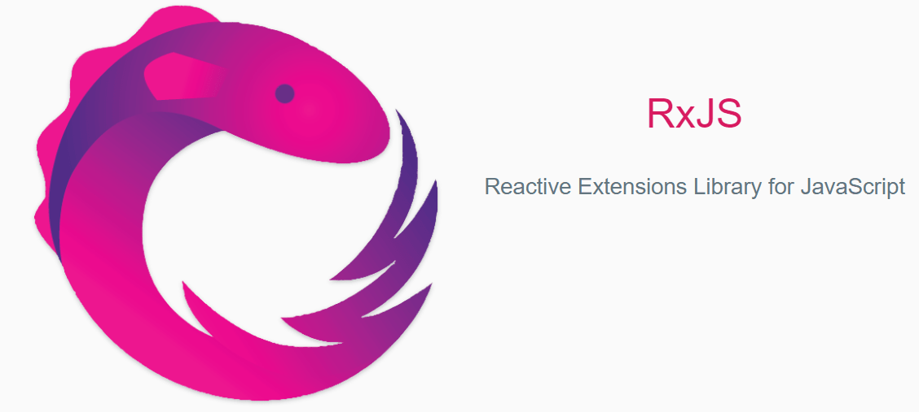

RxJS stands for JavaScript Reactive Extensions and its library that implements the ReactiveX API.  
  
RxJS is awesome for reactive programming, making it easy to write asynchronous code with Observable

Observable has become an ES7 feature that is increasingly used, meaning you don't have to use an external library to use it. RxJS also offers Observable operators to manipulate your data.

Observable:

*An Observable is just a function with a few special features, which uses an "observer" (an object with "next," "error" and "complete" methods) and returns an cancelation logic.*

* This is a class representing a stream of data.
* The observable function is a function that produces a flow of values for an observer over time.
* Observable are cancelable, which gives better control when dealing with in-flow values from stream over promise
* You are an observer if you subscribe to an observable.
* An observable can have multiple observers.

The ability of observable to handle multiple values over time makes them a good candidate to work with real-time data, events, and any stream you might think of.

To work with observable, Lets understand the stream, the stream in the world of RxJS simply represents values (or events) over time, and the Observable are what facilitates the stream in Angular.

Lifecycle of Observable

The observable instance goes through all four phases of its lifespan with assistance from observers and subscriptions:

* Creation
* Subscription
* Execution
* Destruction

Let's see simple example of Observable

Below is basic example before we immerse ourselves in our real world example.

import { Observable } from "rxjs/Observable";

export class AppComponent implements OnInit OnDestroy{

const subscription;

ngOnInit(): void {

// Creating Observable

const observable$ = Observable.create((observer:any) => {

try {

//Execution

observer.next('First value')

observer.next('Second value')

setInterval(() => {

observer.next('Async value')

observer.complete();

observer.next('value not send')

}, 1000)

} catch (err) {

observer.error(err)

}

})

// Subscribing to Observable

this.subscription = observable$.subscribe(function logMessage(message:any) {

console.log(message);

})

}

ngOnDestroy() {

// Destruction

this.subscription.unsubscribe();

}

}

In this example, we first created the observable. The observer is in charge of executing instructions in the Observable, so each observer that subscribes can deliver three values to the Observable, which include:

* next
* error
* complete

In our above example, once we subscribe to observable we will start getting observable data, This will appear like below` in your browser console:

First value

Second value

Async value

Now Let’s see the simple use of RxJS in Angular

In the context of using RxJS for creating Angular applications, an Observable instance will be created by doing one of the following things:

* Creating or fetching data over HTTP with AJAX
* Listening to input changes with reactive fors
* Listening to routing changes
* Listening to UI events
* Wrapping an asynchronous concept

Creating HTTP requests is a critical part of the life of most front-end applications. Angular, which is the hottest thing right now, has a really cool way to do that. To make HTTP requests using the RxJS Observable Library.

Angular is incredible; with angular, you can manage HTTP requests using observable rather than promises.

When you look at the HTTP signature in the Angular source

request(url: string | Request, options?: RequestOptionsArgs): Observable<Response>;

get(url: string, options?: RequestOptionsArgs): Observable<Response>;

post(url: string, body: any, options?: RequestOptionsArgs): Observable<Response>;

put(url: string, body: any, options?: RequestOptionsArgs): Observable<Response>;

delete(url: string, options?: RequestOptionsArgs): Observable<Response>;

patch(url: string, body: any, options?: RequestOptionsArgs): Observable<Response>;

head(url: string, options?: RequestOptionsArgs): Observable<Response>;

Each method takes a url and a payload as the case may be, and returns a generic type of response that can be observed.

Let's see one example, here's our note model.

export class Note {

constructor(

public id: Date,

public author: string,

public text:string

){}

}

Now let's try to create a simple service class that will allow an http request to get data from the server.:

import { Injectable } from '@angular/core';

import { Http, Response, Headers, RequestOptions } from '@angular/http';

import { Note } from '../model/note';

import {Observable} from 'rxjs/Rx';

// Import RxJS required methods

import 'rxjs/add/operator/map';

import 'rxjs/add/operator/catch';

@Injectable()

export class NoteService {

// Resolve HTTP using the constructor

constructor (private http: Http) {}

// private instance variable to hold base url

private noteUrl = 'http://localhost:8000/api/notes;

// Fetch all existing notes

getNotes() : Observable<Note[]> {

// ...using get request

return this.http.get(this.notesUrl)

// ...and calling .json() on the response to return data

.map((res:Response) => res.json())

//...errors if any

.catch((error:any) => Observable.throw(error.json().error || 'Server error'));

}

}

We call this method to pass the basic url, since this is the endpoint for a list of comments Use the http instance.

This observable is cold, which means it's not pushing out data at the moment.

What is left to be done is to subscribe to the data that can be observed and link it to the views.

Let’s build our components. Time to tie things together. We can now build components that tie both together to make the application usable.

// Imports

import { Component, OnInit, Input, OnChanges } from '@angular/core';

import { Observable } from 'rxjs/Observable';

import { Note } from '../model/note';

import {NoteService} from '../services/note.service';

// Component decorator

@Component({

selector: 'note-list',

template: `

<h1>note-list</h1>

<ul>

<li *ngFor="let note of notes" >

{{ [note]="note">}}

</li>

</ul>

})

// Component class

export class NoteListComponent implements OnInit, OnChanges{

// Local properties

notes: Note[];

// Constructor with injected service

constructor(private noteService: NoteService) {}

ngOnInit() {

// Load notes

this.loadNotes()

}

loadNotes() {

// Get all notes

this.noteService.getNotes()

.subscribe(

notes => this.notes = notes, //Bind to view

err => {

// Log errors if any

console.log(err);

});

}

}

No one can hear you stream in RxJS land unless you subscribe. By calling a subscription to an observable one:

1. It transforms the observable to hot so it begins to produce data
2. We pass the callback function, so we react when anything is pushed to the final stream in the observable chain.

In the above implementation, we call loadCommets OnInit by overriding ngOnInit, which has a subscriber that can make an api call to your server through http and load comments into a module that can then be mapped to the UI model.

Isn’t it Awesome!

We can do more with Observable, we can create our own observable that can be used to help Component Interaction You can easily create multiple subscriptions on the same observable.

At this point, you should have a fair understanding of the basics about observable, observers and subscriptions.

Some of these commonly used operators of observable are:

* Map
* Filter
* distinct

#### Overview

In this post, we begin reviewing the operators, we will learn what types of operators are now included in the RxJS and which of them the RxJS team recommends to use.

Also, we will tell you about basic operators that you can typically use in your daily tasks with observables, map, filter, catch error, distant until change scan and buffer operators. So let's exploer working with operators to process stream data.

Lets understand first what operators really are.

Observable produces a sequence of data and we can subscribe to fetch it but what if we need to do some modifications to initial data, before we feed them to some component HTML template.

As RxJS implements declarative programming parity, it means that each value can be transformed with predefined function or as we name it in RxJS, operators.

#### RxJS Operators:

An operator is simply a method that acts on an Observable and changes the stream in some way. Operators are by nature immutable. This immutability makes the code easier to test and reason about.

Let's review definitions of operators from pre ActiveX project:

*An operator is a function which creates a new observable based on the input observed. The purpose of operator, to modify or filter originally emitted values in the way we need for the project tasks.*

[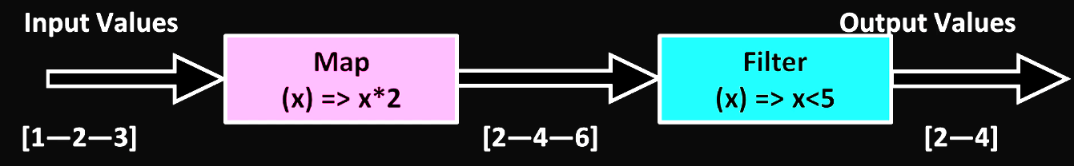](https://www.techgeeknext.com/img/rxjs/rxjs-operators.png)As can be seen in the diagram, operators transfer values to an observable new output and change the values simultaneously.

There are two types of operators :

* Pipeable operators.
* Observable prototype methods.

So what is the difference and which one should we use.[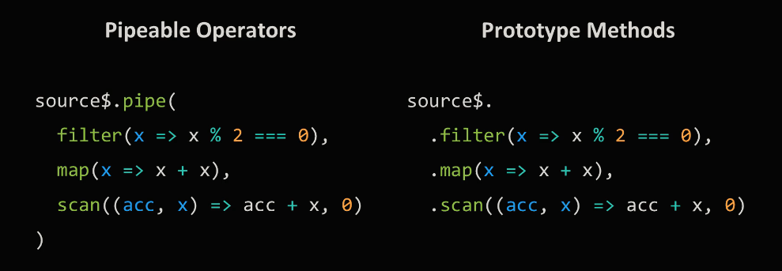](https://www.techgeeknext.com/img/rxjs/rxjs-operators-type.png)So one uses pipeable operators and another prototype method both of which do the same thing.

Pipeable operator is just a function so it becomes easier to combine existing operators in custom operators with specific logic. Starting from RxJS version 5.5, they are announced as preferable way of using operators.

On the other side, operators in prototype do not use Tree shaking.. if you did not know that Tree Shaking is in the process of deleting the code imported but not used in the program to reduce bundled size.

#### RxJS from Operator

*The from() operator allows us to create an Observable from some other asynchronous/synchronous concept. It's really powerful when almost anything (array, promise, or iterable) can be made into an Observable, as this allows for rich composition.*

##### **Let's see typical example of from Operator**

// RxJS v6+

import { from } from 'rxjs';

//emit array as a sequence of values

let stream$ = from([1,2,3,4]);

//output: 1,2,3,4

stream$.subscribe( data => console.log(data));

#### RxJS Map Operator

*Map operator applies a given function to each value emitted by source observable and any resulting values as an observable.*

##### **Let's see simple example of Map Operator**

**EXAMPLE 1:** Add 10 to each number (RxJS v6+)

import { from } from 'rxjs';

import { map } from 'rxjs/operators';

//emit (1,2,3,4)

const source = from([1, 2, 3, 4]);

//add 10 to each value

const example = source.pipe(map(val => val + 10));

//output: 11,12,13,14

const subscribe = example.subscribe(val => console.log(val));

**EXAMPLE 2:** MAP Object property (RxJS v6+)

import { from } from 'rxjs';

import { map } from 'rxjs/operators';

//emit ({name: 'Joe', age: 30}, {name: 'Frank', age: 20},{name: 'Ryan', age: 50})

const source = from([

{ name: 'John', age: 20 },

{ name: 'Alek', age: 25 },

{ name: 'Rosy', age: 18 }

]);

//grab each persons name, could also use pluck for this scenario

const example = source.pipe(map(({ name }) => name));

//output: "John","Alek","Rosy"

const subscribe = example.subscribe(val => console.log(val));

#### RxJS Filter Operator

*Filter operator, filters source observable items by only omitting those that satisfy a specified predicate.*

Filter operator takes items emitted by the source observable and emit only those value that satisfy a specified predicate. As you know, predicate is a function that returns true or false.

##### **Let's see simple example of filter Operator**

import { from } from 'rxjs';

import { filter } from 'rxjs/operators';

let stream$ = from([1, 2]).map( x => x +1 ) .filter( x > 2 );

// output : data 3

stream$.subscribe( data => console.log('data', data))

Here, we can see that we are using the .map() operator and .filter() to change our stream's data. map() operates on each value in the stream by incrementing each value by one. .filter() operates on the changed stream; a change brought about by calling .map(). It also operates on each value in the stream but conditionally decides what should be emitted. The end result is only one value being emitted, 3.

#### RxJS distinct Operators

*The main purpose of distinct operators is preventing subscribers on next handler to run, if observable emits same value again. Sometimes it makes sense since why to do view update or recalculate values if nothing is actually changed.*

At the moment, RxJS has three distinct operators :

* **distinctUntilChanged** - Distinct until changed operator emits all items that are distinct by comparison from only one previous item, complicating compared logic is possible here.
* **distinctUntilKeyChanged** - Distinct until key changed works similar but allows to specify which key value you want to compare.
* **distinct**

- Distinct operator emits all items that are distinct by comparison from all previous items in internal buffer, you can empty its internal buffer with the second flush argument which should be an observable.

#### distinctUntilChanged

distinct until changed operator emits all items that are distinct by comparison (===) from only one previous item, complicating compared logic is possible here.

Distinct until changed returns an observable that emits all items emitted by the source observable that are distinct by comparison from the previous item. Pay attention that operator only compares next value with one previous value.

##### **Let's see an example distinctUntilChanged with basic value (RxJS v6+)**

import { from } from 'rxjs';

import { distinctUntilChanged } from 'rxjs/operators';

// only output distinct values, based on the last emitted value

const source$ = from([1, 1, 2, 2, 3, 3]);

source$

.pipe(distinctUntilChanged())

// output: 1,2,3

.subscribe(console.log);

To compare previous and next values, it uses comparison function as a first param. If a comparator function is not provided, the Equality check is used by default. If a comparator function is provided, then it will be called for each item to test for whether or not this value should be emitted.

If values are objects, you can use second pair on key selector to specify which key of the value you want to compare. But actually, the same result can be easily achieved with the justa comparison function.

#### distinctUntilKeyChanged

Now let's review distinct until key changed. Actually, it is very similar to distinct until changed but it has some minor differences. They have different arguments order and key name argument here is a string, so we can use only with flat objects without deep nesting. Key selector argument of distant until changed operator is a function, so we can reach object property value at any depth.

Both statements do the same thing, which one you want to use it's up to you to decide. Definitely if value is a flat object without deep nesting, distinct until key changed demands much less to type.

##### **Example with object value (RxJS v6+)**

from([{v:1}, {v:2}, {v:2}, {v:3}])

.pipe(

// returns all objects as, quality comparison will not work since each object has different reference.

distinctUntilChanged()

// output : {v:1}, {v:2}, {v:2}, {v:3}

// with comparison callback function as the first argument for distinct until changed by using second parameter key selector

distinctUntilChanged((prev, next) => prev.v === next.v)

// output : {v:1}, {v:2}, {v:3}

// used null as the first argument so the default strict JavaScript equality will be used.

distinctUntilChanged(null, (item) => item.v)

// output : {v:1}, {v:2}, {v:3}

// very similar to distinct until changed but it has some minor differences.

// They have different arguments order and key name argument here is a string

distinctUntilKeyChanged('v')

// output : {v:1}, {v:2}, {v:3}

)

#### distinct

let's try distinct. As you can see, it compares with all previous values.

##### **Let's see an example of distinct**

import { of } from 'rxjs';

import { distinct } from 'rxjs/operators';

of(1, 2, 3, 4, 5, 1, 2, 3, 4, 5)

.pipe(distinct())

// OUTPUT: 1,2,3,4,5

.subscribe(console.log);

What is same and what is different between distinct until changed. Distinct doesn't have comparison callback so some complicated compare logic is not possible here.

It has key selector so we can specify what property value should be compared, but the main difference is next. Distinct operator compares next value, not only with one but with all previous values, so it should store values somewhere in a buffer and if number of values is significant, it can cause a lack of memory issue.

To prevent this, we have second argument here named flush. Flush should be observable, each time flush emits, all buffered values will be erased so the process starts from the beginning. For example, to empty operator internal buffer each ten seconds, we can use interval function.

As you can see, distinct compares next value with all previous values from a sequence, that's why ending value here is filtered out despite of previous item is different.

#### verview

In this article, we will learn new functions and operator that allows to combine a few observable sequences in a different ways. We will review Zip and combineLatest functions and withLatestFrom operator.

Composing functions and operators usually accept observables as their params and also they return observable that emits array with values produced by argument observables.

This result observable emission logic is different depending on which operator or function we use, let's start reviewing them one by one.

#### RxJS Zip function:

*Zip Combines mulitple Observables emitted values with same index. Return array of respective values.*

[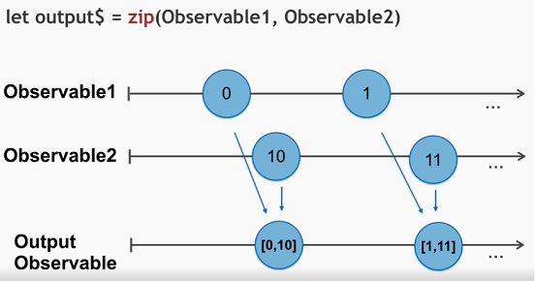](https://www.techgeeknext.com/img/rxjs/rxjs-zip-function.png)

As can be seen in the diagram, So we've had two observable sequences to zip function and want to receive array of values, only after both observables produce values. So the output Observable value would be : [[[0, 10], [1, 11]]

**zip (observable1, [ observable2, observable3,..., resultSelector]);**

* Zip waits until all the params observables emit values with same index number and only then emits array of these values.
* Zip accepts one or more observables as a params and you can also provide last param as function it is treated as a resultSelector
* resultSelector : You can use result selector for additional emitted data manipulation.

Here is a code example of using zip function :

import { zip, of } from 'rxjs';

import { map } from 'rxjs/operators';

let age$ = of<number>(27, 25, 29);

let name$ = of<string>('Foo', 'Bar', 'Beer');

let isDev$ = of<boolean>(true, true, false);

zip(age$, name$, isDev$).pipe(

map(([age, name, isDev]) => ({ age, name, isDev })),

)

.subscribe(x => console.log(x));

// outputs

// { age: 27, name: 'Foo', isDev: true }

// { age: 25, name: 'Bar', isDev: true }

// { age: 29, name: 'Beer', isDev: false }

We have three observable sequences here, ages name and isdev. Each of them will emit three values one by one, we feed them to zip function and subscribe to result observable.

As you can see, each time of the argument observables emit values with same index result observable produces array of these values.

We can use zip function in our web application at time of bootstrap of application or component, where we are waiting for more than one http data to render the component. So zip function can help in better state management.

#### RxJS combineLatest function

*CombineLatest combines multiple observables to create an observable, those values are calculated from the latest values of each of its input observables, once any of them emit irrespective of their index.*

Please note that combineLatest result observable only starts producing values only if all arguments observable has at least one value already emitted, and it doesn't wait for all argument observables to have same index value emitted

Let's take a look at this diagram :[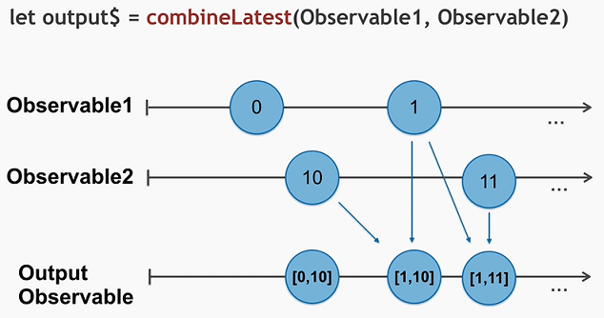](https://www.techgeeknext.com/img/rxjs/rxjs-combinelatest-function.png)

As you can see, if all argument observables has at least one value emitted, combined latest result observable produces array of emitted values ([0,10]). And each time any of param observable sends new data result observable will meet new array of values as well. ([1,10],[1,11])

##### **Let's see simple example**

import { combineLatest, of } from 'rxjs';

import { map } from 'rxjs/operators';

const amount = of(70, 72, 76, 79, 75);

const conversionRate = of(0.06, 0.07, 0.08);

const fees = combineLatest(amount, fees).pipe(

map(([a, r]) => (a * r)),

);

fees.subscribe(x => console.log('commission is ' + x));

#### RxJS withLatestFrom Operator

*withlatestFrom combine the source observable with other observables to create a result observable. Those values are calculated from the latest values of each, only when source emits so source emission is the trigger.*