CREATE PROCEDURE

|  |
| --- |
| **SUPPLIER** |
| Id |
| CompanyName |
| ContactName |
| City |
| Country |
| Phone |
| Fax |

|  |
| --- |
| **PRODUCT** |
| Id |
| ProductName |
| SupplierId |
| UnitPrice |
| Package |
| IsDiscontinued |

Problem: Create a procedure that lists all suppliers and their products.

**CREATE PROCEDURE SupplierProducts**

**AS**

**BEGIN**

**SELECT CompanyName, ProductName, UnitPrice, Package**

**FROM Supplier S**

**JOIN Product P ON P.SupplierId = S.Id**

**ORDER BY CompanyName**

**END**

Result:  Procedure created

EXECUTE PROCEDURE

|  |
| --- |
| **SUPPLIER** |
| Id |
| CompanyName |
| ContactName |
| City |
| Country |
| Phone |
| Fax |

|  |
| --- |
| **PRODUCT** |
| Id |
| ProductName |
| SupplierId |
| UnitPrice |
| Package |
| IsDiscontinued |

Problem: Execute the above SupplierProducts procedure.

**EXEC SupplierProducts**

Try it live

Result:  78 records

|  |  |  |  |
| --- | --- | --- | --- |
| COMPANYNAME | PRODUCTNAME | UNITPRICE | PACKAGE |
| Aux joyeux ecclésiastiques | Côte de Blaye | 263.50 | 12 - 75 cl bottles |
| Aux joyeux ecclésiastiques | Chartreuse verte | 18.00 | 750 cc per bottle |
| Bigfoot Breweries | Sasquatch Ale | 14.00 | 24 - 12 oz bottles |
| Bigfoot Breweries | Steeleye Stout | 18.00 | 24 - 12 oz bottles |
| Bigfoot Breweries | Laughing Lumberjack | 14.00 | 24 - 12 oz bottles |
| Cooperativa de Quesos | Queso Cabrales | 21.00 | 1 kg pkg. |
| https://www.dofactory.com/img/ellipsis.png | | | |

ALTER PROCEDURE

|  |
| --- |
| **SUPPLIER** |
| Id |
| CompanyName |
| ContactName |
| City |
| Country |
| Phone |
| Fax |

|  |
| --- |
| **PRODUCT** |
| Id |
| ProductName |
| SupplierId |
| UnitPrice |
| Package |
| IsDiscontinued |

Problem: Change the SupplierProducts procedure to add a Country column.

**ALTER PROCEDURE SupplierProducts**

**AS**

**BEGIN**

**SELECT CompanyName, ProductName, UnitPrice,**

**Package, Country**

**FROM Supplier S**

**JOIN Product P ON P.SupplierId = S.Id**

**ORDER BY CompanyName**

**END**

Try it live

Result:  Procedure altered

DROP PROCEDURE

|  |
| --- |
| **SUPPLIER** |
| Id |
| CompanyName |
| ContactName |
| City |
| Country |
| Phone |
| Fax |

|  |
| --- |
| **PRODUCT** |
| Id |
| ProductName |
| SupplierId |
| UnitPrice |
| Package |
| IsDiscontinued |

Problem: Remove the SupplierProducts stored procedure.

**DROP PROCEDURE SupplierProducts**

Try it live

Result:  Procedure dropped

RENAME PROCEDURE

|  |
| --- |
| **SUPPLIER** |
| Id |
| CompanyName |
| ContactName |
| City |
| Country |
| Phone |
| Fax |

|  |
| --- |
| **PRODUCT** |
| Id |
| ProductName |
| SupplierId |
| UnitPrice |
| Package |
| IsDiscontinued |

Problem: Rename the SupplierProducts stored procedure to ProductsBySupplier.

**DROP PROCEDURE SupplierProducts**

**CREATE PROCEDURE ProductsBySupplier**

**AS**

**BEGIN**

**SELECT CompanyName, ProductName, UnitPrice, Package**

**FROM Supplier S**

**JOIN Product P ON P.SupplierId = S.Id**

**ORDER BY CompanyName**

**END**

Try it live

Result:  Procedure dropped; procedure created

Note: Renaming a stored procedure is not available in SQL Server. To rename, drop the procedure and then re-create it with a new name.

**T-SQL and Stored Procedures**

[**#**](https://www.dofactory.com/sql/stored-procedures#t-sql)

T-SQL, or Transact-SQL, is an extension to SQL that is available in SQL Server.

It's a basic programming language with variables, flow-control, try-catch, and more.

T-SQL is often used in stored procedures.

Below is a simple T-SQL stored procedure with an if statement.

**CREATE PROCEDURE ListCustomers**

**@top INT,**

**@full BIT**

**AS**

**BEGIN**

**IF (@full = 1)**

**BEGIN**

**SELECT TOP (@top) \***

**FROM Customer**

**END**

**ELSE**

**BEGIN**

**SELECT TOP (@top) FirstName, LastName**

**FROM Customer**

**END**

**END**

Try it live

To execute the above procedure, use EXECUTE with two parameters, like so:  
(true is converted to 1).

**EXECUTE ListCustomers 5, true**

Result:  5 records

|  |  |  |  |  |  |
| --- | --- | --- | --- | --- | --- |
| ID | FIRSTNAME | LASTNAME | CITY | COUNTRY | PHONE |
| 1 | Maria | Anders | Berlin | Germany | 030-0074321 |
| 2 | Ana | Trujillo | México D.F. | Mexico | (5) 555-4729 |
| 3 | Antonio | Moreno | México D.F. | Mexico | (5) 555-3932 |
| 4 | Thomas | Hardy | London | UK | (171) 555-7788 |
| 5 | Christina | Berglund | Luleå | Sweden | 0921-12 34 65 |

**List All system Stored Procedures**

### Example

### [#](https://www.dofactory.com/sql/stored-procedures#example)

This stored procedure returns a list of customers who have ordered products from suppliers in their own country. This procedure accepts a Country argument.

Hint (we have to write 5 table join statement)

**CREATE PROCEDURE InCountryCustomers**

### Example

### [#](https://www.dofactory.com/sql/stored-procedures#example)

This stored procedure returns a list of customers who have ordered products from suppliers in their own country. This procedure accepts a Country 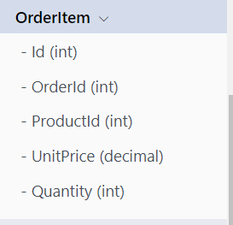 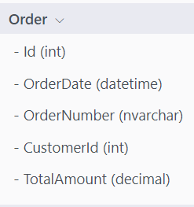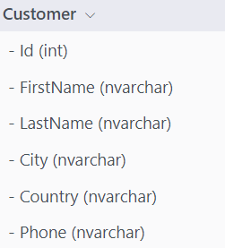

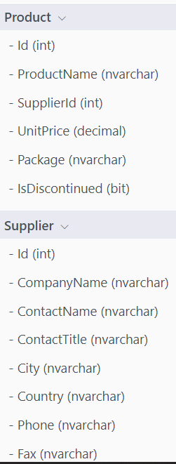

**CREATE PROCEDURE InCountryCustomers**

**@Country NVARCHAR(40)**

**AS**

**BEGIN**

**SELECT DISTINCT FirstName, LastName, C.Country**

**FROM Customer C**

**JOIN [Order] O ON C.Id = O.CustomerId**

**JOIN OrderItem I ON O.Id = I.OrderId**

**JOIN Product P ON I.ProductId = P.Id**

**JOIN Supplier S ON P.SupplierId = S.Id**

**WHERE C.Country = @Country**

**AND S.Country = C.Country**

**END**

Try it live

The above procedure is a reusable SELECT statement with 5 table JOINs.

It offers flexibility by providing a country parameter.

[**#**](https://www.dofactory.com/sql/stored-procedures#list)