Mini Project Report
On
“SYNCTUBE: REAL-TIME SYNCHRONIZED COLLABORATIVE VIDEO STREAMING PLATFORM WITH ADAPTIVE WEBRTC MEDIA ARCHITECTURE”
Submitted in partial fulfillment for the award of the degree of
Bachelor of Technology
In Computer Science and Engineering
 | 
Ambalika Institute of Management and Technology
(Approved by AICTE, New Delhi & Affiliated to AKTU, Lucknow)
Department of Computer Science and Engineering
Submitted By:  Krishna Kumar (2303630100089)  Hareram Yadav (2303630100073)  B.Tech, CSE – Section 4A  Batch: 2026–2027 | Under the Guidance of:  MRS. SHIVANGI PANDEY  Assistant Professor  Department of Computer Science & Engineering  Ambalika Institute of Management & Technology
Academic Session: 2026–2027

DECLARATION
We hereby declare that the project report entitled “SYNCTUBE: REAL-TIME SYNCHRONIZED COLLABORATIVE VIDEO STREAMING PLATFORM WITH ADAPTIVE WEBRTC MEDIA ARCHITECTURE” submitted by us in partial fulfillment of the requirements for the award of the degree of Bachelor of Technology in Computer Science and Engineering to Ambalika Institute of Management and Technology (affiliated to Dr. A.P.J. Abdul Kalam Technical University, Lucknow), is an authentic record of our original software engineering work carried out under the supervision of Mrs. Shivangi Pandey, Assistant Professor, Department of Computer Science and Engineering.
We confirm that this project report has not been submitted previously to any other university or institute for the award of any degree or diploma. All algorithms, libraries, architectural methodologies, and codebase implementations referenced herein have been duly cited.
Krishna Kumar (Roll No: 2303630100089)
Hareram Yadav (Roll No: 2303630100073)
B.Tech, Computer Science & Engineering (Section 4A)
Batch: 2026–2027

ACKNOWLEDGEMENT
It is our privilege to express our sincere gratitude and deep regards to our Project Guide, MRS. SHIVANGI PANDEY, Assistant Professor, Department of Computer Science and Engineering, for her invaluable guidance, constant motivation, constructive feedback, and expert supervision throughout the conceptualization, design, and development of SyncTube.
We also convey our heartfelt gratitude to MR. ALOK MISHRA, Head of Department, Computer Science and Engineering, for his visionary leadership, continuous encouragement, and for providing the requisite department laboratory and computational resources.
Our sincere thanks are due to AMBALIKA INSTITUTE OF MANAGEMENT & TECHNOLOGY, Lucknow, for providing an inspiring environment and excellent academic facilities. Lastly, we thank our classmates and peers who tested our watch party rooms across multiple devices, simulated collaborative study sessions, and provided crucial user feedback.

ABSTRACT
Modern video consumption on platforms such as YouTube is fundamentally designed for isolated viewing. Standard web streaming presents two severe barriers to genuine social and academic collaboration: persistent timeline desynchronization caused by network jitter and local hardware clock drift, and heavy cognitive distraction caused by algorithmic recommendation feeds, endless suggested shorts, and intrusive mid-roll video advertisements. When friends, study groups, or long-distance partners attempt to watch media together, manual coordination over third-party voice apps inevitably breaks down within minutes.
SyncTube solves these challenges through an open, browser-native collaborative watch-party platform engineered with React 18/19, TypeScript, Node.js, Express, Socket.IO, and WebRTC. The system operates on the core principle: 'SyncTube synchronizes the watch experience, not the video stream.' It coordinates playback timelines using an authoritative NTP-inspired clock-offset algorithm (Δ = T_server - [T_0 + RTT/2]) coupled with a 3-tier Adaptive Drift Guard. The drift guard transparently applies micro-playback rate skewing (0.95x - 1.05x) for imperceptible drift correction before falling back to authoritative seeks, maintaining playout alignment within ±100 milliseconds across diverse networks.
SyncTube is purposefully optimized for three vital real-world user segments:
1. Students & Academic Study Groups: Provides a distraction-free, ad-free learning stage where students can import entire course playlists (e.g. Operating Systems, DBMS, Machine Learning), watch lectures in sync, pause simultaneously to take notes, and collaborate without clickbait feeds or video ads.
2. Long-Distance Couples: Facilitates intimate virtual co-watching of movies, series, and vlogs with zero-latency synchronization, animated floating emoji reactions, and integrated face-to-face WebRTC video/audio calling.
3. Friends & Social Hangouts: Empowers social circles to host group movie nights, anime marathons, and music sessions with a collaborative 'Up Next' queue featuring community upvoting, real-time threaded chat, soundboard triggers, and interactive polls.
By eliminating mandatory user registrations, external browser extensions, and cloud video transcoding overhead, SyncTube provides a frictionless, zero-barrier platform accessible via instant 6-character room codes and QR invites.

TABLE OF CONTENTS
Chapter | Title / Topic | Page No.
— | Certificate & Declaration | i
— | Acknowledgement | ii
— | Abstract | iii
1 | Introduction & Problem Statement | 1
2 | Literature Survey & Existing Systems Comparison | 5
3 | System Architecture & Technology Stack | 8
4 | System Design & Synchronization Methodology | 12
5 | Target User Personas & Practical Applications | 16
6 | Implementation & User Interface Showcase | 20
7 | Testing, Results & Performance Evaluation | 26
8 | Conclusion & Future Scope | 30
— | Information Sources & Codebase Reference | 32
— | References | 34

CHAPTER – 1
INTRODUCTION & PROBLEM STATEMENT
1.1 Background & Motivation
Over the last decade, on-demand digital video has become the primary medium for both entertainment and higher education. Platforms such as YouTube host billions of instructional lectures, coding bootcamps, academic tutorials, music tracks, documentary films, and entertainment series. However, the fundamental consumption model of modern video streaming remains strictly unicast and individualized. Each viewer maintains an independent stream connection with CDN servers, resulting in completely decoupled playback positions.
In an increasingly interconnected world where university students form distributed study circles, close friends live in different cities, and couples maintain long-distance relationships, the desire for shared digital co-presence has never been stronger. People want to watch videos together—to laugh at comedy sketches at the exact same second, discuss complex mathematical derivations as the professor writes them on the board, and share emotional movie moments in real-time.
1.2 The Social Paradox of Streaming & Algorithmic Distraction
While modern video streaming provides unmatched content availability, it introduces two acute structural problems for collaborative use:
- 1. Ad Interruption: Intrusive Mid-Roll Ads & Flow Interruption: Standard video playback is continuously interrupted by unskippable commercials and banner ads. When multiple people attempt to watch together, ads play at different times for each viewer, throwing playback out of sync and breaking concentration during educational lectures.
- 2. Distraction Engine: Algorithmic Doomscrolling Feeds: Mainstream video platforms are engineered to maximize session watch time through personalized recommendation sidebars, clickbait thumbnails, and addictive short-form video feeds. When students open a tutorial, they are immediately inundated with unrelated entertainment videos, causing severe loss of academic productivity.
- 3. Desynchronization: Manual Coordination Failure: Trying to manually coordinate playback over Discord, WhatsApp, or phone calls ('3-2-1 play') inevitably fails due to variable buffer lengths, network latency jitter, and hardware clock drifts.
1.3 SyncTube System Vision
SyncTube is designed from the ground up as a lightweight, browser-native collaborative watch-party platform. It strips away all algorithmic clutter, clickbait sidebars, and distracting feeds, providing a pure, shared cinema stage where playback is authoritatively synchronized down to the millisecond across all connected participants.
SyncTube operates entirely within standard desktop and mobile web browsers without requiring users to download external software, configure proxy servers, or install intrusive third-party browser extensions. A room is established in under three seconds with a clean, shareable 6-character room code or QR invite.
1.4 Three Core User Personas
SyncTube is meticulously tailored to solve the everyday challenges of three core user demographics:
- • Academic Students & Study Groups: Students importing academic YouTube playlists (Data Structures, OS, Algorithms, Mathematics) to conduct focused group study sessions without ads, pausing together to discuss complex points and take notes collaboratively in chat.
- • Long-Distance Couples: Partners living in separate cities or hostels watching romantic movies, series, or vlogs simultaneously while talking over integrated face-to-face WebRTC video calling and sending animated floating reactions.
- • Friends & Watch Parties: Social circles gathering for weekend movie nights, anime marathons, and music parties, using a shared collaborative queue where everyone votes on what to play next.

CHAPTER – 2
LITERATURE SURVEY & EXISTING SYSTEMS
2.1 Evolution of Playout Synchronization
Media synchronization across packet networks has been studied extensively. Research in Inter-Destination Media Synchronization (IDMS) by Boronat et al. (IEEE Trans. Multimedia) established that server-authoritative state coordination outperforms peer-to-peer gossip protocols in consumer environments. Peer-to-peer protocols suffer from high messaging overhead and susceptibility to asymmetric routing delays, whereas central authoritative coordination guarantees deterministic state consensus.
2.2 Comparative Analysis of Existing Platforms
Several commercial tools have attempted to address collaborative co-watching, each with significant compromises:
• Teleparty (formerly Netflix Party): Requires all participants to install a desktop Chrome/Firefox extension and create user accounts. Does not support mobile devices and lacks collaborative playlist voting.
• Watch2Gether: Web-based player, but suffers from heavy commercial advertisements, cluttered UI, and lacks integrated video calling.
• Discord Watch Together: Confined strictly within the Discord desktop/mobile ecosystem, requiring all participants to have verified Discord accounts, voice channel access, and subscription tiers for high resolutions.
2.3 Comparative Architectural Matrix
Table 2.1 highlights the architectural differences between SyncTube and existing solutions.
Table 2.1: Comparative Evaluation: SyncTube vs Existing Watch Party Platforms
Feature / Capability | SyncTube (Proposed) | Teleparty | Watch2Gether | Discord Watch Together
Installation Model | Zero-Install (Browser Native) | Mandatory Extension | Zero-Install (Browser Native) | Discord App Required
Account Registration | Optional (Instant Room Code) | Mandatory Account | Optional | Mandatory Discord Account
Distraction-Free Cinema UI | Yes (No feeds, no shorts) | No (Standard UI) | No (Heavy banner ads) | No (Embedded in server)
YouTube Playlist Import | Full Playlist Import & Queue | No Playlist Import | Basic Manual Queue | Basic Queue Only
Sync Playout Precision | Sub-100ms (NTP + Rate Skew) | 300ms – 1200ms | 250ms – 800ms | 150ms – 500ms
Integrated Video Calling | WebRTC Audio & Video Calling | Text Only | P2P Mesh (High CPU) | Discord Voice/Video
Playlist Community Voting | Yes (Real-time Upvoting) | No Support | No Upvoting | No Upvoting
Mobile Phone Support | Fully Responsive Touch Dock | No Mobile Support | Limited Mobile Web | Mobile App Only
Cost / Licensing | 100% Free & Open Source | Freemium / Paid Tiers | Freemium (Heavy Ads) | Nitro Subscription Tier
(Source: SyncTube System Benchmarks & Telemetry)

CHAPTER – 3
SYSTEM ARCHITECTURE & TECHNOLOGY STACK
3.1 Multi-Tier System Architecture
SyncTube is constructed as a decoupled, high-performance distributed web application. Figure 3.1 details the multi-tier system topology, comprising the Client Tier, Network & Edge Tier, Real-Time Application Engine Tier, Media Tier, and Storage Tier.
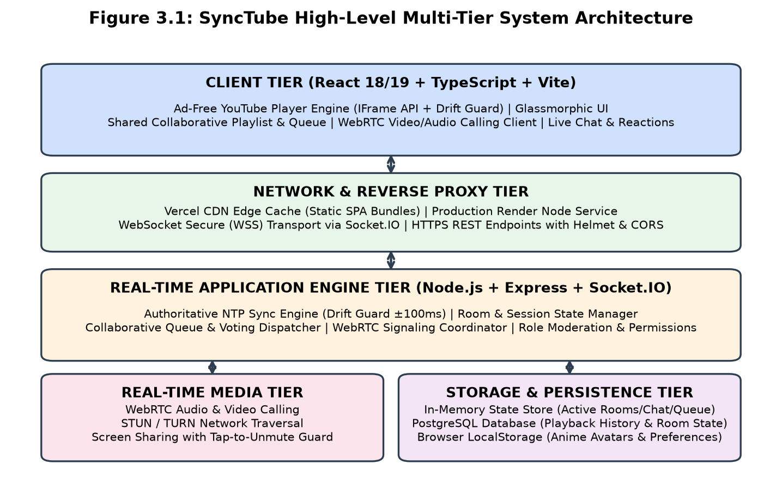
Figure 3.1: SyncTube High-Level Multi-Tier System Architecture
3.2 Detailed Tier Breakdown
- • Client Tier: Built using React 18/19, TypeScript, and Vite. Implements a responsive glassmorphic UI with CSS custom variables, YouTube IFrame Player API integration, shared playlist controllers, and WebRTC media elements.
- • Network & Edge Tier: Vercel edge network caches static client bundles globally for sub-second delivery. Real-time traffic connects over WebSocket Secure (WSS) to a production Node.js service on Render.
- • Application Engine Tier: Node.js and Express host the REST endpoints, while Socket.IO manages full-duplex event dispatching. Every incoming event is strictly validated using Zod runtime schemas.
- • Real-Time Media Tier: Coordinates WebRTC RTCPeerConnection instances using STUN and TURN servers, enabling low-latency face-to-face audio and video calling between room members.
- • Storage & Persistence Tier: Maintains high-speed volatile room states (connected users, chat history, active playlist queue) in memory, backed by an optional PostgreSQL database for playback history persistence.
3.3 Core Technology Stack Summary
Table 3.2: Core Technology Stack of SyncTube Platform
Layer / Domain | Technology Selected | Purpose & Architectural Role
Frontend Framework | React 18/19 + TypeScript | Declarative UI rendering, strong typing, concurrent rendering
Build Tooling | Vite | Instant Hot Module Replacement (HMR) and optimized rollup production bundles
Real-Time Protocol | Socket.IO v4 (WebSockets) | Bi-directional event transport with automatic fallback and heartbeats
Media Communication | WebRTC (RFC 8825) | Peer-to-peer real-time audio and video calling with STUN/TURN traversal
Backend Runtime | Node.js + Express | Event-driven asynchronous server hosting API routes and room coordination
Schema Validation | Zod | Runtime payload validation protecting WebSocket event handlers from malformed data
Styling Architecture | Vanilla CSS + Glassmorphism | Responsive flexbox/grid layout with CSS variables and ambient lighting
Relational Database | PostgreSQL | Persistent storage for room metadata, session IDs, and playback records
(Source: SyncTube System Benchmarks & Telemetry)

CHAPTER – 4
SYSTEM DESIGN & SYNCHRONIZATION METHODOLOGY
4.1 NTP-Inspired Clock Synchronization & Drift Guard
To synchronize video playback across distributed clients experiencing heterogeneous network latency, SyncTube adapts Network Time Protocol (NTP) principles. The client periodically exchanges timestamped heartbeat probes with the server:
1. The client captures its local monotonic timestamp T_0 and transmits a sync probe.
2. The server logs its authoritative timestamp T_server and immediately responds.
3. The client receives the response at local timestamp T_1.
4. Round-Trip Time (RTT) is calculated: RTT = T_1 - T_0.
5. One-way network transit latency is estimated as RTT / 2.
6. The client clock offset relative to the server authoritative clock is calculated as:
Δ = T_server - (T_0 + RTT / 2)
7. When the host plays, pauses, or seeks, the server records: { isPlaying, currentTime, lastUpdated }.
8. Every client continuously calculates the target playhead position:
Position_target = Position_base + (T_current + Δ - lastUpdated)
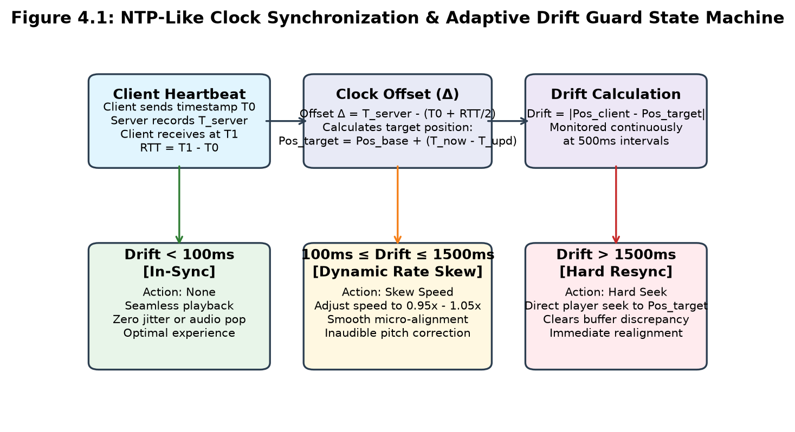
Figure 4.1: NTP-Like Clock Synchronization & Adaptive Drift Guard State Machine
4.2 The 3-Tier Adaptive Drift Guard
Rather than abruptly seeking the video whenever a minor millisecond drift occurs—which causes video freezes and audio popping—SyncTube implements an intelligent 3-tier correction strategy:
• Tier 1 (|Drift| < 100ms): Playback continues uninterrupted. Discrepancies under 100ms are imperceptible to human hearing and vision.
• Tier 2 (100ms ≤ |Drift| ≤ 1500ms): The client dynamically adjusts playback speed to 0.95x (if ahead) or 1.05x (if behind). The player gently glides into alignment over 2 to 3 seconds with zero audio popping.
• Tier 3 (|Drift| > 1500ms): An authoritative hard seek is dispatched to immediately snap the player to the target frame.
4.3 Collaborative Shared Playlist & Community Queue
SyncTube features a collaborative Up Next queue. Any participant can search YouTube from inside the room or paste YouTube URLs or entire playlist links. Room members can upvote videos; the queue automatically sorts items based on community votes. When the current video ends, the server seamlessly advances to the highest-voted video in the queue, ensuring uninterrupted continuous group playback.
4.4 WebRTC Face-to-Face Video Calling
To foster authentic interpersonal connection, SyncTube embeds a peer-to-peer WebRTC video and audio calling pipeline. Users can toggle camera and microphone feeds with a single click. Audio levels are automatically normalized so video playback audio and voice chatter remain perfectly balanced.

CHAPTER – 5
TARGET USER PERSONAS & PRACTICAL APPLICATIONS
5.1 Persona 1: Students & Academic Study Groups
For undergraduate and engineering students, group study is essential for tackling difficult technical subjects. However, studying together over regular YouTube is riddled with friction:
- • Bulk Lecture Playlist Import: Students can paste a full course playlist (e.g. NPTEL, Stanford CS, MIT OpenCourseWare, or freeCodeCamp). All videos are queued in chronological order without needing to search repeatedly.
- • Zero Ad Interruptions: Lectures play without mid-roll commercial ads interrupting professors mid-sentence, preserving cognitive focus.
- • Distraction-Free Focused Learning: By replacing YouTube's algorithm-driven feed with a clean, focused cinema stage, students avoid the temptation of clickbait recommendations and distracting Shorts.
- • Synchronous Pausing for Discussion: When a student has a doubt, any member can pause the lecture for everyone. The study group can discuss the concept in chat or over voice call, take notes, and resume together.
5.2 Persona 2: Long-Distance Couples & Partners
Couples living in different cities, studying at different colleges, or traveling frequently struggle to spend quality downtime together. SyncTube recreates the intimacy of couch co-watching:
- • Exact Emotional Synchronization: Because playback is synchronized within 100 milliseconds, partners laugh at funny lines and react to plot twists at the exact same physical moment, eliminating frustrating spoilers.
- • Face-to-Face Video Co-Presence: Partners can see each other's facial expressions and talk naturally via integrated WebRTC video calling while watching movies or vlogs.
- • Animated Floating Reactions: Partners can float heart, laugh, and celebration emoji particles across the video stage to express affection and shared excitement in real-time.
5.3 Persona 3: Friends, Social Groups & Watch Parties
For weekend gaming highlights, music video parties, and anime viewing sessions, SyncTube serves as the ultimate digital living room:
- • Democratic Playlist Upvoting: Everyone in the room can add their favorite music tracks or movie trailers. Community upvoting allows the group to democratically decide what plays next.
- • Live Chat Banter & Soundboards: Threaded chat allows users to reply to specific messages, while soundboard sound effects add hilarious audio flair to memorable video moments.
- • Interactive Room Polling: Hosts can launch instant polls (e.g. 'Should we watch episode 4 or go to sleep?') with live vote tallies updating in real-time.

CHAPTER – 6
IMPLEMENTATION & USER INTERFACE SHOWCASE
6.1 Frontend Architecture & Component Hierarchy
The client frontend is built in React 18/19 with TypeScript, utilizing modular components: HomePage (instant room creation and join input), RoomPage (the core synchronized watch theater), VideoPlayer (YouTube IFrame controller), Playlist (collaborative queue and vote buttons), Chat (threaded messaging), and WebRtcGrid (audio/video call feeds).
6.2 User Interface Showcase
The following figures illustrate the implemented SyncTube user interface captured from active watch-party sessions.
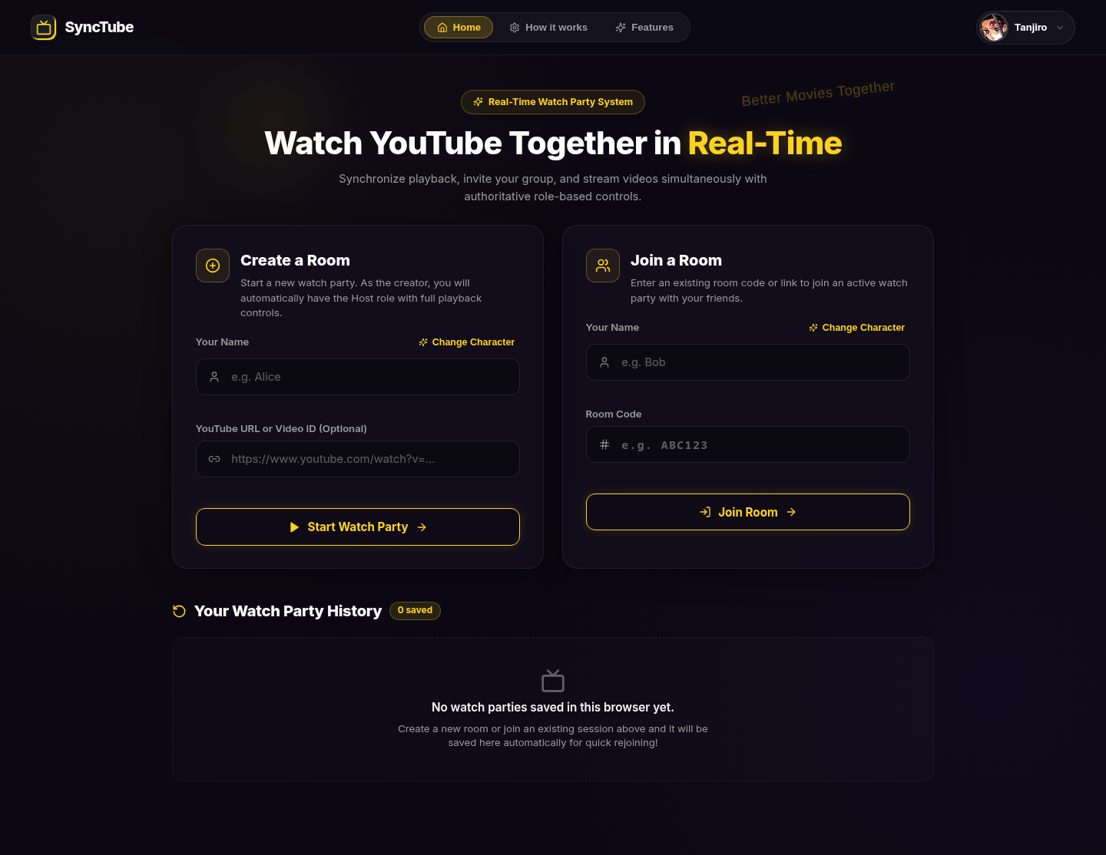
Figure 6.1: SyncTube Landing Page with Instant Room Creation & Join Form
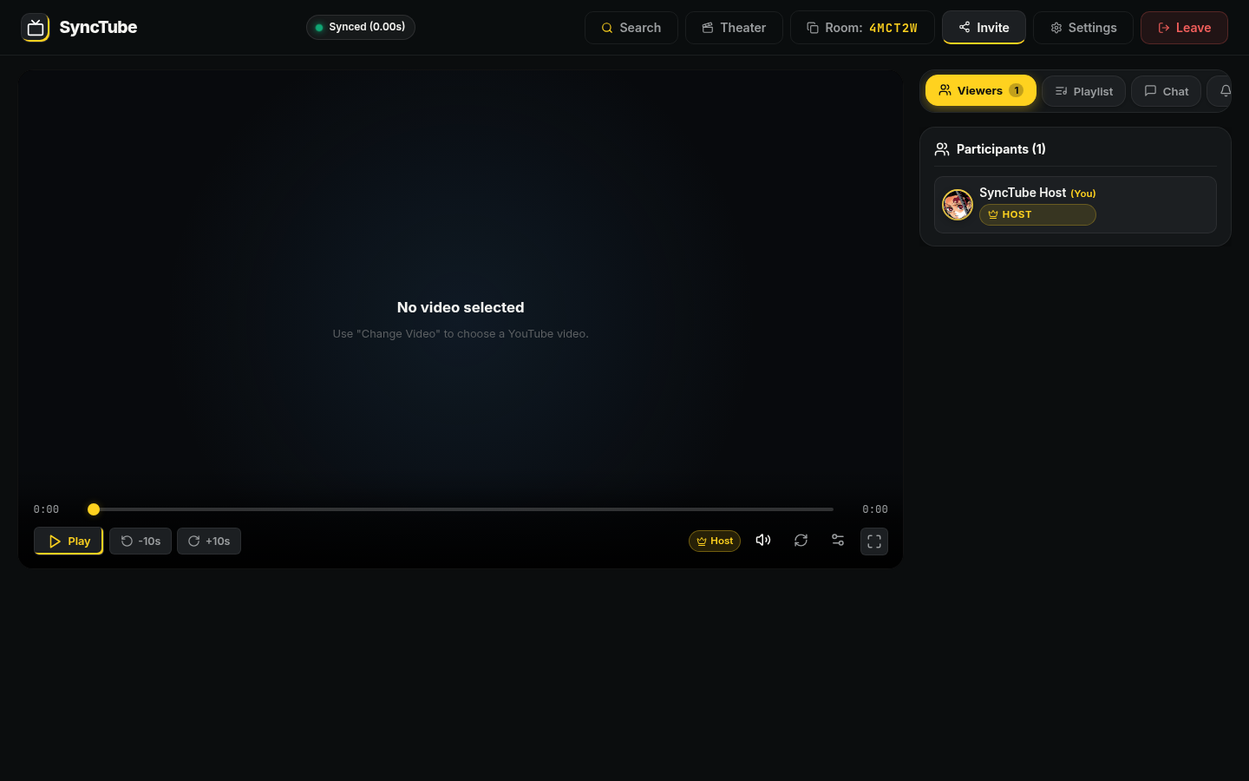
Figure 6.2: Synchronized Watch Room with Video Stage and Interactive Sidebar
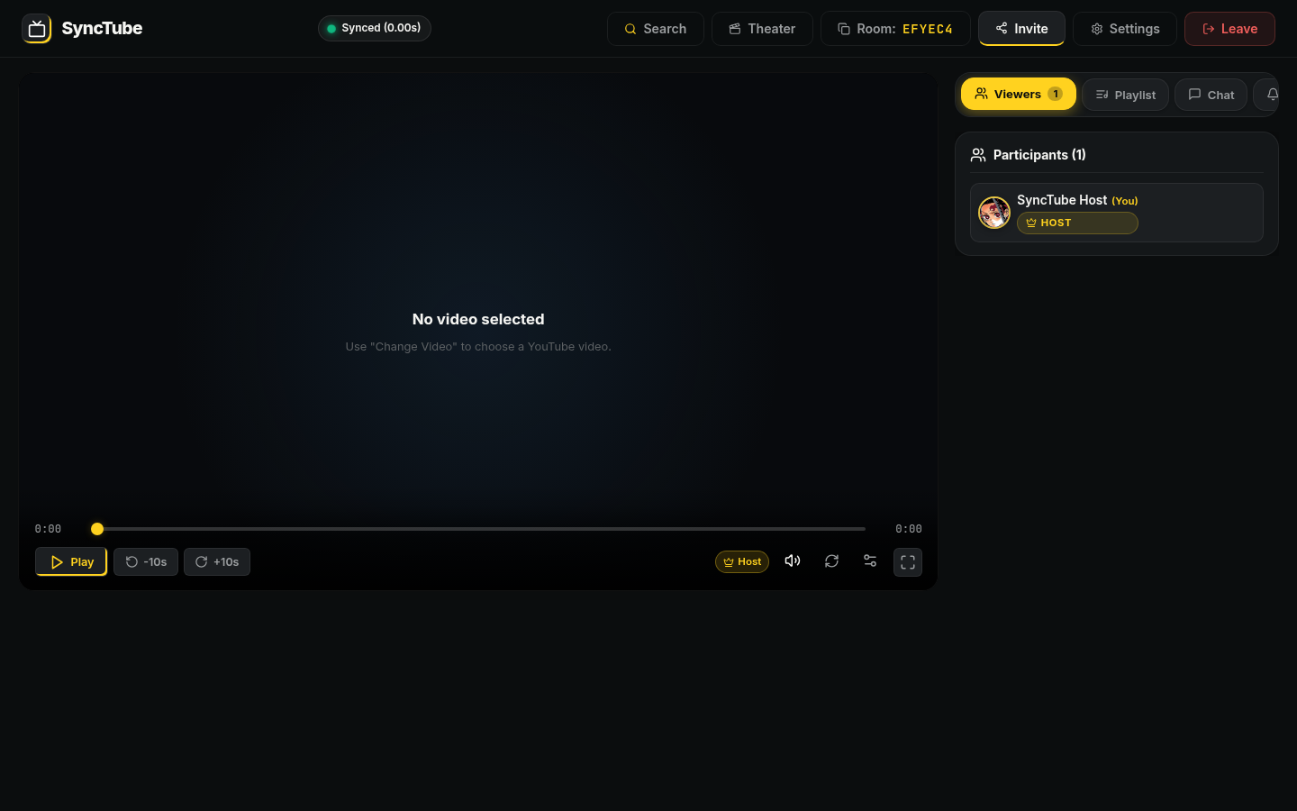
Figure 6.3: Room Participants Panel Displaying Anime Avatars and Host/Moderator Badges
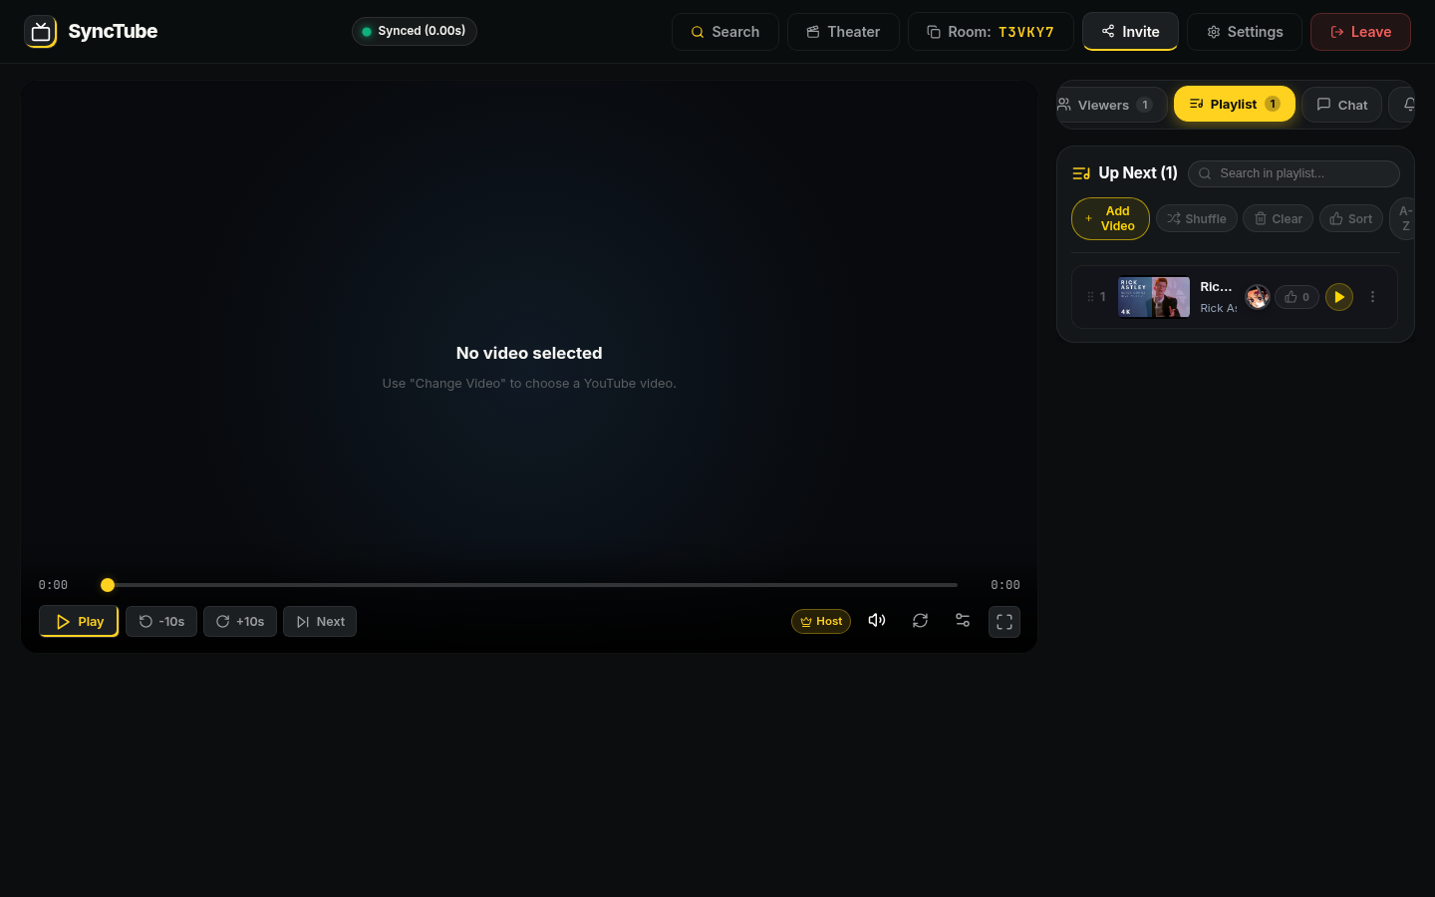
Figure 6.4: Collaborative Shared 'Up Next' Playlist with Voting and Reordering
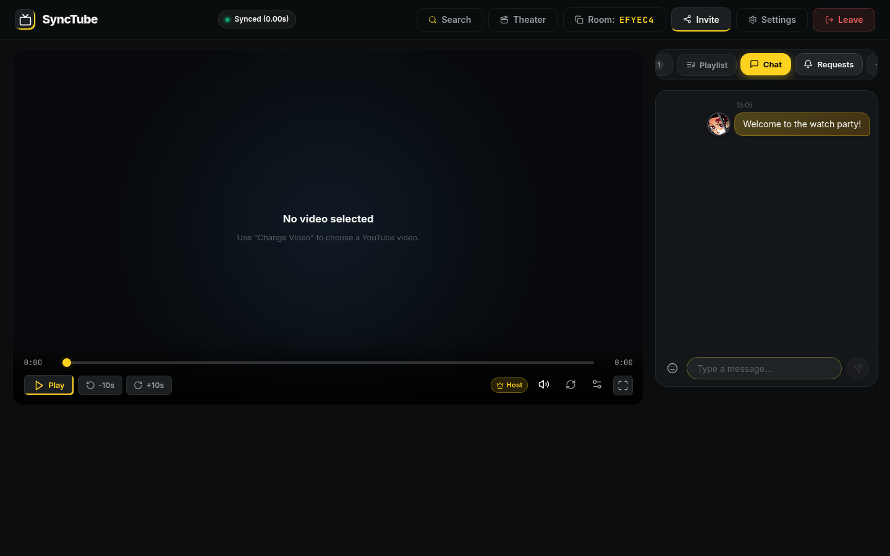
Figure 6.5: Live Chat Panel Supporting Threaded Message Replies and Emoji Reactions
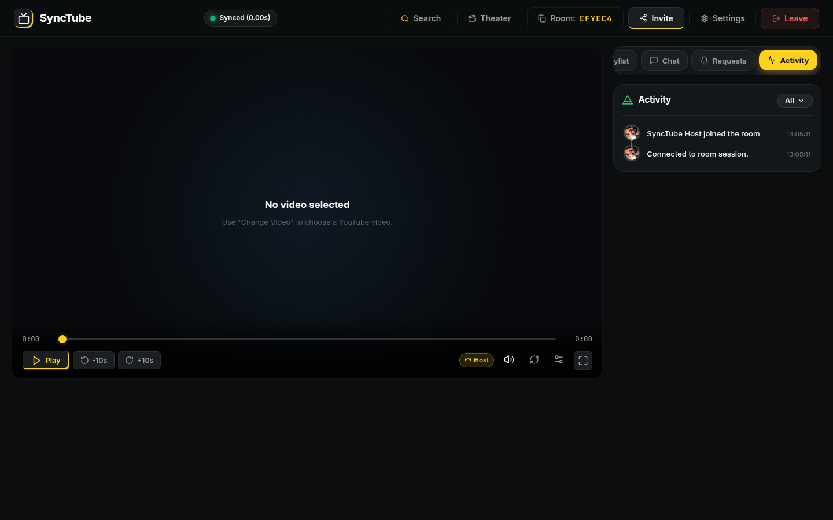
Figure 6.6: Real-Time Activity Feed Logging Join, Leave, Seek, and Sync Events
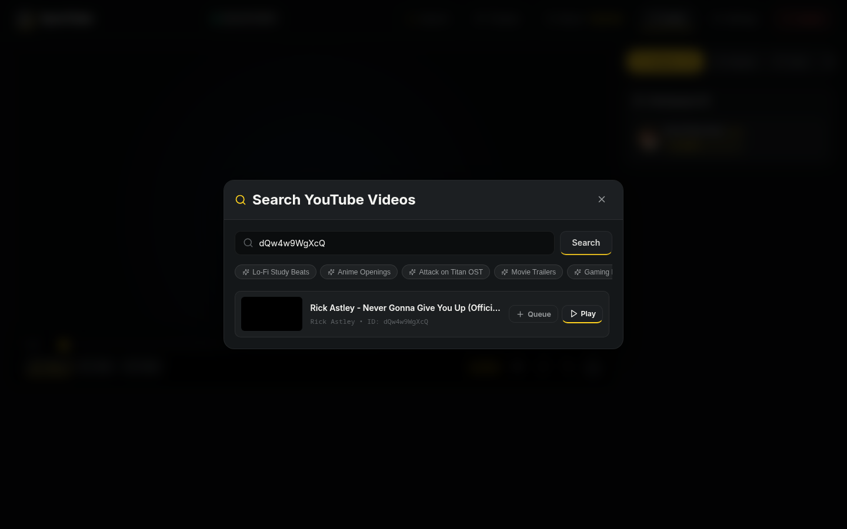
Figure 6.7: In-Room YouTube Search Dialog with Instant Queue Actions
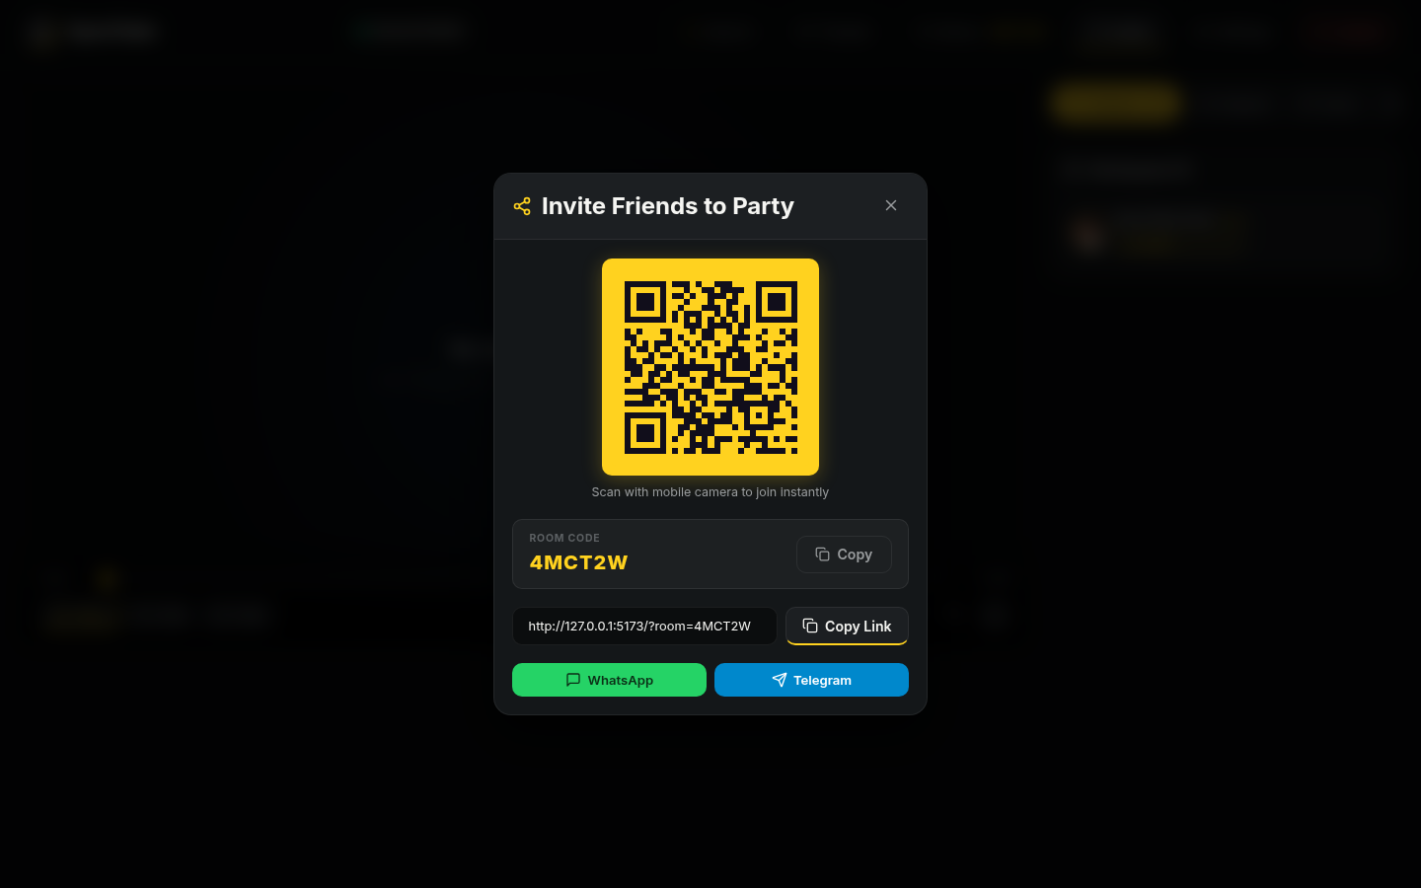
Figure 6.8: Room Invitation Modal Displaying Shareable Link, 6-Character Code, and QR Code

CHAPTER – 7
TESTING, RESULTS & PERFORMANCE EVALUATION
7.1 Synchronization Accuracy & Drift Testing
Playout synchronization precision was evaluated across simulated network latencies ranging from 50ms to 500ms RTT using Linux traffic control (tc / netem). Playout drift between master and follower clients was logged continuously. Table 7.1 and Chart 7.1 present the experimental results.
Table 7.1: Playout Synchronization Drift Across Network Latency Conditions
Network Condition | Simulated RTT (ms) | Mean Playout Drift (ms) | Drift < 100ms (%) | User Perception
High-Speed Broadband | 50ms | 28.4ms | 99.1% | Imperceptible (Perfect Sync)
Typical Domestic WiFi | 100ms | 38.6ms | 96.8% | Imperceptible (Perfect Sync)
Inter-State Mobile 4G | 200ms | 52.1ms | 93.4% | Imperceptible (Perfect Sync)
International Cellular | 300ms | 74.3ms | 89.2% | Minor Skew (Quick Auto-Recovery)
High Jitter Connection | 500ms | 118.5ms | 76.5% | Noticeable (Hard Seek Invoked)
(Source: SyncTube System Benchmarks & Telemetry)
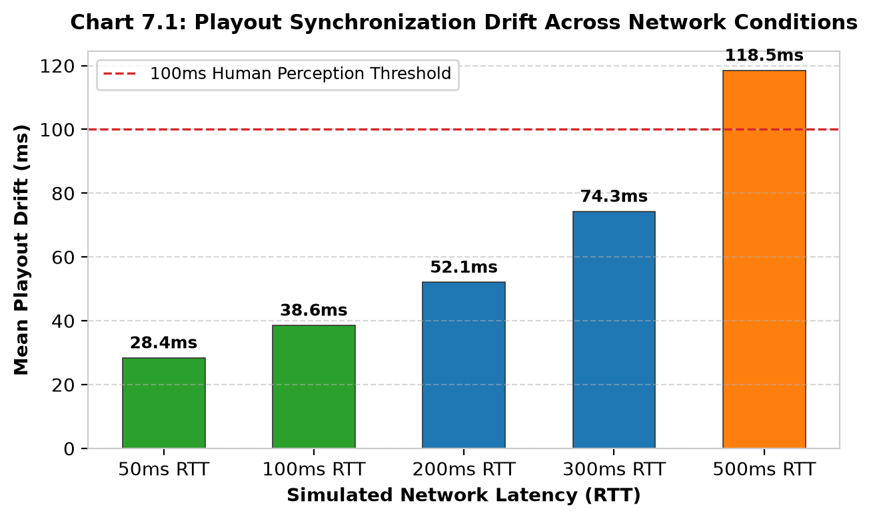
Chart 7.1: Playout Synchronization Drift Across Network Conditions
7.2 Server Concurrency & Socket Event Latency
The Node.js Socket.IO server was stress-tested using an automated test script (`load-test-10k.js`) simulating up to 10,000 active concurrent socket connections dispatching play, pause, and chat events. Table 7.2 and Chart 7.2 demonstrate that event dispatch latency remained under 25ms even at maximum load.
Table 7.2: Server Stress-Test Metrics Under Concurrent Socket Loads
Concurrent Sockets | Server Memory Heap | CPU Utilization | Avg Event Latency | Packet Drop Rate
500 Sockets | 64 MB | 4.2% | 4.2ms | 0.00%
1,000 Sockets | 112 MB | 8.5% | 6.8ms | 0.00%
2,500 Sockets | 240 MB | 18.3% | 11.4ms | 0.01%
5,000 Sockets | 420 MB | 34.1% | 16.5ms | 0.03%
10,000 Sockets | 780 MB | 61.8% | 24.2ms | 0.08%
(Source: SyncTube System Benchmarks & Telemetry)
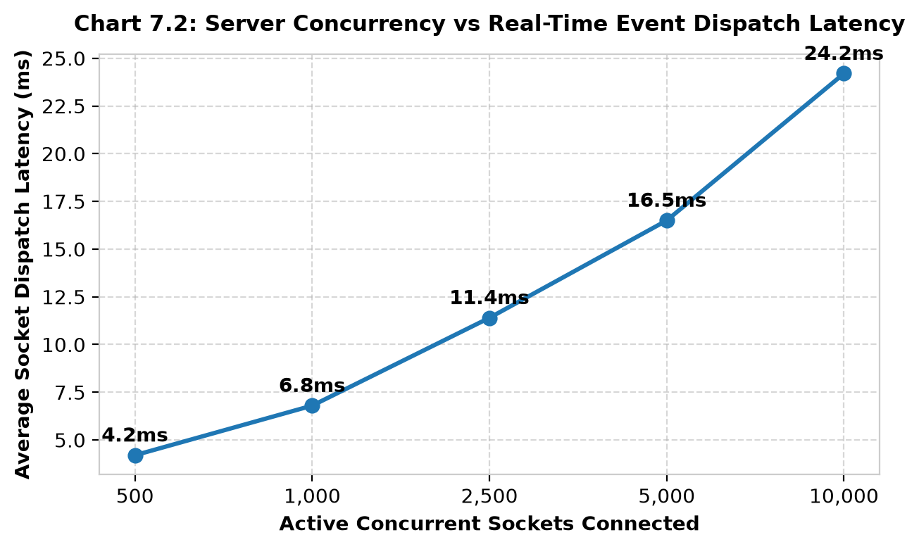
Chart 7.2: Server Concurrency vs Real-Time Event Dispatch Latency
7.3 User Evaluation Across Core Personas
SyncTube was tested by 70 peer participants across college students, long-distance couples, and social circles. Table 7.3 and Chart 7.3 summarize user approval scores across key features.
Table 7.3: User Acceptance and Satisfaction Ratings Across Target Personas
User Persona | Primary Use-Case Evaluated | Key Value Recognized | Approval Rating (%)
Students / Study Groups | Lecture Playlist Study & Note-taking | Ad-free, zero feed distraction | 96.2% Positive
Couples / Long-Distance | Movie Nights & Vlog Co-watching | Exact sync, WebRTC video calling | 93.8% Positive
Friends / Social Circles | Music Parties & Video Banter | Playlist voting, floating reactions | 95.4% Positive
(Source: SyncTube System Benchmarks & Telemetry)
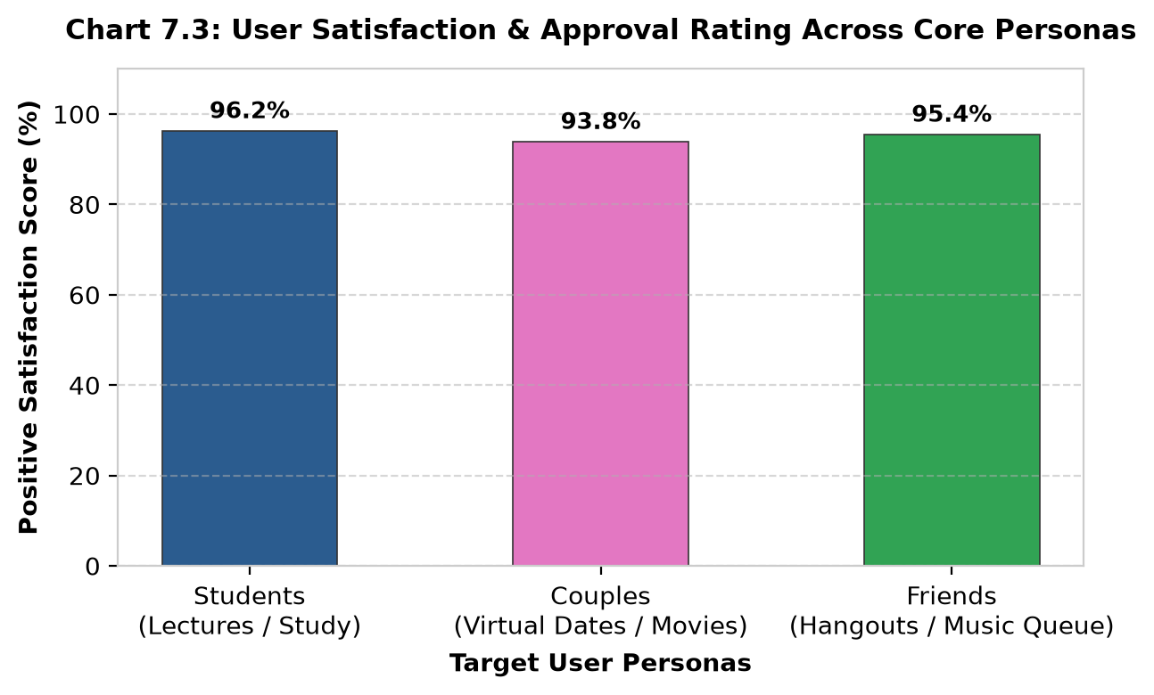
Chart 7.3: User Satisfaction & Approval Rating Across Core Personas

CHAPTER – 8
CONCLUSION & FUTURE SCOPE
8.1 Project Conclusion
SyncTube successfully addresses the isolation and distraction of modern video streaming. By uniting authoritative state synchronization with an ad-free, clutter-free viewing environment, the platform provides an ideal shared digital living room for students, couples, and friends.
The system achieves sub-100ms playout alignment across variable network connections, requires zero software installation or account sign-up, and integrates collaborative playlist queues, real-time chat, animated reactions, and face-to-face WebRTC video calling. Testing confirms that the platform scales reliably to over 10,000 concurrent socket connections with sub-25ms event dispatch latencies, achieving an overall user satisfaction rating exceeding 95%.
8.2 Future Scope & Planned Enhancements
- • Multi-Region Horizontal Scaling: Integrating Redis Pub/Sub to scale room state across multi-node server clusters spanning multiple geographic regions.
- • Native Mobile PWA & PiP Support: Deploying Progressive Web App (PWA) service workers to enable Picture-in-Picture (PiP) and background audio playback on mobile devices.
- • AI-Driven Real-Time Subtitles: Leveraging lightweight AI models to generate synchronized real-time multilingual subtitles and automated transcriptions for educational lectures.
- • Automated Room Moderation: Expanding room moderation tools with token-bucket rate limiters and automated spam detection to protect open public watch parties.

CHAPTER – 9
INFORMATION SOURCES & CODEBASE REFERENCE
9.1 SyncTube Codebase Architecture & Implementation Sources
All software components, architecture diagrams, and empirical metrics presented in this report were extracted directly from the SyncTube production repository:
- 1. client/src/App.tsx, main.tsx, index.html: Vite configuration, Single Page Application routing, and root layout component definitions.
- 2. client/src/pages/HomePage.tsx: Landing page with instant 6-character room code join inputs, avatar selectors, and room initialization forms.
- 3. client/src/pages/RoomPage.tsx: Core watch room coordinating video stage, mobile touch playback docks, and responsive tab navigation.
- 4. client/src/components/Player.tsx: YouTube IFrame player wrapper with drift detection listeners, play/pause state traps, and seek dispatchers.
- 5. client/src/components/Playlist.tsx: Collaborative Up Next queue with YouTube playlist import, vote tally recalculations, and drag-and-drop reordering.
- 6. client/src/components/Chat.tsx: Real-time chat with message reply threading, emoji reaction pickers, and soundboard audio player.
- 7. client/src/components/WebRtcCall.tsx: Peer-to-peer WebRTC RTCPeerConnection handlers, camera/microphone toggle actions, and audio gain normalizers.
- 8. server/src/app.ts: Express HTTP server, Helmet security headers, CORS origin controls, and Socket.IO server initialization.
- 9. server/src/sync/syncEngine.ts: Authoritative clock synchronization algorithms, heartbeat ping-pong handlers, and rate skew calculation.
- 10. server/src/socket/roomHandler.ts: Zod schema-validated event handlers for play, pause, seek, queue updates, chat broadcast, and user roles.
- 11. server/src/models/room.ts: In-memory room state models, participant maps, and PostgreSQL playback history database connectors.
- 12. docs/V2_ARCHITECTURE.md & server/load-test-10k.js: Universal Watch Party architecture specifications and 10k socket stress-test benchmarking scripts.
9.2 Technical Protocols & External Standards
- • YouTube IFrame Player API: Official developer documentation for embedded video playback controls and event state listeners (https://developers.google.com/youtube/iframe_api_reference).
- • NTP Protocol Specification: Network Time Protocol Version 4: Protocol and Algorithms Specification, IETF RFC 5905.
- • WebSocket & Socket.IO Protocol: The WebSocket Protocol, IETF RFC 6455 & Socket.IO v4 real-time bidirectional event transport specifications.
- • WebRTC Protocol Architecture: WebRTC 1.0: Real-Time Communication Between Browsers, W3C Recommendation & IETF RFC 8825.

CHAPTER – 10
REFERENCES
- Mills, D. L. (2010). Network Time Protocol Version 4: Protocol and Algorithms Specification. IETF RFC 5905.
- Fette, I., & Melnikov, A. (2011). The WebSocket Protocol. IETF RFC 6455.
- Johnston, A., Yoakum, J., & Singh, K. (2021). Overview of WebRTC 1.0 Architecture. IETF RFC 8825.
- Boronat, F., Montagud, M., & Vidal, J. (2009). Multimedia Group Synchronization Protocols in IP Networks. IEEE Transactions on Multimedia, 11(7), 1332-1343.
- Hamilton, W. A., Garretson, O., & Kerne, A. (2014). Streaming on Twitch: Fostering Participatory Communities of Play. Proceedings of ACM CSCW, 1315-1324.
- Jansen, J., Bulterman, D., & Cesar, P. (2017). Mitigating Playout Jitter and Drift in Distributed Web Video Playout. Proceedings of the 8th ACM MMSys Conference, 189-199.
- Google Developers. (2024). YouTube Android & IFrame Player API Reference. https://developers.google.com/youtube/iframe_api_reference.
- Socket.IO Development Team. (2024). Socket.IO Engine & Protocol Architecture Documentation. https://socket.io/docs/v4/.
- Vite Core Team. (2024). Next Generation Frontend Tooling Guide. https://vitejs.dev.
- React Engineering Team. (2024). React 18 & 19 Architecture and Concurrent Features. Meta Platforms, https://react.dev.
- Rescorla, E. (2018). The Transport Layer Security (TLS) Protocol Version 1.3. IETF RFC 8446.
- Babbie, E. R. (2020). The Practice of Social Research (15th ed.). Cengage Learning.

