[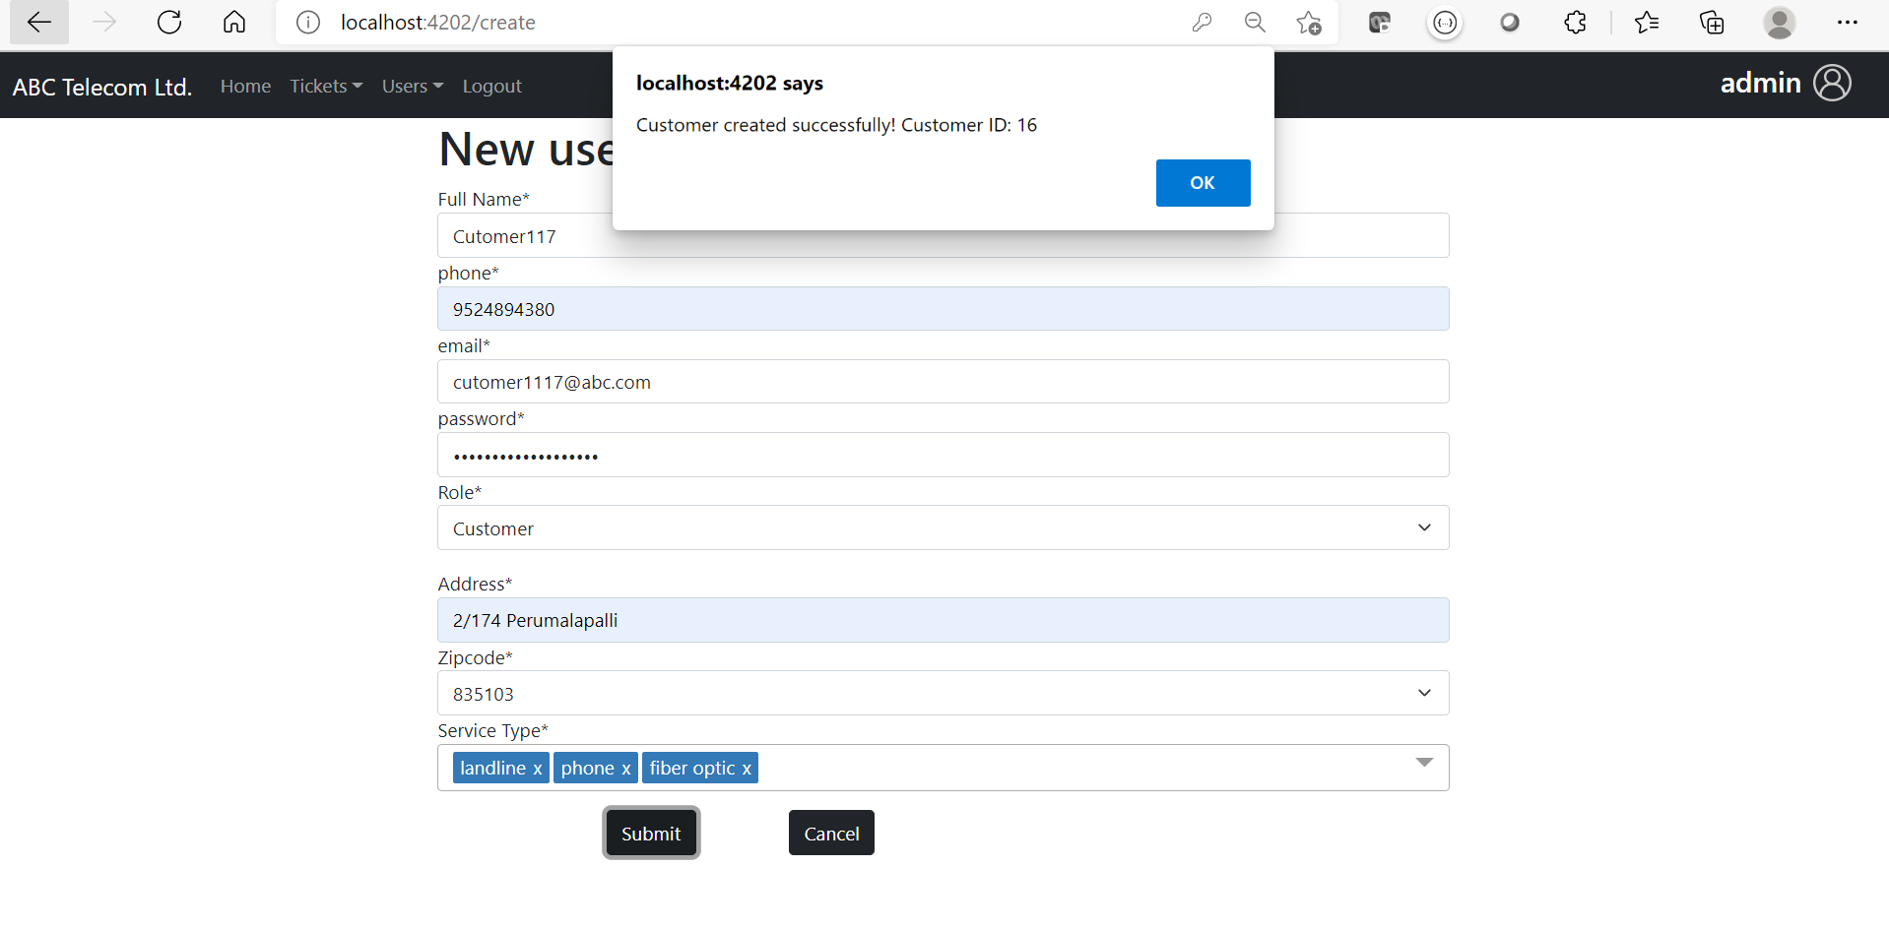](https://github.com/mcvrvikram/Complaint-Frontend/blob/master/src/assets/admin-create-user.PNG)

### Sample 2

[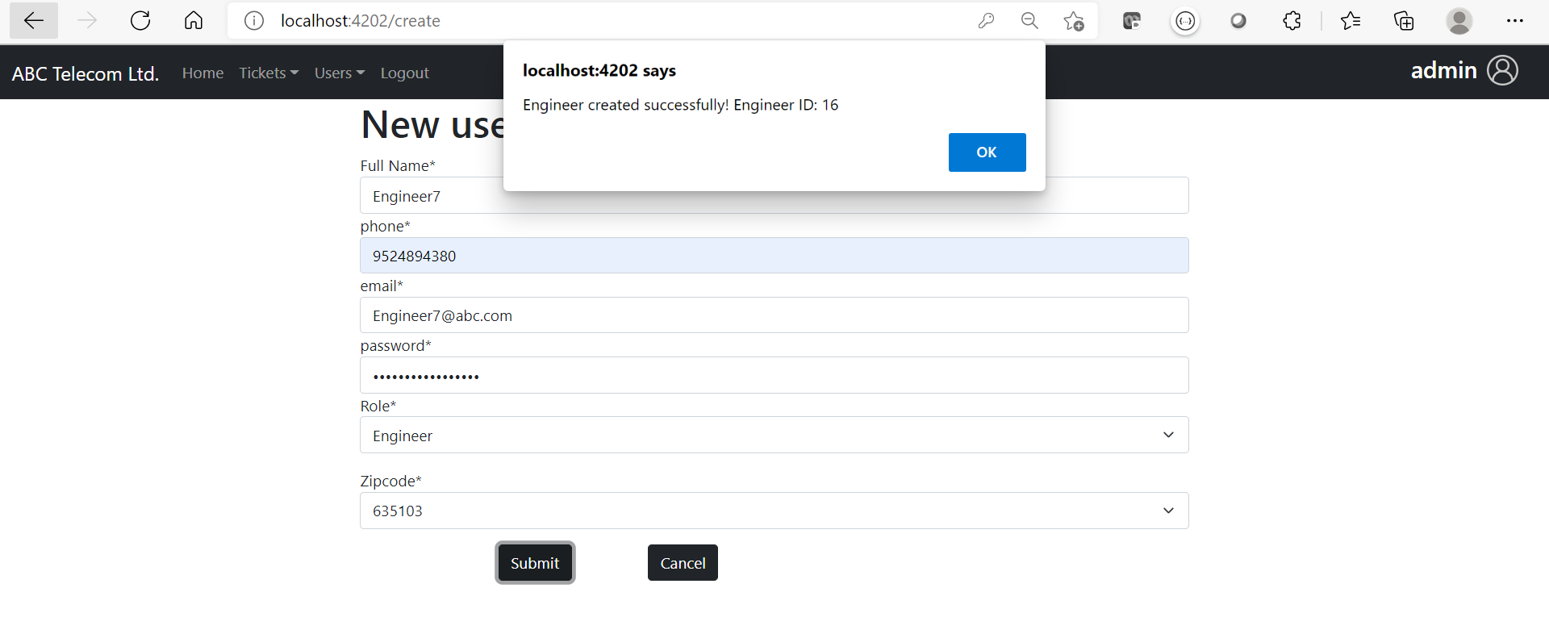](https://github.com/mcvrvikram/Complaint-Frontend/blob/master/src/assets/admin-create-user-success.PNG)

### Sample 3

[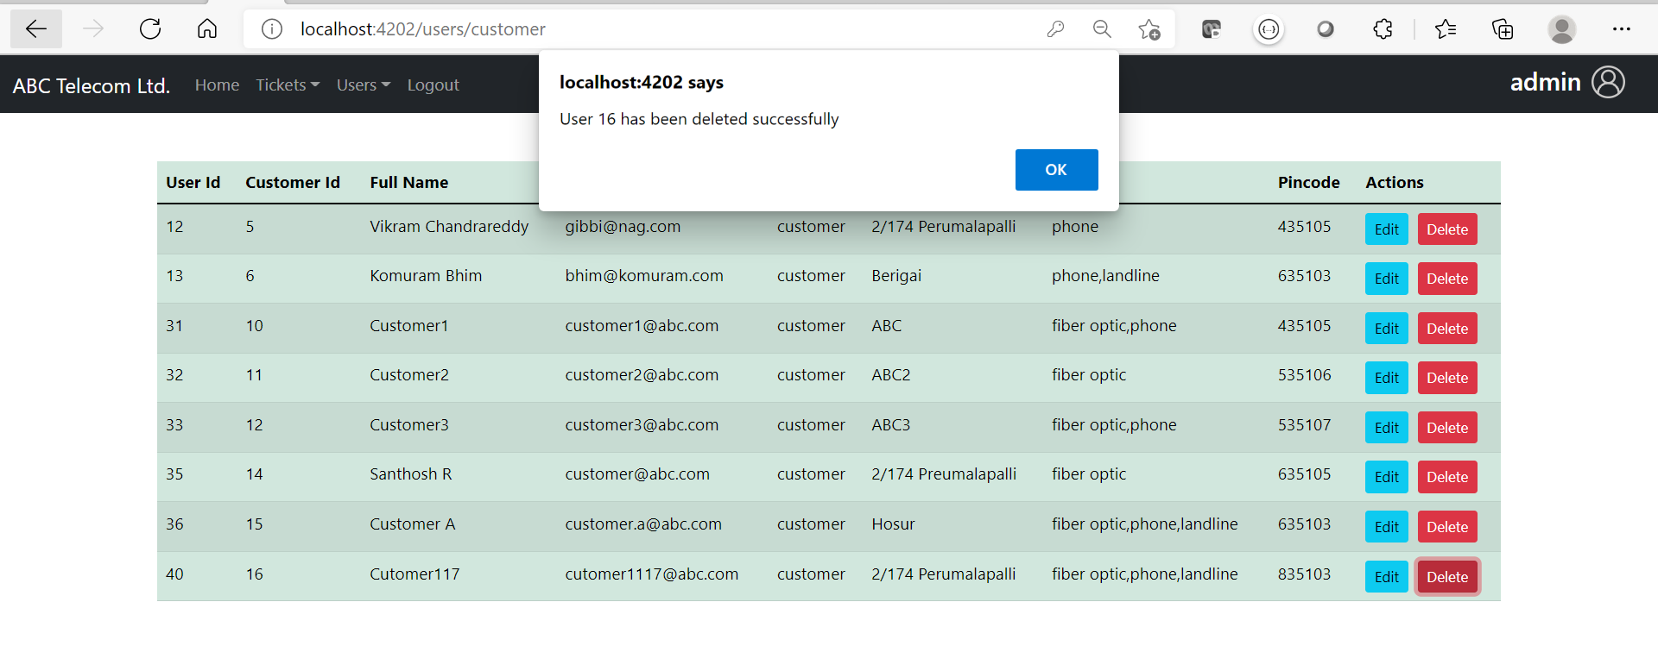](https://github.com/mcvrvikram/Complaint-Frontend/blob/master/src/assets/admin-delete-user.PNG)

### Sample 4

[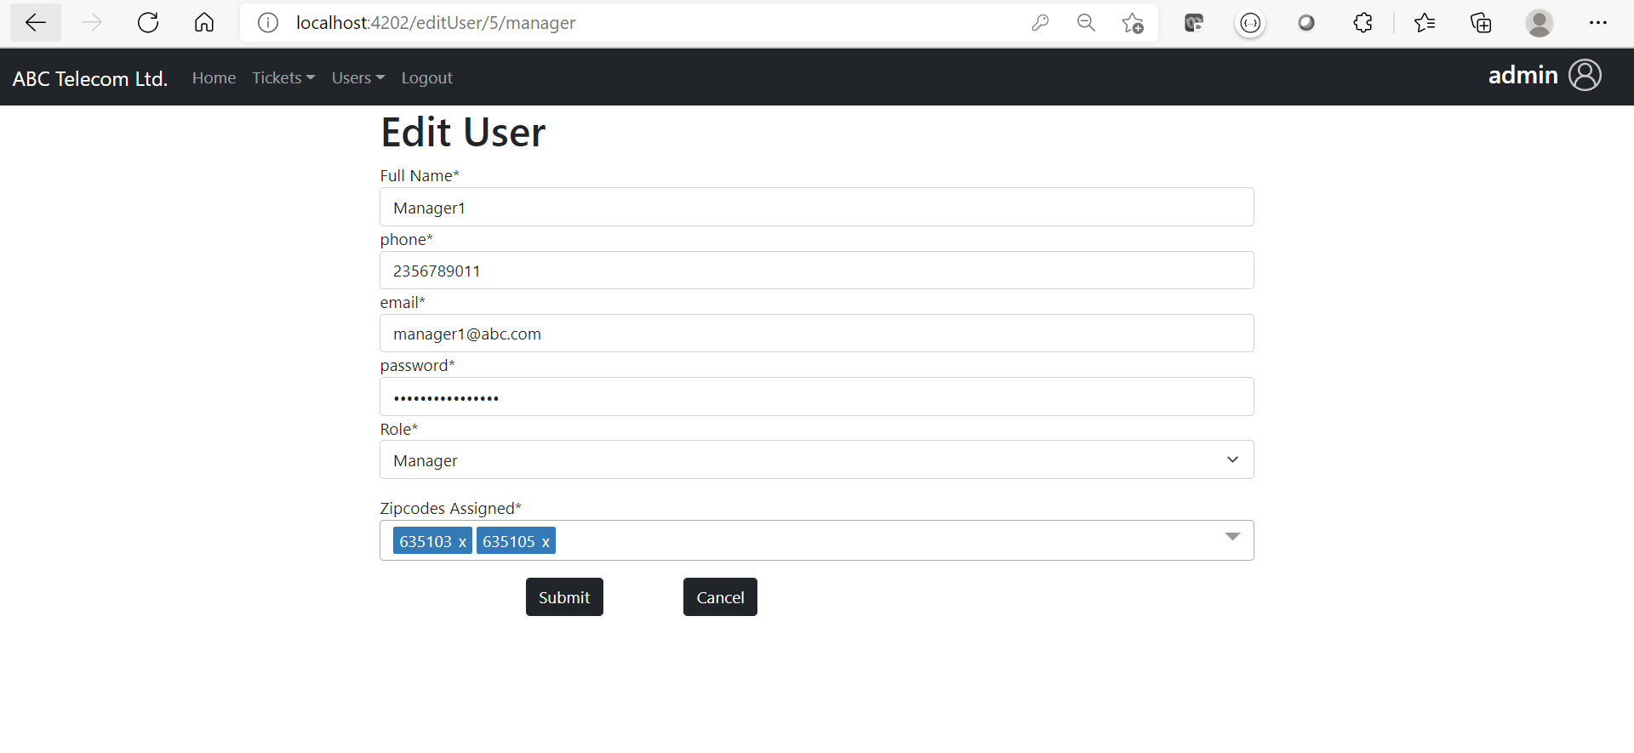](https://github.com/mcvrvikram/Complaint-Frontend/blob/master/src/assets/admin-edit-user.PNG)

### Sample 5

[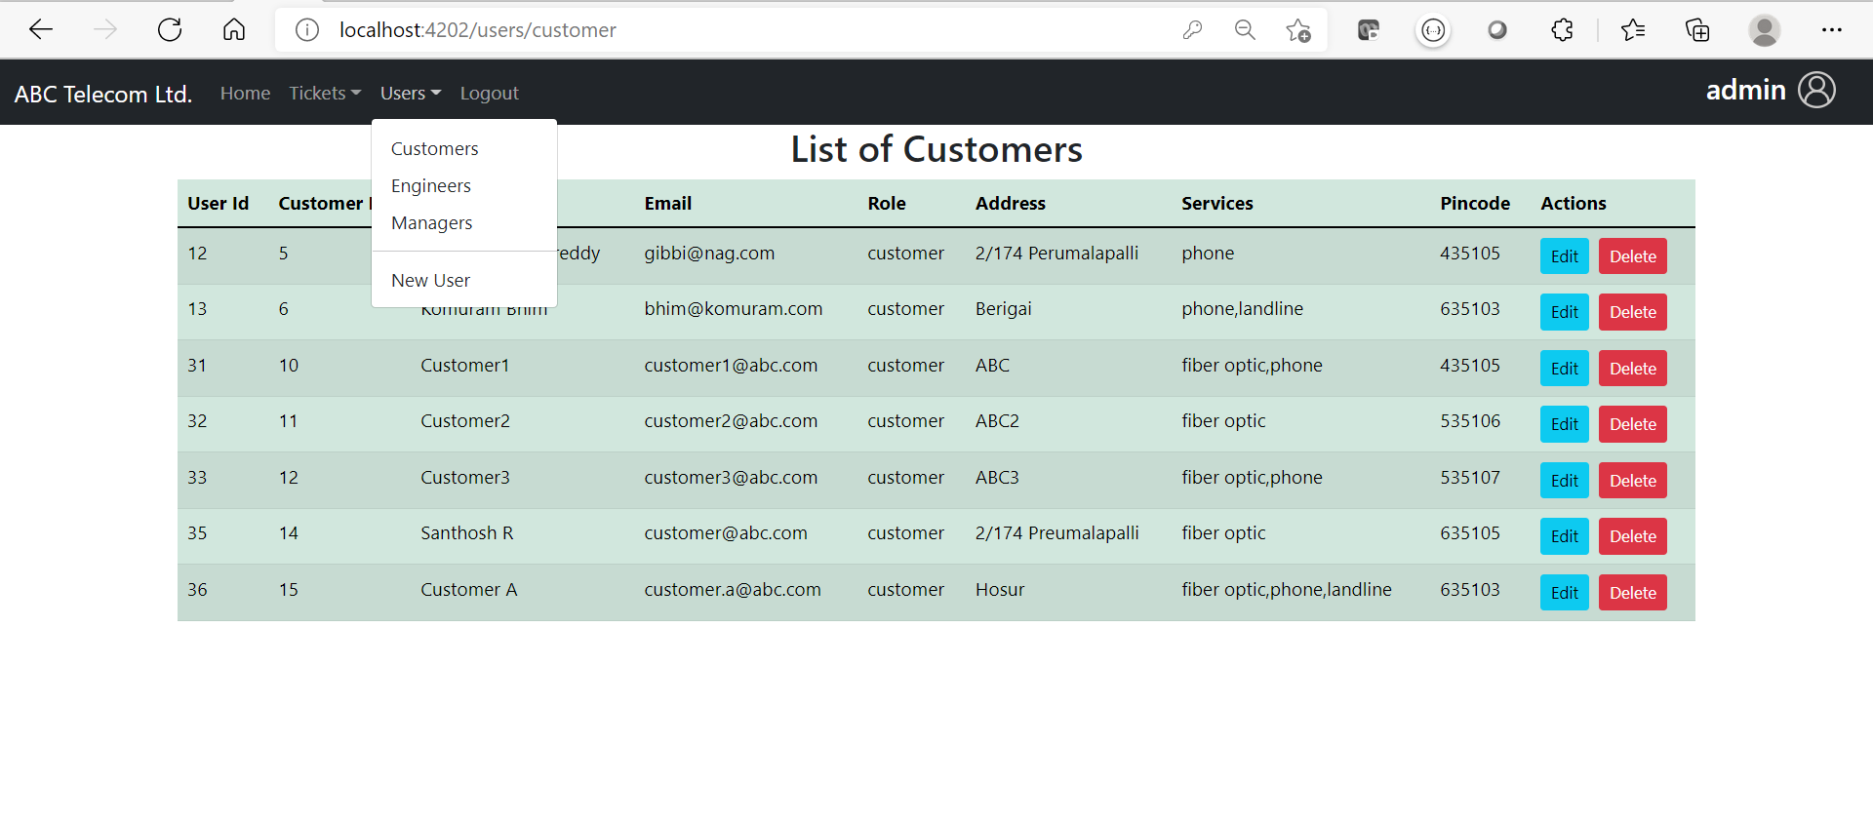](https://github.com/mcvrvikram/Complaint-Frontend/blob/master/src/assets/admin-list-users.PNG)

### Sample 6

[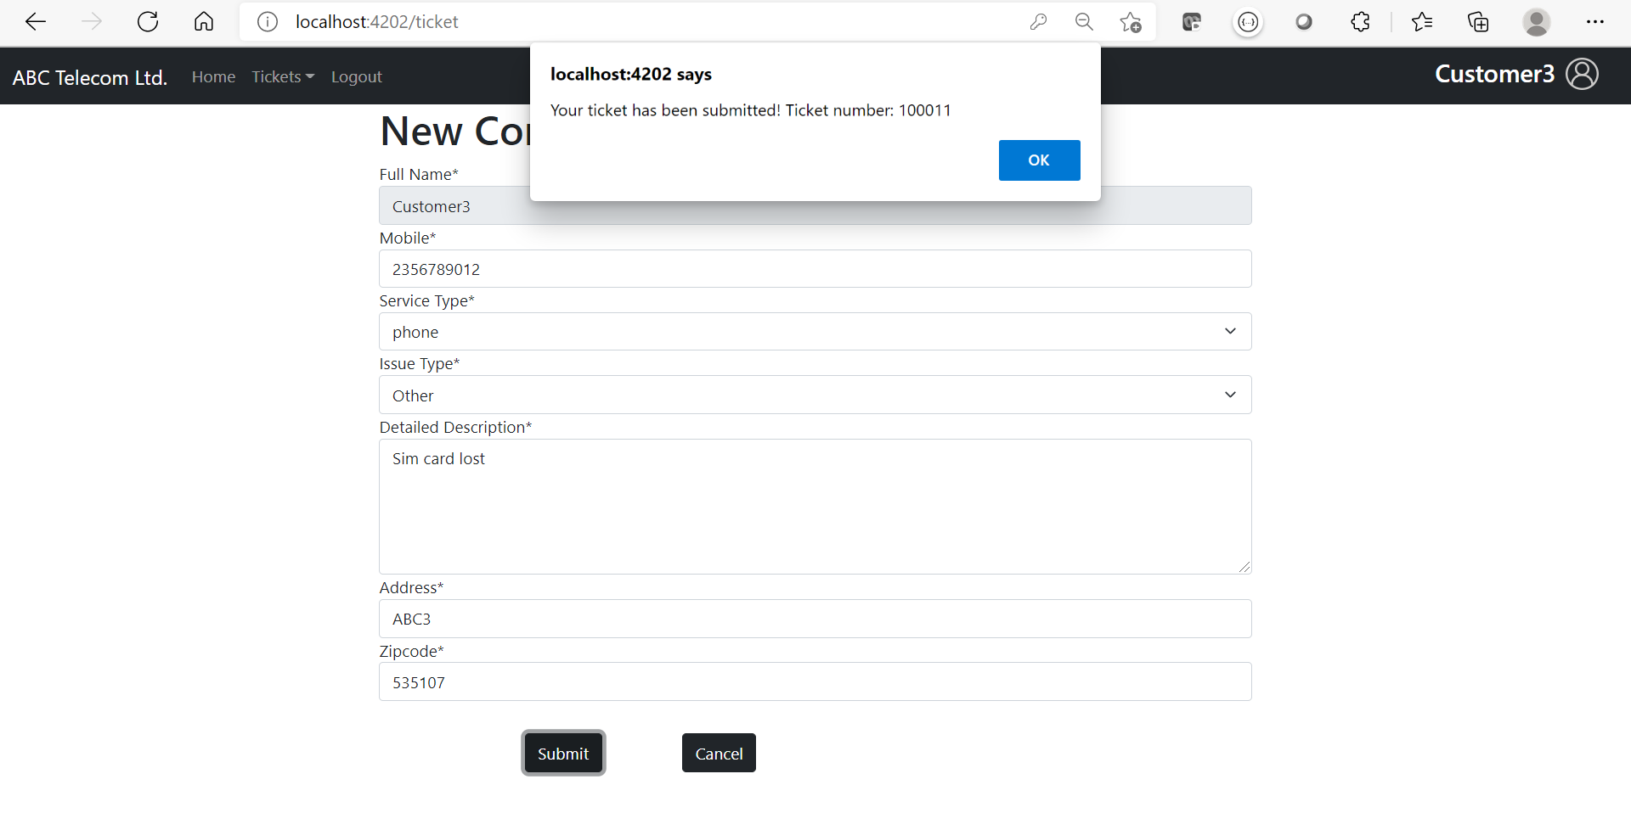](https://github.com/mcvrvikram/Complaint-Frontend/blob/master/src/assets/customer-create-ticket.PNG)

### Sample 7

[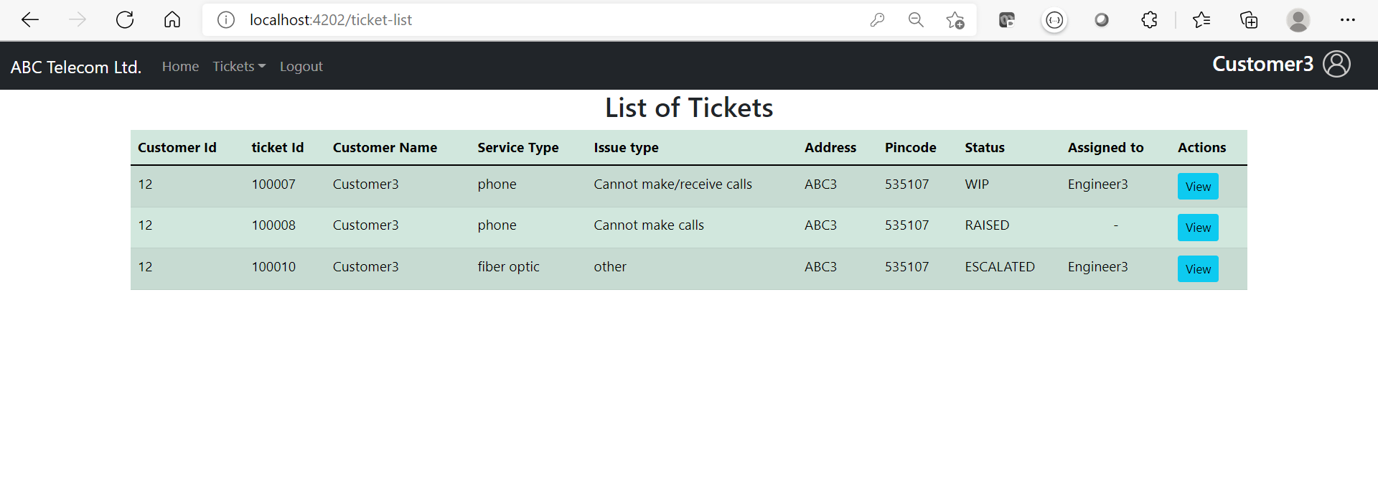](https://github.com/mcvrvikram/Complaint-Frontend/blob/master/src/assets/customer-see-tickets.PNG)

### Sample 8

[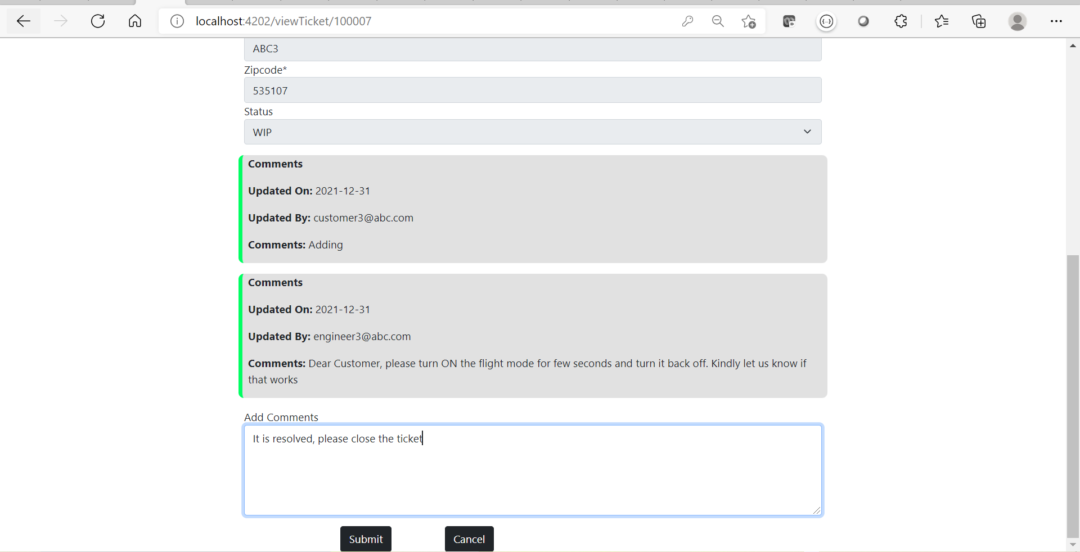](https://github.com/mcvrvikram/Complaint-Frontend/blob/master/src/assets/Customer-add-comments.PNG)

### Sample 9

[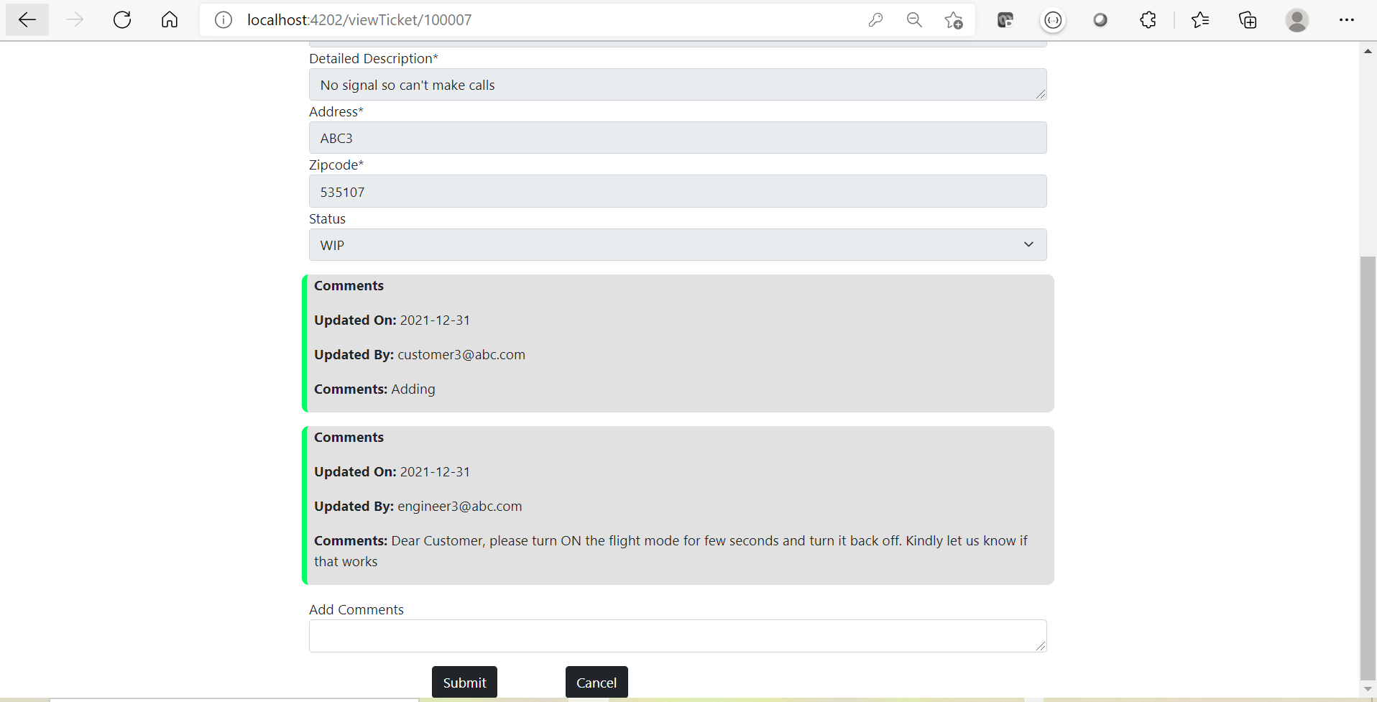](https://github.com/mcvrvikram/Complaint-Frontend/blob/master/src/assets/Customer-check-comments.PNG)

### Sample 10

[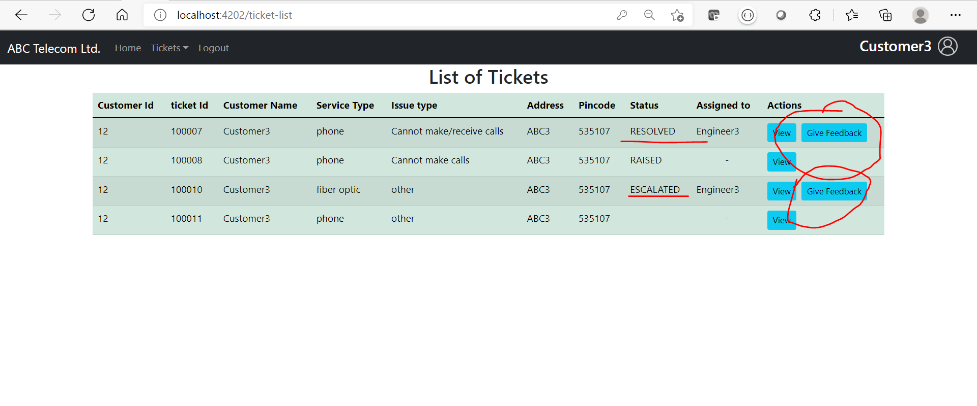](https://github.com/mcvrvikram/Complaint-Frontend/blob/master/src/assets/customer-feedback.PNG)

### Sample 11

[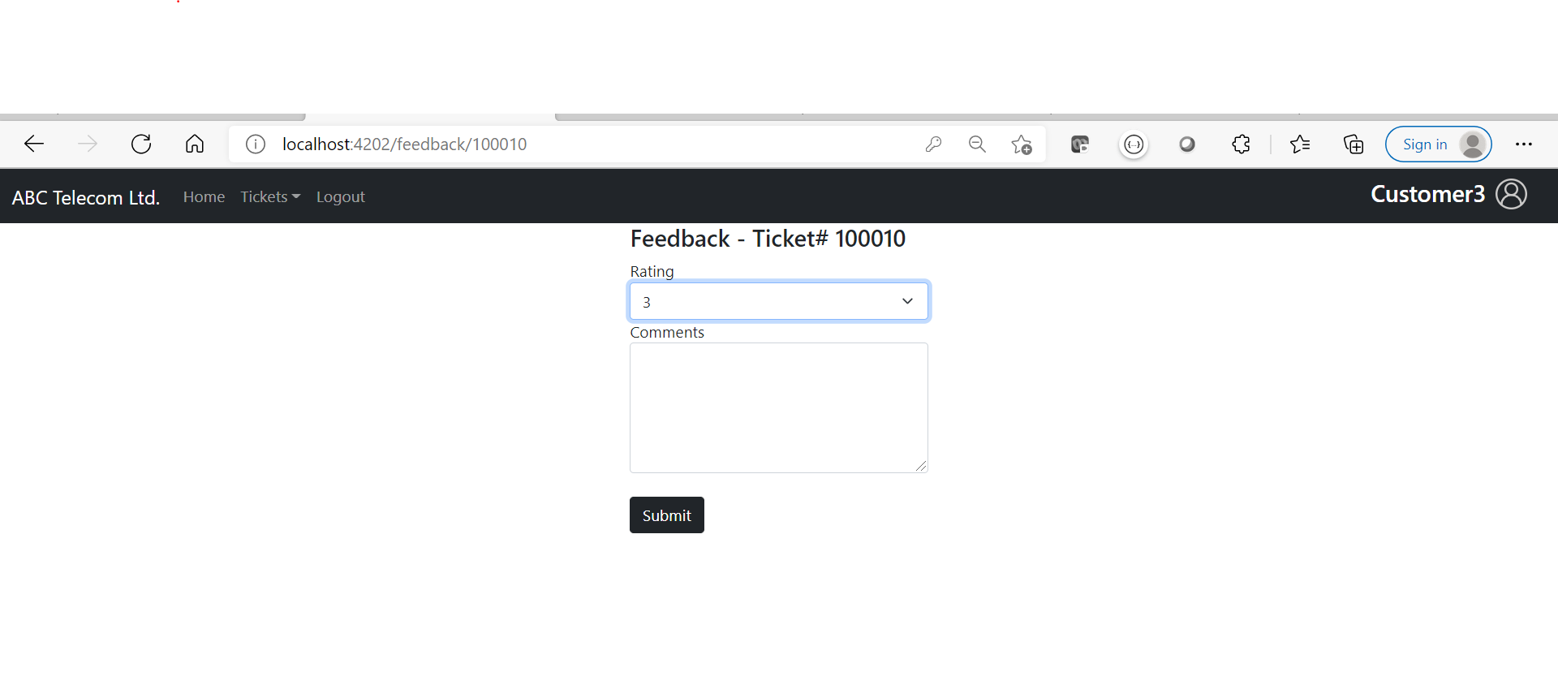](https://github.com/mcvrvikram/Complaint-Frontend/blob/master/src/assets/customer-feedback-form.PNG)

### Sample 12

[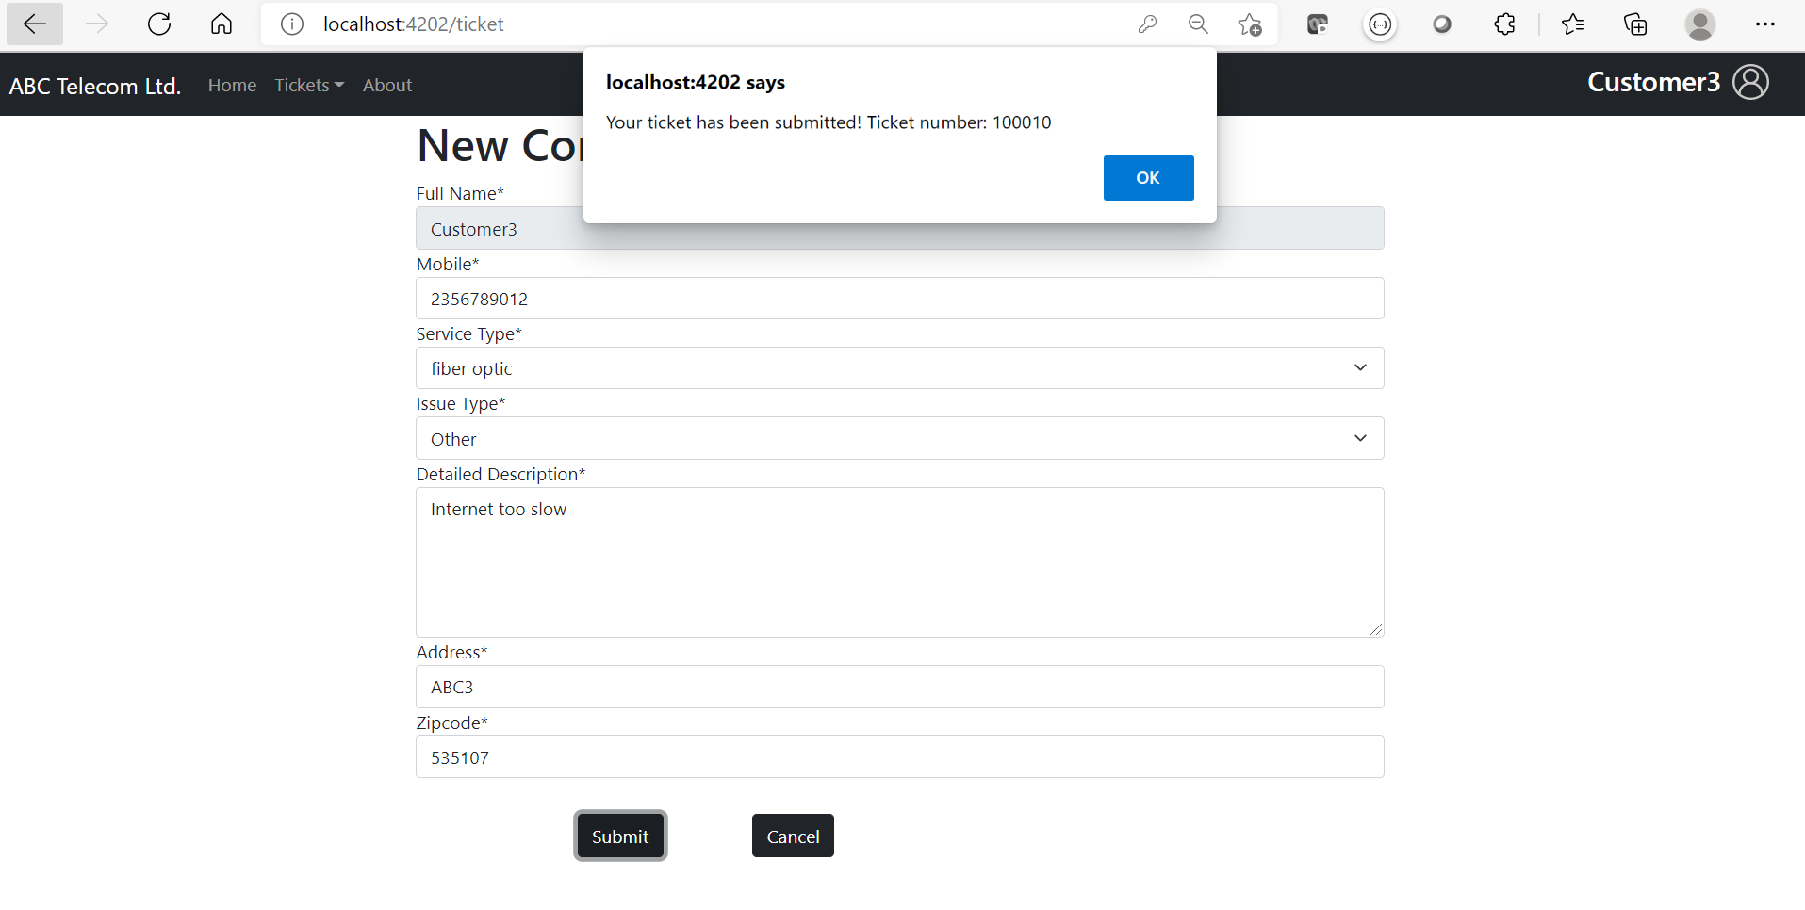](https://github.com/mcvrvikram/Complaint-Frontend/blob/master/src/assets/customer-ticket-acknowledge.PNG)

### Sample 13

[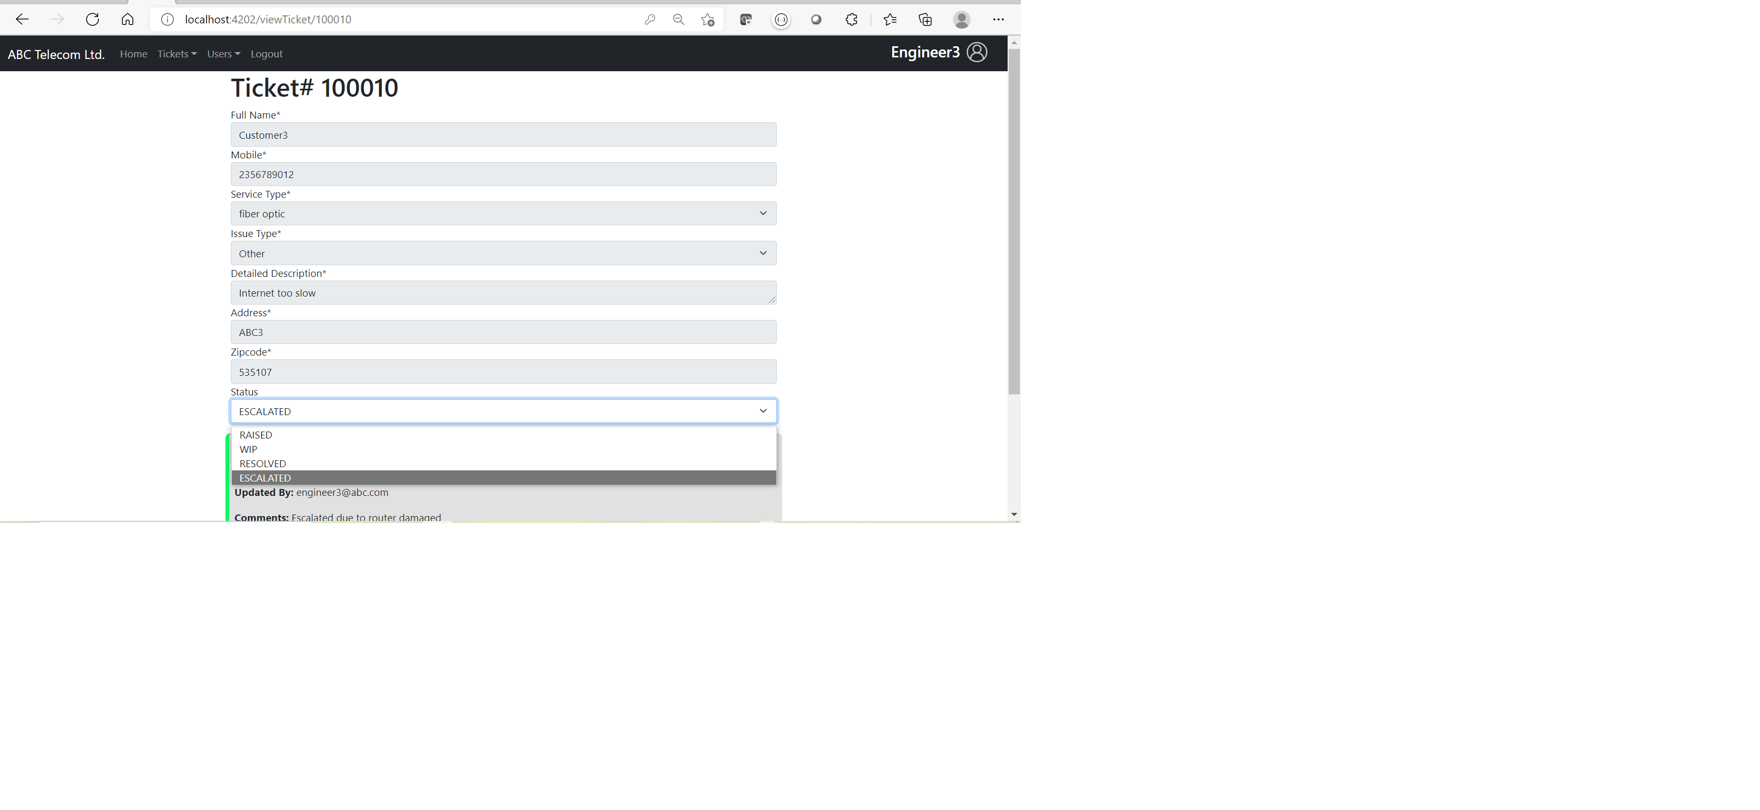](https://github.com/mcvrvikram/Complaint-Frontend/blob/master/src/assets/engineer-update-status.png)

### Sample 14

[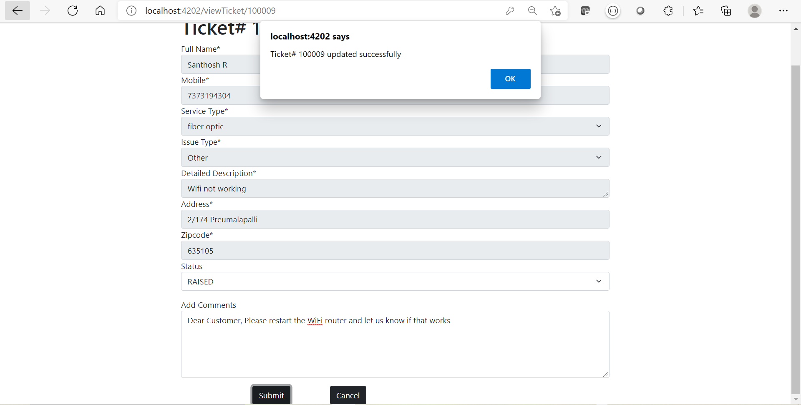](https://github.com/mcvrvikram/Complaint-Frontend/blob/master/src/assets/engineer-add-comments.PNG)

### Sample 15

[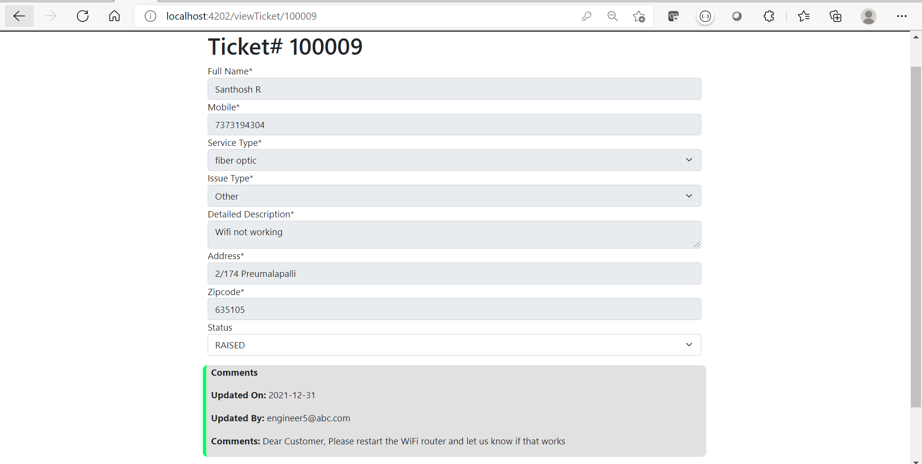](https://github.com/mcvrvikram/Complaint-Frontend/blob/master/src/assets/engineer-see-comments.PNG)

### Sample 16

[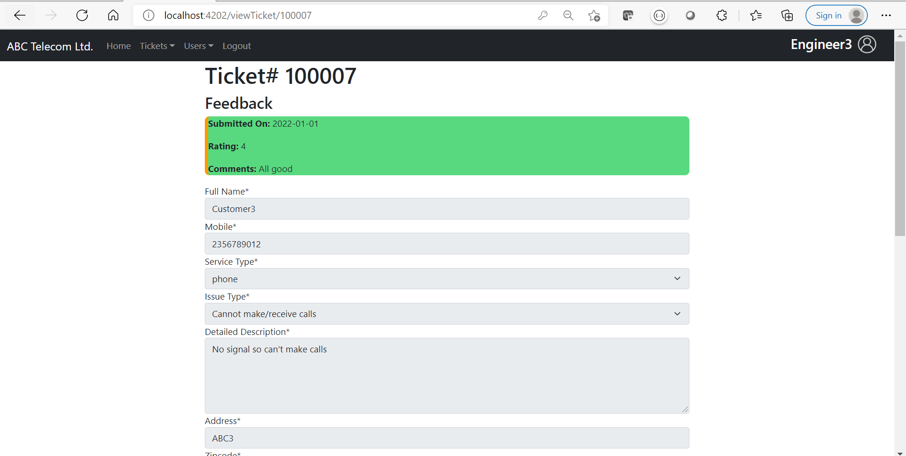](https://github.com/mcvrvikram/Complaint-Frontend/blob/master/engineer-view-feedback.PNG)

### Sample 17

[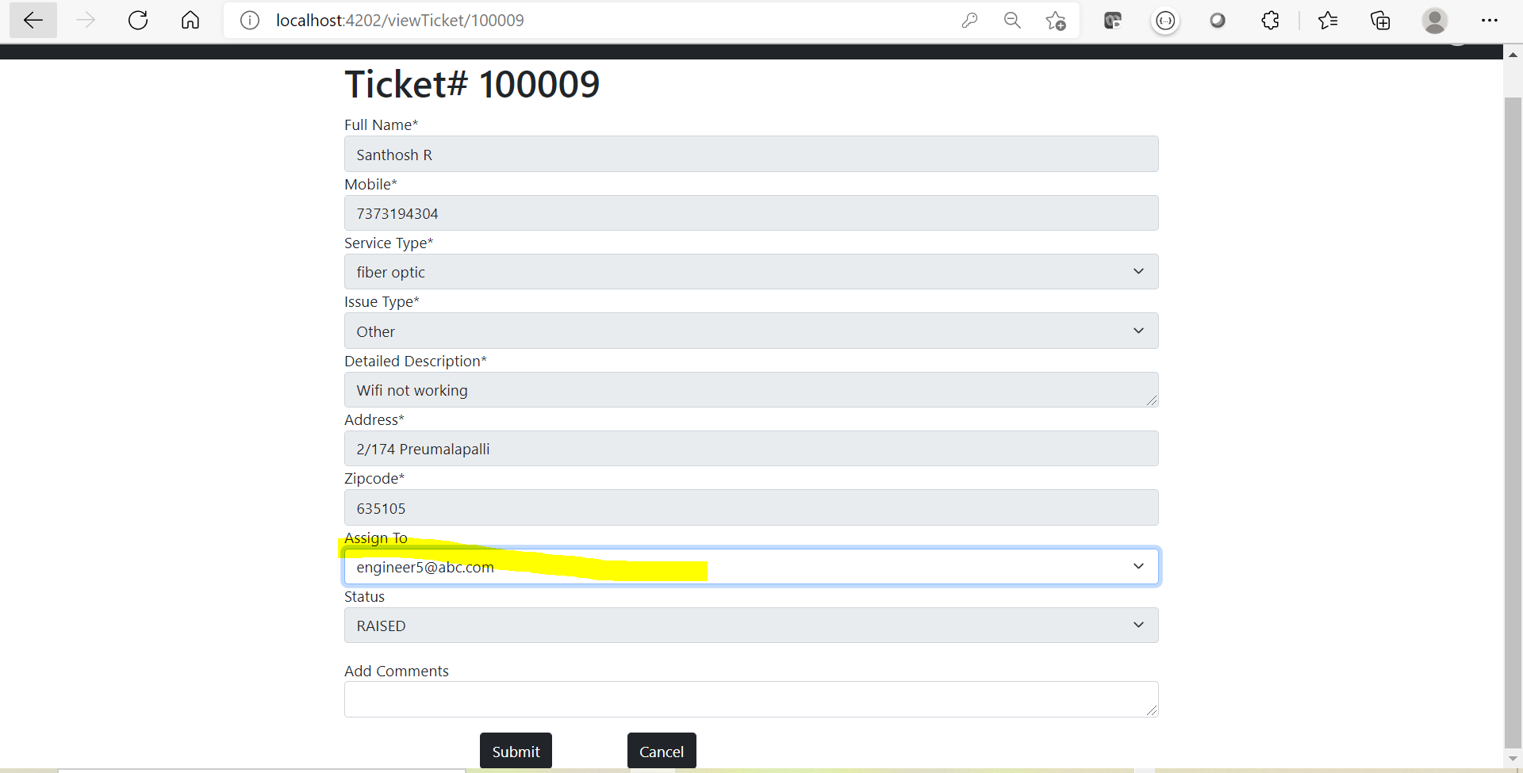](https://github.com/mcvrvikram/Complaint-Frontend/blob/master/src/assets/manager-can-assign.PNG)

### Sample 18

[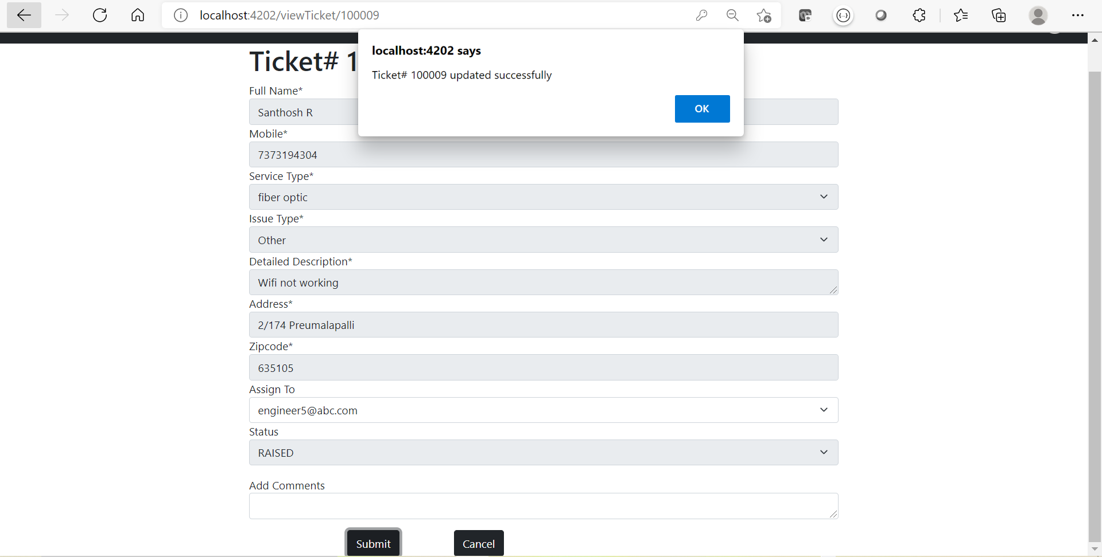](https://github.com/mcvrvikram/Complaint-Frontend/blob/master/src/assets/manager-assign-success.PNG)

### Sample 19

[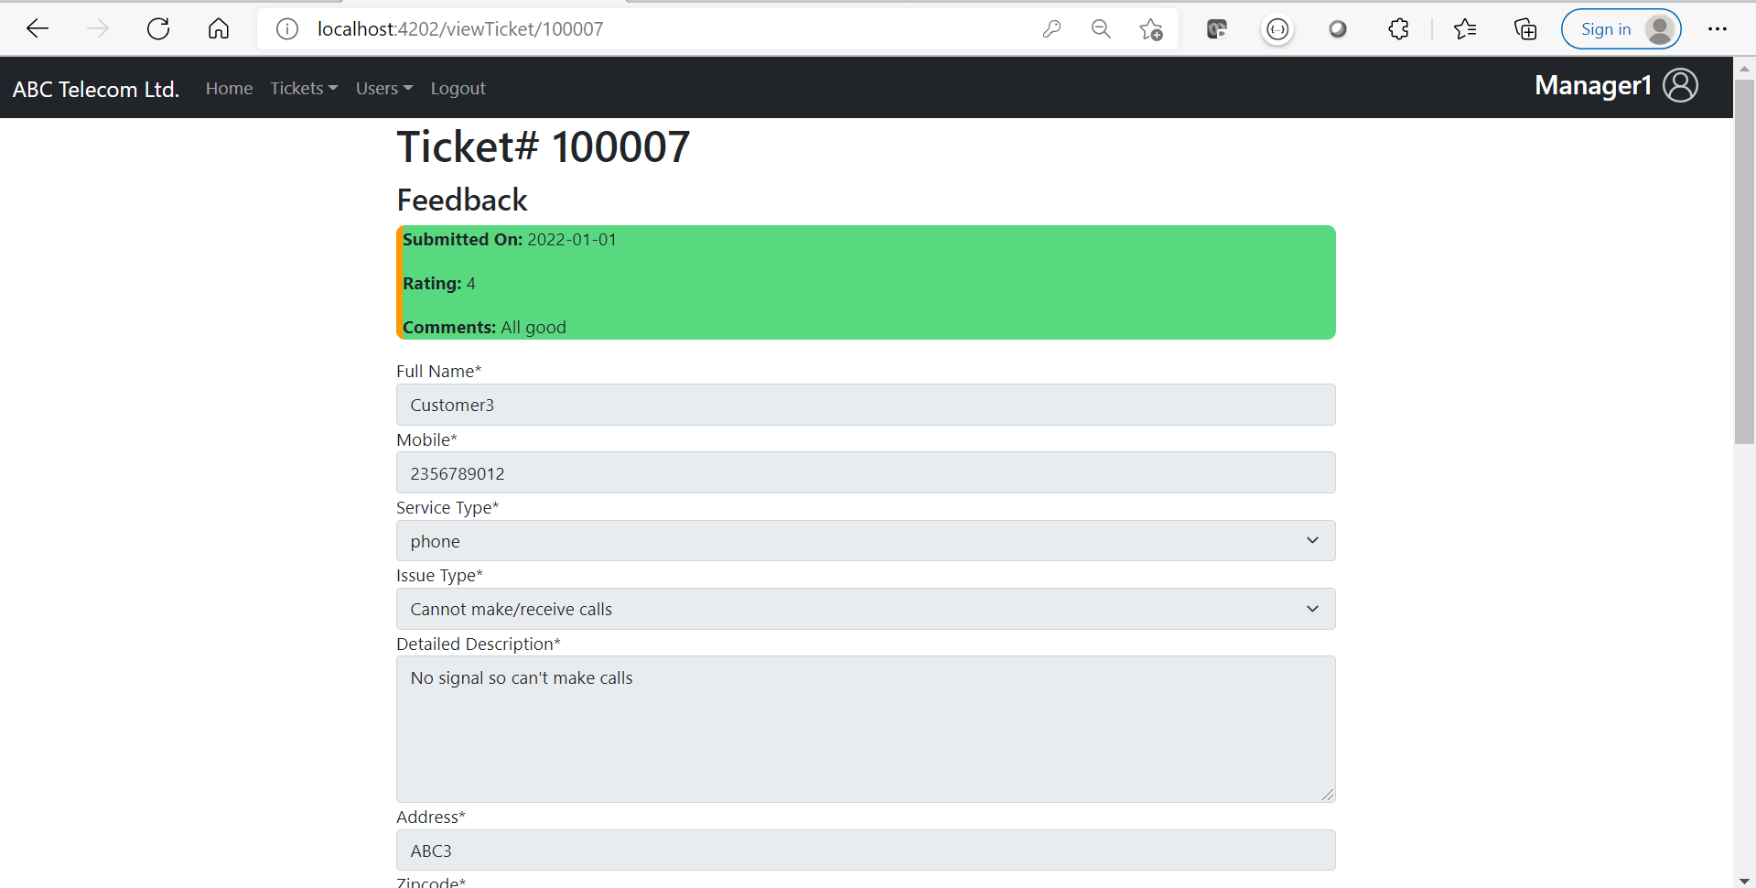](https://github.com/mcvrvikram/Complaint-Frontend/blob/master/src/assets/Manager-view-feedback.PNG)

Give feedback