Name: B. Krishna
Id: 2400030120
Exp: 10
Sec: 09
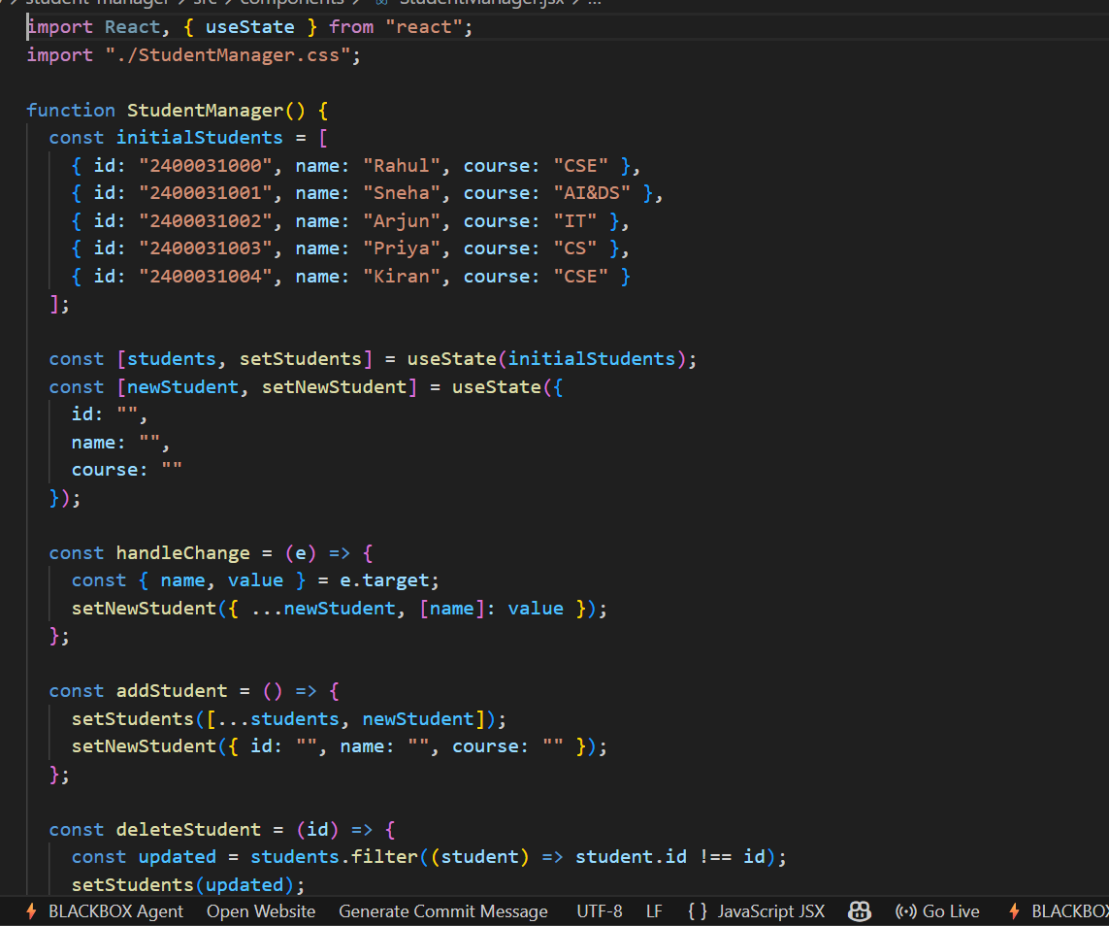

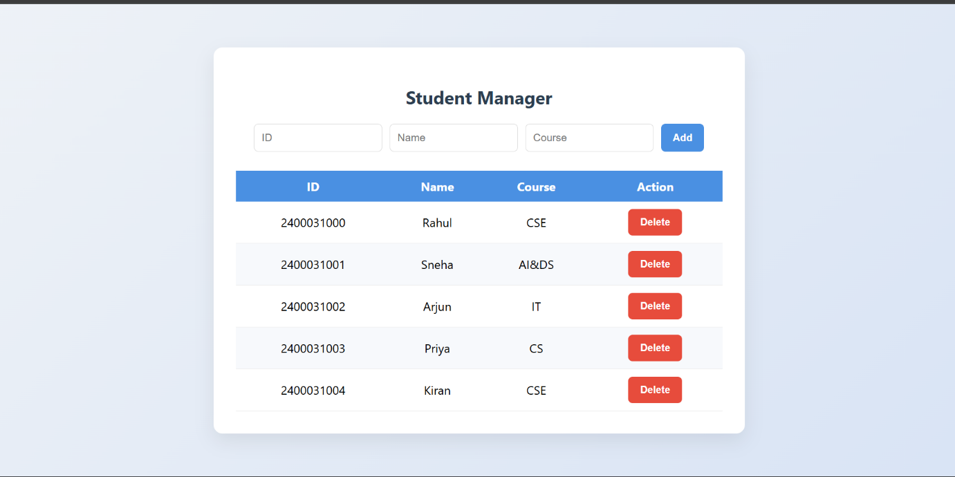

https://github.com/krishna3324/FSAD-SkillExperiments.git

