AI Experiment 15:
Generate an image using DALL-E or similar tool for a given prompt.
For you can use the following prompt to generate an image with DALL-E or a similar AI image-generation tool.

Prompt :
Generate a realistic and visually appealing image of a futuristic smart city in India. Show autonomous electric vehicles, smart traffic lights, IoT-enabled streetlights, solar panels, green buildings, drones, and people using smart technology. Use a modern futuristic style, high detail, realistic lighting, and a clean urban environment.
Expected output: A generated image representing a future smart city powered by Artificial Intelligence and IoT.
Using chatgpt:
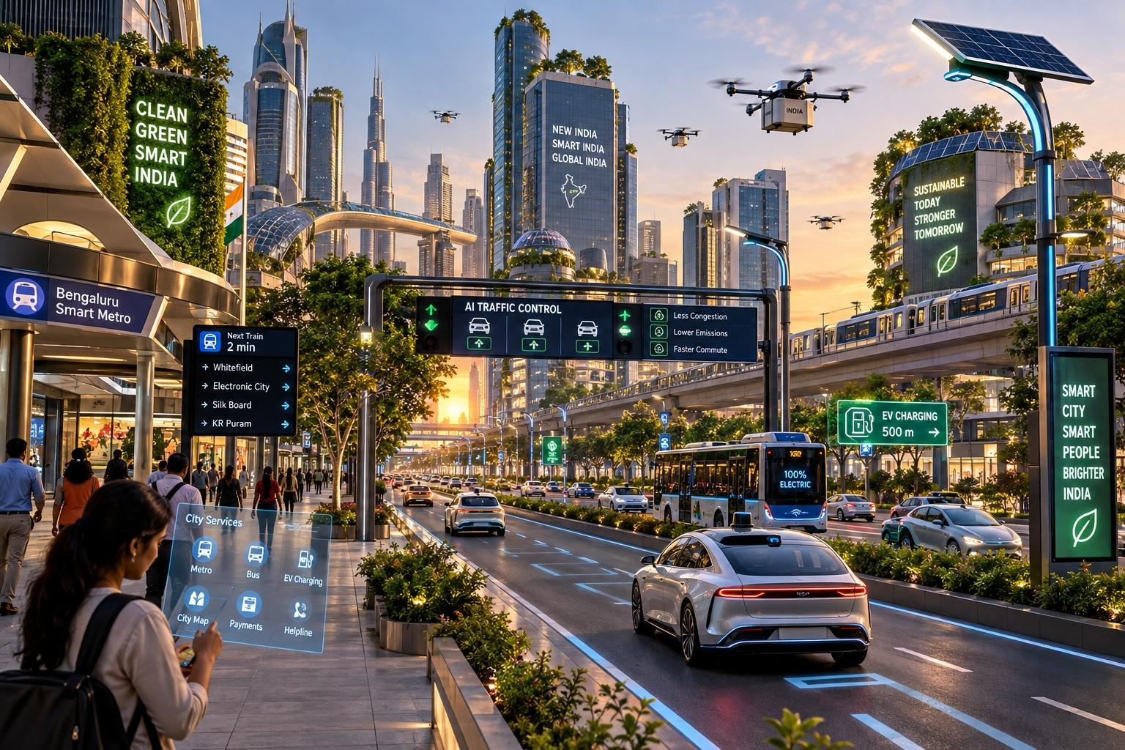
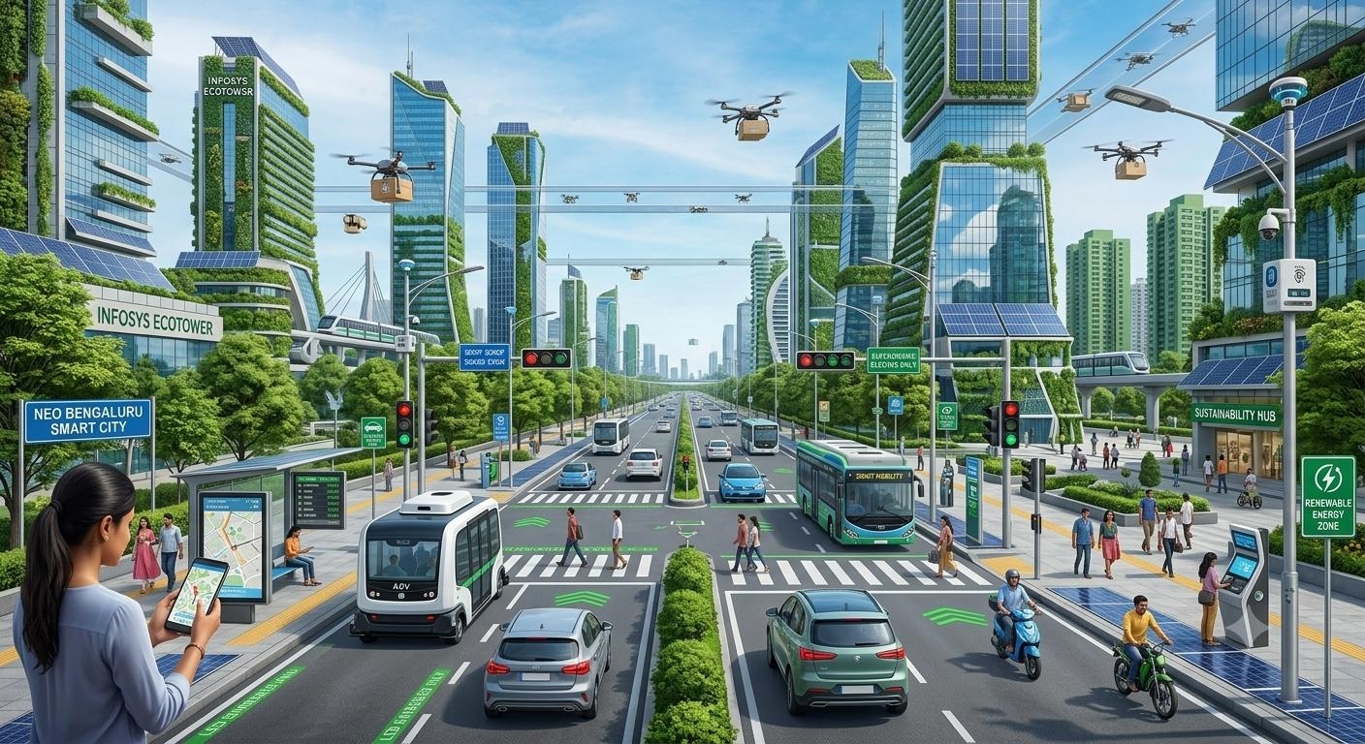
Using Gemini :

